***ShopNest***

***ShopNest Store Capstone Project Analysis:***

**Introduction:**

According to the data received, ShopNest is an e-Commerce Marketplace, and the data for analysis consisted of 9 different data tables.

To understand the data set please find below the data relationship model:

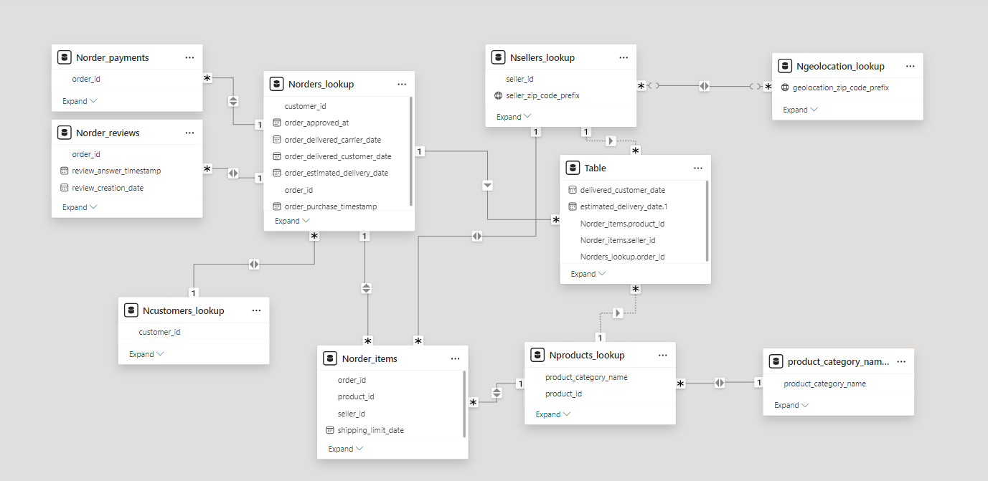

Table refers to the custom table created for analysis purpose.

It is understandable from the questions that the main focus is on understanding the operational efficiency. Please find the explanation for each questions as under.

**Dashboard:**

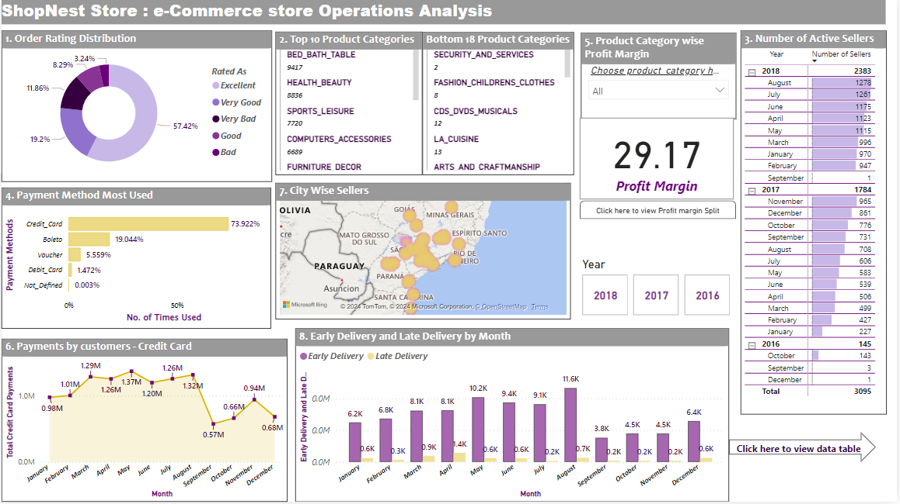

Explanations for the questions are as follows:

1. Identify the rating distribution in the Shop_Nest dataset, showcasing ratings categorized as Excellent, Very Good, Good, Bad, and Very Bad, along with corresponding orders.

Donut visualization is used to visualise this against Distinct Order ids.

We can conclude from visual majority rated ***Excellent*** (5) being ***57.42%*** and least rated ***Bad*** (2) being ***3.24%*** but should work on ***Very Bad*** (1) as it is ***11.86%***.

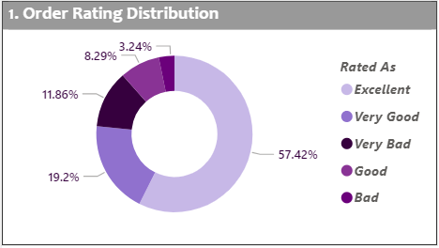

1. What are the top 10 and bottom 18 most popular product categories in the ShopNest dataset? Please list them based on the number of orders.

Multi-row card provides the list of the top 10 and bottom 18 product categories. Please utilise the scroll option in the power bi file to view complete list. To achieve this feature and limit it to certain ranks Top N feature in filtering is used for the visual.

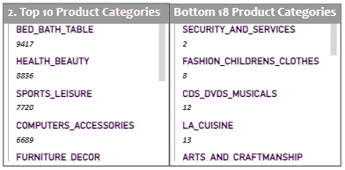

1. List the total number of active sellers by yearly and monthly.

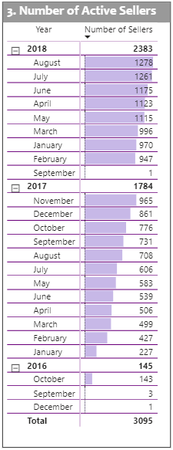

Here Matrix visual is used, Count of Seller Id for active sellers taken based on order id details. It also helps to understand quantity easily with help of data bars.

As a comparative approach we can see there are more sellers in year 2018 who are active than previous years as there is approximately 50% increase.

This increase in sellers also signify that number of orders has scope to increase in further years. This is a good sign.

1. Which payment methods are most commonly used by ShopNest customers.

Bar chart is being used to visualise this, for easy understanding values are being displayed as a % of Grand Total.

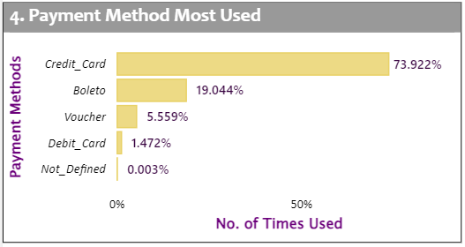

1. Identify the product category. wise profit margin using the formula

Hint: (Payment value -price + Freight_value)/payment_value*100 (Rounded to two decimal points).

Here page navigation drill through is used. Also Slicer option is used. For this Card and Table are used to visualise. Highest Profit Margin is from Home Comfort 2.

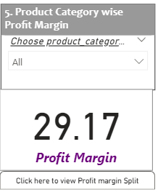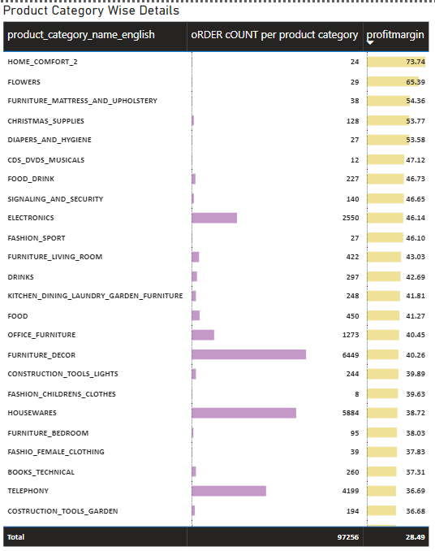

1. Determine the monthly payments made by customers using credit cards.

Line Chart Visualization is used, using DAX formula measure is used to count only where payment is made through Credit Card. The visual shows monthly fluctuations. Using Year Slicer available in Dashboard we can also know the year wise pattern.

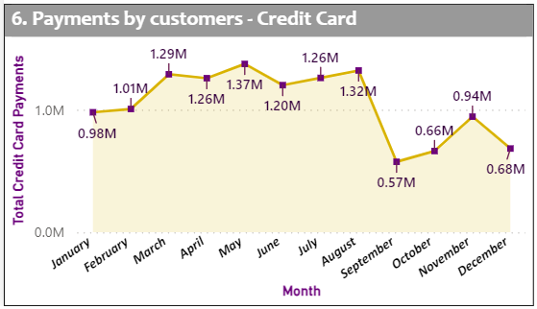

1. Identify sellers categorized by city, excluding cities starting with the letters S and B.

Here Map is used to visualise distribution of sellers across different cities through heat maps as longitude and latitude details was available. Higher concentration represented by yellow, medium by pink and less by purple.

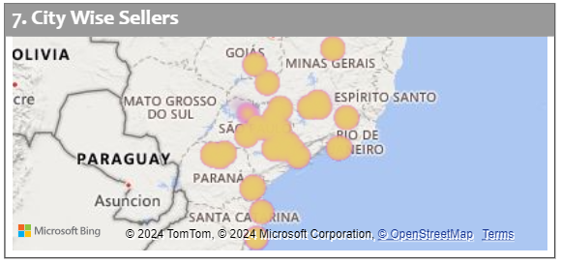

1. Create a dynamic visual that compares the number of delayed orders to the number of orders received earlier for each month. Utilize the drill through the cross-report feature to provide a detailed analysis of late and on-time deliveries.

Clustered Column Visual is used, measures are created for this analysis to specifically count Early, On-Time and Late Deliveries. Conditional column is also used.

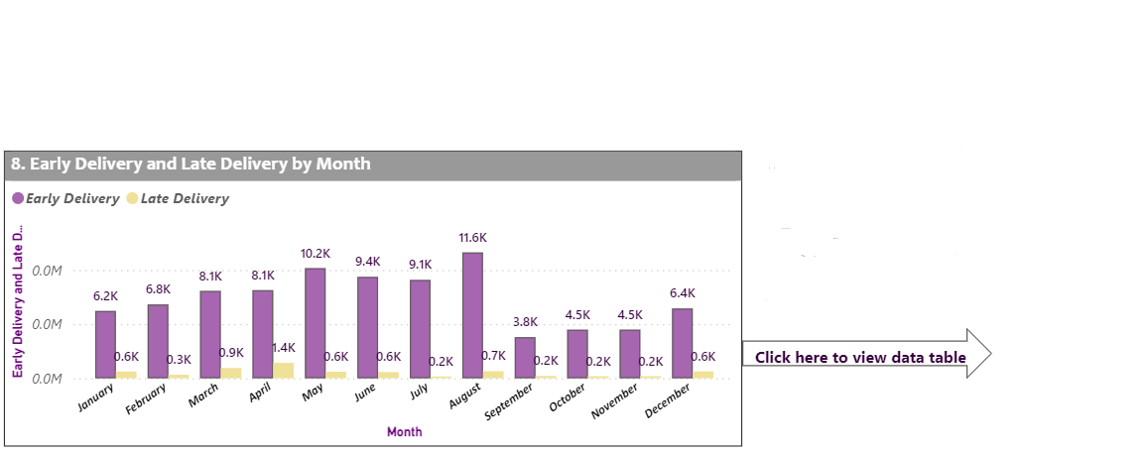

Previous visual clearly shows there are more early delivery compared to late delivery. Since On-time was not asked for comparison it is not shown. However, in detailed analysis it is also projected in report as it is one of the important element. On clicking on the button page is navigated to a drill through page showing more details. Kindly refer to image below.

