Slide 1

Autonomous Volcanic Terrain Exploration

Using a Markov Decision Process (MDP)
Final Project Presentation
We are Group 5:
Shakil Ahmed · Fahim Foysal · Shefa Tabassum · Tanvir Ahmed
CSE 440 (Artificial Intelligence) · Section 1 · Instructor: Dr. Mohammad Shifat-E-Rabbi

Slide 2

The problem
- Volcanic terrain is too dangerous for humans to explore directly
- An autonomous rover must collect science samples and survive
- Lava is fatal; craters and gas are costly; rock blocks movement
- Movement is unreliable: the rover can slip sideways or stall
- The terrain itself changes during the mission
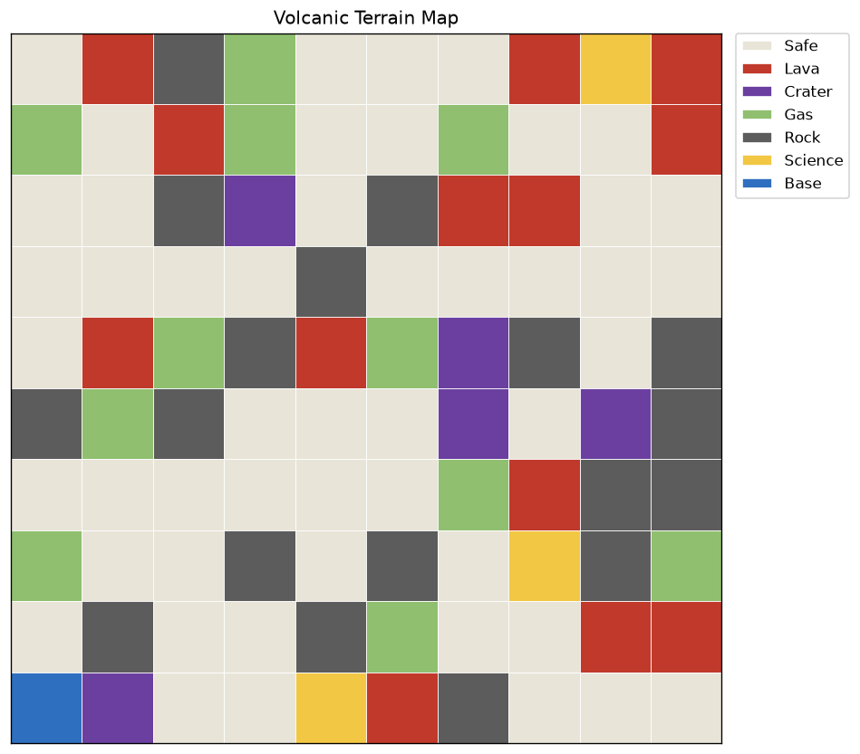

Slide 3

The task as an MDP
- States: every walkable cell of the grid (rock excluded)
- Actions: up / down / left / right / stay / scan
- Transitions: 75% intended, 10% drift each side, 5% stall
- Rewards: science +20, base +5, safe −1, gas −15, crater −40, lava −100
- Discount γ = 0.9, tuned so distant science never justifies deadly gambles
- Solved exactly with value iteration (converges in milliseconds)
V(s) ← max over a of Σ P(s′|s,a) [ R(s,a,s′) + γ V(s′) ]
The Bellman backup, repeated until convergence

Slide 4

The computed policy
- One optimal action per cell: a complete plan, not a single path
- The flow field bends around lava and craters
- It converges on science points and the base
- Robust by construction: slips land the agent on cells that already have a plan
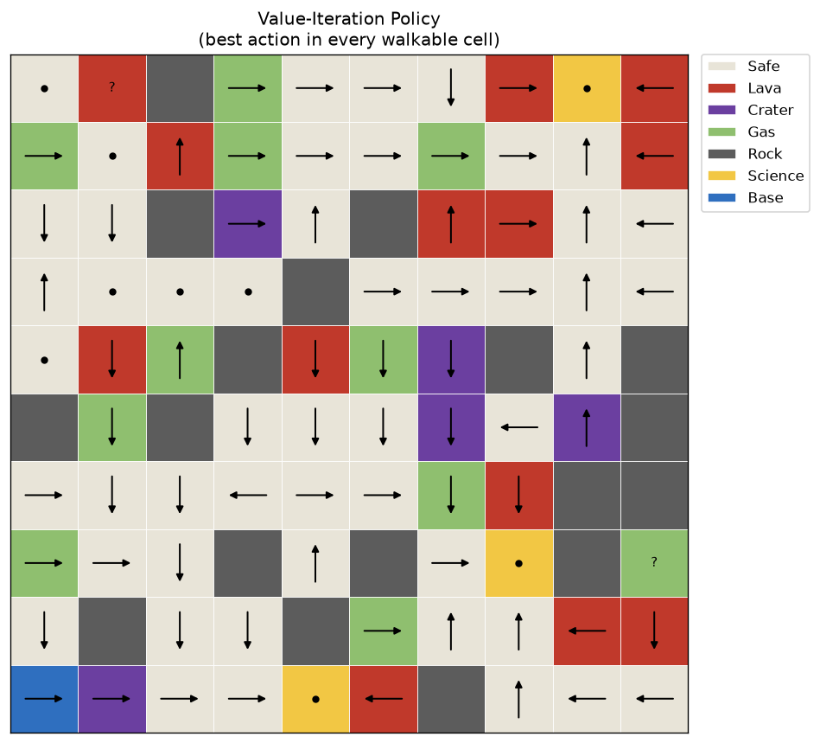

Slide 5

Collect-once science + re-planning
- Naive MDP behavior: camp forever on one +20 science cell
- Our rule: a sample is collected once, then the cell becomes ordinary ground
- The agent immediately re-runs value iteration (warm start: a few sweeps)
- Result: an efficient, risk-adjusted tour of the objectives, then return to base

Slide 6

Dynamic hazards
- Gas clouds drift into neighboring safe cells (p = 0.15 per cloud per step)
- Lava spills into safe neighbors (p = 0.08) and cools back after 6 steps
- Base, science, rock, and craters are never destroyed, so the state space stays fixed
- Every terrain change triggers a fresh re-plan
- A lava flow reaching the rover destroys it

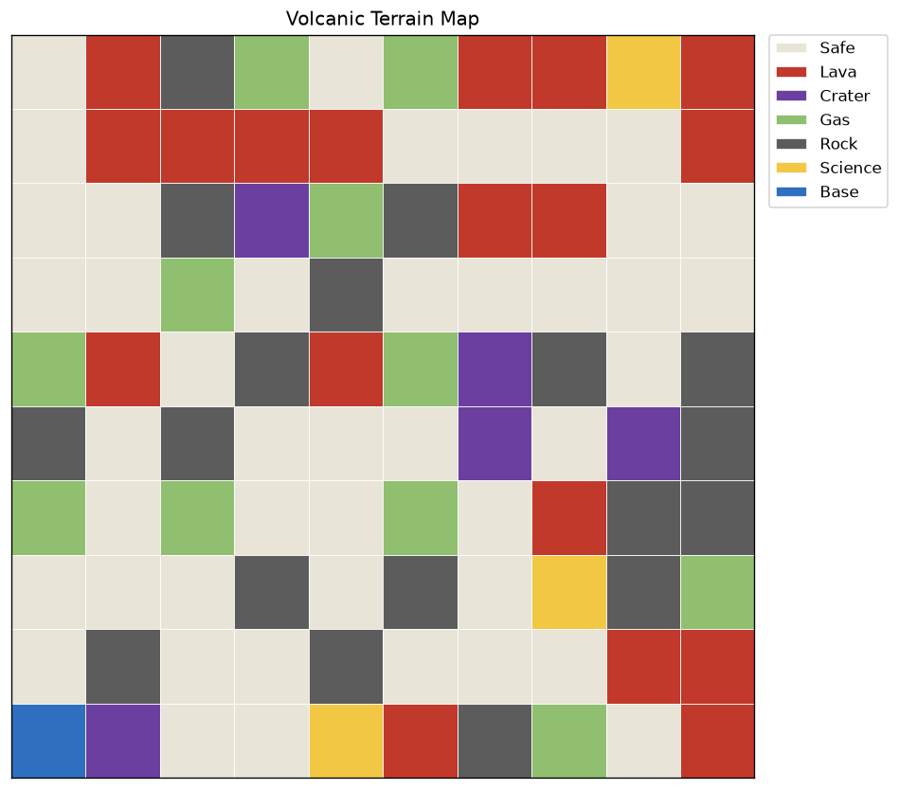
Same map: initial (left) and after 20 hazard steps, 58 change events (right)

Slide 7

A completed mission
- Seed 42, dynamic hazards ON
- 24 steps, 2 science samples, survived
- 71 terrain-change events during the mission
- Reward higher than the static run of the same seed: re-planning exploited a gas cloud drifting off its route
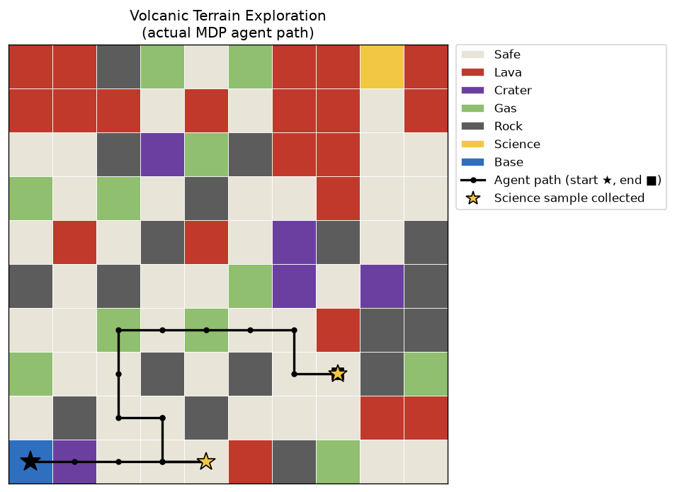

Slide 8

Does planning beat heuristics? 20 random terrains
- MDP: follows the value-iteration policy
- Greedy: BFS to nearest unvisited cell, ignoring soft hazards
- Random: uniform random direction
- Only the MDP agent earns positive reward: +42 vs −124 vs −180
- It survives 60% of missions (2× greedy) with ~5× fewer hazard entries
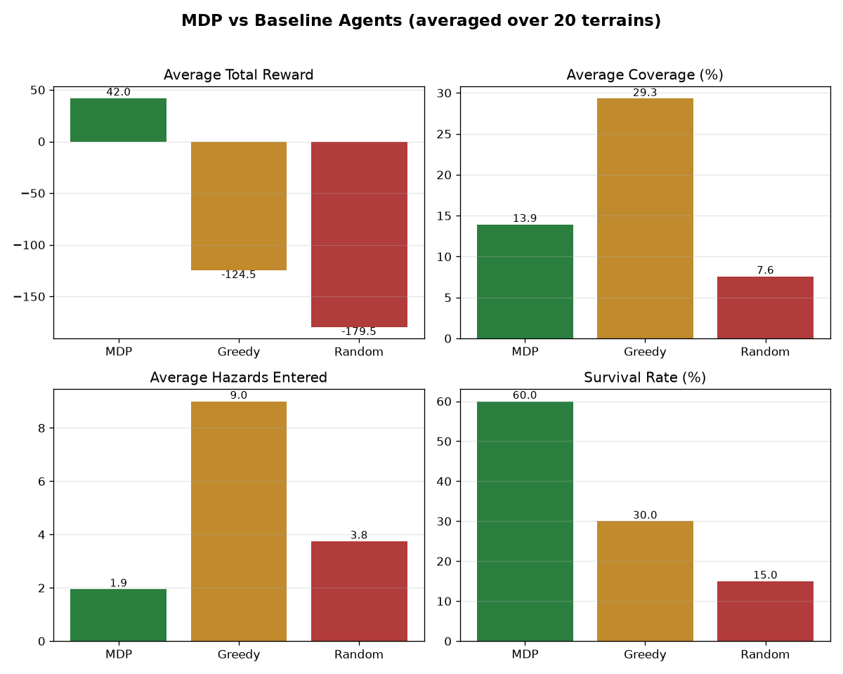

Slide 9

Conclusions & future work
- Decision-theoretic planning decisively beats heuristics in hazardous exploration
- Safety and science behavior emerge from the reward model, with no hand-coded rules
- The reward model IS the specification: 'camping' was optimal until we changed the rules
- Future: risk-sensitive objectives, energy budgets, fog-of-war POMDP, multi-rover teams
- Everything is seeded and reproducible: python main.py

