Slide 1

Autonomous Volcanic Terrain Exploration

Using a Markov Decision Process (MDP)
Project Update 1
We are Group 5:
Shakil Ahmed · Fahim Foysal · Shefa Tabassum · Tanvir Ahmed
CSE 440 (Artificial Intelligence) · Section 1 · Instructor: Dr. Mohammad Shifat-E-Rabbi

Slide 2

Problem & goal
- An autonomous rover exploring hazardous volcanic terrain
- Grid world: safe ground, lava, craters, gas, rock, science points, base
- Movement is stochastic: the rover can slip or stall
- Goal: collect science, avoid hazards, and survive, planned with an MDP
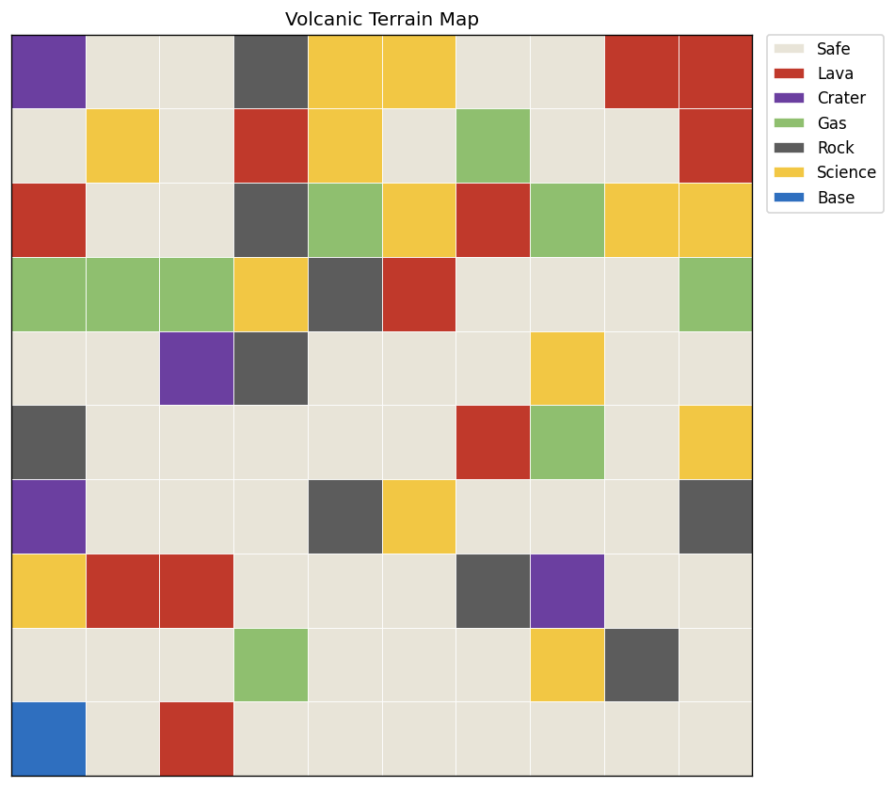

Slide 3

Done: terrain generator & MDP core (Member 1)
- Seeded procedural terrain with configurable cell probabilities
- Hazard density capped so maps stay traversable; CSV save/load
- MDP formulation: states, 6 actions, slip transitions, reward model
- Value iteration + optimal policy extraction, γ = 0.9
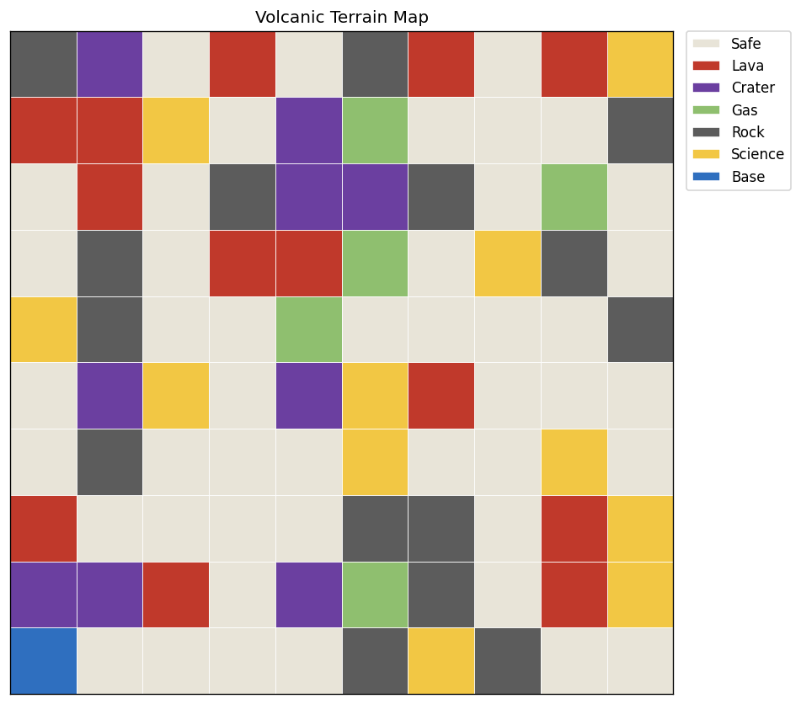

Slide 4

Done: agent, simulation & visualization (Members 2 & 3)
- MDPExplorerAgent: starts at base, follows the policy, samples real outcomes
- Tracks reward, hazards, science, survival; mission summary
- Simulation loop with step budget and coverage target
- Matplotlib terrain rendering with legend, one color per cell type

Slide 5

Done: baseline experiments (Member 4)
- Three agents compared on identical terrains: MDP vs Greedy vs Random
- Shared metrics: reward, coverage, hazards, science, survival
- CSV results + performance plot generated automatically
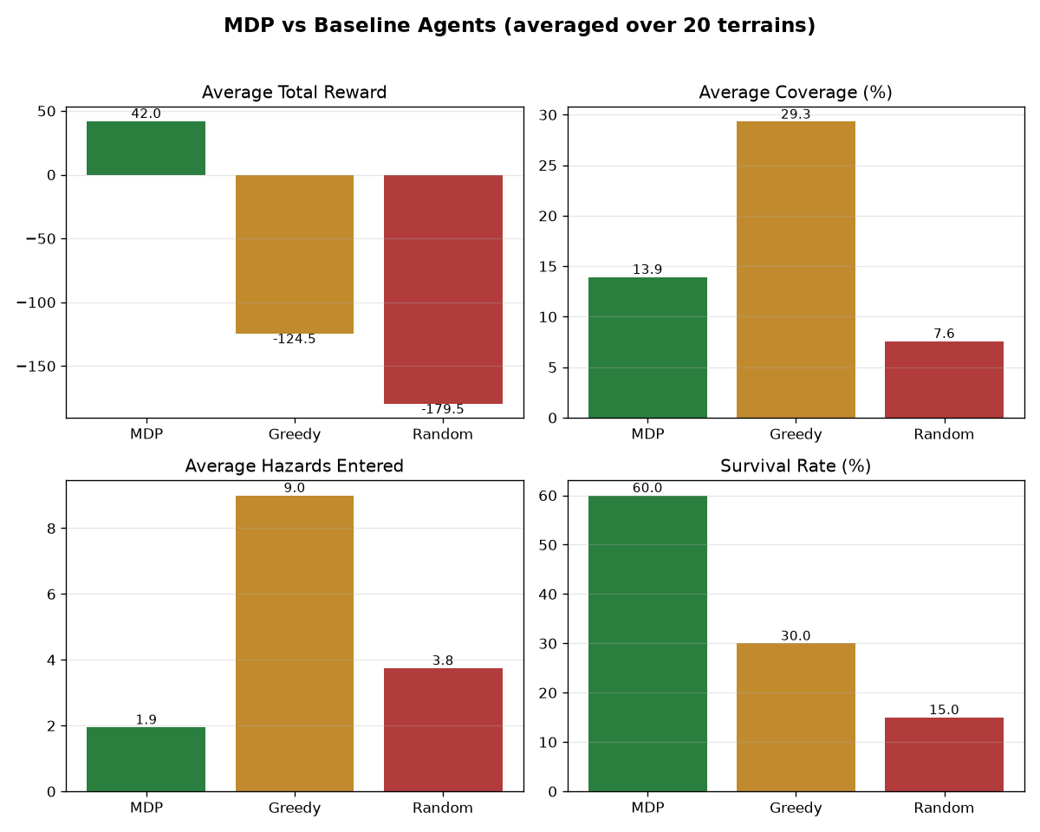

Slide 6

Plan to the final submission
- Dynamic hazards: drifting gas and spreading lava, with re-planning
- Fix the science-camping behavior (collect-once rule in the core agent)
- Mission map with the real agent path instead of a sample path
- Full pipeline in main.py; final report, slides, one-minute demo video

