NAME: INYANG AKANIMOH

**APIs: An In-Depth Look**

**TABLE OF CONTENTS**

* Introduction
* Definition of an API
* How does API work
* Importance and Uses of APIs
* Types of API
* Web APIs
* Operating System APIs
* Database APIs
* Library/Framework APIs
* Remote APIs]
* SOAP APIs
* REST APIs
* GraphQL APIs
* gRPC APIs
* APIs in Modern Software Development
* Conclusion

**INTRODUCTION**

Application Programming Interfaces, better known as APIs, are essential elements in the modern digital landscape, acting as the glue that holds disparate applications together. They form the nexus of interaction, enabling software applications to communicate, share data, and work in concert to perform complex tasks. APIs are essentially the unsung heroes of our connected world, working behind the scenes to make software integration possible.

**DEFINITION OF AN API**

An application programming interface (API) is code that enables two software programs to communicate. An API defines how a developer should request services from an operating system (OS) or other application, and expose data within different contexts and across multiple channels.

Any data can be shared with an application programming interface. APIs are implemented by function calls composed of verbs and nouns; the required syntax is described in the documentation of the application being called. For example, on a real estate website, one API might publish available real estate properties by geography, while a second API provides current interest rates and a third offers a mortgage calculator.

**HOW DOES API WORK**

The working principle of an API is commonly expressed through the request-response communication between a client and a server. The client is any front-end application that a user interacts with. The server is in charge of backend logic and database operations. In this scenario, an API works as a middle layer between the client and the server, making it possible to send data requests and responses.

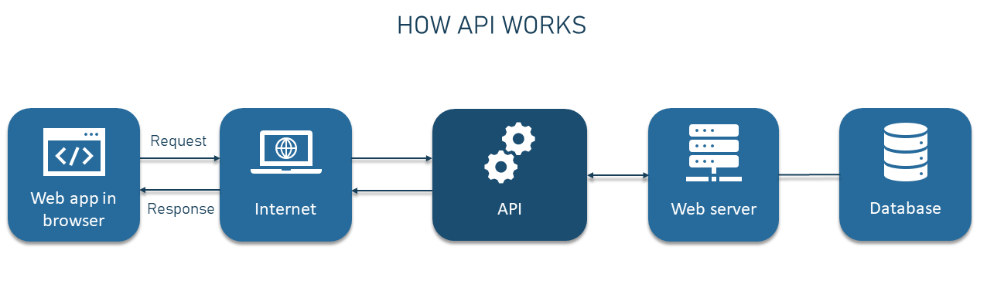

**USES OF AN APIs**

1. Integration: APIs facilitate seamless integration of diverse software applications. They enable different software systems to communicate and share data with each other, allowing for the creation of more complex and feature-rich applications.
2. Automation: APIs make automation possible by allowing software applications to manage tasks without user intervention. Tasks that might otherwise require human input can be automated, enhancing efficiency and reducing the potential for error.
3. Data Accessibility: APIs provide a structured and secure way for applications to access and manipulate data stored in databases or other applications. They allow software systems to retrieve, update, and manage data effectively.
4. Extensibility: APIs allow developers to extend an application's functionality by integrating it with other services. For example, a website might use a Google Maps API to display a map, rather than developing its own mapping feature.
5. Simplification: APIs abstract the complexity of back-end systems, providing developers with a simpler set of commands or requests to work with. This makes the development process easier and more efficient.
6. Real-time Data: Many APIs provide real-time data that can be used to create dynamic, responsive applications. For example, social media APIs can provide real-time updates, while financial APIs can provide real-time stock prices.
7. Development Speed: APIs can speed up the software development process. Developers can leverage APIs to use pre-existing functionality, saving the time and resources that would otherwise be required to build these functions from scratch.
8. Monetization: Many companies monetize their APIs by charging for their use. This enables them to generate revenue from the data or functionality they provide.

**TYPES OF APIs**  
Here's a broader explanation of different types of APIs:

1. **Web APIs**: Web APIs, often referred to as HTTP or REST APIs, are designed for interaction between a client (usually a web browser) and a server over the internet. These APIs utilize HTTP methods such as GET, POST, PUT, DELETE to perform operations on the server's resources. They're primarily used to build web-based applications where the client and server need to exchange data seamlessly. Web APIs are often designed to return data in formats like JSON or XML which can be easily parsed in any programming language.
2. **Operating System APIs**: Operating System (OS) APIs provide an interface between software applications and the operating system. They offer services and functionalities provided by the operating system such as input/output processing, memory management, process control, and network access. Applications can leverage these APIs to perform low-level operations like managing files or network connections, interacting with hardware devices, and more. Examples of OS APIs include Windows API for Microsoft Windows and POSIX API for UNIX-based systems.
3. **Database APIs**: These APIs allow applications to interact with a database system. They provide functions to perform operations such as creating, reading, updating, and deleting records in the database (CRUD operations). Database APIs abstract the underlying database system's complexities, providing a simpler and consistent way for applications to work with the database. SQL API for relational databases and MongoDB API for NoSQL databases are examples.
4. **Library/Framework APIs**: These are sets of predefined functions, methods, or classes provided by a programming library or framework. These APIs help programmers by simplifying common programming tasks such as string handling, file I/O, network communication, graphical user interface creation, and more. They help developers save time by reusing code provided by the library or framework. Examples include .NET APIs for Microsoft's .NET framework and Java APIs for various Java libraries.
5. **Remote APIs**: Remote APIs (often Remote Procedure Call APIs, or RPC APIs) allow interaction between software applications running on different machines within a network. They abstract the network's complexities and allow developers to invoke methods as if they were running on the local machine. This type of API is used commonly in distributed systems and micro services architecture.
6. **SOAP APIs**: SOAP (Simple Object Access Protocol) APIs are a standardized protocol for exchanging structured information in web services using XML. They are platform- and language-independent and can operate over any network protocol, although they are most commonly used with HTTP. SOAP APIs are highly extensible and secure, supporting WS-Security and other web service standards.
7. **REST APIs**: REST (Representational State Transfer) APIs are a style of web development that uses stateless, client-server communication. Instead of using a service-specific protocol like SOAP, REST APIs use standard HTTP methods. They are designed to be lightweight, fast, and efficient, making them a popular choice for public-facing web services.
8. **GraphQL APIs**: GraphQL is a query language for APIs that allows clients to request specific data, reducing unnecessary data transfers. It also enables clients to aggregate responses across multiple sources. GraphQL APIs provide a more efficient alternative to RESTful services by minimizing data over-fetching and under-fetching issues.
9. **gRPC APIs**: gRPC is a high-performance, open-source framework for RPC communication, developed by Google. gRPC APIs use Protocol Buffers (protobuf) as their interface definition language, enabling the definition of services and message types in a language-neutral format. This promotes system interoperability and efficient communication between services.

**APIs IN MODERN SOFTWARE DEVELOPMENT**

In the current digital ecosystem, APIs are fundamental to the creation of flexible, scalable, and interconnected applications. They provide the backbone for building complex software systems by connecting disparate services and enabling them to work in unison.

Whether it's integrating third-party services, automating processes, managing data flow between systems, or simplifying the development process, APIs are the linchpin of modern software development. Their role in enabling innovation and digital transformation cannot be overstated.

**CONCLUSION**

APIs form the communication bridge in the software world, enabling interactions between diverse systems. Their capacity to share data, automate tasks, integrate different software, and abstract complexity is what empowers developers to create intricate and feature-rich applications. As digital landscapes continue to evolve and become more interconnected, the importance and utility of APIs are only set to increase.

REFERENCES

Ben Lutkevich. Application Programming Interface (API). Techtarget

<https://www.techtarget.com/searchapparchitecture/definition/application-program-interface-API>

Altex. How API works. Altexsoft

<https://www.altexsoft.com/blog/engineering/what-is-api-definition-types-specifications-documentation/>