Murtaza Hakimi

CSCE121-501

HW7_PR2:

* Description:

*

* Create a graphics display window to display Bell Curve, with the following

* GUI widgets:

* In-Box’s to specify X and Y coordinate points in the Window for the Bell Curve

* Out-Box to show the last X,Y coordinate points for the Bell Curve

* In-Box’s to specify X and Y scalars to control the size of the Bell Curve

* Out-Box to show the last X,Y scalars for the Bell Curve

* Next Button to redraw the Bell Curve with the last X,Y coordinate points and scalars

* Menu Button and Color Menu (red, blue, black) to change Bell Curve color

* Quit Button to exit Window and program

Input 1:

* X=300, Y=300, XS=250, YS=200, “press Next Curve button”
* •  XS=25, YS=20, “press Next Curve button”
* •  XS=125, YS=100, “press Next Curve button”
* •  XS=210, YS=140, “press Next Curve button”
* •  “press Color Menu button”, “press Red button”

To test the mandatory test case, and using the Quit button to exit

Output 1:

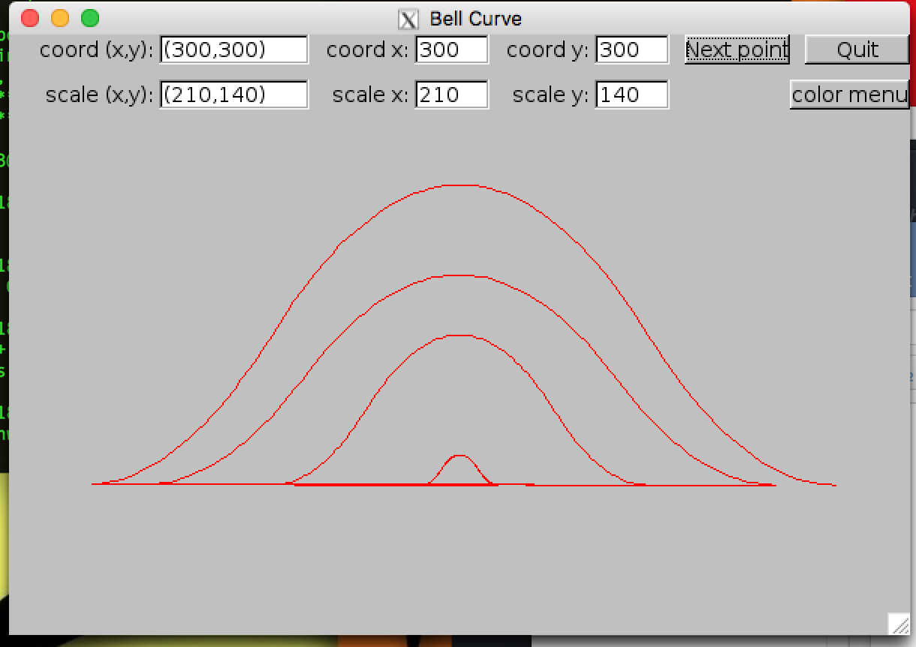

Input 2:

* X=200, Y=600, XS=50, YS=20, “press Next Curve button”
* •  XS=25, YS=20, “press Next Curve button”
* •  XS=15, YS=10, “press Next Curve button”
* •  XS=310, YS=140, “press Next Curve button”
* •  “press Color Menu button”, “press Blue button”

To test a different set of graphs, make sure they are still centered, and test a different color

Output 2:

