CRUMBLE

By:

Mihir J. Gosai

Exam No:-20

&

Foram R. Gajjar

Exam No:-09

Submit as

Partial fulfillment of

Bachelor of Computer Application (BCA) Degree

Year 2021



VP & RPTP Science College

Sardar Patel University
CERTIFICATE

Date:- 15/03/2021

This is to certify that Mihir J. Gosai of BCA – SEM – VI(Seat No. 20) has worked on project entitled CRUMBLE. This (US06CBCA04) is in-house project course of three credits.

He was regular in his work and developed around 70 hours for the project including analysis and design. He has completed the project satisfactorily. Head / Coordinator Project satisfactory

Head / Coordinator Project Guide
CERTIFICATE

Date:- 15/03/2021

This is to certify that Foram R. Gajjar of BCA – SEM – VI(Seat No. 09) has worked on project entitled CRUMBLE. This (US06CBCA04) is in-house project course of three credits.

He was regular in his work and developed around 70 hours for the project including analysis and design. He has completed the project satisfactorily. Head / Coordinator Project satisfactory

Head / Coordinator Project Guide

ACKNOWLEDGEMENT

This project work has been the most practical and exciting part of we learning
experience, which would be an asset for our future carrier.

This project is completed after hardworking of Mihir J. Gosai and Foram R. Gajjar. So we are thankful each other for better co-ordination and hardworking. The project was started during the month of November 2021 and completed in the march 2021.

We would like to thank VP & RPTP Science College for providing Computer Lab. And proper environment to develop the application.

Our sincere thanks to our principal Dr. Bhavesh Patel for mounding our thoughts and vision and vision thoughts towards all the subjects, we were studying in all these three years. We are thankful to Mr. Ashish Joshi (Head of the BCA department VP & RPTP Science College) for providing me facilities and knowledge. We are also thankful for the inspiration given by them. We would like to thankful to Mr. Navtej Bhatt who provided us expert guidance and inspiration during all phase of this project as our project guide. Her guidance and suggestion have been a source of inspiration and helpful in refining my thinking and approaches during the project time.

We are also greatly thankful to the entire B.C.A department who has helped me in completion of this project directly or Indirectly.

Mihir J. Gosai
Foram R. Gajjar

INDEX
Sr. No | CONTENT | Page No.
1. | PROJECT PROFILE
2. | DEFINITION
3. | PURPOSE
4. | SCOPE
5. | PRODUCT FUNCTIONS
6. | CONSTRAINTS
7. | LOGICAL DATABASE REQUIREMENTS
8. | FEATURES OF PROPOSED SYSTEMS
9. | AIMS & OBJECTIVES TO BE FULLFILLED
10. | REQUIREMENTS ANALYSIS
11. | FEASIBILITY STUDY
12. | TECHNICAL FEASIBILITY
13. | ECHONOMICAL FEASIBILITY
14. | OPERATIONAL FEASIBILITY
15. | SYSTEM TESTING
16. | SYSTEM IMPLEMENTATION
17. | SYSTEM MAINTANANCE
18. | SYSTEM REQUIREMENTS SPECIFICATION
19. | TOOLS INFORMATION
19.1 | SPRIG-BOOT
19.2 | ANGULAR
19.3 | MYSQL
20. | Data Flow Diagrams
21. | DATA DICTIONARY
22. | SCREEN LAYOUT
23. | PREFERENCES

INTRODUCTION

CRUMBLE is a social news aggregation and discussion website.
Users can create posts as per his wish in any community and can also participate in discussions.
Community provide a platform to organize content based on different categories and get latest updates leading to a uniform discussion on it.
In Crumble, Posts are organized into different communities which include variety of topics like science, politics, movies, games, sports, music, fitness and many more.
Only Registered members can submit their content through text posts and also can like or dislike other posts created by different members.

PROJECT PROFILE

Project Profile
Project Title | CRUMBLE
Objective | social news aggregation and discussion website.
Operating System | Windows, Mac OS, Linux
Front End Tool | IntelliJ IDEA
Back End Tool | IntelliJ IDEA
Other Tool | MySQL Workbench
Project Guide | Mr. Navtej Bhatt
Submitted By | Mihir J. Gosai(Roll: 20)  Foram R. Gajjar(Roll: 09)
Submitted To | SP University

Definition
CRUMBLE is a social news aggregation and discussion website.
Posts are organized into different communities which include variety of topics like science, politics, movies, games, sports, music, fitness and many more.
Registered members can submit their content through text posts, and others can like or dislike and can comment on the posts.

PURPOSE
Crumble is website comprising user-generated content and discussion.
The content on site is divided into categories called communities which can be in any specific interest, subject, object, or any belief.
User can like /dislike or comment any post and continue further conversation in comment section.
Discussions are organized on user-created areas of interest. The post must be in correct community.

SCOPE
Registration of account is free. Account verification process is completed via email. After verification user can browse communities and even create new community.
User can participate in any community of his/her interests. The discussions are organized on the basis of community. User can participate in any discussion and put forward his/her opinion by commenting on particular post. The discussions mainly includes current topics of the community. This all is based fully on user-created areas of interests.

Product Function
Registration is validated through email verification.
Only Authenticated users can make posts and comment on website.

CONSTRAINTS

✓ Only valid users can make any posts or create community on the website.
✓ Guest users are not allowed to make posts or comment or participate in any discussion.
✓ To make a post or to comment on other posts or to report a post the user must be logged in his/her account.

Tools & Technologies Used

For Front-End:- Angular, Type Script.
For Back-End:- Spring Boot, Spring Security, Spring Data JPA, MySQL

Logical_Database Requirements

This website contains database necessary for it to function according to requirements.
It includes database such as User, User-Community, User Post, Community, Community-Posts, Post, Comments, Vote, Verification Token, Refresh Token.

Features in proposed system.

✓ Users can Create Account Via email ID.
✓ Email ID is Verified after The Registration. Verification Is Required To Log In.
✓ Verification Code is Sent On Registered Email. Verification Code is In Form Of a Link.
✓ Users Have to Click On The Link To Verify The Registration.
✓ CRUMBLE provides the Environment To create Community, Community Posts & Comments On The Post.

Aims and Objectives to be fulfilled

✓ Right To Security
In the proposed system, we have kept user Log in Facility for the user. Because of this only authorized person can operate it and access to site. This is helpful to stop unauthorized access so that sensitive information can be kept secured.

✓ Right To Privacy:
This system is focused around Privacy & anonymity Of users. We do not collect or share any user info regardless of their email ID. Password Is highly Encrypted & Stored in secured database.

✓Time Effective:
This system is very fast for retrieving information from the
Database. It makes the information available on the click of the mouse. This saves the user’s time and it stops it as being time consuming process.

✓No Restriction on sharing
This system Has NO Limits on sharing Content or Criticizing The content.

✓Moderation by Community Moderators
Every Community Will be Highly Moderated by Moderators. Moderators have access & right To delete Posts, Comments or Even Ban someone form Site permanently or temporary, to maintain the authenticity & safety of the site

SYSTEM FEATURES

✓ It offers better services in terms of speed, accuracy and Security.
✓ It provide the timely information to any person who wants to know about any information regarding community
✓ It can also get the general information about the Community Information provided by the Moderators.
✓ Moderators will keeps community Hostile & as friendly as possible.
✓ Immediate information access about any post can be possible through the system.
✓ In this system one more facility is provided that It does not ask about any of your personal information except your Email ID.
✓ It provided better security and stops unauthorized access to important and sensitive.

PROPOSED SYSTEM
The System of crumble Is designed for users to share OR create content based on the type of the content in the appropriate community.
With registered account in CRUMBLE user will be able to also create the community if it does not exist. Multiple community of same subject(s)can not be created.
Users will have full control over their account & it's information regardless any restrictions.

Advantages Of the Proposed System

- Due to advance technology faster computer means more speedy systems & sharing & spreading news on the internet.
- As the computers are highly accurate, accuracy in work is increased.
- Storage of large volume of data is facilitated due to high storage capacity of Computers
- Decrease the load of the person involved in existing system due to automation of task.
- Sharing & Updating of information is easily.
- Because of related database provide by MySQL, the data will be consistent & Secure.

Some of the features of the proposed system.
✓ Removal of Data Redundancy.
✓ Data Consistency.
✓ Data Security.
✓ Help in storing and retrieving Information.

✓ Removal of Data Redundancy
Due to the interrelation between the tables and proper assignation of primary keys and foreign keys a data except primary key will never be repeated and hence will cause extremely low redundancy compared to the existing system. This will cause easy data recording and low time consuming.

✓Data Consistency
Due to proper interrelationship and required validations on each and every field any invalid data will not be entered in the system and also due to very less data redundancy. Any one change in the data will be reflected in every place of the system
✓Data Security
In the manual system there is no security of data. Because there any one can access data, but in proposed system the data of the people are stored securely in database and no one can access it. So there is high security of data in proposed system.

PROJECT ACTIVITIES
✓ Preliminary Investigation
The purpose of preliminary investigation was to evaluate the project request. It relates to collection of information that permits committee member to evaluate the merits of the project request and make an informed judgment about the feasibility of the proposed projects.

✓ Requirement Analysis
The main purpose was determining the information requirement of the users. Several fact-finding techniques such as questionnaires, interviews, observing decision maker and their office environment etc were used for understanding the requirements.

✓ System Design
During system design, the user requirements that arose from analyzing the user application environments were incorporated into a new system design. The design of an information system produces the details that state how a system will meet the requirements identified above.

✓ Software Development
After the system design details were resolved, such resources needs as specific type of hardware, software and Services were determined. Then the necessary coding was done to meet the requirements of the users and incorporate the design developed during the system design phase.

✓ System Testing
Before the system was used, it was tested. System testing was done experimentally to ensure that the software does not fail that is it runs according to its specification and in the way users expect. Special test data were inputted for processing, and the results were examined. After that, it was tested with actual data from the current system.

✓ Implementation and maintenance
After the system will found to be fit, it was implemented with the actual data. Necessary hardware and software were installed and users were then trained on the new system. The result of the development efforts was reviewed to ensure that the new system satisfied user requirements.

Requirement Analysis
Fact Finding Techniques
Information gathering in any information system is not an easy task. It has to be gathered in an organized way so that No system details are left out. Right problems are identified. Repetitive work is avoided. Wrong or incomplete details are not collect Here an overall idea about the search methods or fact gathering techniques which are used while gathering the information, they are:
• Observation
These techniques are used in system analysis and design stage. For the development of the “CRUMBLE” we have used following fact gathering techniques.

OBSERVATION:
✓ Our observation in the current World I that information goes through many sources & sites before end user can reach it. It risks being fraudulent & fake.

✓Every Platform which is community driven collects & sells user data That threatens User privacy.

FEASIBILITY STUDY
✓ A feasibility study is undertaken to determine the possibility or probability of either improving the existing system or developing a completely new system.
✓ It helps to obtain an overview of the problem to get rough assessment of whether feasible solution exists.
✓ This is essential to avoid committing large recourse to project and then repent on it later.
✓ Need for feasibility Study:
✓ The Feasibility study is needed to:

- Answer the question whether a new system is to be installed or not?
- Determined the potential of the existing system.
- Improved the existing system.
- Know what should be embedded in the new system.
- Define the problem and objective involved in project.
- Avoid costly repairs at a later stage when the system is implemented.
- Avoid Crash implemented of a new system.
- Avoid the ‘Hardware Approach ‘ that is getting a computer first and then deciding how to use it.
✓ There are aspects in feasibility study portion of the preliminary
investigation
• Technical Feasibility
• Economic Feasibility and
•Operational Feasibility Of the Project.

1. Technical Feasibility:
✓ Technical feasibility determines the works for the projects to be done with the present equipments, control procedures, existing software’s technology an available personnel.
✓ If new technology is needed then what alternatives will be needed in the present’s structure and work ethos?
✓This will require a close examination of the present system.
• Adequacy of available technology.
• Adequacy of hardware
• Adequacy of Computer
• Operating time and support facilities.
✓ The Technical feasibility in the proposed system deals with the technology used in the system, it deals with hardware and software used in the system whether they are of latest technology or not. It happens that after a system is prepared a new technology arises and the user wants the system based on that technology.

2. ECONOMICAL FEASIBILITY:
✓ Economical Feasibility looks at the financial aspects of the project.
✓ Economical Feasibility concern with the return from the investment of project.
✓ It determines whether it is worthwhile to invest the money on a project for no returns.
✓ To carry out an economical feasibility for a system, it is necessary to place actual money value against any purchases or activities needed to implemented the project.
3. OPERATIONAL FEASIBILITY:
✓ Operational Feasibility determined how the proposed system will fit in the current operation and what if any retaining may be needed to implement the system.
✓ In the system operational feasibility checks, whether the user who is going to use the system is able to works with the software’s with which the system is ‘coded and also the mind of the user going to use the system. If the user does not understand or is able does not understand or is able to work on the system further development is of waste.

SYSTEM TESTING
SYSTEM TESTING
It is measure to check the quality of software during development.
To detect the errors in requirements, design and coding phases.
This phase starts with test plan, which gives all activities to be done for testing.
Testing can be done by:
✓ Underline Testing: It is a process to test an individual module of software.
✓ Integration testing: it is a process to perform a testing after combine modules.
✓ System Testing: It is a process to check the whether the software is working according to user requirement or not.
✓ Acceptance Testing: It is a process to check software with actual data. Method of Testing:
✓ Functional Testing: It is also known as black box testing. It is not know what is inside code.
✓ Structural Testing: the test data is given to check the logic of the code called as glass box testing.
For Example:
To check that format of output is as per requirement is functional, but to check that negative no is allowed or not is structural.
This phase ends with the test report which specifies the different test data and its output and the action taken of error is found.

SYSTEM IMPLEMENTATION
SYSTEM IMPLEMENTATION
✓ System acquisition:
An important part of system acquisition is the actual purchase of goods and services. It involves the purchase of hardware. Packaged software and software services are available. Here system analyst and designer work together to determine best policy for this purchasing.
✓ Programming:
Computer programmer performs programming. Programming is the writing coded instruction, testing each segment of the code and testing the entire computer programmed once it is complete. Normally a team of programmer work under the direction by system analyst.
✓ Testing:
It consists of putting together the various coded pieces of a design, testing them and correction the parts of the code or the design that are not correct.
This requires
1. Training of personnel.
2. Modifying parts of the old system.
3. Running parallel both the system until everything goes as planned.
✓ Documentation:
Documentation means the written from about how a system design or function. It includes,
• Design Documentation: It describes the overall system design and it includes system flowchart, all input/output formats, file description, control requirements and report specification.
• Program Documentation: It consists of programming specification like program logic.
• Training Documentation: it includes user training and materials to be used conversion and the installation of new system.
• Operation Documentation: It contains instruction from normal operation as well as from handling problems.
• User Reference Documentation: It should provide quick, clear answer like a dictionary.

SYSTEM MAINTENANCE
SYSTEM MAINTENANCE
In it not part of software development, but important activity in life of software.
Two types of maintenance:
✓ Adaptive maintenance: It means that there is not any error in the system, but there may be some changes required by the clients in the input or the output formats, or in the requirement analysis, which is found after the testing is overall such operation are done here.
✓ Corrective maintenance: It means the software is giving some errors and they are solved. In the maintenance, the testing is required. This means that when the changes are made in software, we have to again check it with old data, which is working.
For Example:
We have made maintenance to check that negative values is not allowed, but we should do regression testing to check that old positive values is accepted and gives same result as previous. I.e. Changes should not have any side-effect.

SYSTEM REQUIREMENT SPECIFICATION

SYSTEM REQUIREMENT SPECIFICATION
1. HARDWARE REQUIREMENT OF THE SYSTEM:
This phase of the software development process deals with a brief study of different hardware used in the computerized system. There is a list of hardware materials used during the making and also during the use if the proposed system. As the new system to be made into a computerized functional system, requirement of a computer is must. All the hardware needed here are generally the basic configuration of a typical office computer. A list of the hardware requirement used in the system given below:

✓ Minimum Configuration:
To run the website in the computer the minimum configuration required is as below:
• Intel® Pentium® P4 1.5 GHz or equivalent AMD® Athlon TM processor or higher.
• 512 MB RAM
• 64 MB video card (with Hardware T&L including Pixel Shader 1.1 or higher support).
• 1.5 GB of free hard disk space.
• CD-ROM Drive.
• Broadband 256 Kbps.
• Mouse.
• Keyboard.
• 14 inch monitor.
2. SOFTWARE REQUIREMENT OF THE SYSTEM:
Along with the hardware used in the system it requires software to make a system as well as to run a system with the computer hardware. Collection of different types of hardware into a specific type can form a computer but it cannot execute different process on its own. For efficient and proper working of any system software must be installed. This software may be in the form of operating system or application software. To make the system one also needs to use software.

To make the Website “CRUMBLE” we have used certain software, which is listed below. The software used in the proposed system is the latest versions of them and can give up-to-date and perfect result of every process in the system. This software comprises operating system and application software used in the system.
✓ Software used in designing of the system:
• Operating System: Linux, Windows 10.
• Application Software:
1. Front End Tool: IntelliJ IDEA. Visual Studio Code.
2. Back End Tool: MySQL Workbench, IntelliJ IDEA

Front-End
User can view posts created by other members on the website.
User can log in to his account through user name and password.
User can browse different communities.

BACK-END
The database includes various tables -
- User Table
- User_Community Table
- User_Posts Table
- Community Table
- Community_Posts Table
- Post Table
- Comments Table
- Vote Table
- Token Table
- Refresh_token Table

TOOLS INFORMATION

Spring Boot^{[1]}

Spring Boot makes it easy to create stand-alone, production-grade Spring based Applications that you can "just run".We take an opinionated view of the Spring platform and third-party libraries so you can get started with minimum fuss. Most Spring Boot applications need minimal Spring configuration.

Features
- Create stand-alone Spring applications
- Embed Tomcat, Jetty or Undertow directly (no need to deploy WAR files)
- Provide opinionated 'starter' dependencies to simplify your build configuration
- Automatically configure Spring and 3rd party libraries whenever possible
- Provide production-ready features such as metrics, health checks, and externalized configuration
- Absolutely no code generation and no requirement for XML configuration

Spring Data^{[2]}
Spring Data’s mission is to provide a familiar and consistent, Spring-based programming model for data access while still retaining the special traits of the underlying data store.
It makes it easy to use data access technologies, relational and non-relational databases, map-reduce frameworks, and cloud-based data services. This is an umbrella project which contains many sub projects that are specific to a given database. The projects are developed by working together with many of the companies and developers that are behind these exciting technologies.

Features
- Powerful repository and custom object-mapping abstractions
- Dynamic query derivation from repository method names
- Implementation domain base classes providing basic properties
- Support for transparent auditing (created, last changed)
- Possibility to integrate custom repository code
- Easy Spring integration via Java Config and custom XML NameSpaces
- Advanced integration with Spring MVC controllers
- Experimental support for cross-store persistence

Spring Data JPA[2]

Spring Data JPA, part of the larger Spring Data family, makes it easy to easily implement JPA based repositories. This module deals with enhanced support for JPA based data access layers. It makes it easier to build Spring-powered applications that use data access technologies.
Implementing a data access layer of an application has been cumbersome for quite a while. Too much boiler plate code has to be written to execute simple queries as well as perform pagination, and auditing. Spring Data JPA aims to significantly improve the implementation of data access layer by reducing the effort to the amount that's actually needed. As a developer you write repository interface, including customer finder methods, and Spring will provide the implementation automatically.

Features
- Sophisticated support to build repositories based on Spring and JPA
- Support for Querydsl predicates and thus type-safe JPA queries
- Transparent auditing of domain class
- Pagination support, dynamic query execution, ability to integrate custom data access code
- Validation of @Query annotated queries at bootstrap time
- Support for XML based entity mapping
- JavaConfig based repository configuration by introducing @EnableJpaRepoaitories..

Spring Security ^{[3]}

Spring Security is a powerful and highly customizable authentication and access-control framework. It is the de-facto standard for securing Spring-based applications.
Spring Security is a framework that focuses on providing both authentication and authorization to Java applications. Like all Spring projects, the real power of Spring Security is found in how easily it can be extended to meet custom requirements

Features
- Comprehensive and extensible support for both Authentication and Authorization
- Protection against attacks like session fixation, click jacking, cross site request forgery, etc
- Servlet API integration
- Optional integration with Spring Web MVC.

MySQL^{[4]}

MySQL is an open-source relational database management system (RDBMS). the abbreviation for Structured Query Language. A relational database organizes data into one or more data tables in which data types may be related to each other; these relations help structure the data. SQL is a language programmers use to create, modify and extract data from the relational database, as well as control user access to the database. In addition to relational databases and SQL, an RDBMS like MySQL works with an operating system to implement a relational database in a computer's storage system, manages users, allows for network access and facilitates testing database integrity and creation of backups.

MySQL is free and open-source software under the terms of the GNU General Public License, and is also available under a variety of proprietary licenses. MySQL was owned and sponsored by the Swedish company MySQL AB, which was bought by Sun Microsystems (now Oracle Corporation). In 2010, when Oracle acquired Sun, Widenius forked the open-source MySQL project to create MariaDB.

MySQL has stand-alone clients that allow users to interact directly with a MySQL database using SQL, but more often MySQL is used with other programs to implement applications that need relational database capability. MySQL is a component of the LAMP web application software stack (and others), which is an acronym for Linux, Apache, MySQL, Perl/PHP/Python. MySQL is used by many database-driven web applications, including Drupal, Joomla, phpBB, and WordPress. MySQL is also used by many popular websites, including Facebook, Flickr, MediaWiki, Twitter, and YouTube.

Features
- Cross-platform support
- Stored procedures, using a procedural language that closely adheres to SQL/PSM[79]
- Triggers
- Cursors
- Updatable views
- Online Data Definition Language (DDL) when using the InnoDB Storage Engine.
- Information schema
- Performance Schema that collects and aggregates statistics about server execution and query performance for monitoring purposes.[80]
- A set of SQL Mode options to control runtime behavior, including a strict mode to better adhere to SQL standards.
- Angular Web Framework^{[5]}
Differences between Angular and AngularJS
Architecture of an Angular application. The main building blocks are modules, components, templates, metadata, data binding, directives, services, and dependency injection.

Google designed Angular as a ground-up rewrite of AngularJS.

- Angular does not have a concept of "scope" or controllers; instead, it uses a hierarchy of components as its primary architectural characteristic.
- Angular has a different expression syntax, focusing on "[ ]" for property binding, and "( )" for event binding
- Modularity – much core functionality has moved to modules
- Angular recommends the use of Microsoft's TypeScript language, which introduces the following features:
- Static typing, including Generics
- Annotations
- TypeScript is a superset of ECMAScript 6 (ES6), and is backwards compatible with ECMAScript 5 (i.e.: JavaScript).
- Dynamic loading
- Asynchronous template compilations
- Iterative callbacks provided by RxJS. RxJS limits state visibility and debugging, but these can be solved with reactive add-ons like ngrx or ngxs.
- Support for Angular Universal, which runs Angular applications on servers.

DATA FLOW DIAGRAMS

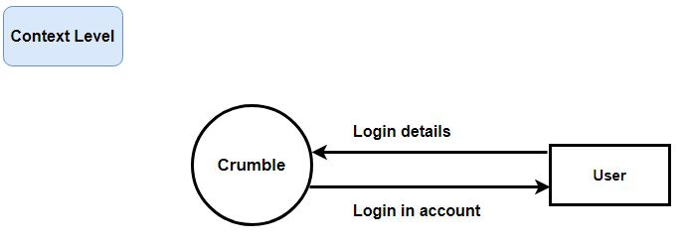

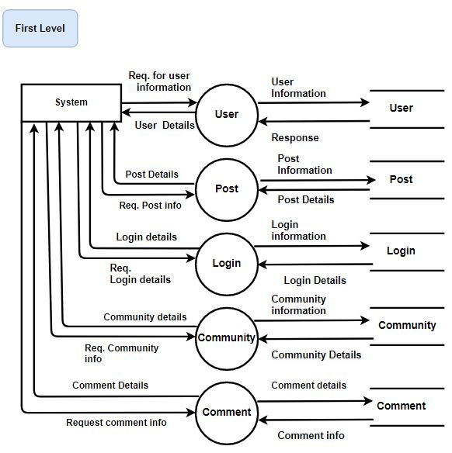

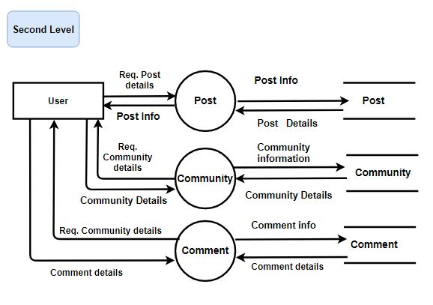

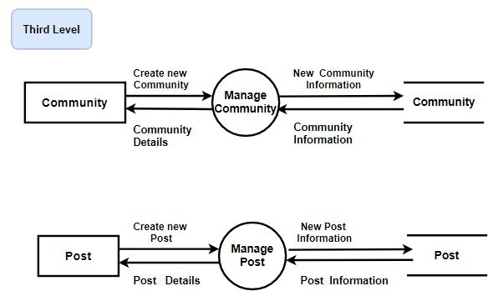

DATA DICTIONARY
DATABASE TABLES

DATA DICTIONARY

User Table
FIELD NAME | TYPE | CONSTRAINTS | DESCRIPTION
user_id | int | PRIMARY KEY | user id
created | Date | NOT NULL | date when user created account
email | Varchar(255) | NOT NULL | user's email
enabled | bit(1) | NOT NULL | id enabled
password | Varchar(255) | NOT NULL | password
user name | Varchar(255) | NOT NULL | user name

User_Community Table
FIELD NAME | TYPE | CONSTRAINTS | DESCRIPTION
user_id | int | Foreign Key(user) | user id
community_id | int | Foreign key | community id

User_Posts Table
FIELD NAME | TYPE | CONSTRAINTS | DESCRIPTION
user_id | int | Foreign Key(user) | user id
post_id | int | Foreign key | post id

Community Table
FIELD NAME | TYPE | CONSTRAINTS | DESCRIPTION
community_ id | int | PRIMARY KEY | community id
created_date | Date | NOT NULL | community created date
description | Varchar(255) | NOT NULL | community description
name | int | NOT NULL | community name
user_id | int | Foreign Key(user) | user id

Community_Posts Table
FIELD NAME | TYPE | CONSTRAINTS | DESCRIPTION
community_id | int | Foreign Key(community) | community id
posts_post_id | int | Foreign Key(post) | post id

Post Table
FIELD NAME | TYPE | CONSTRAINTS | DESCRIPTION
post_id | int | PRIMARY KEY | post id
created_date | Date | NOT NULL | date when post created
description | Long Text | NOT NULL | post description
post_name | Varchar | NOT NULL | name of post
URL | Varchar(255) | NOT NULL | URL of post
vote_count | int(11) | NOT NULL | count no of votes
community_id | int | Foreign Key(community) | community id of post
user_id | int (20) | Foreign Key(user) | user id

Comments Table
FIELD NAME | TYPE | CONSTRAINTS | DESCRIPTION
id | int | PRIMARY KEY | id
created_date | Date | NOT NULL | comment created date
text | Varchar(255) | NOT NULL | comment
post_id | int | Foreign Key | post_id
user_id | int | Foreign Key(user) | user id

Vote Table
FIELD NAME | TYPE | CONSTRAINTS | DESCRIPTION
id | int | PRIMARY KEY | vote id
vote_type | int | NOT NULL | like/dislike vote
post_id | int | Foreign Key(post) | post id
user_id | int | Foreign key(user) | user id

Token Table
FIELD NAME | TYPE | CONSTRAINTS | DESCRIPTION
id | int | PRIMARY KEY | token id
expiry_date | Date | NOT NULL | expiry date of token
token | Varchar(255) | NOT NULL | token
user_user_id | int | NOT NULL | user id

Refresh_token Table
FIELD NAME | TYPE | CONSTRAINTS | DESCRIPTION
id | Int | Foreign KEY(token) | token id
created_date | Date | NOT NULL | created date of token
token | Varchar(255) | NOT NULL | token

Conclusion

Crumble is a web application which provides a platform to communicate your ideas, interests and opinion to other people. People with common interests get a ground to share their opinion and ideas for a specific topic. Users can participate in various discussions and put forward their thoughts and suggestions. Users are updated with the latest news regarding a particular community which keeps them posted with current news. It is a platform to reach a wide range of people with different ideas and opinion.

SCREEN LAYOUT

HOME PAGE
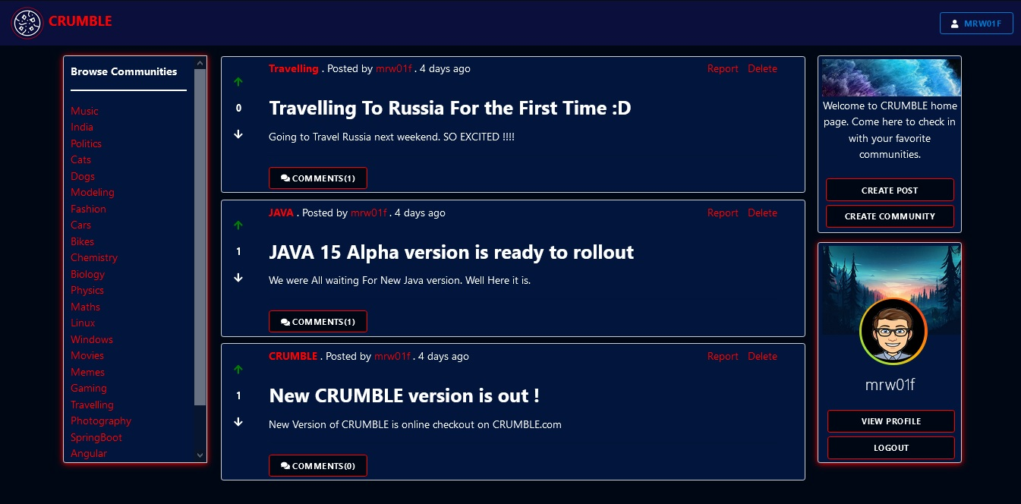

LOGIN PAGE
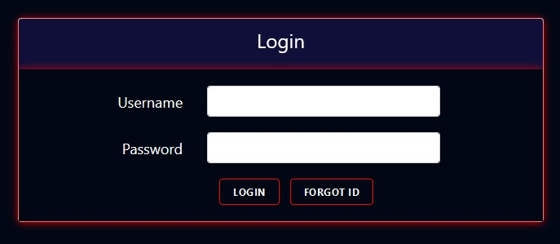

SIGNUP PAGE
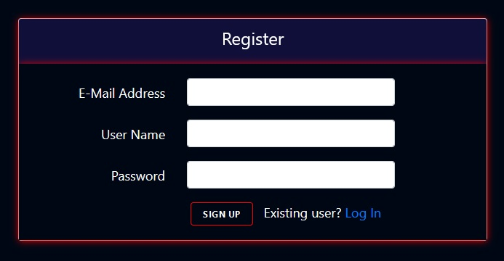

CREATE POST
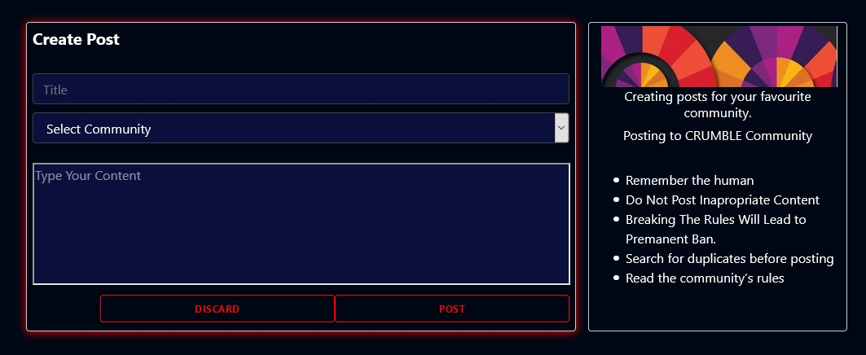

CREATE COMMUNITY
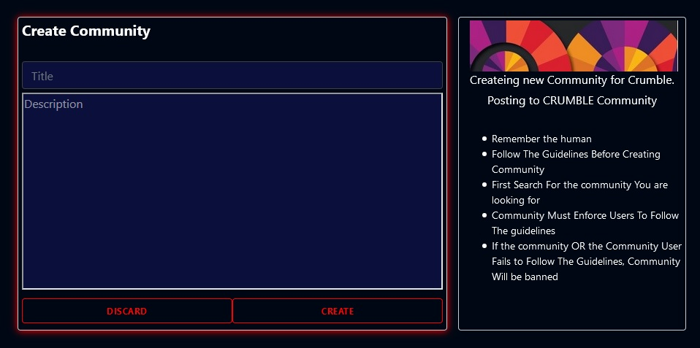

VIEW POST


USER PROFILE
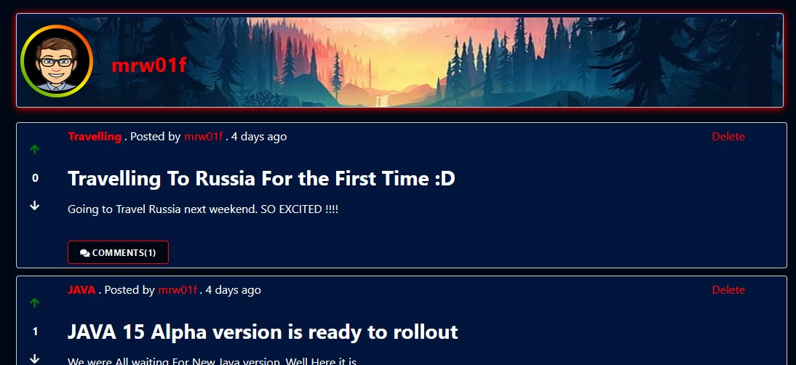

References
[1] https://spring.io/projects/spring-boot
[2] https://spring.io/projects/spring-data
[3] https://spring.io/projects/spring-security
[4] https://en.wikipedia.org/wiki/MySQL
[5] https://en.wikipedia.org/wiki/Angular_(web_framework)

