**Muhammad Ahmad**

**19F-1011**

**SE-7B**

**Project Phase 2**

**Issues faced:**

While working on phase 2, task 1 and 2, I faced several issues that when I installed docker on my windows, it gave error of installing wsl on my system. When I installed wsl on my pc through running wsl –install by running cmd in administrator mode it also stopped installation in mid and showed me error. When I searched for that error on internet, I found the solution that I have to turn on windows subsystem for linux in control panel. When I did that my pc required a restart and after the restart the issue was not resolved.

Then I decided to switch to kali linux. I made a bootable kali linux in a usb and tried to install it in my pc, on this stage kali linux also showed error and not started to install.

Then I made bootable ubunto in the usb and tried to install it in my pc. On this stage ubunto started the installation but it hangs after a while and stops. After all, I installed vmware workstation pro on my laptop and created a virtual machine and then installed docker on it by following the steps provided.

First of all I set up the repository for docker and then downloaded the deb package and then installed the docker setup through apt



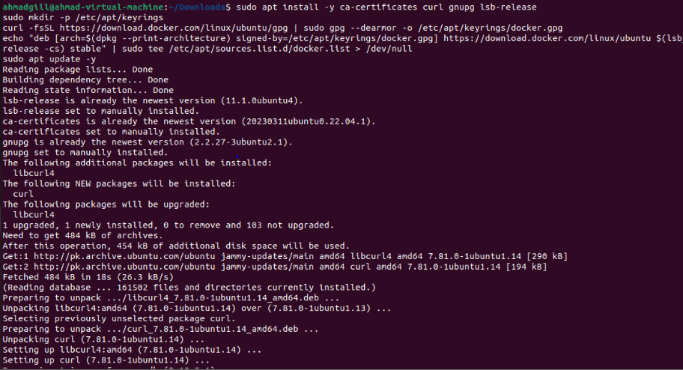

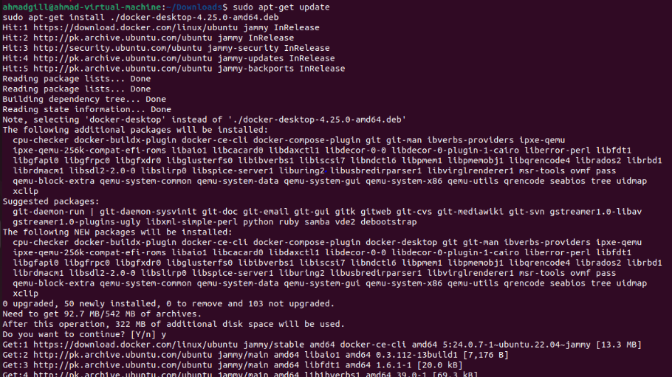



After that , this issue arised:

