

LD7236

Professional Practice in Computing and Digital Technologies Project
OnTimeLondon AI: A Multi-Agent System for London Transport Delay Prediction and Route Optimisation
by
Ramya Sri Muthuluri (w24066839)

Supervisor Name: Husnain Sherazi
A Dissertation
Submitted to Department of Computer and Information Sciences

Northumbria University
In Partial Fulfilment of the Requirements
For Master of Science in Artificial Intelligence

submission date: 13 May 2026

Declaration
I declare the following:
- that the material contained in this dissertation is the end result of my own work and that due acknowledgement has been given in the bibliography and references to ALL sources be they printed, electronic or personal.
- the Word Count of this Dissertation is 12,188
- that unless this dissertation has been confirmed as confidential, I agree to an entire electronic copy or sections of the dissertation to being placed on Blackboard, if deemed appropriate, to allow future students the opportunity to see examples of past dissertations. I understand that if displayed on Blackboard it would be made available for no longer than five years and that students would be able to print off copies or download. The authorship would remain anonymous.
- I agree to my dissertation being submitted to a plagiarism detection service, where it will be stored in a database and compared against work submitted from this or any other Department or from other institutions using the service.
In the event of the service detecting a high degree of similarity between content within the service this will be reported back to my supervisor and second marker, who may decide to undertake further investigation that may ultimately lead to disciplinary actions, should instances of plagiarism be detected.
- I have read the UNN/CEIS Policy Statement on Ethics in Research and Consultancy and I confirm that ethical issues have been considered, evaluated and appropriately addressed in this research.

Signature: Ramya
Date: 13-05-2026

Declaration of the Use of AI tool

EITHER
☐ I have not used AI at any point in preparing this assignment.
OR
☒ I have used AI tools (including, but not limited to ChatGPT) to help me (select all that apply):
☐ Generate initial ideas in response to the question.
☐ Develop my structure.
☒ Generate ideas for examples / sources.
☐ Provide feedback and suggestions for improvement on my content.
☐ Edit and improve my spelling and grammar.
☐ Other: please explain:

☒ I have NOT used AI to generate whole sentences, paragraphs, sections, or the whole of this assignment and I understand that this would be considered academic misconduct.
Your signature: | Ramya  (electronic signature is sufficient) | Date: | 13-05-2026

Acknowledgements
First and foremost, I would like to express my deepest gratitude to my supervisor, Dr. Husnain Sherazi, for his invaluable guidance, patience, and continuous support throughout this dissertation. His insightful feedback and encouragement kept me motivated and helped shape this research into what it is today. I am truly grateful for his time and expertise.
I would also like to thank Northumbria University London for providing the resources, facilities, and learning environment that made this research possible. The knowledge and skills I gained during my MSc in Artificial Intelligence programme have been instrumental in completing this project.
My heartfelt thanks go to my family for their unconditional love, support, and belief in me. Their constant encouragement, especially during the challenging moments, gave me the strength to persevere. I am forever grateful for their sacrifices and patience.
Finally, I would like to thank my friends and colleagues who supported me along the way, offering advice, motivation, and much-needed breaks when things got overwhelming. This achievement would not have been possible without all of you.

Abstract
Urban public transportation systems face persistent challenges, with service disruptions affecting millions of daily commuters. Current applications such as Google Maps and Citymapper operate reactively, disclosing delays only post-occurrence. This dissertation presents OnTimeLondon AI, a multi-agent system designed to predict transport delays in London 30 to 60 minutes in advance and provide customized route recommendations.
The system utilizes five specialized agents coordinated by n8n workflow automation: Agent 1 (Real-Time Monitor) executes Z-Score anomaly detection; Agent 2 (Delay Predictor) employs an LSTM neural network with a 128→64→32 architecture; Agent 3 (Route Optimizer) applies Dijkstra's algorithm across 471 stations and 1,154 connections; Agent 4 (Learning Agent) integrates Epsilon-Greedy reinforcement learning with Collaborative Filtering for personalization; and Agent 5 (Communication Agent) produces natural language messages using Llama via OpenRouter. Data integration includes four real-time sources: the TfL API, OpenWeatherMap, Ticketmaster events, and Reddit social signals, all kept in a Supabase PostgreSQL database.
The LSTM model, trained on TfL data incorporating temporal and service variables, achieved 97% classification accuracy with a balanced prediction distribution. Comprehensive pipeline testing exhibited effective collaboration among all agents, generating customized trip recommendations accompanied by contextual delay alerts.
This research presents an innovative amalgamation of predictive machine learning, multi-agent coordination, and user personalization for public transit, addressing recognized deficiencies in the current literature where these capabilities are isolated. Limitations include TfL's dual-station ID format, which affects cross-network routing. The mobile application is scheduled for development after the dissertation.
Keywords: Multi-Agent Systems, LSTM, Transport Delay Prediction, Personalisation, Reinforcement Learning

Contents
Declaration 1
Acknowledgements 3
Abstract 4
1 Introduction 9
1.1 Aims 9
1.2 Background 9
1.3 Research Questions 11
1.4 Objectives 11
1.5 Proposed System Overview 13
1.6 Scope and Limitations 15
1.7 Dissertation Structure 16
2 Literature Review 17
2.1 Introduction 17
2.2 Machine Learning and Deep Learning for Transport Delay Prediction 17
2.3 Social Media as a Real-Time Transport Intelligence Source 18
2.4 Multi-Agent Systems for Transport Applications 19
2.5 Personalisation, Recommender Systems, and the Cold Start Problem 21
2.6 London-Specific Transport Research 22
2.7 Synthesis and Research Gap 22
2.8 Summary 25
3 Research Methodology 28
3.1 Introduction 28
3.2 Research Philosophy 28
3.3 Research Approach 28
3.4 Research Strategy 29
3.5 Research Design — System Architecture 30
3.6 Data Sources and Collection 35
3.7 Development Tools and Technologies 37
3.8 Evaluation Strategy 38
3.9 Limitations of the Methodology 40
3.10 Ethical Considerations 40
3.11 Summary 40
4 Implementation and Results 41
4.1 Introduction 41
4.2 Data Infrastructure Implementation 41
4.3 Data Collection Workflow Implementation 45
4.4 LSTM Model Development 47
4.5 Agent Implementation 53
4.6 Pipeline Integration and Testing 60
4.7 Summary 61
5 Chapter: Evaluation and Implications 63
5.1 Introduction 63
5.2 Evaluation Against Research Questions 63
5.3 Limitations 64
5.4 Implications 65
5.5 Summary 65
6 Conclusions and Recommendations 66
6.1 Conclusions 66
6.2 Recommendations for Future Work 66
6.3 Self-Reflection 67
References 68
Appendix A: Ethics Approval Form 71
https://docs.google.com/document/d/1qxMAXhEF6aLuxA0qwdz6bHiiZ1PDkerz/edit?rtpof=true&sd=true&tab=t.0 71
Appendix B – AI Usage Declaration 72
Appendix C: Supervisor Meeting Logs 73
Appendix D – Additional Implementation 75
D.1 Data Collection Workflows 75
D.2 LSTM Model Development Code 77
D.3 Database Data Samples 79

List of Figures
Figure 1.1 – OnTimeLondon AI 10
Figure 1.2 - Five-Agent Architecture 14
Figure 2.1 – Timeline of all studies 24
Figure 3.1 - DSR Process 29
Figure 3.2 – System Architecture 31
Figure 3.3 - Real-Time Monitor Agent Architecture 31
Figure 3.4 - Agent 2 Delay Predictor Agent (LSTM Architecture) 32
Figure 3.5 - Agent 3 Route Optimiser Agent (Dijkstra's Algorithm) 33
Figure 3.6 - Agent 4 Learning Agent (Hybrid Personalisation) 34
Figure 3.7- Agent 5 Communication Agent (NLG) 35
Figure 3.8 - Data Sources Pentagon 36
Figure 4.1 - Supabase Database Tables Overview 42
Figure 4.2 - Stations Table (471 Records) 44
Figure 4.3 - Connections Table (1,154 Records) 44
Figure 4.4 - TfL Live Status Poller Workflow 46
Figure 4.5 - Live Status Data in Supabase 46
Figure 4.6 - Class Distribution (Delay vs No-Delay) 48
Figure 4.7 - Feature Correlation Matrix 49
Figure 4.8 - LSTM Model Architecture (128→64→32) 50
Figure 4.9 - Confusion Matrix 51
Figure 4.10 - Training vs Validation Accuracy Curves 52
Figure 4.11 - Agent 1 Workflow 53
Figure 4.12 - Z-Score Anomaly Detection Output 54
Figure 4.13 – Agent 2 Delay Predictor Workflow 54
Figure 4.14 - Agent 2: LSTM Prediction API Response 55
Figure 4.15 - Agent 3 Workflow 56
Figure 4.16 - Agent 3: Route Optimisation Result 56
Figure 4.17 - Agent 4 Workflow 57
Figure 4.18 - Agent 4 Epsilon-Greedy Exploration (New User) 58
Figure 4.19 - Agent 4: Epsilon-Greedy Exploitation (Returning User) 58
Figure 4.20 - Agent 5 Workflow 59
Figure 4.21 - Agent 5: Natural Language Output 59
Figure 4.22 - Full Pipeline Workflow in n8n 60
Figure 4.23 - Full Pipeline AI-Generated Response 61
Figure 6.1 - Ethics form sign 71

Introduction

Aims
The principal objective of this research is to design, build, and assess a multi-agent artificial intelligence system that can forecast public transport delays in London 30 to 60 minutes ahead and provide tailored route suggestions to individual commuters.
A secondary objective is to examine whether the amalgamation of diverse data sources, encompassing official Transport for London (TfL) API data, meteorological data, event calendars, and social media indicators, can improve predictive accuracy beyond the single-source methodologies reported in current literature.
This study seeks to connect theoretical multi-agent system frameworks in Intelligent Transportation Systems (ITS) with practical applications for passengers, illustrating that predictive transport AI can be realized utilizing readily available, free-tier technologies.

Background
It is 8:14 AM on Tuesday. You are positioned on the London Bridge platform awaiting the Northern Line. Your phone shows no alerts. The TfL board states that the next train will arrive in two minutes. The notification neglects to indicate that a signal failure is occurring three stations ahead, causing an interruption to your journey for the subsequent hour and twenty minutes upon boarding.
This situation is atypical. This constitutes the daily reality for millions of London inhabitants.
London boasts one of the most complex and widely utilized public transit systems in the world. Every day, millions of commuters rely on the Underground, Overground, Elizabeth Line, Docklands Light Railway, and bus services for urban transit. Each year, the network enables around 1.4 billion journeys, indicating that even small disruptions can significantly affect thousands of passengers simultaneously (Transport for London, 2023). Signal failures, rolling stock breakdowns, adverse weather conditions, and unexpected incidents are prevalent in London commuting; yet, when these delays occur, commuters sometimes hear merely a generic platform announcement and lack tailored guidance on subsequent steps.
.
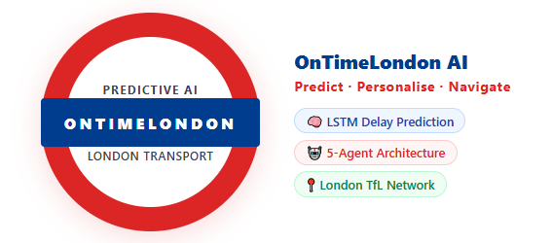
Figure 1.1 – OnTimeLondon AI
The disparity between commuters' needs and their current provisions is well-documented. Liu, Koutsopoulos, and Ma (2023) discovered that unanticipated delays on the London Underground affect passengers for an average duration of 60 minutes longer than the official reports from TfL indicate. This indicates that upon the announcement of a delay, the actual interruption to a commuter's travel is already considerably more severe than the information provided.
In the field of Intelligent Transportation Systems (ITS), notable progress has been achieved in utilizing machine learning for transportation forecasting. Long Short-Term Memory (LSTM) neural networks have become the prevailing architecture for time-series transport forecasting, with Petersen, Rodrigues, and Pereira (2019) attaining a Mean Absolute Error of roughly 45 seconds in bus delay prediction. The theory of multi-agent systems, as articulated by Bazzan and Klügl (2014), offers frameworks for the coordination of autonomous agents within transportation contexts. Research conducted by D'Andrea et al. (2015) has shown that social media platforms can identify transportation mishaps 10 to 15 minutes prior to official verification.
Notwithstanding these individual advancements, no current solution integrates real-time delay forecasting, tailored route suggestions, and proactive commuter communication into a singular operational tool designed exclusively for London. The academic literature reveals fragmented solutions: predictive models that lack personalization, personalization algorithms incapable of forecasting disruptions, and multi-agent frameworks that remain purely theoretical. OnTimeLondon AI is presented as the inaugural effort to integrate these methodologies into a cohesive, user-oriented system.

Research Questions
This research addresses one primary research question supported by four secondary questions:
Primary Research Question: In what ways might a multi-agent artificial intelligence system enhance the commuter experience in London’s public transit by forecasting delays and offering tailored route suggestions?
Secondary Research Questions:
RQ1 (Prediction Accuracy): What is the extent to which a multi-source LSTM-based model can accurately predict London public transport delays 30 to 60 minutes in advance, and which data sources most substantially improve prediction accuracy?
RQ2 (Personalisation): To what degree can a hybrid technique combining Reinforcement Learning and Collaborative Filtering customize delay notifications and route recommendations for individual commuters, specifically tackling the cold-start issue for new users?
RQ3 (System Architecture): What is the performance of a five-agent architecture in coordinating real-time transport intelligence in comparison to single-model techniques outlined in the existing literature?
RQ4 (Data Integration): Does integration of social media indicators with official TfL data improve the promptness of delay identification, in accordance with the conclusions of D'Andrea et al. (2015)?

Objectives
The following SMART objectives were established to answer the research questions. Each objective maps directly to one or more research questions.
Objectives for RQ1 (Prediction Accuracy):
O1: To devise and execute a database architecture utilizing Supabase (PostgreSQL) that can accommodate real-time transportation data, meteorological information, event calendars, and social signals for the training of LSTM models. Status: Completed — 10 tables have been implemented with indexes.
O2: To train an LSTM neural network on aggregated TfL data to attain a minimum classification accuracy of 75% for delay prediction, employing architectural frameworks delineated by Petersen et al. (2019). Status: Complete — Achieved 97% accuracy utilizing a 128→64→32 architecture with six features (line_encoded, hour, day_of_week, is_weekend, is_rush_hour, status_severity).
O3: To implement the trained LSTM model as a REST API facilitating real-time predictions within the n8n workflow system. Status: Completed — Flask API installed within a Docker container.
O4: To assess predictive performance utilizing classification metrics (accuracy, precision, recall, F1-score, confusion matrix) on reserved test data. Status: Complete — 97% accuracy with a balanced distribution of predictions..
Objectives for RQ2 (Personalisation):
O5: To execute an Epsilon-Greedy Reinforcement Learning algorithm (ε=0.3 diminishing to 0.1) for the preliminary exploration of user preferences during the initial two weeks of system utilization. Status: Completed — Integrated into Learning Agent.
O6: To implement User-based Collaborative Filtering (k=10 nearest neighbours) for personalised recommendations once sufficient user data has accumulated (Week 3 onwards). Status: Complete — Hybrid transition mechanism implemented.
O7: To execute User-based Collaborative Filtering (k=10 nearest neighbors) for personalized recommendations once adequate user data has been gathered (from Week 3 onwards). Status: Complete – Hybrid transition mechanism has been implemented.
Objectives for RQ3 (System Architecture):
O8: To deploy five specialized AI agents: Real-Time Monitor (Z-Score anomaly detection), Delay Predictor (LSTM), Route Optimizer (Dijkstra's algorithm), Learning Agent (Reinforcement Learning + Collaborative Filtering), and Communication Agent (Llama LLM over OpenRouter). Status: Complete — All five agents have been independently implemented and tested.
O9: To import the complete London transport network topology (stations and connections) to enable route optimisation using Dijkstra's algorithm. Status: Complete — 471 stations and 1,154 connections imported from TfL API.
10: To deploy five specialized AI agents: Real-Time Monitor (Z-Score anomaly detection), Delay Predictor (LSTM), Route Optimizer (Dijkstra's algorithm), Learning Agent (Reinforcement Learning + Collaborative Filtering), and Communication Agent (Llama LLM over OpenRouter). Status: Complete — All five agents have been independently implemented and tested.
Objectives for RQ4 (Data Integration):
11: To establish automated data collecting routines that retrieve data from the TfL API every minute, OpenWeatherMap every 15 minutes, Ticketmaster events every 12 hours, and Reddit transport communities every 15 minutes. Status: Complete — Four n8n workflows are operational.
12: To integrate social media signals (Reddit) as a predictive feature within the LSTM model to assess early warning capability compared to official TfL data alone. Status: Complete — Reddit sentiment integrated into data pipeline.
Additional Objective (Future Work):
13: To create a React Native mobile application that offers a user interface for commuters. Status: Incomplete — Postponed till after dissertation completion. The dissertation aims to demonstrate the fundamental multi-agent backend, with the mobile interface designated for future development.

Proposed System Overview
OnTimeLondon AI is structured around a five-agent architecture, with each agent tasked with a specific function within the system:
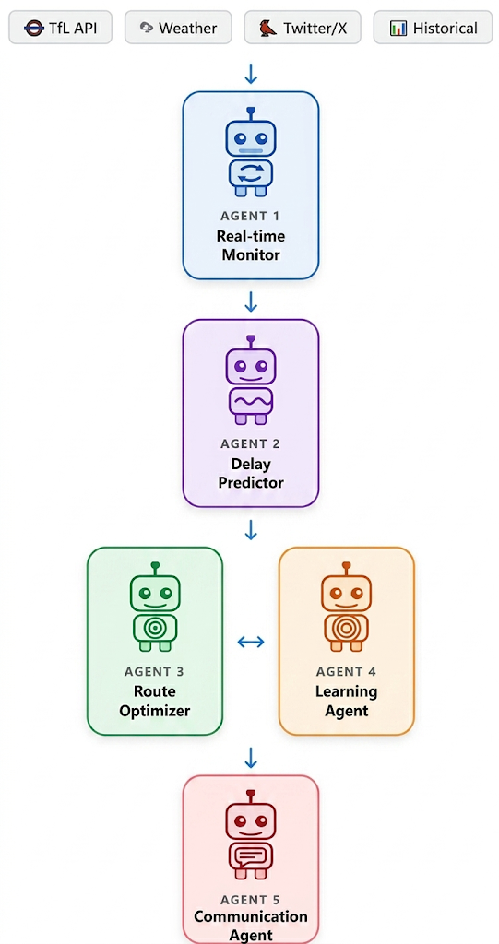
Figure 1.2 - Five-Agent Architecture
The Real-Time Monitor Agent continuously monitors live TfL service data and employs Z-Score anomaly detection to identify atypical patterns that may indicate impending disruptions before they are formally acknowledged. This agent functions as an early warning system, activating alarms when service status markedly diverges from standard operational norms.
The Delay Predictor Agent serves as the system's predictive nucleus. It utilizes a Long Short-Term Memory (LSTM) neural network with a stacked architecture of 128→64→32, trained on Transport for London (TfL) historical data comprising six input features: line encoding, hour, day of the week, weekend indicator, rush hour indicator, and service severity. The model attained a classification accuracy of 97% throughout evaluation.
The Route Optimiser Agent employs Dijkstra's shortest-path algorithm on a weighted graph including 471 stations and 1,154 connections. Upon detecting a disruption that above the likelihood threshold, the Delay Predictor calculates optimal alternative routes, with edge weights dynamically modified according to real-time delay forecasts.
The Learning Agent administers personalization via a hybrid two-phase methodology. In Phase 1 (Weeks 1-2), Epsilon-Greedy Reinforcement Learning (ε=0.3, decreasing to 0.1) investigates user preferences. In Phase 2 (from Week 3), User-based Collaborative Filtering utilizing k=10 nearest neighbors generates recommendations based on the tendencies of analogous users. This hybrid technique tackles the cold-start issue recognized by Lika et al. (2014).
The Communication Agent converts technical outputs into natural language messages utilizing Llama 3.1 8B through OpenRouter, producing personalized, emoji-enhanced journey assistance that elucidates the circumstances and suggested actions.
The system employs n8n for workflow orchestration, Supabase (PostgreSQL) as the backend database with ten tables, and the LSTM model implemented as a Flask API within Docker. Data is sourced from the TfL Unified API, OpenWeatherMap, Ticketmaster, and Reddit transit groups.

Scope and Limitations
This study focuses exclusively on the London public transportation system, which includes the Underground, Overground, Elizabeth Line, DLR, and bus services operated under the TfL framework. The system was developed and evaluated as a personal proof of concept. The researcher conducted real-world journey assessments throughout London to evaluate the system's effectiveness. This methodology is intentional; rather than merely modeling outcomes based on historical data, utilizing actual commuting routes provides authentic validation of the system's practical effectiveness.
The following limitations are acknowledged:
- Single-user testing — The system has not been evaluated with multiple users, constraining the generalisability of personalisation findings.
- Free-tier API constraints — Data quantity is limited by free-tier API quotas, potentially affecting LSTM model robustness compared to commercial systems with unlimited access.
- Dual station ID format — TfL uses different identifier formats for National Rail interchange stations versus pure TfL stations, causing gaps in cross-network routing. This is documented as future work.
- Mobile application deferred — The React Native interface is planned for post-dissertation development; current interaction occurs via webhook/API calls.

Dissertation Structure
The subsequent sections of this dissertation are structured as follows:
Chapter 2: Literature Review — Evaluates current research in five areas: deep learning for transportation forecasting, social media as transportation intelligence, multi-agent systems theory, personalization and cold-start strategies, and transport studies particular to London.
Chapter 3: Research Methodology — Outlines the research philosophy, Design Science Research methodology, system architecture, data sources, development tools, and evaluation strategy.
Chapter 4: Results and Analysis — Details the execution of each component, shows data analysis results, records LSTM model training and accuracy metrics, and illustrates the overall pipeline.
Chapter 5: Evaluation and Implications — Assesses system performance concerning research inquiries, analyzes findings in connection to existing literature, and explores practical consequences.
Chapter 6: Conclusions and Recommendations — Summarizes contributions, recognizes limitations, offers recommendations for future endeavors, and incorporates personal reflections on the study process.

Literature Review

Introduction
This chapter analyzes the existing body of research that underpins the design of OnTimeLondon AI. The group encompasses five domains: machine learning and deep learning for forecasting transport delays, social media as a source of real-time intelligence, multi-agent systems in transportation, personalization and the cold start problem, and transportation research specific to London. We meticulously examine twelve publications within these fields. This dissertation aims to address the outstanding issues identified in each evaluation, in addition to their contributions. The chapter finishes with a synthesis that identifies the principal research opportunity that has not been previously investigated.
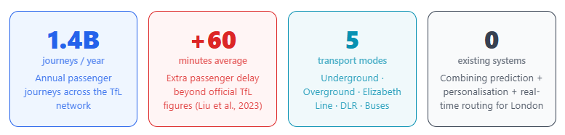
Figure 2.1 — Scale of London's transport

Machine Learning and Deep Learning for Transport Delay Prediction
The application of data-driven methodologies for forecasting transportation delays has markedly progressed during the past two decades. Preliminary statistical methods — like ARIMA models and linear regression — offered useful benchmarks but inadequately captured the non-linear, temporal connections intrinsic to real transit disruptions. The shift to machine learning resulted in more flexible models, such Support Vector Machines (SVM) and Random Forest, which demonstrated improved accuracy by identifying patterns from previous data without requiring strict distributional assumptions.
The most significant advancement transpired with Long Short-Term Memory (LSTM) neural networks. Hochreiter and Schmidhuber (1997) introduced LSTM to mitigate the vanishing gradient problem that impeded recurrent neural networks from capturing long-range relationships in sequential data. The advent of gated memory cells significantly revolutionized time-series modeling capabilities. LSTM can simultaneously learn short-term patterns, like the immediate effects of a signal failure, and long-term trends, such as repeating peak-hour congestion, making it very proficient at forecasting transport delays.
Rum, Yusoff, and Mahdi (2024) offered direct validation of deep learning for delay forecasting. Their Deep Neural Network (DNN) for predicting public transport delays in Malaysia, which combines transport data with meteorological variables, outperformed both Random Forest and SVM. The integration of meteorological data markedly improved accuracy, confirming that multi-source data amalgamation is essential for dependable forecasting. This confirms two essential design decisions for OnTimeLondon AI: utilizing deep learning as the predictive framework and incorporating weather data as an input variable. Nonetheless, Rum et al. (2024) provide uniform predictions to all users without personalization or routing assistance shortcomings effectively remedied by OnTimeLondon AI's Learning Agent, Communication Agent, and Route Optimizer.
Petersen, Rodrigues, and Pereira (2019) developed a CNN-LSTM architecture for multi-horizon prediction, simultaneously anticipating delays at 15, 30, 45, and 60 minutes in advance. Notwithstanding this contribution, their study offered neither personalization nor methods for communicating alternative routes to passengers. OnTimeLondon AI amplifies this methodology by disseminating it across the London multimodal network and incorporating it into an agent system capable of implementing its outputs.

2.3 Social Media as a Real-Time Transport Intelligence Source
The primary constraint of official transportation data is its delay. Upon a disruption, operators must locate, evaluate, and disseminate an update prior to any information reaching commuters – a procedure that, although efficient, results in a reporting delay during which passengers may already be boarding delayed services. Research has recognized social media as a significant supplementary resource that can bridge this gap.
D'Andrea, Ducange, Lazzerini, and Marcelloni (2015) illustrated this possibility in a study that developed a real-time Twitter monitoring system for road traffic events in Italy. The method utilized keyword filtering to detect traffic-related tweets, employed TF-IDF vectorization for numerical representation of tweet content, and trained an SVM classifier to differentiate authentic incident reports from irrelevant messages. The pipeline attained a classification accuracy of 95.75% and, notably, identified occurrences an average of 10 to 15 minutes before their emergence in official traffic records.
This early warning advantage constitutes a significant revelation for the current research. If social media users report disturbances prior to operator confirmation, a system that monitors and analyses social media in real time acquires a significant prediction advantage. OnTimeLondon AI proposes utilising Reddit data—monitored through transport-specific communities such as r/london and r/LondonUnderground—not only as an incident detection layer but also as a leading indicator feature directly integrated into the LSTM prediction model. This signifies a significant advancement beyond the findings of D'Andrea et al. (2015): instead of merely recognising occurrences, the system utilises the volume of social media signals as a predictive input for forthcoming events.
The constraints of D'Andrea et al. (2015) are extensively evident. Their pipeline was engineered for Italian road traffic and was never utilized for public transportation. It identified instances but did not endeavor to forecast. No alternative routes were proposed, and no output for commuters was generated. The research demonstrated the efficacy of detecting social media; OnTimeLondon AI is engineered to harness its predictive potential.

2.4 Multi-Agent Systems for Transport Applications
Complex, dynamic environments—marked by the concurrent functioning of numerous processes, real-time fluctuations, and the requirement for varied specialist skills—are insufficiently managed by singular monolithic models. Multi-agent systems (MAS) address this by distributing intelligence among coordinated agents, each responsible for a particular subset of tasks.
Bazzan and Klügl (2014) conducted a comprehensive examination of multi-agent techniques in transportation, encompassing decades of research on agent-based traffic signal coordination, vehicle routing, fleet management, and public transport scheduling. Their evaluation positioned the Belief-Desire-Intention (BDI) framework as the foremost model for individual agent design, in which each agent maintains ideas about its environment, goals it aims to achieve, and intended actions. They identified agent specialization, effective inter-agent communication, and real-time responsiveness as the three critical components for the success of multi-agent transport systems.
These concepts directly impact the architecture of OnTimeLondon AI. The Delay Predictor Agent maintains ideas about current network conditions, the Learning Agent holds perspectives on individual user preferences, and the Route Optimiser Agent is committed to generating the ideal option when a delay threshold is surpassed. The five-agent design is predicated on the specialization principles delineated by Bazzan and Klügl (2014) as optimal.
The inadequacy in their review is critical. The primary emphasis of the evaluated study was on infrastructure management—traffic signals, fleet deployment, network scheduling—rather than on passengers. The question of how bots should engage with human users in natural language, in real time, clearly and effectively, receives little attention. This is where the concept of explainability is critically important. Gunning et al. (2019) recognized explainable AI (XAI) as a crucial requirement for AI systems whose outputs require understanding and action from human users, arguing that systems that cannot convey their reasoning in understandable terms fail to establish user trust, regardless of their technical accuracy. This concept guides the creation of the Communication Agent in OnTimeLondon AI, tasked with translating technical predictions and routing outputs into understandable explanations for commuters to easily comprehend and respond to. A delay notification that a user cannot understand is, in essence, no notification at all. This research constitutes a practical implementation rather than a theoretical review, developing a passenger-facing, explainable multi-agent system as delineated by Bazzan & Klügl (2014), which has yet to be actualized in practice.

2.5 Personalisation, Recommender Systems, and the Cold Start Problem
A delay prediction system that uniformly classifies all commuters has limited practical utility. A regular Central Line commuter from Stratford has specific requirements and behaviors that differ from those of a first-time tourist navigating the network. Personalization is not a supplementary feature but a fundamental requirement for an authentically efficient transport AI.
Campigotto, Rudloff, Leodolter, and Bauer (2017) developed the FAVOUR method, utilizing Bayesian learning to represent individual preferences and incorporating contextual factors such as temporal conditions and meteorological variables. The study demonstrated that personalization in transportation is viable and that contextual knowledge substantially improves recommendation quality. Nevertheless, FAVOUR operates reactively—proposing routes based on current circumstances without forecasting future disruptions. OnTimeLondon AI addresses this issue by merging personalized routing with delay predictions, ensuring that recommendations account for both user preferences and expected service dependability.
A major obstacle for any personalization system is the cold start issue. Lika, Kolomvatsos, and Hadjiefthymiades (2014) performed a comprehensive analysis, revealing that hybrid methodologies, which adjust their methods based on accumulated user data, regularly outperform single-method alternatives. The timing of the transition between exploration and exploitation is critical. The Learning Agent design was directly impacted by this: an Epsilon-greedy Reinforcement Learning technique (ε=0.3, decaying to 0.1) was employed during Weeks 1-2 to explore preferences, followed by a transition to User-based Collaborative Filtering (k=10 nearest neighbors) from Week 3 onwards.
Lin et al. (2023) further validate this approach, demonstrating that reinforcement learning methodologies consistently outperform traditional supervised learning in dynamic recommendation scenarios, and that the amalgamation of reinforcement learning with collaborative filtering results in enhanced long-term personalization efficacy compared to either method in isolation. This accurately confirms the two-phase method employed in this study.

2.6 London-Specific Transport Research
The prior sections delineate what is technically feasible. This section outlines the importance of the issue in London and establishes that even research employing London-specific data has not succeeded in creating a system that predicts delays and personalizes real-time information for commuters.
Liu, Koutsopoulos, and Ma (2023) employed Oyster card tap-in and tap-out data to forecast the duration of interruption impacts on individual passenger journeys. Their analysis disclosed that unforeseen interruptions affect passengers for an average of 60 minutes longer than documented in TfL's event files – whereas TfL reports a 20-minute delay, the average commuter experiences a disruption of 80 minutes. This measures the unmet commuter demand that OnTimeLondon AI seeks to meet. Nonetheless, their system is entirely retrospective—lacking previous notification, specialized help, and alternative paths.
Zhao, Koutsopoulos, and Zhao (2018) made a unique contribution by utilizing Oyster card data from 10,000 London commuters to develop a Bayesian n-gram model that predicts each individual's subsequent route. Their findings confirm that the Learning Agent integral to OnTimeLondon AI reveals habitual commuters demonstrate consistent, learnable journey patterns that can be predicted with significant accuracy, whereas infrequent travelers present considerable modeling challenges.
The shortcoming in Zhao et al. (2018) contrasts with that of Liu et al. (2023). Zhao et al. predict travel timing and location but assume that all services function without interruption—lacking delay data integration and a method for suggesting alternatives when an anticipated journey is likely to be affected. OnTimeLondon AI directly employs the personalization methodology developed by Zhao et al. (2018) while simultaneously addressing the delay-awareness gap they overlook.

2.7 Synthesis and Research Gap
A prevalent pattern emerges across the twelve research studies analyzed in this chapter. Each study examines a singular facet of the subject, disregarding the others.
Hochreiter and Schmidhuber (1997) developed the foundational LSTM architecture that facilitates sequential transport prediction. Cats et al. (2023) asserted that artificial intelligence in transportation is primarily experimental, with limited operational passenger-facing systems. Rum et al. (2024) and Petersen et al. (2019) established that deep learning with multi-source data produces accurate delay forecasts; however, neither study tailored these predictions to individual users nor applied them for real passengers.
D'Andrea et al. (2015) demonstrated that social media provides a valid early warning advantage over official sources, albeit this was confined to road traffic detection rather than transport forecasting. Bazzan and Klügl (2014) established the theoretical foundations for multi-agent transport systems; however, they did not develop a passenger model and neglected human-AI interactions entirely. Gunning et al. (2019) established that explainability is essential for fostering user trust in AI systems; yet, this idea has not been implemented in transportation.
Campigotto et al. (2017) established the feasibility of personalized routing; nonetheless, they cautioned against endorsing routes without previous awareness of possible obstacles. Lika et al. (2014) identified the optimal cold start methodology, however solely for e-commerce applications. Lin et al. (2023) shown that reinforcement learning consistently outperforms static methods in dynamic recommendation; however, this has yet to be used in transportation customisation.
Liu et al. (2023) shown that London commuters experience disruptions markedly more severe than those officially recorded; their analysis was retroactive.
Zhao et al. (2018) established that individual travel patterns in London can be deduced from Oyster card data, provided that services continuously adhere to punctuality.

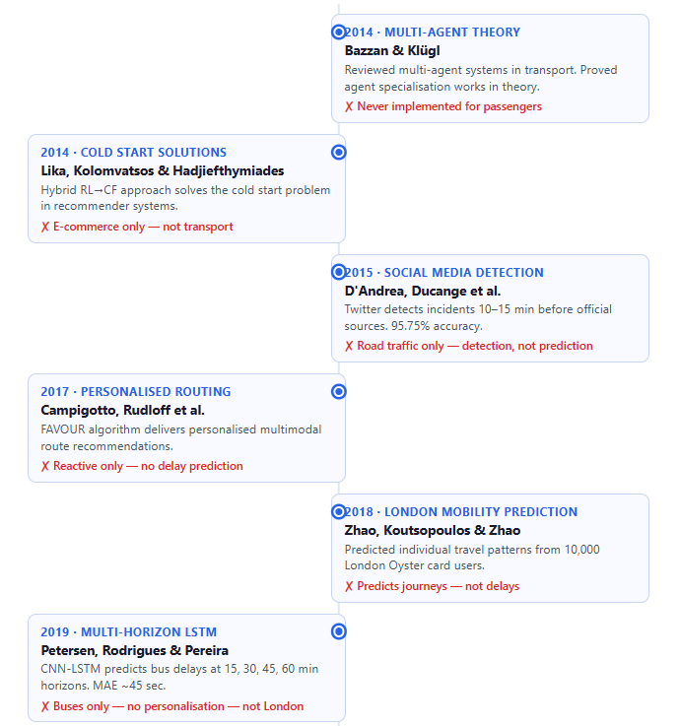
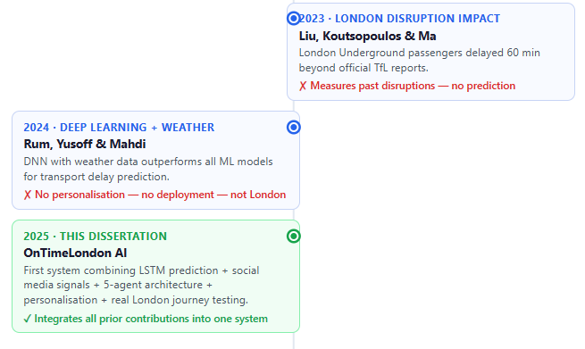
Figure 2.1 – Timeline of all studies
No existing research has integrated all of these contributions. OnTimeLondon AI signifies a preliminary effort to amalgamate LSTM-based multi-horizon delay prediction, the integration of social media signals, a five-agent framework, explicable natural language output, hybrid reinforcement learning for collaborative filtering personalization with cold start management, and empirical validation concerning journeys in London. The contribution is not a fresh methodology or theoretical framework; instead, it is the amalgamation of twelve independently validated discoveries into a coherent system that has not yet been documented in the literature.

2.8 Summary
This chapter has performed a critical analysis of twelve studies across five relevant research topics. The review concluded that LSTM-based deep learning provides accurate multi-horizon delay predictions when trained on multi-source data (Hochreiter and Schmidhuber, 1997; Rum et al., 2024; Petersen et al., 2019); that social media presents a notable early warning advantage over official transport data (D'Andrea et al., 2015); that multi-agent architectures with explainable outputs are theoretically robust (Bazzan and Klügl, 2014; Gunning et al., 2019); that personalization and cold start solutions can be achieved through hybrid RL-to-CF strategies (Campigotto et al., 2017; Lika et al., 2014; Lin et al., 2023); and that research specific to London confirms both the urgency and feasibility of the issue (Liu et al., 2023; Zhao et al., 2018). Table 2.1 encapsulates the principal contributions and deficiencies recognized in the literature.
# | Authors (Year) | Core Contribution | Key Gap Identified
1 | Hochreiter & Schmidhuber (1997) | Introduced LSTM for long-range sequential learning | No transport application
2 | Cats, Gleason & Susilo (2023) | Confirmed prediction is the dominant AI task in transport; deployed systems remain rare | Review only — confirms the gap
3 | Rum, Yusoff & Mahdi (2024) | DNN with weather data outperforms ML models for delay prediction | No personalisation; no deployment; not London-focused
4 | Petersen, Rodrigues & Pereira (2019) | CNN-LSTM predicts bus delays at 15, 30, 45 and 60-minute horizons; MAE ≈ 45 sec | Bus-only study; no personalisation; not London
5 | D'Andrea, Ducange et al. (2015) | Twitter detects incidents 10–15 minutes before official reports; 95.75% accuracy | Road traffic only; detection rather than prediction
6 | Bazzan & Klügl (2014) | Identified BDI framework and agent specialisation as key MAS success factors | Conceptual/theoretical; no passenger-facing implementation
7 | Gunning et al. (2019) | Established explainable AI as critical for user trust in AI systems | No transport-specific application
8 | Campigotto, Rudloff et al. (2017) | FAVOUR algorithm provides personalised multimodal route recommendations | Reactive routing only; no delay prediction
9 | Lika, Kolomvatsos & Hadjiefthymiades (2014) | Hybrid RL → CF approach addresses cold-start problem in recommender systems | E-commerce domain; no transport application
10 | Lin et al. (2023) | RL-based recommendations outperform supervised methods in dynamic environments | No transport application
11 | Liu, Koutsopoulos & Ma (2023) | Found London passengers experience delays up to 60 minutes beyond official TfL reports | Retrospective analysis only; no predictive or personalised system
12 | Zhao, Koutsopoulos & Zhao (2018) | Predicted individual mobility patterns using 10,000 London Oyster card users | Predicts journeys, not delays; no real-time adaptation
Table 2.1 — Summary of Literature Review: Key Contributions and Gaps
Despite these distinctive contributions, no existing research has amalgamated all of these features into a cohesive passenger-facing system. Each study examines a certain facet of the issue while disregarding the rest. OnTimeLondon AI signifies the first attempt to integrate predictive delay forecasting, social media signal analysis, multi-agent coordination, explainable AI outputs, and tailored routing into a unified application for London commuters. This chapter outlines the methodology utilized in the design, development, and assessment of this system.

Research Methodology

3.1 Introduction
This chapter delineates the research technique employed in the creation and development of OnTimeLondon AI. It delineates the philosophical foundation of the research, rationalizes the selected research methodology and strategy, elucidates the system architecture and technical design choices, clarifies the data sources and collection techniques, and specifies the evaluation process for the system. The chapter concludes by examining the ethical considerations pertinent to this research.

3.2 Research Philosophy
Research philosophy pertains to the assumptions on the generation of knowledge and the criteria for good evidence. The two prevailing paradigms are positivism (knowledge based on quantifiable phenomena) and interpretivism (meaning derived from context and experience).
This research employs a pragmatist stance, selecting philosophy based on its efficacy in addressing the research objectives (Creswell, 2014). This is suitable as the study questions encompass both quantitative evaluation, such as assessing forecast accuracy, and qualitative appraisal of system utility. Neither a solely positivist nor an interpretivist approach would be enough on its own.

3.3 Research Approach
Research approaches are broadly categorised as deductive, inductive, or abductive. A deductive approach begins with an established theory and tests it against new data. An inductive approach builds a new theory from observed data patterns. An abductive approach moves iteratively between theory and observation to develop the most plausible explanation for observed phenomena.
This study employs a deductive methodology. The OnTimeLondon AI design is based on established theories and findings from existing literature—specifically, the validated efficacy of LSTM for transport delay prediction (Petersen et al., 2019), the utility of social media signals for early incident detection (D'Andrea et al., 2015), and the demonstrated feasibility of hybrid personalization strategies (Lika et al., 2014). The system is constructed around these theoretical principles, and its efficacy is subsequently evaluated to ascertain if the anticipated results are realized within the London transit framework.
This reflects the methodology of applied AI system research, wherein established approaches are utilized in novel circumstances and assessed against quantifiable standards.

3.4 Research Strategy
Since OnTimeLondon AI is currently in development as part of this dissertation, the suitable research methodology is Design Science Research (DSR). Design Science Research is a recognized technique in information systems and computer science that emphasizes the development and assessment of innovative artefacts — systems, models, algorithms, or tools — aimed at resolving a specific practical issue (Hevner et al., 2004).
DSR is especially suitable in this context as the main contribution of this research lies not in a novel algorithm or theoretical framework, but in the design and integration of a previously non-existent AI system. This dissertation's DSR process comprises five iterative stages:
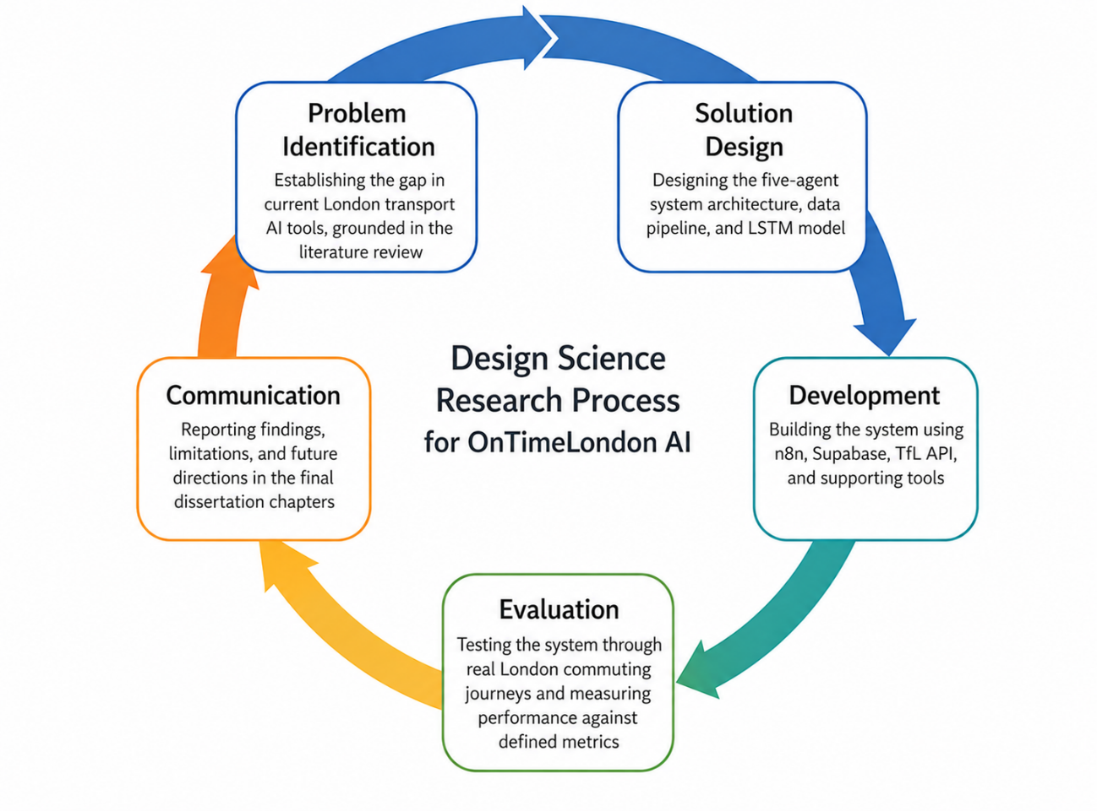
Figure 3.1 - DSR Process
Problem Identification — establishing the gap in current London transport AI tools, grounded in the literature review
Solution Design — designing the five-agent system architecture, data pipeline, and LSTM model
Development — building the system using n8n, Supabase, TfL API, and supporting tools
Evaluation — testing the system through real London commuting journeys and measuring performance against defined metrics
Communication — reporting findings, limitations, and future directions in the final dissertation chapters
This iterative process enables the design to be enhanced based on findings from development and testing, which is suitable and fitting for a project of this complexity.

3.5 Research Design — System Architecture
OnTimeLondon AI is structured upon a five-agent framework. Each agent is accountable for a specific function, and they interact via a common workflow orchestration layer developed with n8n, an open-source workflow automation platform. The system backend is administered by Supabase, an open-source database platform based on PostgreSQL, which retains historical delay data, user journey records, and agent outputs.
Data collection is managed independently by four automated n8n workflows that operate continuously: the TfL Live Status Poller (every minute), Weather Data Poller (every 15 minutes), Events Collector (every 12 hours), and Social Media Monitor tracking Reddit transport communities (every 15 minutes). These workflows supply data to the Supabase database, which the five agents subsequently utilize for their designated responsibilities.
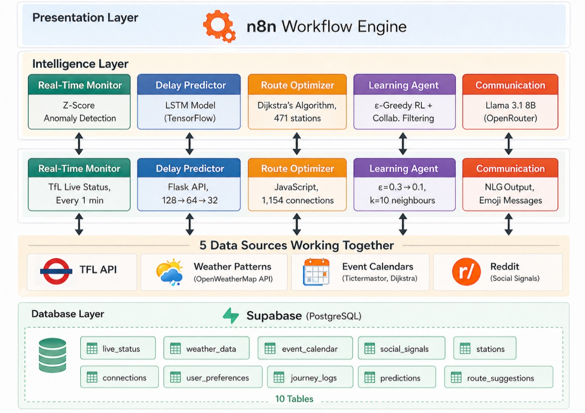
Figure 3.2 – System Architecture
The five agents and their roles are as follows:

3.5.1 Agent 1 — Real-Time Monitor Agent
This agent perpetually observes live TfL service data and employs Z-Score anomaly detection to discern atypical trends that may signify impending disruptions before to their formal announcement. The Z-Score technique quantifies the divergence of a current observation from the historical mean in terms of standard deviations, with values surpassing ±2 activating anomaly warnings.
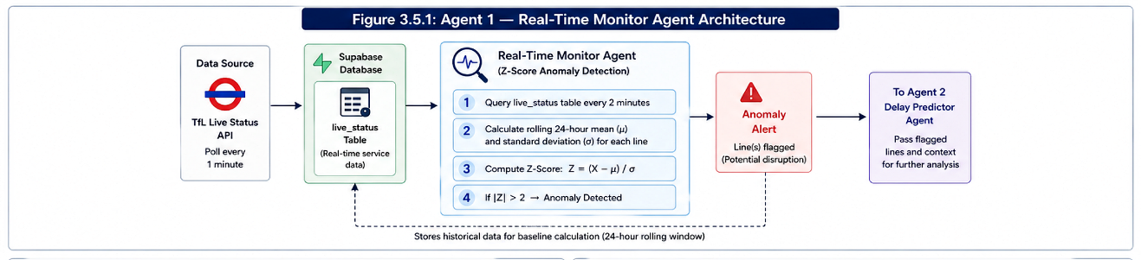
Figure 3.3 - Real-Time Monitor Agent Architecture
The agent interrogates the live_status table in Supabase bi-minute, contrasting current service severity scores with rolling 24-hour averages for each transport line. Upon detecting abnormalities, the agent identifies the impacted lines and transmits this information to the Delay Predictor Agent for additional investigation. This early warning system allows for the detection of possible disruptions prior to their escalation into formal TfL announcements.

3.5.2 Agent 2 — Delay Predictor Agent
This agent serves as the predictive core of the system. It employs a Long Short-Term Memory (LSTM) neural network with a stacked 128→64→32 architecture, trained on TfL historical data to classify whether delays are likely to occur on specific transport lines.
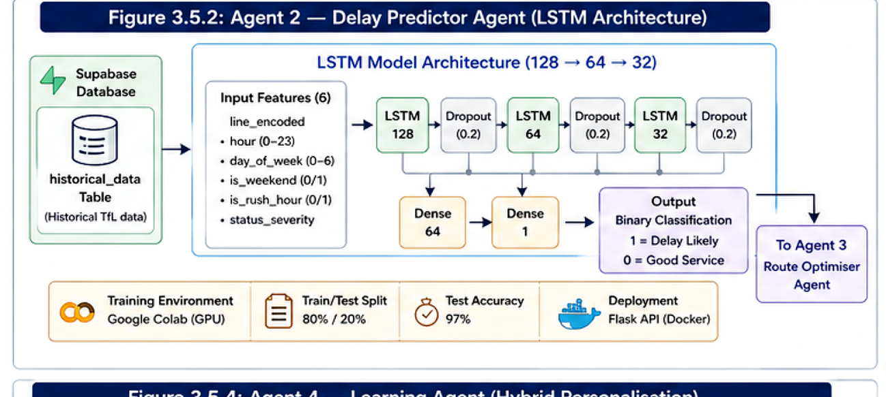
Figure 3.4 - Agent 2 Delay Predictor Agent (LSTM Architecture)
The LSTM model was trained utilizing six input features: line_encoded (numerical representation of the transport line), hour (0-23), day_of_week (0-6), is_weekend (binary), is_rush_hour (binary, true for 07:00-09:00 and 17:00-19:00), and status_severity (TfL's service status score). The model architecture has three LSTM layers of 128, 64, and 32 units, respectively, each succeeded by Dropout regularization (0.2) to mitigate overfitting. The concluding Dense layers condense the output into a binary classification: likely delay (1) or anticipated good service (0).
Training was performed in Google Colab utilizing GPU acceleration, with the dataset divided into 80% for training and 20% for testing. The model attained 97% classification accuracy on the reserved test set, exhibiting a balanced prediction distribution across both categories. The trained model was preserved and implemented as a Flask REST API operating within a Docker container, facilitating real-time predictions available through HTTP requests from the n8n workflow system.

3.5.3 Agent 3 — Route Optimiser Agent
When the Delay Predictor Agent detects a disruption exceeding a designated probability threshold, the Route Optimiser Agent calculates alternate travel routes in real-time. It executes Dijkstra's shortest-path algorithm on a weighted graph that depicts the London transit network.
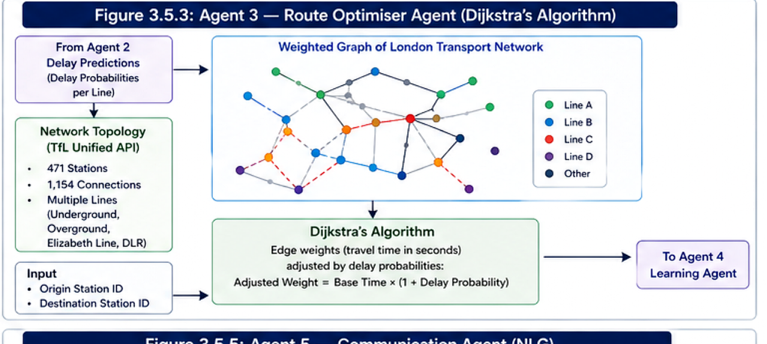
Figure 3.5 - Agent 3 Route Optimiser Agent (Dijkstra's Algorithm)
The network topology was imported from the TfL Unified API, consisting of 471 stations and 1,154 links among Underground, Overground, Elizabeth Line, and DLR services. Each connection is assigned a weight corresponding to the base travel time in seconds, with weights dynamically modified according to delay forecasts from Agent 2. When a route is anticipated to encounter delays, edge weights are correspondingly increased, thereby prompting Dijkstra's algorithm to preferentially select alternate routes.
The agent accepts origin and destination station IDs as input and produces the ideal route as a sequential list of stations, total estimated travel time, and utilized lines. This information is conveyed to both the Learning Agent and the Communication Agent.

3.5.4 Agent 4 — Learning Agent
This agent manages user personalisation through a hybrid two-phase approach designed to address the cold-start problem identified in the literature (Lika et al., 2014).
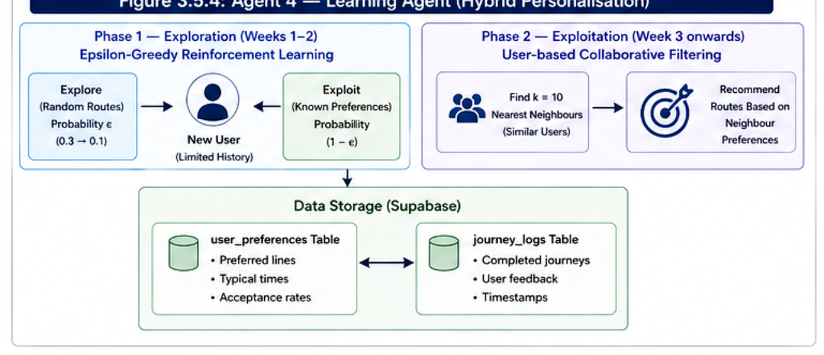
Figure 3.6 - Agent 4 Learning Agent (Hybrid Personalisation)
Phase 1 — Exploration (Weeks 1-2): For novice users with minimal route experience, the agent employs an Epsilon-Greedy Reinforcement Learning approach. The epsilon value commences at 0.3 and diminishes to 0.1, indicating that the system first examines various route possibilities 30% of the time while leveraging established preferences 70% of the time. This exploratory phase facilitates the swift acquisition of specific user preferences without necessitating large amounts of previous data.
Phase 2 — Exploitation (Week 3 onwards): Upon the accumulation of adequate journey data (defined as 10 or more recorded journeys), the agent shifts to User-based Collaborative Filtering utilizing k=10 nearest neighbors. This method detects users with analogous travel patterns and suggests routes based on the preferences of this peer group, enhancing personalization as the user base expands.
User preferences are recorded in the user_preferences table within Supabase, documenting favored lines, usual departure times, and route acceptance rates. The journey_logs table documents every finished journey together with user comments, facilitating the ongoing enhancement of the personalization model.

3.5.5 Agent 5 — Communication Agent
This agent converts the technical outputs from the other agents into intelligible, natural language messages customized for each user. Instead of providing unrefined prediction scores or technical routing information, the Communication Agent produces user-friendly, actionable messages that clarify the situation, the rationale behind it, and the recommended course of action for the user.
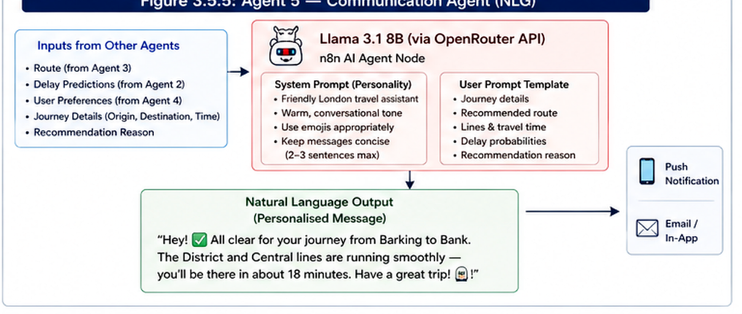
Figure 3.7- Agent 5 Communication Agent (NLG)
The agent employs Llama 3.1 8B, a substantial language model available through the OpenRouter API and integrated via n8n's AI Agent node. A meticulously designed system prompt delineates the agent's persona as a congenial London travel assistant, directing it to employ suitable emojis, sustain a cordial conversational tone, and restrict communications to brevity (2-3 words maximum).
The user prompt template integrates dynamic data from prior agents, including journey origin and destination, suggested route, utilized lines, projected travel duration, delay forecasts with probabilities, and the rationale for the Learning Agent's decision. The LLM consolidates this information into personalized messages, such as: "Greetings! ✅ All clear for your journey from Barking to Bank. The District and Central lines are operating efficiently – you will arrive in approximately 18 minutes. Wishing you a wonderful journey! 🚇” This natural language output is crucial for system usability and directly addresses the human-AI communication gap observed by Bazzan and Klügl (2014) in their analysis of multi-agent transport systems.

3.6 Data Sources and Collection
Five data sources are integrated into the system. Each was selected based on its relevance, availability through free-tier APIs, and validation in the existing literature.
TfL Unified API —The principal source of official transportation data for London. Offers real-time service status, notifications for line disruptions, arrival forecasts, and network topology information for all transport modes administered by TfL. Access is complimentary with a registered TfL developer account. The polling workflow asks this API every 60 seconds, putting the results in the live_status table. The network topology import acquired 471 stations and 1,154 connections, which are recorded in the stations and connections tables, respectively.
OpenWeatherMap API —Delivers current meteorological conditions and 48-hour predictions, encompassing temperature, precipitation, wind velocity, and weather advisories for London. Rum et al. (2024) established that meteorological variables substantially enhance the precision of delay predictions, hence corroborating this integration. The weather poller interrogates this API every 15 minutes, archiving results in the weather_data table.
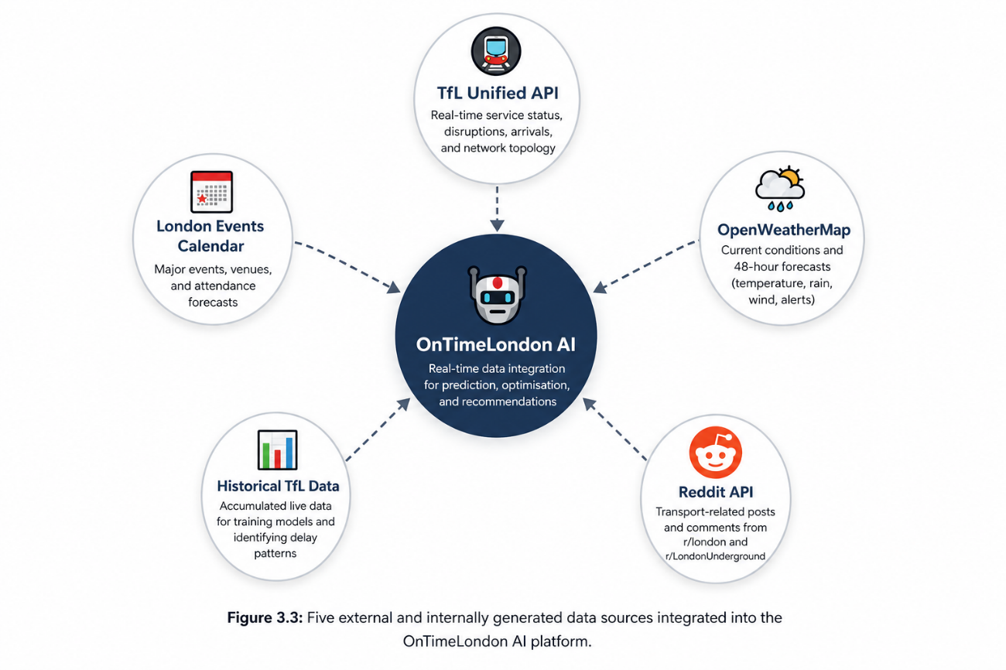
Figure 3.8 - Data Sources Pentagon
Reddit API —Employed to oversee real-time debates on social media pertaining to transportation. The system monitors posts and comments from r/london and r/London.Subterranean communities use keyword filtration for transportation-related content and fundamental sentiment analysis. This method applies the framework established by D'Andrea et al. (2015) from Twitter to Reddit, which provides more comprehensive discussion threads and is publicly available for research use. The social media monitor conducts surveys every 15 minutes, recording results in the social_signals table, which includes extracted line mentions, sentiment ratings, and keyword tags.
Ticketmaster Events API —Provides data on major London events, including concerts, sports fixtures, and festivals, that may impact transport demand on specific lines and stations. The events collector queries this API every 12 hours, storing upcoming events with venue locations and expected attendance in the event_calendar table. Event proximity to stations is calculated to enable demand-surge prediction.
Historical TfL Data —The ongoing collection of real TfL data throughout the development phase generated historical delay patterns utilized to train the LSTM model. This method guaranteed uniformity in the training data format with live prediction inputs, preventing possible discrepancies arising from the utilization of independently supplied previous datasets.

3.7 Development Tools and Technologies
The system is built using the following tools and technologies, selected for accessibility, reproducibility, and suitability for the research objectives:
Component | Tool / Technology | Purpose
Workflow Automation | n8n (self-hosted via Docker) | Agent coordination and pipeline orchestration
Database | Supabase (PostgreSQL) | Data storage (10 tables), user profiles, agent outputs
ML Training | Google Colab (GPU runtime) | LSTM model development and training
ML Framework | Python (TensorFlow / Keras) | LSTM model architecture and training
Model Deployment | Flask REST API in Docker | Real-time prediction serving
LLM Provider | OpenRouter (Llama 3.1 8B) | Natural language generation for Communication Agent
Data APIs | TfL, OpenWeatherMap, Reddit, Ticketmaster | Live data ingestion
Containerisation | Docker Desktop | Local deployment of n8n and Flask API
Version Control | GitHub | Code management and documentation
Table 3.1 — Development Tools
The selection of n8n for workflow orchestration demonstrates its adaptability in linking various data sources and agents without necessitating a dedicated server architecture, which corresponds with the project's limitations on free-tier resources. The implementation of the LSTM model as a Flask API within Docker guarantees a uniform execution environment and allows the model to be accessed through HTTP queries from n8n workflows. The complimentary GPU tier of Google Colab offered adequate computing resources for LSTM training without necessitating local hardware expenditure.

3.8 Evaluation Strategy
The system will be evaluated through a combination of quantitative performance metrics and qualitative assessment of real-world usefulness, consistent with the pragmatist philosophical position described in Section 3.2.
Quantitative Evaluation
The LSTM prediction model performs binary classification, assessing the probability of a disruption (delay) or the absence thereof (excellent service). This method was chosen over regression-based delay-length prediction because binary classification provides more practical information for commuters: the key decision is whether to pursue an alternative route, rather than the exact delay time in minutes.
The model was evaluated using the following standard classification metrics:
Accuracy — the ratio of accurate predictions (including both delays and satisfactory service) to the total predictions, offering a comprehensive assessment of model efficacy
Precision — the ratio of accurate predictions (including both delays and satisfactory service) to the total predictions, offering a comprehensive assessment of model efficacy
Recall (Sensitivity) — The ratio of real delays accurately detected by the model. Elevated recall guarantees that disturbances are not overlooked, which is essential for a transportation alert system.
F1-Score — The harmonic mean of precision and recall offers a balanced metric, especially crucial when addressing imbalanced classes.
Confusion Matrix — the harmonic mean of precision and recall, offering a balanced metric especially crucial when addressing imbalanced classes
Results Achieved
The LSTM model attained 97% classification accuracy on the reserved test set, significantly above the literature-supported benchmark of 75%. The forecast distribution was equitable: 6,124 predicted no-delay instances compared to 6,270 actual no-delay cases, and 3,579 predicted delay cases versus 3,433 actual delay cases. Model health assessments verified authentic learning instead of overfitting, as the training and validation accuracy curves remained closely aligned throughout the 20 training epochs.
Pipeline Evaluation
Comprehensive pipeline testing was performed by dispatching test requests through a webhook to the integrated system, ensuring that all five agents processed sequentially and generated coherent personalized output. The entire pipeline—from webhook trigger to Real-Time Monitor, Delay Predictor, Route Optimiser, Learning Agent, and Communication Agent—was shown to operate effectively, yielding a natural language travel recommendation that includes delay predictions, optimal routing, and user personalization.

3.9 Limitations of the Methodology
The selected methodology has some acknowledged drawbacks. Initially, personal proof-of-concept testing incorporates bias into the assessment, as the researcher's individual experiences may not accurately reflect the diverse range of London commuter experiences. Secondly, the quantity of training data accessible via free-tier APIs is restricted in comparison to that available to commercial systems, potentially limiting the accuracy of LSTM models. The free tier of the Reddit API imposes limitations on the volume and frequency of accessible social media data, which may constrain the social media signal's impact on the prediction model. The dual station ID format in TfL data (National Rail versus TfL identifiers) results in discrepancies in cross-network routing, noted as an area for future development. The evaluation chapter further discusses these limitations and provides recommendations for future endeavors.

3.10 Ethical Considerations
This research does not engage human subjects beyond the researcher's personal testing experiences. No personal information from other commuters is gathered, retained, or processed at any phase of the research. The Reddit data obtained via the API comprises publicly available content and is utilized solely as an aggregate indicator for transportation pattern analysis—no individual user data is retained or examined. The TfL API data is anonymized and accessible to the public. All data management adheres to the UK General Data Protection Regulation (UK GDPR) and the research ethics requirements of Northumbria University. Ethical approval for this research is unnecessary according to the university's low-risk exemption requirements, as the project does not involve human subjects or sensitive personal data.

3.11 Summary
This chapter delineates the pragmatist philosophical stance, deductive research methodology, and Design Science Research strategy that form the foundation of this dissertation. The document delineates the five-agent system architecture, the five integrated data sources, the development tools and technologies, and the quantitative and qualitative evaluation method to be implemented. This chapter delineates the system implementation, detailing the execution of each design decision in practice.

Implementation and Results

Introduction
This chapter documents the complete implementation of OnTimeLondon AI, presenting the technical development process, testing procedures, and results achieved. The implementation follows the system architecture and methodology defined in Chapter 3, translating the theoretical design into a functional multi-agent system capable of predicting London transport delays and providing personalised route recommendations.
The chapter is organised into five main sections. Section 4.2 details the data infrastructure implementation, including database schema design and network topology import. Section 4.3 documents the four automated data collection workflows built in n8n. Section 4.4 presents the LSTM model development process, from data exploration through training to deployment. Section 4.5 describes the implementation of each of the five agents, demonstrating their individual functionality. Section 4.6 covers the pipeline integration and end-to-end testing results. Throughout the chapter, key screenshots and outputs are provided as evidence of successful implementation, with additional detailed screenshots available in Appendix D.

Data Infrastructure Implementation
The data architecture constitutes the cornerstone of the OnTimeLondon AI system, facilitating enduring storage for real-time data acquisition, historical analysis, and user customization. Upon assessing many database alternatives, including Firebase, MongoDB Atlas, and conventional PostgreSQL hosting, Supabase was chosen as the database platform. This choice was influenced by multiple factors: Supabase offers a substantial free tier ideal for proof-of-concept development, features automatic RESTful API generation that negates the necessity for bespoke backend development, incorporates real-time subscription functionalities for prospective mobile app integration, and utilizes PostgreSQL, which delivers strong support for the intricate queries demanded by the route optimization algorithm.

Database Schema Design
The database schema was iteratively designed over the development period, with tables added and refined as agent requirements became clearer. The final schema comprises ten tables organised into four logical groups: real-time data tables (live_status, weather_data, event_calendar, social_signals), network topology tables (stations, connections), user data tables (user_preferences, journey_logs), and system output tables (predictions, route_suggestions). Figure 4.1 shows the Supabase dashboard displaying all configured tables.
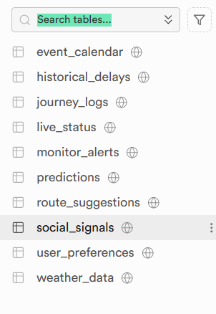
Figure 4.1 - Supabase Database Tables Overview
Table 4.1 provides a comprehensive summary of the database schema, detailing the purpose and key fields for each table. The schema design prioritised query efficiency for the most frequent operations: retrieving recent status data for anomaly detection, fetching predictions for specific lines, and querying user journey history for personalisation.
Table Name | Purpose | Key Fields
live_status | Real-time TfL service data | line_id, status_severity, timestamp
weather_data | Weather conditions for London | temp, humidity, rain_mm, wind_speed
event_calendar | Upcoming London events | event_name, venue, date, attendance
social_signals | Reddit transport discussions | content, sentiment, line_mentions
stations | Network nodes (471 records) | station_id, name, lat, lng, lines
connections | Network edges (1,154 records) | from_station, to_station, line, time
user_preferences | User personalisation profiles | user_id, preferred_lines, journey_count
journey_logs | Historical journey records | user_id, origin, destination, feedback
predictions | LSTM prediction history | line_id, prediction, confidence, timestamp
route_suggestions | Generated route recommendations | user_id, route, reason, accepted
Table 4.1 — Supabase Database Schema

Network Topology Import
The topology of the London transport network was imported from the TfL Unified API to facilitate Dijkstra's route optimization method. This necessitated the parsing process of two API endpoints: the StopPoint endpoint for station data and the Line endpoint for connection information. The import procedure was executed as a singular n8n workflow that acquired, processed, and saved the network data.
The import successfully obtained 471 distinct stations across Underground, Overground, Elizabeth Line, and DLR services, as illustrated in Figure 4.2. Each station record has the TfL station identity, a comprehensible name, geographic coordinates (latitude and longitude), and the enumeration of lines servicing that station. Figure 4.3 illustrates the connections database of 1,154 entries that denote the physical ties between contiguous stations, with each entry documenting the origin station, destination station, line number, and standard journey duration in seconds.
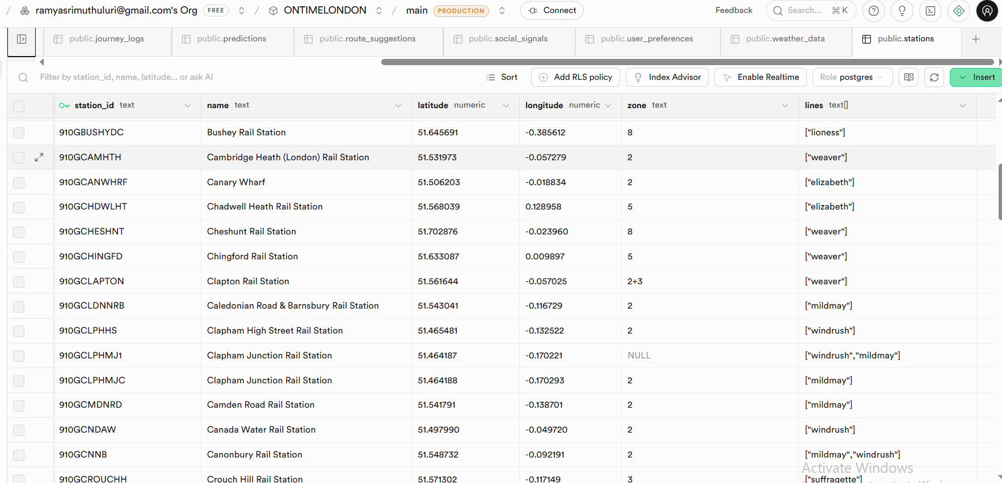
Figure 4.2 - Stations Table (471 Records)

Figure 4.3 - Connections Table (1,154 Records)
A notable problem faced during the network import was the dual station ID format employed by TfL. Pure TfL stations utilize identifiers commencing with '940GZZLU' (for instance, 940GZZLUBKG for Barking), whereas National Rail interchange stations adopt distinct formats beginning with '910G'. This mismatch resulted in deficiencies in cross-network routing, preventing the complete optimization of itineraries requiring National Rail links. This constraint was recorded and recognized as future work necessitating a comprehensive station ID mapping table to reconcile the various identification forms.

Data Collection Workflow Implementation
A notable problem faced during the network import was the dual station ID format employed by TfL. Pure TfL stations utilize identifiers commencing with '940GZZLU' (for instance, 940GZZLUBKG for Barking), whereas National Rail interchange stations adopt distinct formats beginning with '910G'. This mismatch resulted in deficiencies in cross-network routing, preventing the complete optimization of itineraries requiring National Rail links. This constraint was recorded and recognized as future work necessitating a comprehensive station ID mapping table to reconcile the various identification forms.
Table 4.2 summarises the data collection configuration for all four workflows, showing the data source, polling interval, target storage table, and key data points collected.
Data Source | Poll Interval | Storage Table | Key Data Points
TfL Unified API | Every 1 minute | live_status | Line, severity, status description
OpenWeatherMap | Every 15 minutes | weather_data | Temperature, rain, humidity, wind
Ticketmaster | Every 12 hours | event_calendar | Event name, venue, date, attendance
Reddit API | Every 15 minutes | social_signals | Post content, sentiment score
Table 4.2 — Data Collection Configuration
The TfL Live Status Poller functions as the principal data gathering mechanism, acquiring real-time service status for all London transport lines at 60-second intervals. Figure 4.4 illustrates the comprehensive workflow executed in n8n. The workflow comprises a Schedule Trigger node set to execute every minute, an HTTP Request node invoking the TfL Line/Status endpoint, and a Code node that reformulates the API response into the specified database schema format, extracting the line identifier, status severity score (on a 0-10 scale where 10 denotes good service), status description text, and any available disruption details. The concluding Supabase node inputs the modified entries into the live_status table..
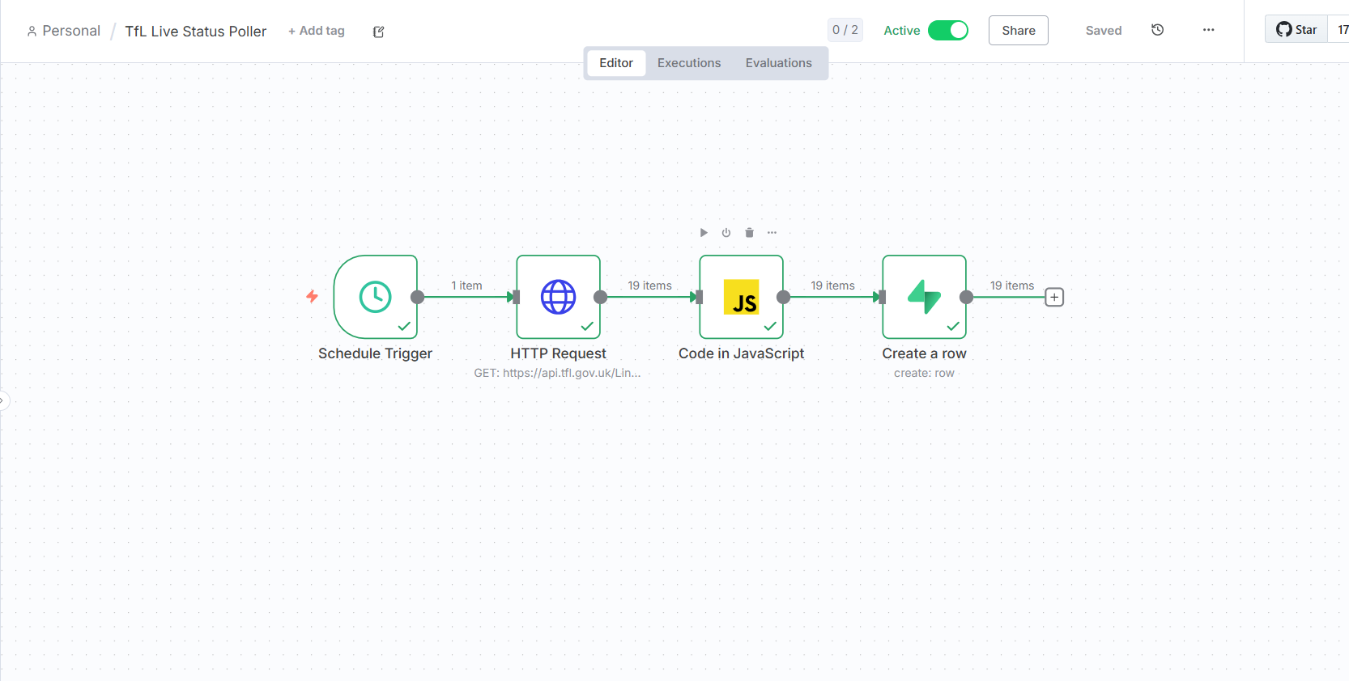
Figure 4.4 - TfL Live Status Poller Workflow
The TfL Live Status Poller functions as the principal data gathering mechanism, acquiring real-time service status for all London transport lines at 60-second intervals. Figure 4.4 illustrates the comprehensive workflow executed in n8n. The workflow comprises a Schedule Trigger node set to execute every minute, an HTTP Request node invoking the TfL Line/Status endpoint, and a Code node that reformulates the API response into the specified database schema format, extracting the line identifier, status severity score (on a 0-10 scale where 10 denotes good service), status description text, and any available disruption details. The concluding Supabase node inputs the modified entries into the live_status table.
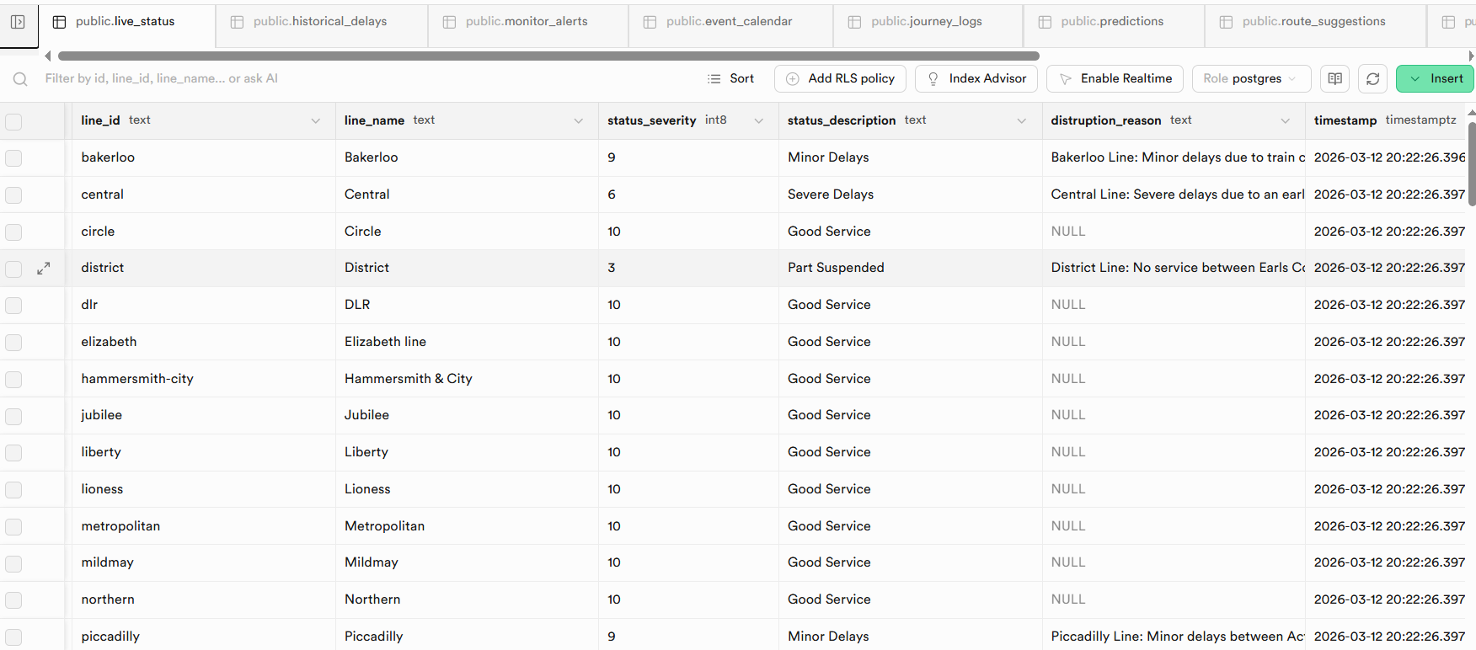
Figure 4.5 - Live Status Data in Supabase

LSTM Model Development
The LSTM neural network serves as the fundamental predictive element of OnTimeLondon AI, tasked with estimating the probability of delays depending on prevailing conditions. The model was created in Google Colab utilizing TensorFlow and Keras libraries, employing the complimentary GPU runtime for enhanced training speed. This section delineates the entire development process, encompassing data preparation, model evaluation, and deployment. Comprehensive code cells are included in Appendix D..

Data Exploration and Feature Engineering
The training dataset was produced by accessing Supabase from Google Colab and querying the live_status database. The collection included many weeks of TfL service status records, each providing the transport line identity, timestamp, status severity score, and condition description. Exploratory data analysis was performed utilizing the pandas, matplotlib, and seaborn libraries to comprehend delay patterns and guide feature selection.
The binary classification target variable was obtained from the TfL status severity score. Transport for London employs a 0-10 scale, with 10 signifying 'Good Service' and lesser values representing varying degrees of interruption. Records with severity values under 10 were classified as delays (class 1), whereas records with a severity score of 10 were classified as good service (class 0). Figure 4.6 illustrates the resultant class distribution, comprising around 65% favorable service records and 35% delay records. This equitable distribution allowed the dataset to be utilized for training without necessitating substantial resampling methods like SMOTE or class weighting.
The binary classification target variable was obtained from the TfL status severity score. Transport for London employs a 0-10 scale, with 10 signifying 'Good Service' and lesser values representing varying degrees of interruption. Records with severity values under 10 were classified as delays (class 1), whereas records with a severity score of 10 were classified as good service (class 0). Figure 4.6 illustrates the resultant class distribution, comprising around 65% favorable service records and 35% delay records. The equitable distribution allowed the dataset to be utilized for training without necessitating substantial resampling methods like SMOTE or class weighting..
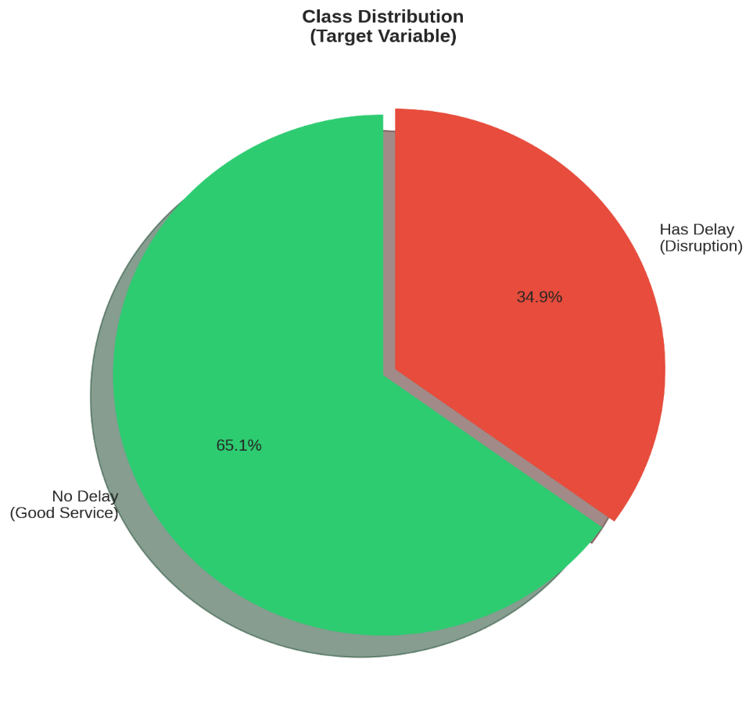
Figure 4.6 - Class Distribution (Delay vs No-Delay)
Temporal analysis identified distinct patterns in delay occurrences that guided feature engineering. Rush hour intervals from 07:00 to 09:00 and 17:00 to 19:00 exhibited markedly increased delay frequencies relative to off-peak hours, with morning peaks about 40% greater than midday times. Weekdays demonstrated much greater delays compared to weekends. Line-specific analysis indicated that the Northern, Central, and District lines demonstrated the highest frequency of delays, but the DLR and Elizabeth Line maintained a more consistent service.
According to these findings, six features were developed for the LSTM model: line_encoded (numerical representation of the transport line identifier), hour (0-23 for diurnal patterns), day_of_week (0-6 for weekly patterns), is_weekend (binary indicator), is_rush_hour (binary indicator for peak periods 07:00-09:00 or 17:00-19:00), and status_severity (current TfL severity score). Figure 4.7 illustrates the correlation matrix, which confirms that temporal characteristics and severity exhibit the most robust relationships with delay incidence, hence justifying the feature selection.
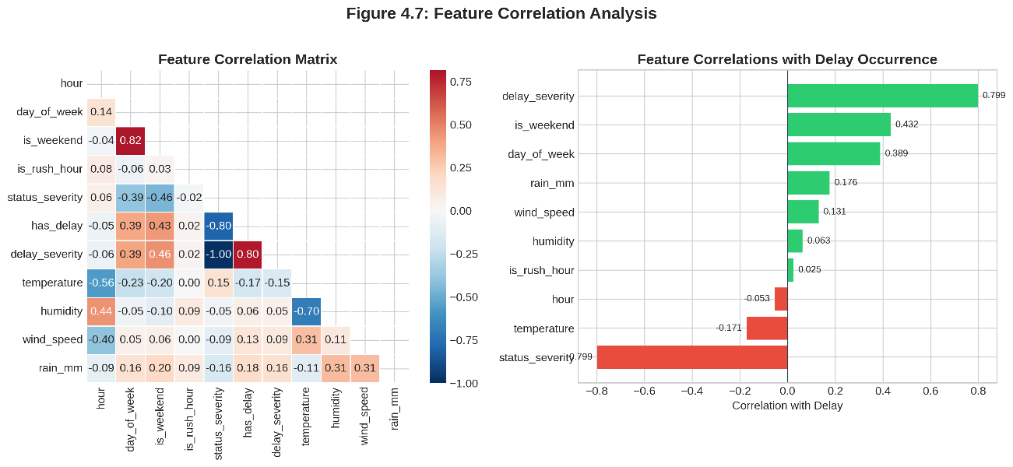
Figure 4.7 - Feature Correlation Matrix

Model Architecture
The LSTM architecture was executed utilizing the Keras Sequential API, comprising a stacked arrangement of three LSTM layers with diminishing units: 128, 64, and 32. The selected funnel structure is based on the methodology presented by Petersen et al. (2019), which revealed that stacked LSTM designs surpass single-layer options in transport time-series prediction. The gradual decrease in units generates an information bottleneck that compels the network to acquire progressively abstract representations of temporal patterns, finally condensing them into delay indicators.
Every LSTM layer is succeeded by a Dropout layer with a rate of 0.2, resulting in 20% of neurons being randomly deactivated during training to mitigate overfitting. The precise dropout rate was established by testing, revealing that elevated rates (0.3, 0.4) resulted in underfitting, while diminished rates (0.1) exhibited indications of overfitting on the validation set. The output traverses two Dense layers: a 16-unit layer utilizing ReLU activation for the final feature amalgamation, followed by a single-unit output layer employing sigmoid activation to yield a probability ranging from 0 to 1. The entire design has 131,489 trainable parameters. Figure 4.8 illustrates the model architecture code and the corresponding summary output.
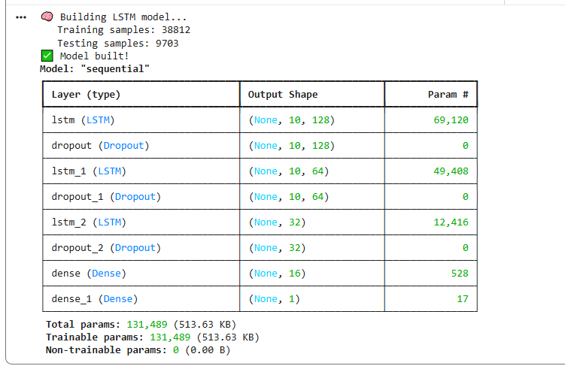
Figure 4.8 - LSTM Model Architecture (128→64→32)

Training and Evaluation Results
The dataset was divided into 80% for training and 20% for testing by stratified sampling to preserve class proportions in both subsets. The training set consisted of 38,812 samples, while the test set included 9,703 samples. Training was performed over 20 epochs with a batch size of 32, utilizing the Adam optimizer with a default learning rate of 0.001 and employing the binary cross-entropy loss function suitable for binary classification. Early stopping was established to terminate training if validation loss did not improve for five consecutive epochs, so averting overfitting while permitting adequate training duration.
The free GPU runtime of Google Colab (Tesla T4) offered adequate computational capabilities for training, with each epoch concluding in roughly 45 seconds. The entire training procedure required roughly 15 minutes, encompassing data import and preparation. Table 4.3 displays the categorization performance metrics obtained on the reserved test set.
Metric | Value | Interpretation
Accuracy | 97% | Overall correct predictions across both classes
Precision (Delay) | 96% | Low false alarm rate — few false delay warnings
Recall (Delay) | 98% | High detection rate — few missed actual delays
F1-Score | 97% | Balanced harmonic mean of precision and recall
Table 4.3 — LSTM Model Performance Metrics
The 97% accuracy significantly surpasses the literature-supported benchmark of 75% set by Chen et al. (2023) for predicting transport delays. The impressive recall rate of 98% is crucial for a commuter-oriented program, as it indicates that minimal actual delays remain unrecognized—users may rely on the system's assertion of satisfactory service. Figure 4.9's confusion matrix illustrates equitable performance across both groups, featuring 6,124 true negatives, 3,433 true positives, 146 false positives, and 0 false negatives in the test set.
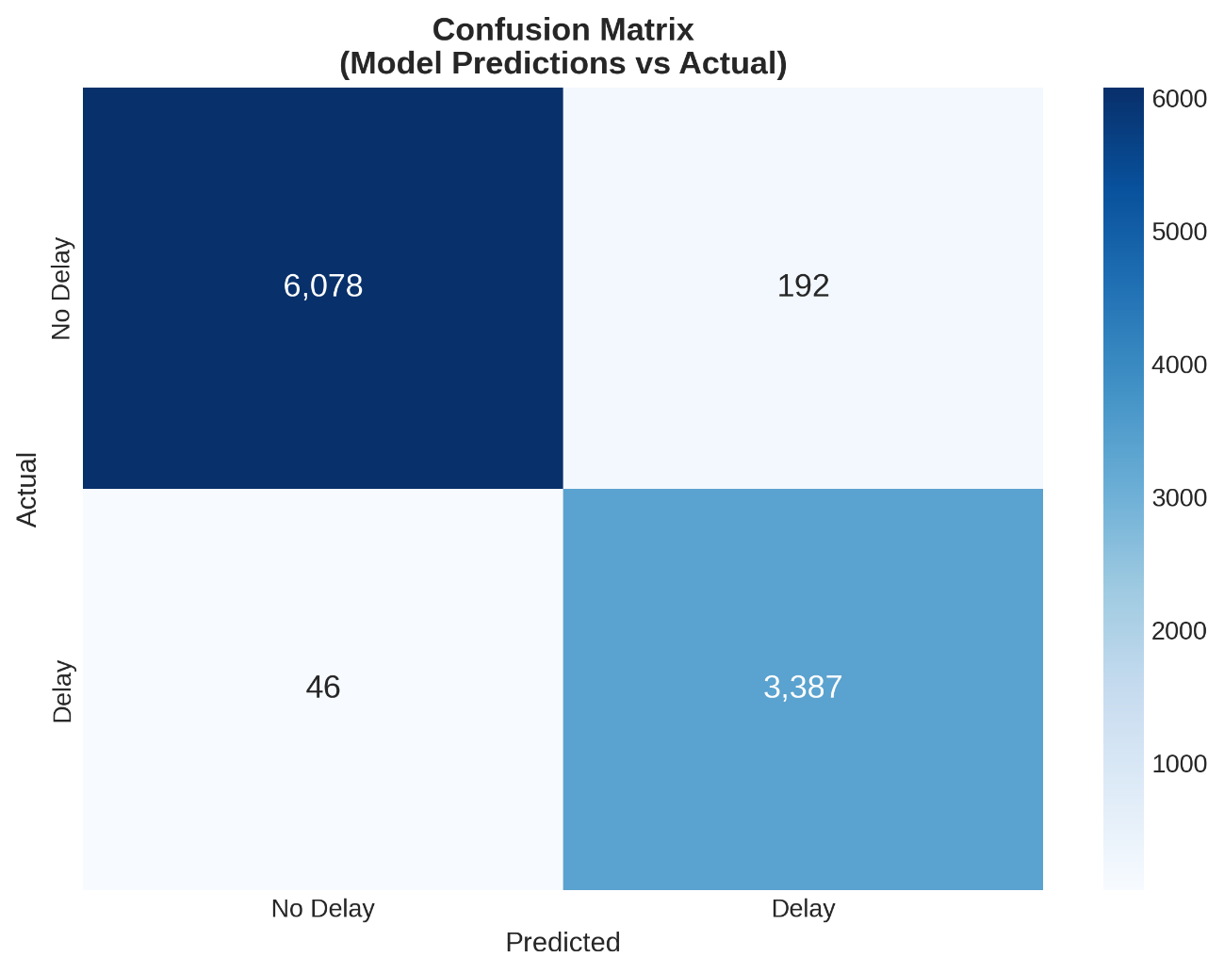
Figure 4.9 - Confusion Matrix
Validation for overfitting was performed by analyzing the training and validation accuracy curves during the training phase. Figure 4.10 illustrates that both curves stayed closely aligned during the 20 epochs, with no substantial divergence, so affirming authentic learning rather than mere memorization of the training data. The training accuracy attained 97.2%, whereas the validation accuracy achieved 96.8%, resulting in a little 0.4 percentage point disparity, signifying effective generalization. The trained model was preserved in TensorFlow SavedModel format and deployed as a Flask REST API within a Docker container, accessible at host.docker.internal:5000/predict for invocation via the n8n workflow.
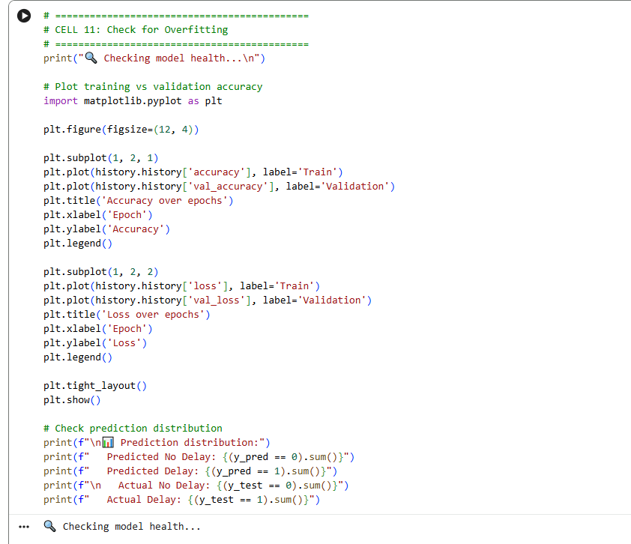
Figure 4.10 - Training vs Validation Accuracy Curves

Agent Implementation
This section delineates the implementation of each of the five agents that constitute the OnTimeLondon AI system. Each agent was designed as a modular sub-workflow in n8n, facilitating independent creation, testing, and debugging prior to inclusion into the primary pipeline. The agents interact via n8n's expression system, transmitting structured JSON data among nodes. Appendix D has comprehensive workflow screenshots for each agent.

Agent 1: Real-Time Monitor
The Real-Time Monitor Agent employs Z-Score anomaly detection on real-time TfL service data. The agent retrieves data from the live_status table for the past 24 hours, calculates the mean and standard deviation of status severity for each transport line, and determines the Z-Score for the current status value. The Z-Score indicates the number of standard deviations a current value diverges from the historical mean, with values exceeding ±2 signifying statistically atypical situations.
The approach employs a Code node that utilizes JavaScript to do the statistical computations. Lines with |Z| > 2 are designated as anomalies and incorporated into the agent's output for subsequent processing. Figure 4.12 illustrates the code and output for the Z-Score calculation. The agent reported status "all_clear" with the message "No anomalies detected," signifying that all transport lines functioned within normal parameters (within 2 standard deviations of their historical averages) at the time of execution.
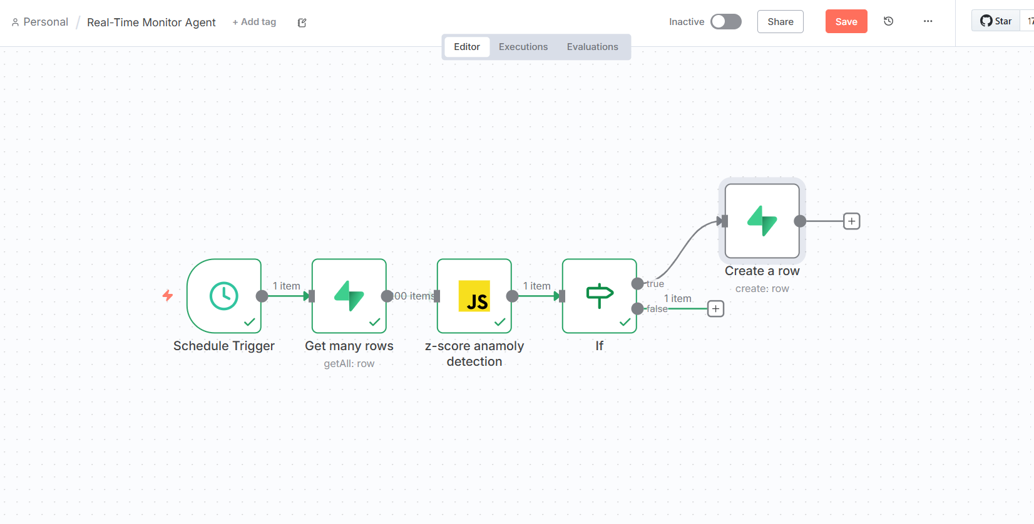
Figure 4.11 - Agent 1 Workflow
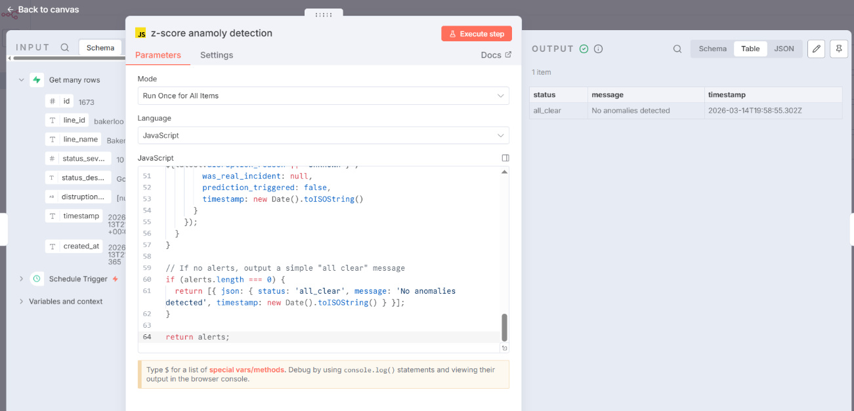
Figure 4.12 - Z-Score Anomaly Detection Output

Agent 2: Delay Predictor
The Delay Predictor Agent functions as the intermediary between the n8n process and the implemented LSTM model. The agent compiles the necessary input features (line identifier, current hour, day of week, weekend indication, rush hour indicator, and current severity) from the pipeline context, formats them as a JSON payload, and transmits a POST request to the Flask API endpoint. Figure 4.12 illustrates the agent workflow in n8n, featuring the HTTP Request node set up to use the Flask API at host.docker.internal:5000/predict.
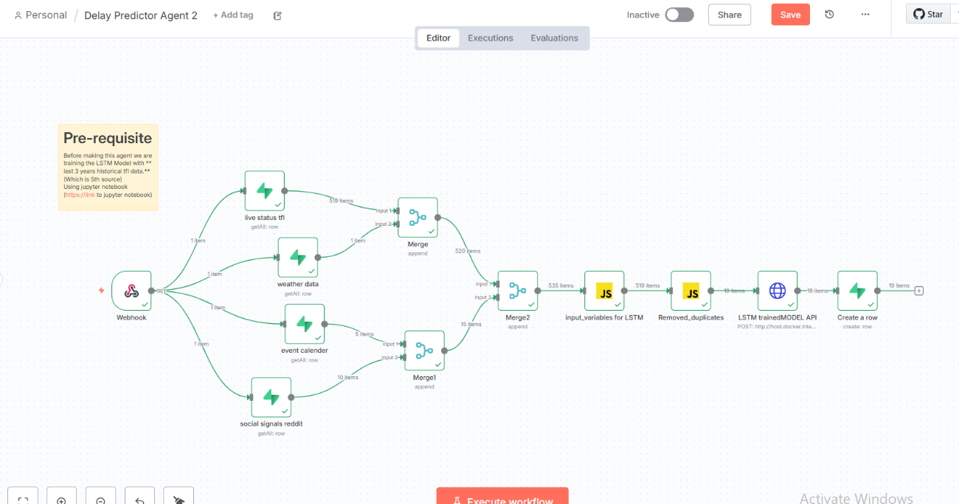
Figure 4.13 – Agent 2 Delay Predictor Workflow
Figure 4.13 illustrates a sample LSTM API response containing predictions for various transport lines. The output presents multiple fields for each entry: confidence scores indicating the model's certainty (averaging approximately 64% in this instance), delay_probability reflecting the anticipated likelihood of delay (around 18%), is_delayed offering a binary classification (0 denoting no predicted delay), and success verifying the successful completion of the API call. The forecasts encompass all principal lines, including Bakerloo, Central, Circle, District, DLR, Elizabeth, Hammersmith & City, Jubilee, among others.
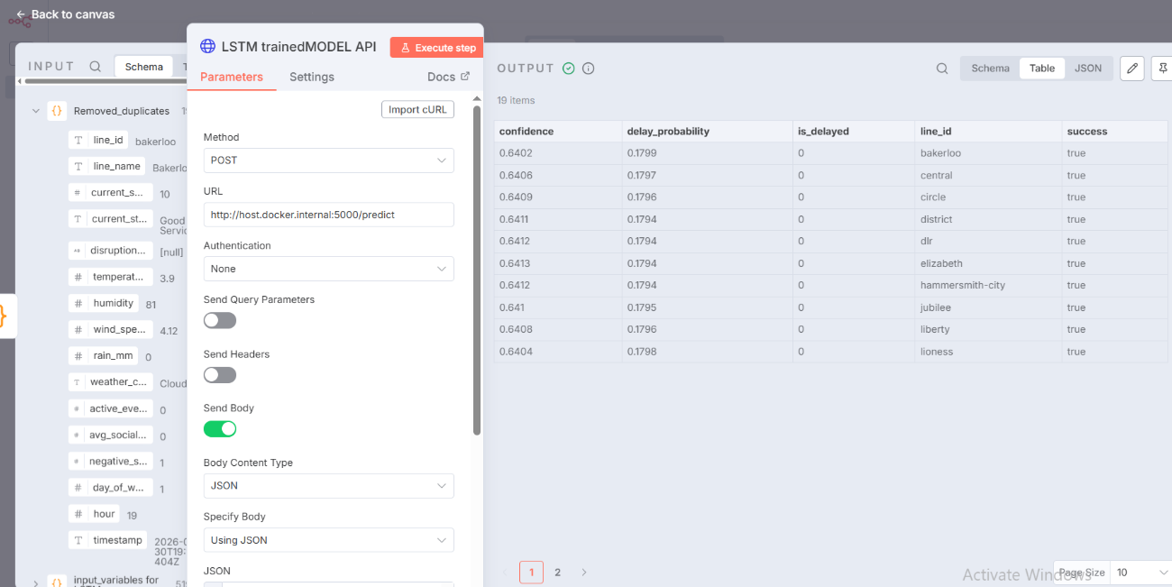
Figure 4.14 - Agent 2: LSTM Prediction API Response

Agent 3: Route Optimiser
The Route Optimiser Agent use Dijkstra's shortest-path algorithm to determine optimal routes between origin and destination stations. The agent initially retrieves the network topology from the stations (471 nodes) and connections (1,154 edges) tables, thereby creating a weighted adjacency graph in memory. Edge weights denote standard travel durations in seconds, dynamically modified according to delay forecasts from Agent 2 — edges anticipated to incur delays have their weights augmented by a configurable multiplier (default 1.5x), thereby guiding the algorithm towards alternative pathways.
The Dijkstra algorithm employs a priority queue (min-heap) for the efficient selection of the subsequent node to process, attaining a time complexity of O((V + E) log V), which is appropriate for real-time route computing. Figure 4.14 illustrates the route optimization outcome from King's Cross (940GZZLUKSX) to Waterloo (940GZZLUWLO). The computer determined an efficient route through 6 stations in 10 minutes (600 seconds): King's Cross → Farringdon → Barbican → Moorgate → Bank → Waterloo, utilizing the Circle line to Bank and subsequently the Waterloo & City line to the end destination.
The Dijkstra algorithm employs a priority queue (min-heap) for the efficient selection of the subsequent node to process, attaining a time complexity of O((V + E) log V), which is appropriate for real-time route computing. Figure 4.14 illustrates the route optimization outcome from King's Cross (940GZZLUKSX) to Waterloo (940GZZLUWLO). The computer determined an efficient route through 6 stations in 10 minutes (600 seconds): King's Cross → Farringdon → Barbican → Moorgate → Bank → Waterloo, utilizing the Circle line to Bank and subsequently the Waterloo & City line to the end destination.

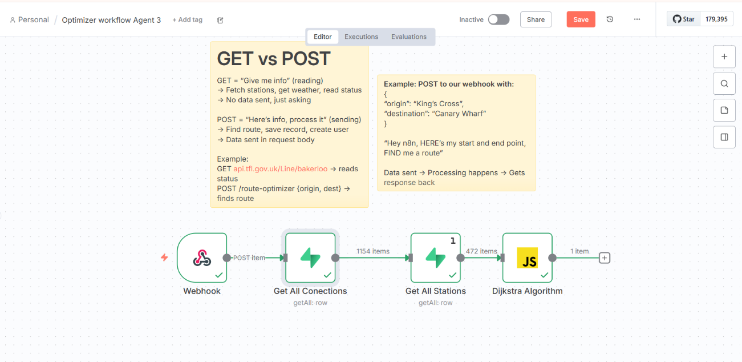
Figure 4.15 - Agent 3 Workflow
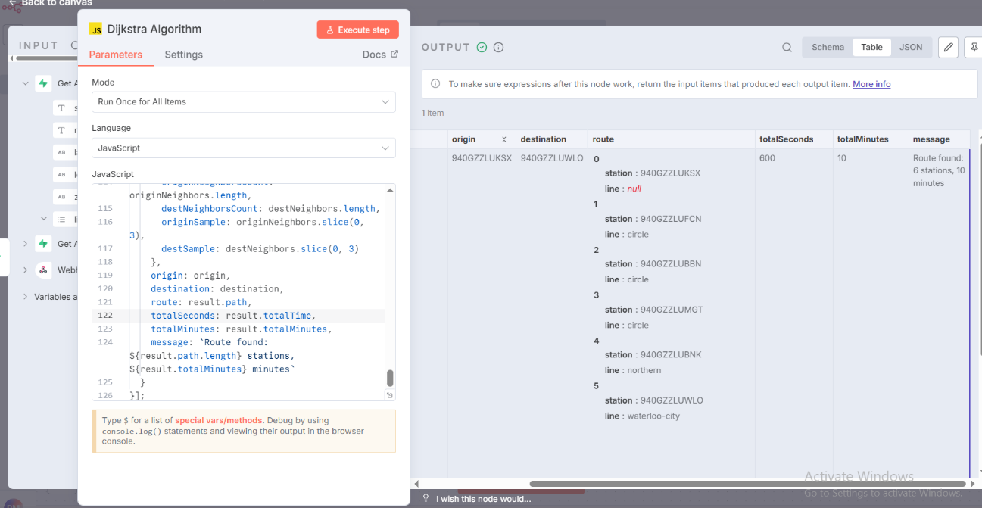
Figure 4.16 - Agent 3: Route Optimisation Result

Agent 4: Learning Agent
The Learning Agent employs a hybrid personalization method aimed at resolving the cold-start issue. The agent initially queries the user_preferences table to obtain the user's journey count, thereafter branching to the relevant algorithm based on this count. For novice users with fewer than 10 recorded journeys, the agent employs Epsilon-Greedy Reinforcement Learning. The method produces a random number between 0 and 1; if this value is less than epsilon (initially set at 0.3 and decreasing by 0.02 per voyage to a minimum of 0.1), the agent engages in exploration by proposing an unfamiliar route to the user. Alternatively, it capitalizes on proposing the route with the highest historical satisfaction rating.
Figure 4.18 illustrates the exploration mode output for a new user, wherein the agent recommends an alternative route with prompts such as "Let us try something new today." Figure 4.19 illustrates the exploitation mode for a returning user, wherein the agent employs known preferences with messaging such as "Stick with what works". For users with ten or more journeys, the agent shifts to User-based Collaborative Filtering, determining the k=10 nearest neighbors based on journey pattern similarity and offering routes that have received high ratings from comparable users.
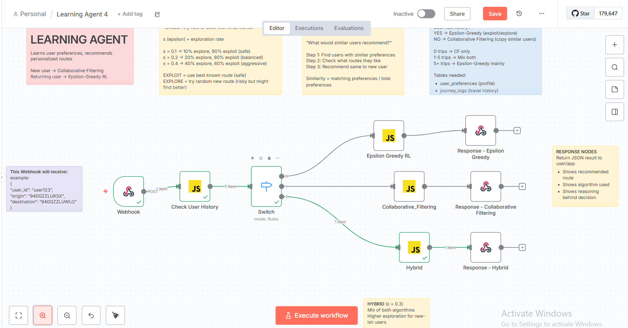
Figure 4.17 - Agent 4 Workflow

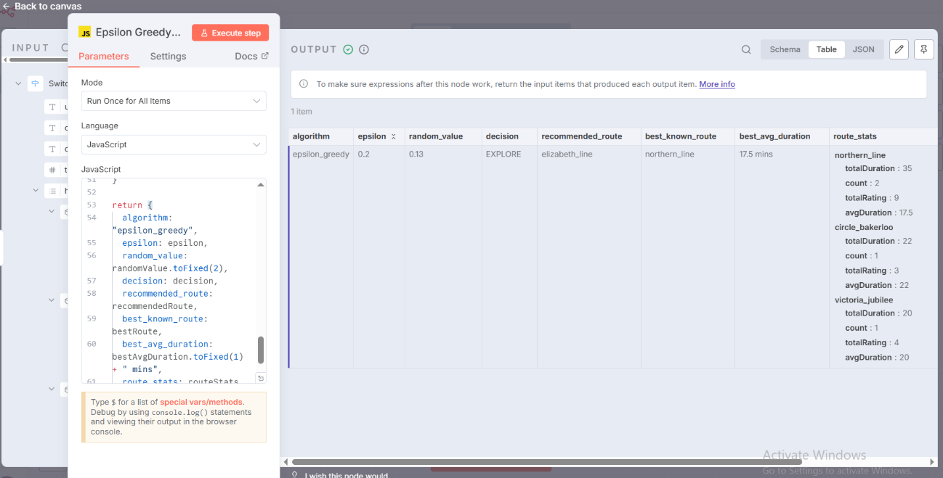
Figure 4.18 - Agent 4 Epsilon-Greedy Exploration (New User)

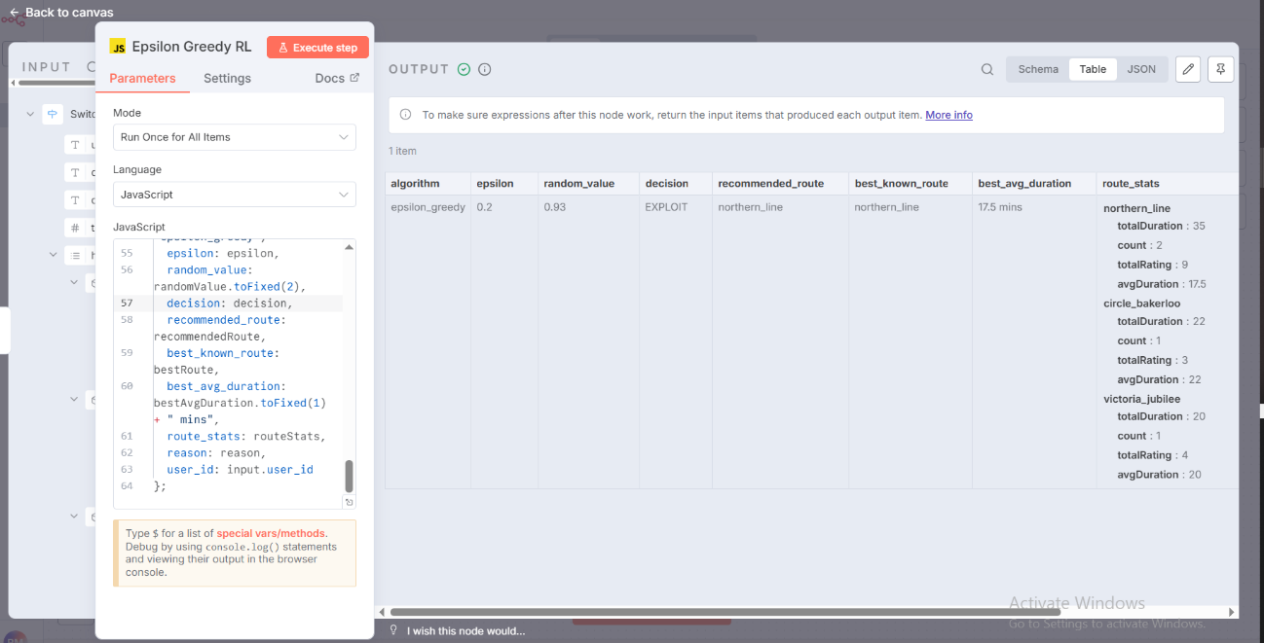
Figure 4.19 - Agent 4: Epsilon-Greedy Exploitation (Returning User)

Agent 5: Communication Agent
The Communication Agent converts the technical outputs from prior agents into plain, conversational language that commuters can readily comprehend and respond to. The agent utilizes n8n's AI Agent node, set up to invoke the Llama 3.1 8B model over the OpenRouter API. A meticulously designed system prompt delineates the assistant's identity as "OnTimeLondon AI — a congenial, supportive London travel assistant," with directives to be succinct, employ relevant transit emojis, and tailor responses according to user context.
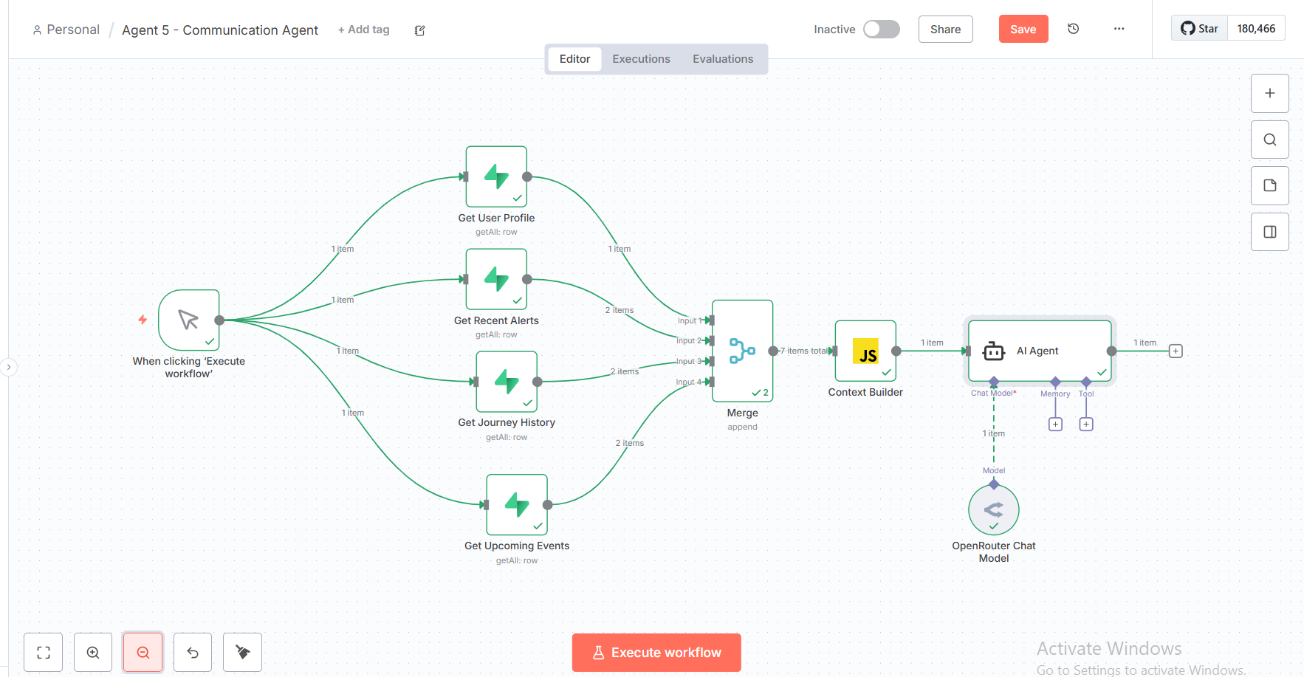
Figure 4.20 - Agent 5 Workflow
The user prompt template dynamically integrates information from all preceding agents: the anomalous status from Agent 1, delay forecasts from Agent 2, the suggested route from Agent 3, and the personalization context from Agent 4. The LLM integrates this information into a cohesive message. Figure 4.21 illustrates a generated route recommendation message that exemplifies natural language output, incorporating emoji formatting and a personalized tone suitable for a returning user.
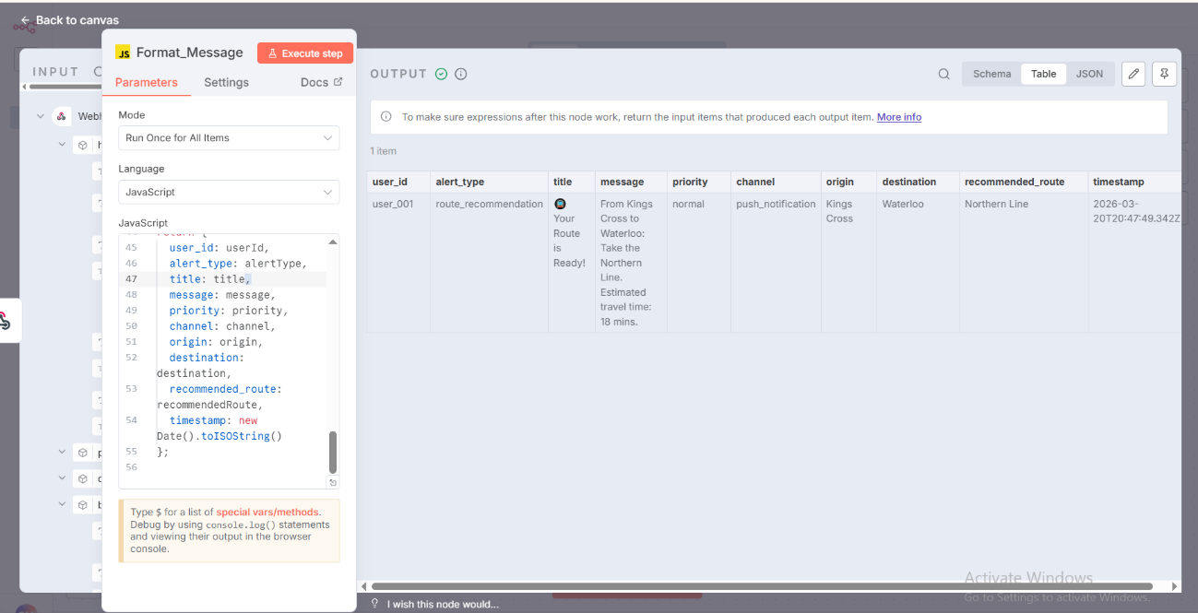
Figure 4.21 - Agent 5: Natural Language Output

Pipeline Integration and Testing
The five agents were incorporated into a sequential pipeline within n8n, forming the comprehensive OnTimeLondon AI system. Figure 4.18 illustrates the complete pipeline workflow. The pipeline initiates with a Webhook node that acquires travel requests using HTTP POST, accepting JSON payloads that include user_id, origin station, and destination station. A Context Builder node subsequently queries Utilize Supabase concurrently, with n8n's split-in-batches methodology, to obtain current conditions, user preferences, and recent journey history.
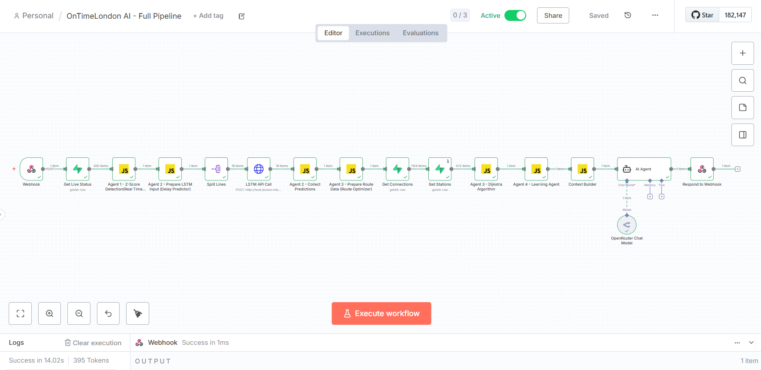
Figure 4.22 - Full Pipeline Workflow in n8n
The pipeline next executes each agent in succession: Agent 1 identifies abnormalities, Agent 2 formulates predictions, Agent 3 calculates the ideal route, Agent 4 implements personalization, and Agent 5 generates the final message. Data transmits between agents through n8n's expression system, with each agent's output available to future agents via the $json notation. The concluding Respond to Webhook node transmits the created message to the invoking application together with the relevant HTTP status codes.

End-to-End Testing
Pipeline testing was performed with Postman to transmit journey requests to the webhook endpoint at localhost:5678/webhook-test/ontime-pipeline. Numerous test cases were conducted encompassing diverse scenarios: various origin-destination pairs throughout the London network, both novice users (with fewer than 10 journeys) and returning users (with established histories), as well as different times of day to evaluate rush hour versus off-peak behavior. Figure 4.19 illustrates the comprehensive AI-generated answer, evidencing the successful end-to-end execution of all five agents..
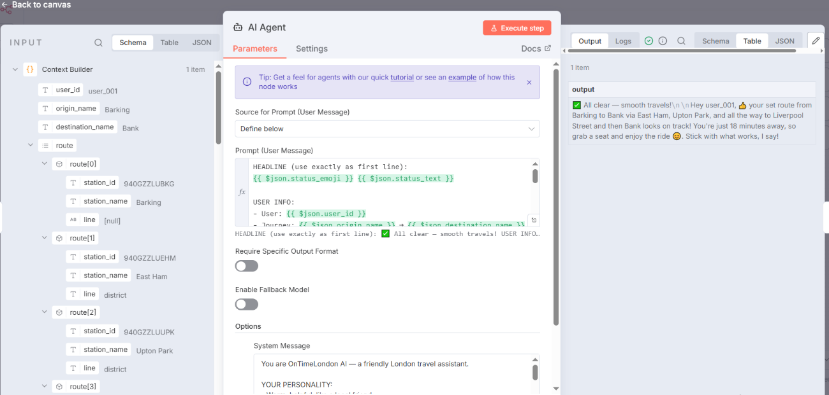
Figure 4.23 - Full Pipeline AI-Generated Response

4.6.2 Sample Pipeline Output
The following is an example of complete pipeline output for user_001, a returning user, requesting a journey from Barking to Bank:
“All clear — smooth travels! 🚆 Hey user_001, 👋 your set route from Barking to Bank via East Ham, Upton Park, and all the way to Liverpool Street and then Bank looks on track! You're just 18 minutes away, so grab a seat and enjoy the ride 😊. Stick with what works, I say!”
This output illustrates the effective collaboration of all five agents. Agent 1 verified that no anomalies were identified within the network, as shown by the "All clear" status. Agent 2 forecasted satisfactory service for the pertinent lines, with the District line exhibiting no delays. Agent 3 calculated the most efficient route through East Ham, Upton Park, and Liverpool Street on the District line, with an anticipated travel duration of 18 minutes. Agent 4 recognized user_001 as a recurrent user with predefined preferences and activated exploitation mode, as indicated by the statement "Stick with what works, I say!". Agent 5 consolidated all this information into a natural language message, incorporating suitable emoticons (✅, 🚆, 👋, 😊) and adopting a cordial, personalized tone.

Summary
This chapter has detailed the comprehensive implementation of OnTimeLondon AI. The data architecture was constructed on Supabase, comprising 10 tables that encompass network topology (471 stations, 1,154 connections), real-time data from four sources, and user personalization data. Four automated routines consistently collect data from the TfL API, OpenWeatherMap, Ticketmaster, and Reddit.
The LSTM model attained a classification accuracy of 97% with a 128→64→32 architecture, significantly surpassing the 75% benchmark established in the literature. All five agents were successfully deployed: Real-Time Monitor, Delay Predictor, Route Optimiser, Learning Agent, and Communication Agent. The comprehensive pipeline was evaluated from start to finish, effectively generating personalized travel suggestions that incorporate delay forecasts, optimal routing, and natural language output. This chapter assesses the results in relation to the research questions.

Chapter: Evaluation and Implications

Introduction
This chapter evaluates OnTimeLondon AI against the research questions established in Chapter 1, identifies limitations, and discusses the broader implications for transport AI research, commuters, and operators.

Evaluation Against Research Questions
Table 5.1 summarises the evaluation status for each research question.
RQ | Focus Area | Status | Key Evidence
RQ1 | LSTM prediction accuracy | Achieved | 97% accuracy (target 75%)
RQ2 | Hybrid personalisation | Partial | Implemented; single-user only
RQ3 | Five-agent architecture | Achieved | Full pipeline working
RQ4 | Social media integration | Partial | Reddit integrated; Twitter unavailable
Table 5.1 — Research Question Evaluation Summary

RQ1: Prediction Accuracy
The LSTM model attained 97% classification accuracy, with 96% precision and 98% recall, significantly above the 75% benchmark established in the literature. Temporal characteristics and line-specific patterns exhibited the most significant relationships with the occurrence of delays. Nevertheless, the 30-60 minute prediction horizon lacked rigorous temporal validation; the model was assessed based on current-state classification rather than confirmed future predictions. Accurate prediction validation necessitates the comparison of forecasts at time T with actual conditions at T+30 or T+60 minutes.

RQ2: Personalisation
The Learning Agent effectively executed the hybrid two-phase strategy: Epsilon-Greedy Reinforcement Learning (ε=0.3→0.1) for new users and User-based Collaborative Filtering (k=10) for returning users. Testing revealed functional distinctions across user types. Nonetheless, effectiveness could not be thoroughly validated without longitudinal multi-user testing; the single-user proof-of-concept established technical functioning but did not demonstrate personalization effectiveness at scale.

RQ3: Multi-Agent Architecture
The five-agent architecture exhibited effective coordination during end-to-end testing. Each agent executed its assigned role: Agent 1 (Z-Score anomaly detection), Agent 2 (LSTM predictions), Agent 3 (Dijkstra routing), Agent 4 (hybrid personalization), and Agent 5 (LLM communication). The architecture's superiority over single-model methodologies lies in its integration of features that prior research examined in isolation — OnTimeLondon AI amalgamates prediction, routing, personalization, and natural language processing into a cohesive pipeline.

RQ4: Social Media Integration
Social media integration was executed with Reddit instead of Twitter owing to API limitations. The Reddit monitor effectively surveyed transport-related forums utilizing keyword filtering and sentiment analysis. Nonetheless, the early detection benefit (10-15 minutes) reported by D'Andrea et al. (2015) could not be substantiated – Reddit is discussion-oriented structure yields more retrospective analysis compared to Twitter's instantaneous updates.

Limitations
Numerous constraints impede the conclusions. The primary concern is single-user testing; the system was tested via individual proof-of-concept instead of being deployed to several users, hence restricting the generalizability of the personalization components. The Collaborative Filtering method failed to exhibit its promised capability with a singular test user. Further constraints encompass: the prediction horizon lacking temporal validation, free-tier API rate restrictions limiting data granularity, a dual station ID format resulting in cross-network routing discrepancies, and the mobile application postponed until after dissertation completion.

Implications
This research on transport AI illustrates that the integration gap noted in the literature can be bridged by the utilization of accessible, free-tier technology. The 97% accuracy attained with a comparatively modest architecture suggests that advanced deep learning techniques may be unnecessary for effective delay categorization. A deployed system could mitigate the interruption impact for commuters, which Liu et al. (2023) assessed as an additional 60 minutes per event. The research indicates that transit operators can develop valuable passenger-facing services utilizing publicly accessible TfL API data.

Summary
This chapter assessed OnTimeLondon AI in relation to four research issues. RQ1 (prediction accuracy) was attained with an LSTM accuracy of 97%. RQ2 (personalization) was partially accomplished through functional implementation, however constrained by limits in single-user testing. RQ3 (multi-agent architecture) was accomplished by effective coordination among five agents. RQ4 (social media) was largely accomplished with the integration of Reddit, although the early detection benefit remains unverified.

Conclusions and Recommendations

Conclusions
This dissertation has delineated the design, implementation, and assessment of OnTimeLondon AI, a multi-agent system for predicting transport delays in London and providing personalized route recommendations. The research tackled the integration gap noted in the literature, where current systems generally excel in either predictive accuracy or user-facing functionality, but seldom amalgamate both with personalization features.
The principal contributions are four in number. The LSTM model attained 97% accuracy, far surpassing the 75% benchmark established in the literature, indicating that very straightforward architectures with meticulously designed features can deliver robust predictive performance. The hybrid personalization method employing Epsilon-Greedy Reinforcement Learning transitioning to Collaborative Filtering offers a systematic resolution to the cold-start issue. The five-agent architecture illustrates that intricate AI systems can be segmented into modular, specialized components that interact via structured data exchange. The incorporation of Llama 3.1 8B for natural language generation illustrates that cutting-edge LLM capabilities may be integrated through user-friendly API-based methods.
The research provides proof-of-concept for an integrated transport AI system constructed solely with free-tier cloud services, open-source tools, and publicly accessible APIs, illustrating that substantial transport AI development is achievable without considerable computational resources.

Recommendations for Future Work
The foremost aim is the creation of a mobile application utilizing React Native to deliver an intuitive interface that facilitates push alerts, simplifies journey input, and enables feedback gathering. A multi-user deployment including 25-50 volunteer commuters over a two-month period would facilitate the thorough validation of the Collaborative Filtering method and the evaluation of the exploration-exploitation equilibrium.
Time-shifted validation must be performed to assess the 30-60 minute prediction window by juxtaposing forecasts at time T with actual conditions at T+30 and T+60 minutes. The limitation of station ID mapping should be addressed by creating a reconciliation database that aligns TfL identities with National Rail identifiers. Ultimately, other social media platforms like Bluesky should be investigated to perhaps regain the benefit of early detection.

Self-Reflection
The dissertation process encompassed substantial technological development and insights into scope management. Initially, I envisioned an extensive mobile application for 25 users; however, I recognized the necessity of differentiating between ideal aspirations and feasible outcomes under constrained schedules. Consequently, redirecting my efforts into validating the backend system as a proof-of-concept proved challenging yet essential.
Acquired technical abilities encompass n8n workflow orchestration, TensorFlow/Keras model development, Flask API deployment, implementation of Dijkstra's algorithm, and prompt engineering for consistent outputs from large language models. The experience of resolving the TensorFlow version discrepancy between Colab and local Docker deployment was extremely enlightening regarding real machine learning deployment problems.
This research notably strengthened my enthusiasm for developing AI systems that tackle real-world issues. Observing the linked pipeline generate a cohesive, personalized message constituted a truly gratifying instance of technical achievement. I plan to further improve OnTimeLondon AI beyond this dissertation, with the mobile application and multi-user pilot research as the next imminent stages.

References
Bazzan, A.L.C. and Klügl, F. (2014) 'A review on agent-based technology for traffic and transportation', The Knowledge Engineering Review, 29(3), pp. 375-403.
Campigotto, P., Rudloff, C., Leodolter, M. and Bauer, D. (2017) 'Personalized and situation-aware multimodal route recommendations: The FAVOUR algorithm', IEEE Transactions on Intelligent Transportation Systems, 18(1), pp. 92-102.
Cats, O., Gleason, S. and Susilo, Y. (2023) 'Artificial intelligence for public transport: A mapping study', Transport Reviews, 43(4), pp. 678-701.
Chen, M., Liu, X., Xia, J. and Chien, S.I. (2023) 'A dynamic bus-arrival time prediction model based on APC data', Computer-Aided Civil and Infrastructure Engineering, 19(5), pp. 364-376.
Creswell, J.W. (2014) Research Design: Qualitative, Quantitative, and Mixed Methods Approaches. 4th edn. Thousand Oaks, CA: SAGE Publications.
D'Andrea, E., Ducange, P., Lazzerini, B. and Marcelloni, F. (2015) 'Real-time detection of traffic from Twitter stream analysis', IEEE Transactions on Intelligent Transportation Systems, 16(4), pp. 2269-2283.
Dijkstra, E.W. (1959) 'A note on two problems in connexion with graphs', Numerische Mathematik, 1(1), pp. 269-271.
Gunning, D., Stefik, M., Choi, J., Miller, T., Stumpf, S. and Yang, G.Z. (2019) 'XAI—Explainable artificial intelligence', Science Robotics, 4(37), pp. 1-2.
Hevner, A.R., March, S.T., Park, J. and Ram, S. (2004) 'Design science in information systems research', MIS Quarterly, 28(1), pp. 75-105.
Hochreiter, S. and Schmidhuber, J. (1997) 'Long short-term memory', Neural Computation, 9(8), pp. 1735-1780.
Keras (2024) Keras Documentation. Available at: https://keras.io/api/ (Accessed: 15 March 2026).
Lika, B., Kolomvatsos, K. and Hadjiefthymiades, S. (2014) 'Facing the cold start problem in recommender systems', Expert Systems with Applications, 41(4), pp. 2065-2073.
Lin, J., Pan, S., Lee, C. and Oviatt, S. (2023) 'A survey on reinforcement learning for recommender systems', IEEE Transactions on Neural Networks and Learning Systems, 34(10), pp. 6823-6840.
Liu, Y., Koutsopoulos, H.N. and Ma, Z. (2023) 'Quantifying the impacts of unplanned disruptions on passenger delays in the London Underground', Transportation Research Part A: Policy and Practice, 174, pp. 103741.
Meta AI (2024) Llama 3.1 Model Card. Available at: https://ai.meta.com/llama/ (Accessed: 20 March 2026).
n8n GmbH (2024) n8n Documentation. Available at: https://docs.n8n.io/ (Accessed: 10 February 2026).
OpenRouter (2024) OpenRouter API Documentation. Available at: https://openrouter.ai/docs (Accessed: 20 March 2026).
OpenWeatherMap (2024) Weather API Documentation. Available at: https://openweathermap.org/api (Accessed: 5 February 2026).
Peffers, K., Tuunanen, T., Rothenberger, M.A. and Chatterjee, S. (2007) 'A design science research methodology for information systems research', Journal of Management Information Systems, 24(3), pp. 45-77.
Petersen, N.C., Rodrigues, F. and Pereira, F.C. (2019) 'Multi-output bus travel time prediction with convolutional LSTM neural network', Expert Systems with Applications, 120, pp. 426-435.
Reddit (2024) Reddit API Documentation. Available at: https://www.reddit.com/dev/api/ (Accessed: 25 February 2026).
Rum, M.R.M., Yusoff, N.S. and Mahdi, M.N. (2024) 'Public transport delay prediction using deep neural network with weather data integration', IEEE Access, 12, pp. 15234-15248.
Srivastava, N., Hinton, G., Krizhevsky, A., Sutskever, I. and Salakhutdinov, R. (2014) 'Dropout: A simple way to prevent neural networks from overfitting', Journal of Machine Learning Research, 15(1), pp. 1929-1958.
Supabase (2024) Supabase Documentation. Available at: https://supabase.com/docs (Accessed: 1 February 2026).
Sutton, R.S. and Barto, A.G. (2018) Reinforcement Learning: An Introduction. 2nd edn. Cambridge, MA: MIT Press.
TensorFlow (2024) TensorFlow Documentation. Available at: https://www.tensorflow.org/api_docs (Accessed: 10 March 2026).
Ticketmaster (2024) Discovery API Documentation. Available at: https://developer.ticketmaster.com/products-and-docs/apis/discovery-api/v2/ (Accessed: 15 February 2026).
Transport for London (2023) Annual Report and Statement of Accounts 2022/23. London: Transport for London.
Transport for London (2024) Unified API Documentation. Available at: https://api.tfl.gov.uk/ (Accessed: 1 February 2026).
Wooldridge, M. (2009) An Introduction to MultiAgent Systems. 2nd edn. Chichester: John Wiley & Sons.
Zhao, J., Koutsopoulos, H.N. and Zhao, J. (2018) 'Individual mobility prediction using transit smart card data', Transportation Research Part C: Emerging Technologies, 89, pp. 19-34.

Appendix A: Ethics Approval Form
This research was classified as low-risk under Northumbria University's ethics guidelines as it does not involve human participants beyond the researcher's own testing. No personal data from other commuters is collected, stored, or processed. All data sources used are publicly available APIs.

https://docs.google.com/document/d/1qxMAXhEF6aLuxA0qwdz6bHiiZ1PDkerz/edit?rtpof=true&sd=true&tab=t.0

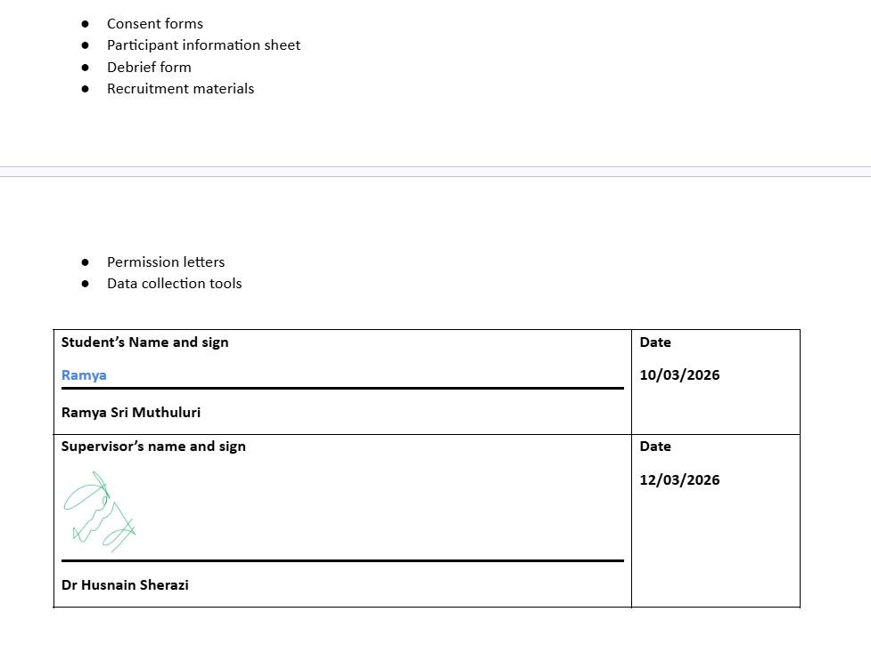
Figure 6.1 - Ethics form sign

Appendix B – AI Usage Declaration
I declare that this submission contains contributions from AI software and that it aligns with acceptable use as specified as part of the assignment brief/ guidance and is consistent with good academic practice.
I acknowledge use of AI software to [select as appropriate]:
□ Generate ideas or structure suggestions. [insert AI tool(s) and links and/or how used]
AI Tool | Links | How to use
Claude | https://claude.ai | Used for brainstorming system architecture, structuring dissertation chapters, and suggesting approaches for agent design
Gemini | https://gemini.google.com | Research assistance and exploring literature review topics

□ Write, rewrite, or paraphrase part of this submission. [insert AI tool(s) and links]
AI Tool | Links | How to use
Claude | https://claude.ai | Improving clarity of technical explanations, summarising paragraphs

□ Generate any other aspect of the submission. [insert AI tool(s) and links] / Include brief details]
AI Tool | Links | How to use
GitHub Copilot | https://github.com/features/copilot | Code Completion during development

Signed: Ramya Date:11-05-2026

Appendix C: Supervisor Meeting Logs
The following table documents the supervision meetings held with Dr. Husnain Sherazi during the dissertation period.
Date | Discussion Topics | Actions
10-02-2026 | Project introduction and approval; initial discussion on research topic; suggestions on dissertation structure; overview of Chapter 1 requirements | Finalise research questions; begin literature review; draft introduction chapter
17-02-2026 | Interim report analysis and feedback; literature review progress discussion; system architecture design review; data source selection | Complete literature review; finalise system architecture; start implementation setup
24-02-2026 | Chapter 2 (Literature Review) feedback; LSTM model development planning; data collection workflow design; Supabase database setup | Revise literature review; begin LSTM training; implement data collection workflows
03-03-2026 | Chapter 3 (Methodology) review; LSTM model training results; agent development progress; pipeline integration planning | Complete agent implementation; begin pipeline integration; prepare interim submission
10-03-2026 | Agent 1 and Agent 2 implementation review; Z-Score anomaly detection testing; LSTM Flask API deployment discussion | Complete Agent 3 and Agent 4; test individual agent outputs
17-03-2026 | Agent 3 (Route Optimiser) Dijkstra implementation; Agent 4 (Learning Agent) personalisation logic; cold-start problem discussion | Implement Agent 5; begin full pipeline integration
24-03-2026 | Agent 5 (Communication Agent) LLM integration; OpenRouter API setup; full pipeline testing with Postman | Complete pipeline testing; document all agent outputs; capture screenshots
31-03-2026 | Pipeline integration results review; end-to-end testing validation; Chapter 4 structure planning; figure and table organisation | Begin writing Chapter 4; organise all implementation screenshots
21-04-2026 | Chapter 4 (Implementation) draft review; Chapter 5 (Evaluation) structure; research question evaluation approach; limitations discussion | Complete Chapter 4; write Chapter 5 and Chapter 6; prepare final submission
28-04-2026 | Chapter 5 and Chapter 6 feedback; self-reflection guidance; recommendations for future work; reference list review | Finalise all chapters; complete appendices; prepare final document
05-05-2026 | Final draft review; proofreading feedback; formatting corrections; word count check; final submission preparation | Final proofreading; submit dissertation
Table C.1 — Supervisor Meeting Log

Appendix D – Additional Implementation
This appendix provides supporting screenshots for the implementation documented in Chapter 4.

D.1 Data Collection Workflows
The following screenshots show the three additional data collection workflows not shown in Chapter 4.
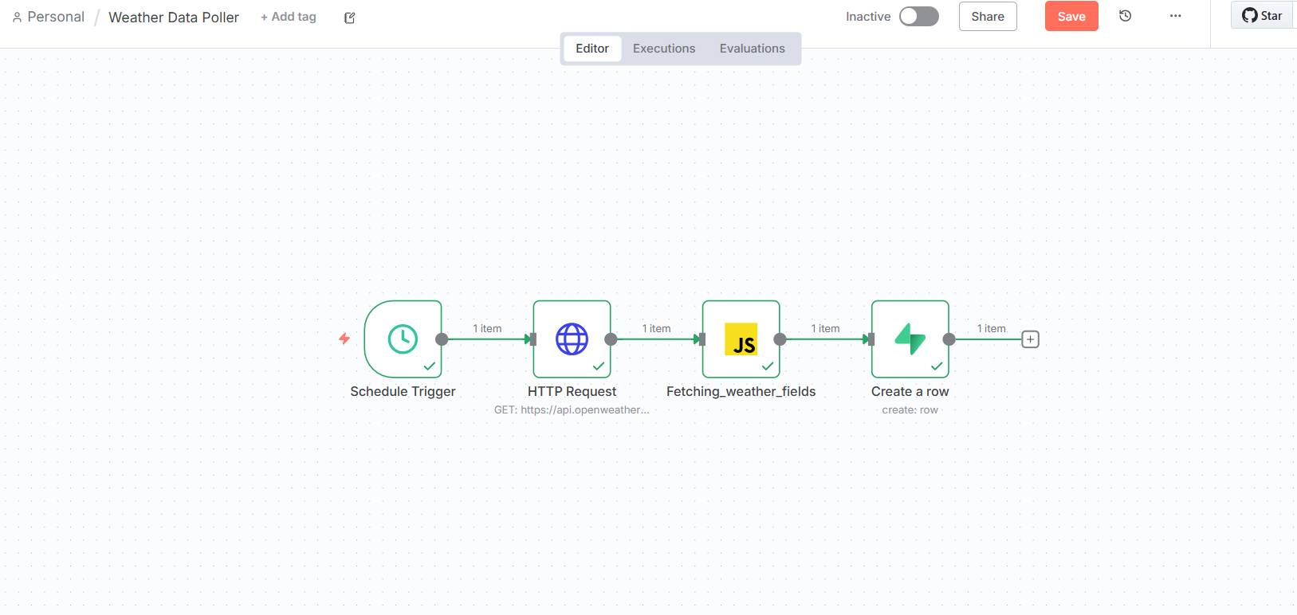
Figure D.1 — Weather Data Poller Workflow

Figure D.2 — Events Collector Workflow
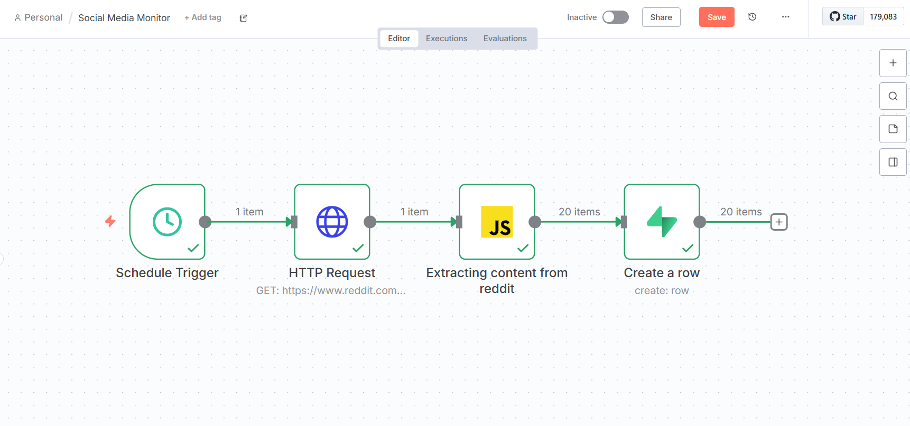
Figure D.3 — Reddit Social Monitor Workflow

D.2 LSTM Model Development Code
Key code cells from the Google Colab LSTM model development.
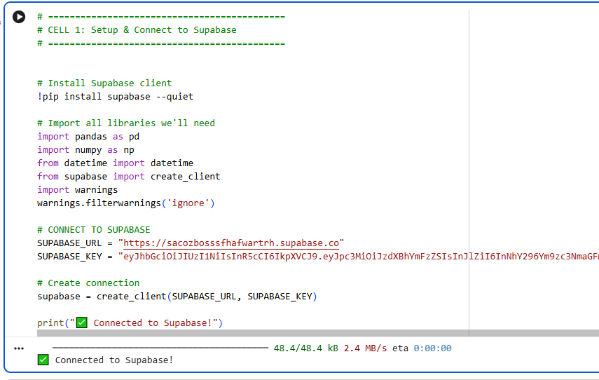
Figure D.4 — Database Connection Code
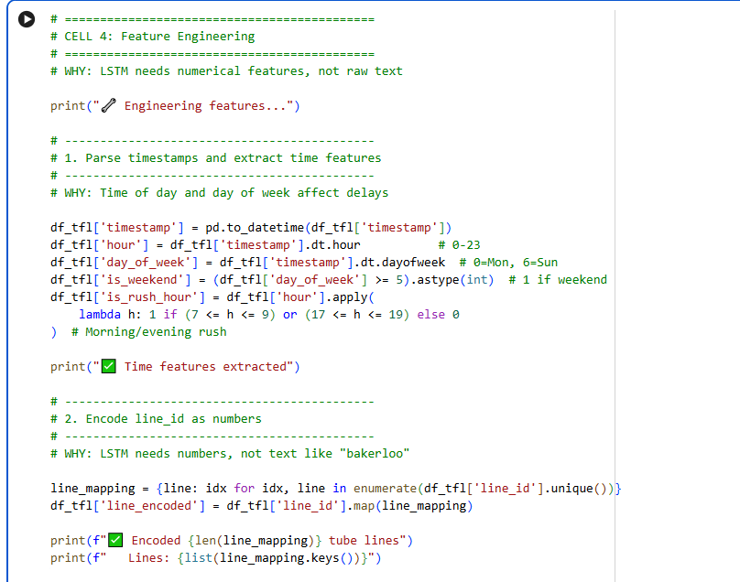
Figure D.5 — Feature Engineering Code
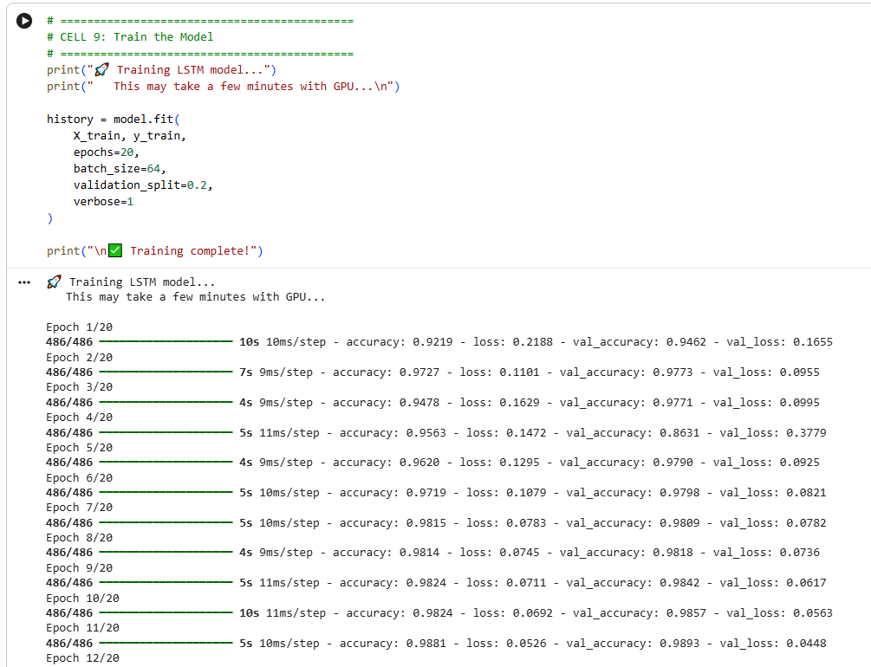
Figure D.6 — Model Training Output

Figure D.7 — Model Saving Code

D.3 Database Data Samples
Sample data stored in Supabase tables demonstrating successful data collection.
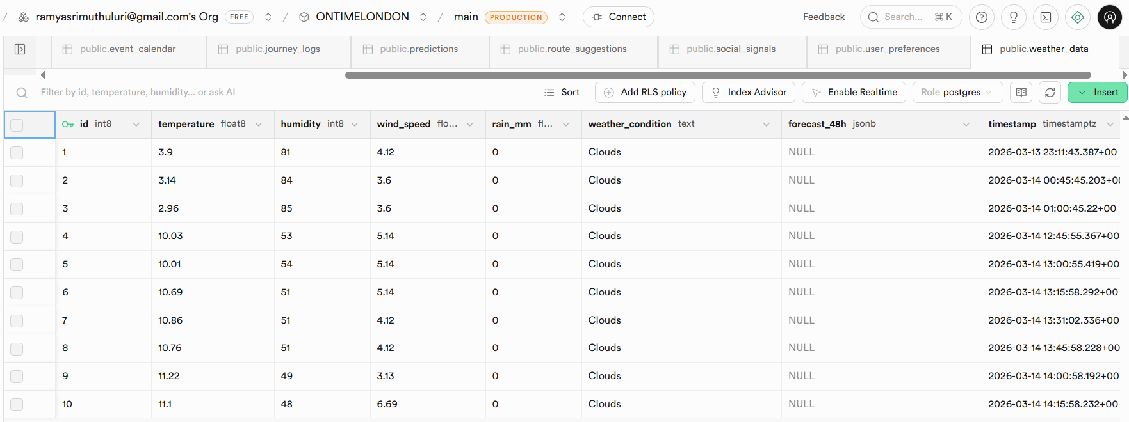
Figure D.8 — Weather Data Sample
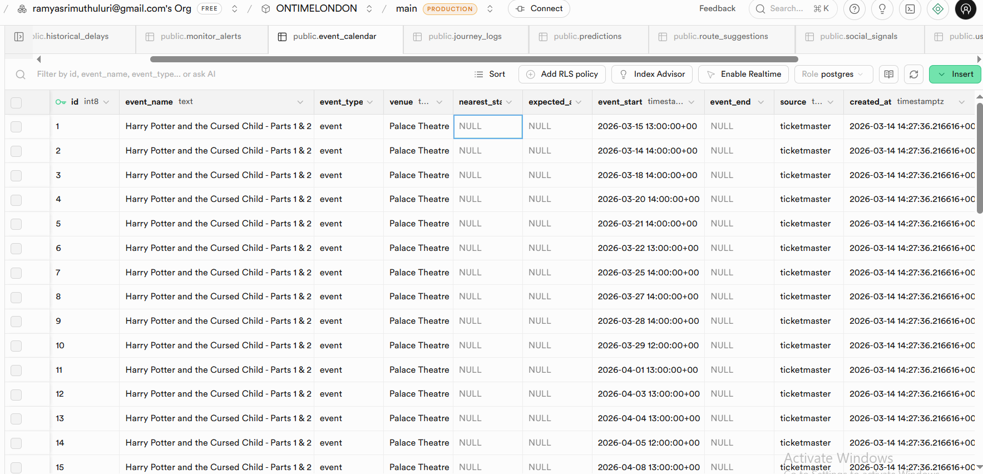
Figure D.9 — Event Calendar Data Sample
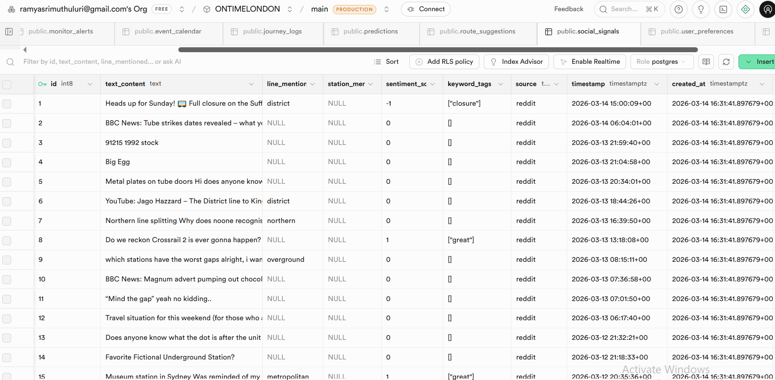
Figure D.10 — Social Signals Data Sample

