Report

Of
DEVOPS ENGINEER INTERNSHIP:
MULTI-CLOUD & AI PLATFORM ENABLEMENT ACROSS
CLAUDE, AWS, AZURE AND SNOWFLAKE
Submitted To
School of Computer Science and Engineering
IILM University, Greater Noida, U.P.
In partial fulfilment of the requirement of degree of
B.Tech CSE

By
Roll Number of Student: CS-2341452
Name of Student: MOON RATHI
Batch: 2026-27 (Section: 4CSE8)
CANDIDATE'S DECLARATION
I, Moon Rathi, do hereby declare that the internship report titled "DevOps Engineer Internship: Multi-Cloud & AI Platform Enablement Across Claude, AWS, Azure and Snowflake" has been completed by me to fulfil the requirement for the award of the degree of Bachelor of Technology in Computer Science and Engineering. All the references have been quoted and I have not taken as such any material from any other source. I affirm that this report is my own and has not been submitted to any other institute for any degree/diploma requirement, and further I shall be solely responsible for any kind of copyright violation in this regard.

Student Name: Moon Rathi
Roll No.: CS-2341452

ACKNOWLEDGEMENT
I am using this opportunity to express my gratitude to everyone who supported me throughout the Internship Program. I am thankful for their aspiring guidance, invaluably constructive criticism and friendly advice during this work. I am sincerely grateful to them for sharing their truthful and illuminating views on a number of issues related to this work.
I would like to express my sincere thanks to Mactores Cognition Private Limited for giving me the opportunity to intern as a DevOps Engineer (Intern), and to my mentors and the HR & Operations team at the organisation for their continuous support and guidance throughout the internship period.
I also extend my heartfelt thanks to the faculty of the School of Computer Science and Engineering, IILM University, Greater Noida, for their constant encouragement, valuable inputs and support during the course of this internship.

Student Name: Moon Rathi
Roll No.: CS-2341452

CHAPTER 3: INTERNSHIP CERTIFICATE & SUPPORTING CREDENTIALS
This chapter presents three distinct categories of supporting evidence: (a) the Internship Offer Letter issued at the start of the internship (Section 3.1); (b) the industry credentials earned during the internship as direct evidence of the project work described in Chapter 4 (Sections 3.2–3.4); and (c) the final Internship Completion Certificate, which is a separate document issued by Mactores only upon conclusion of the internship (Section 3.5).
3.1 Internship Offer Letter — Mactores Cognition Private Limited
Below is the official Internship Offer Letter issued by Mactores Cognition Private Limited (CIN: U72900MH2017PTC295824), signed by Dhwani Thakkar (HR Manager) and Tejas Pawar (Sr. Operations Manager), appointing Moon Rathi as DevOps Engineer (Intern) for a 3-month internship period commencing June 17, 2026. This letter confirms the internship engagement itself and is distinct from the project credentials and completion certificate presented below.
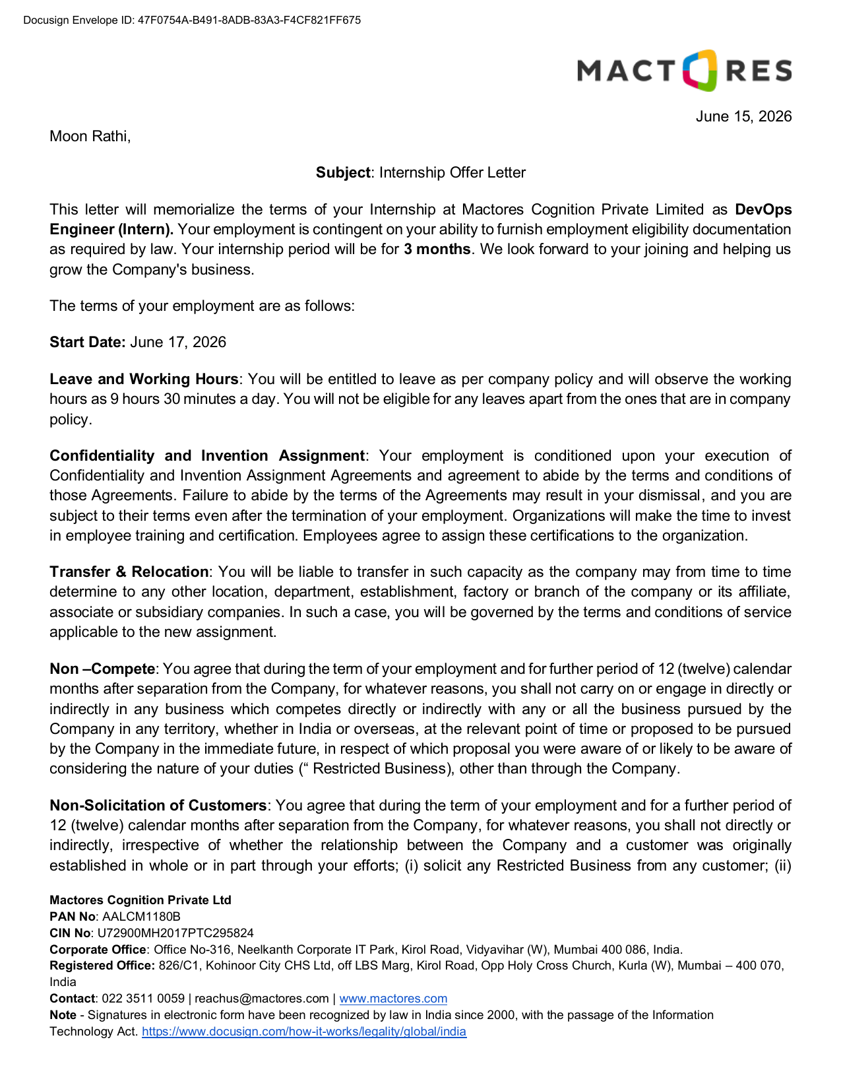
Fig 3.1 — Mactores Internship Offer Letter (Page 1 of 5)
3.2 Claude Certified Architect – Foundations (Project 1 Deliverable, Earned During Internship)
The credential below was earned during the internship period and issued by Anthropic via Credly on August 26, 2026, confirming successful completion of the Claude Certified Architect – Foundations examination. This is direct evidence of the Project 1 work undertaken and described in Section 4.8.
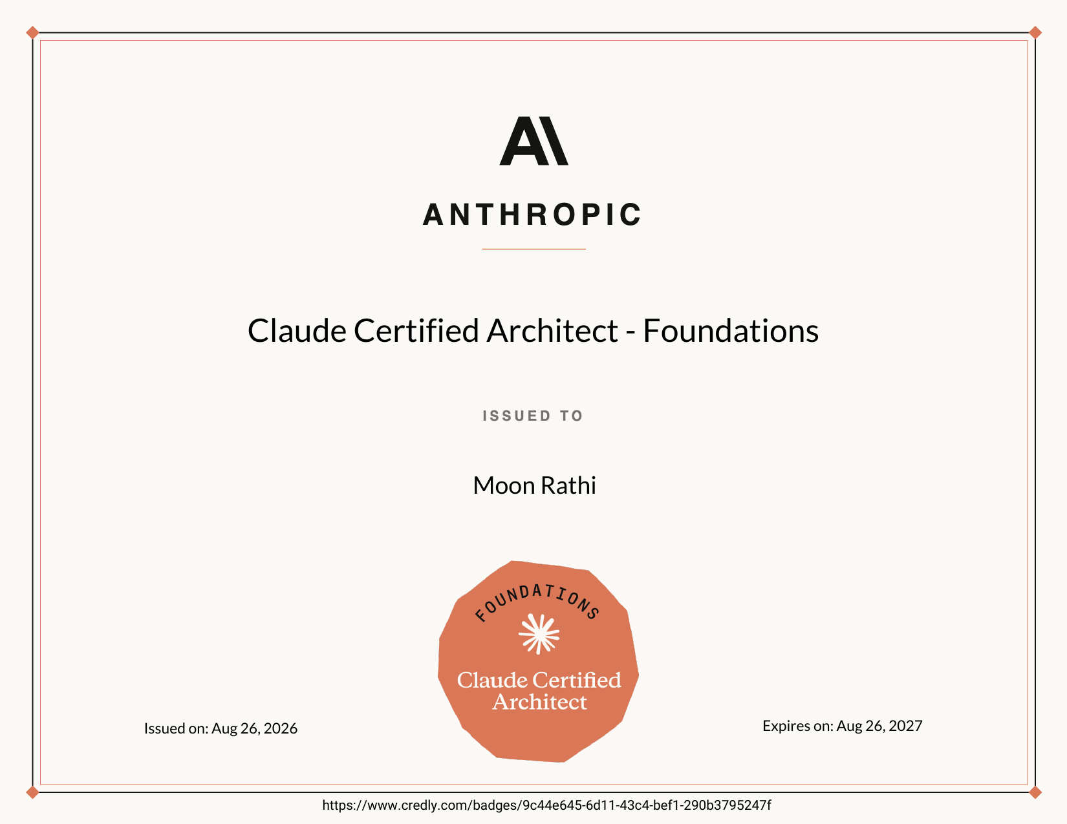
Fig 3.2 — Claude Certified Architect – Foundations, Anthropic (Credly)

3.3 Anthropic Academy Course Completion Certificates (Project 1, Earned During Internship)
The following certificates were earned during the internship period and confirm completion of the Anthropic Academy coursework undertaken as part of Project 1, covering the Claude API, Claude Code, Agent Skills and the Model Context Protocol (MCP):
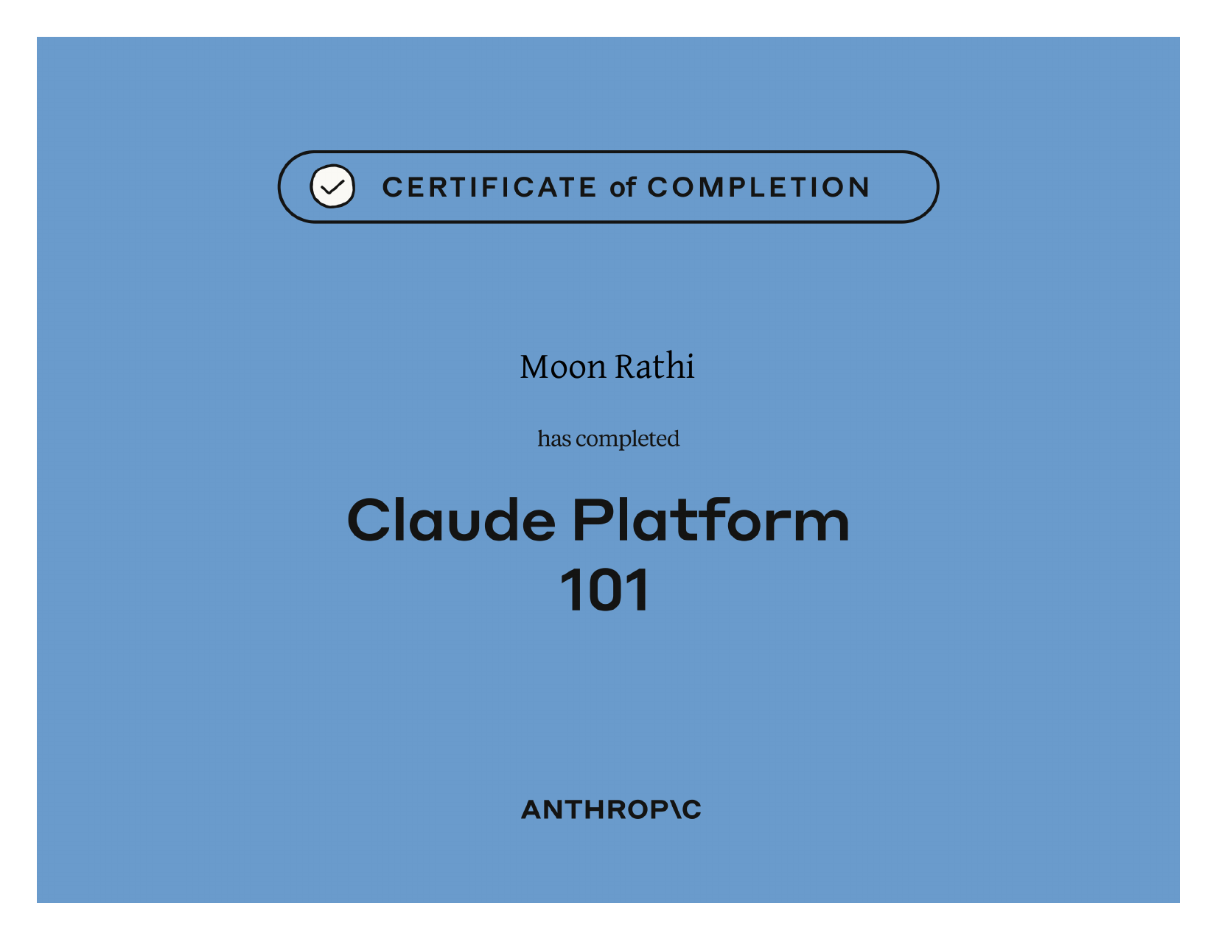
Fig 3.3a — Claude Platform 101

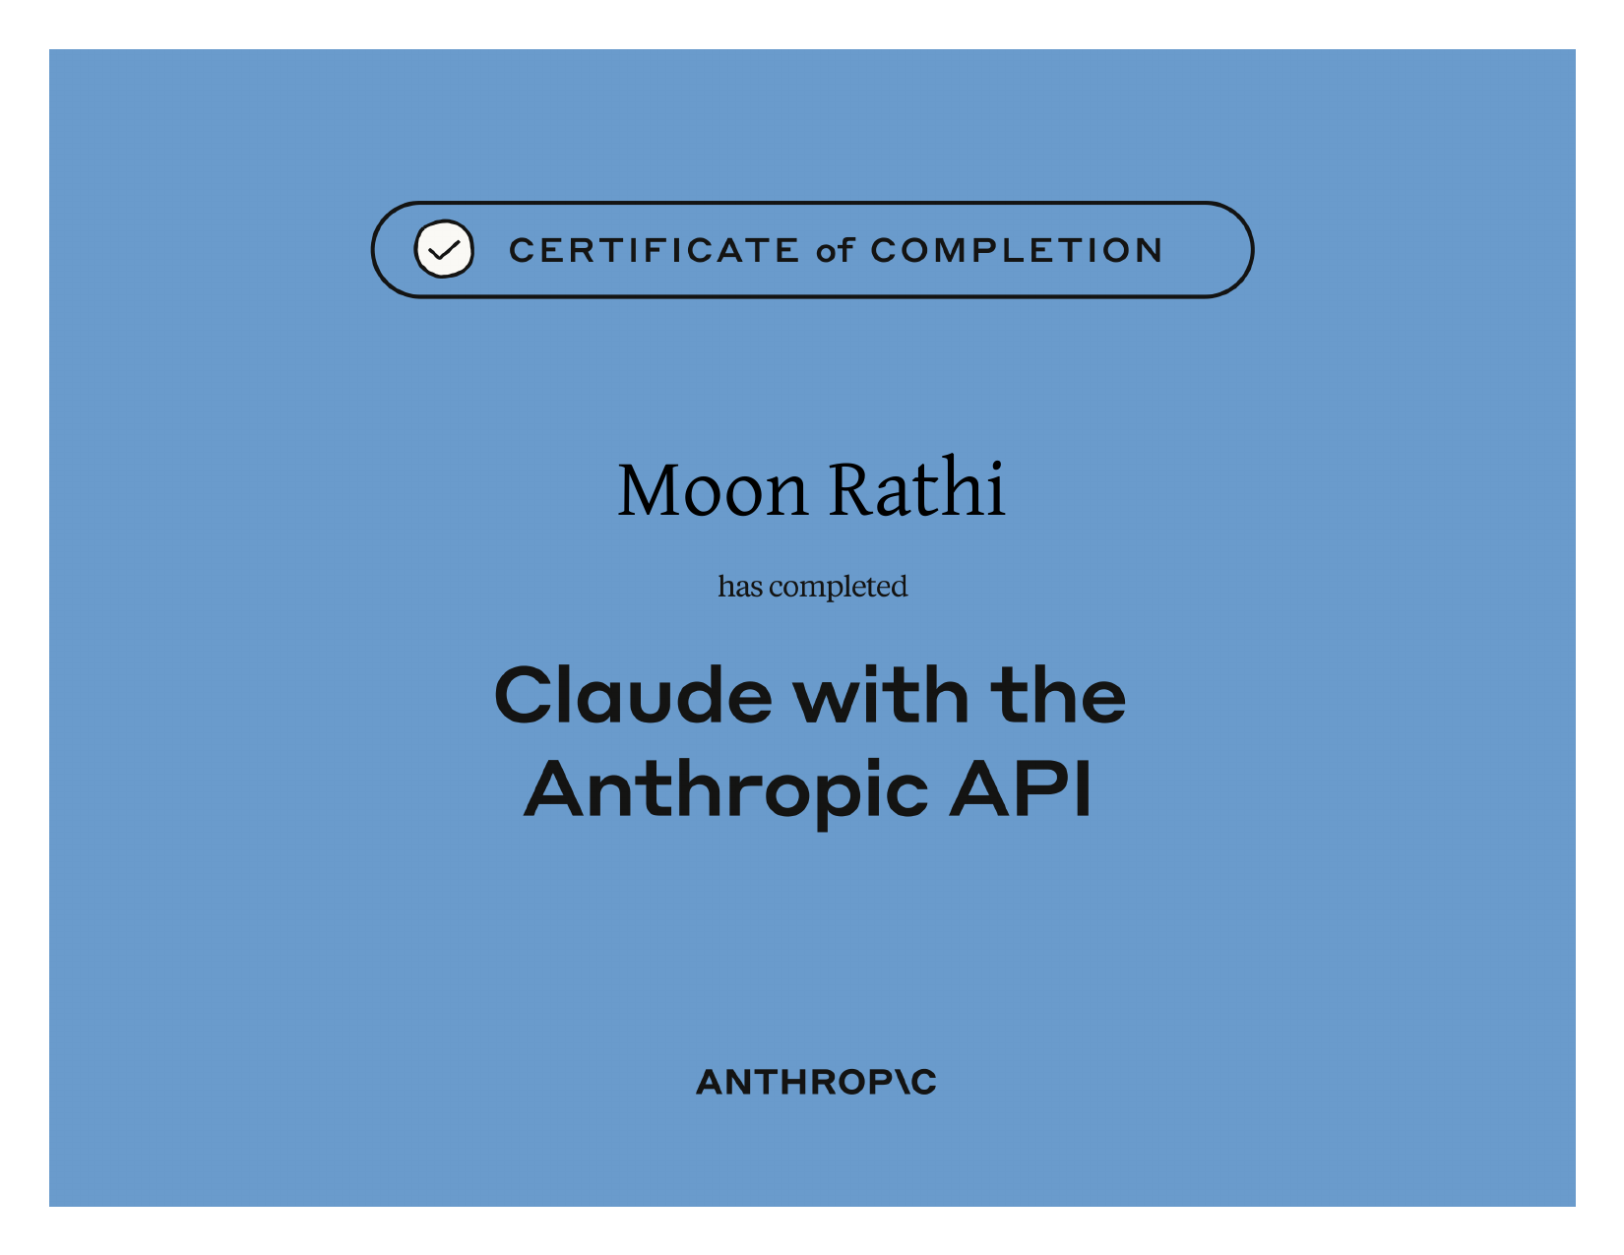
Fig 3.3b — Building with the Claude API
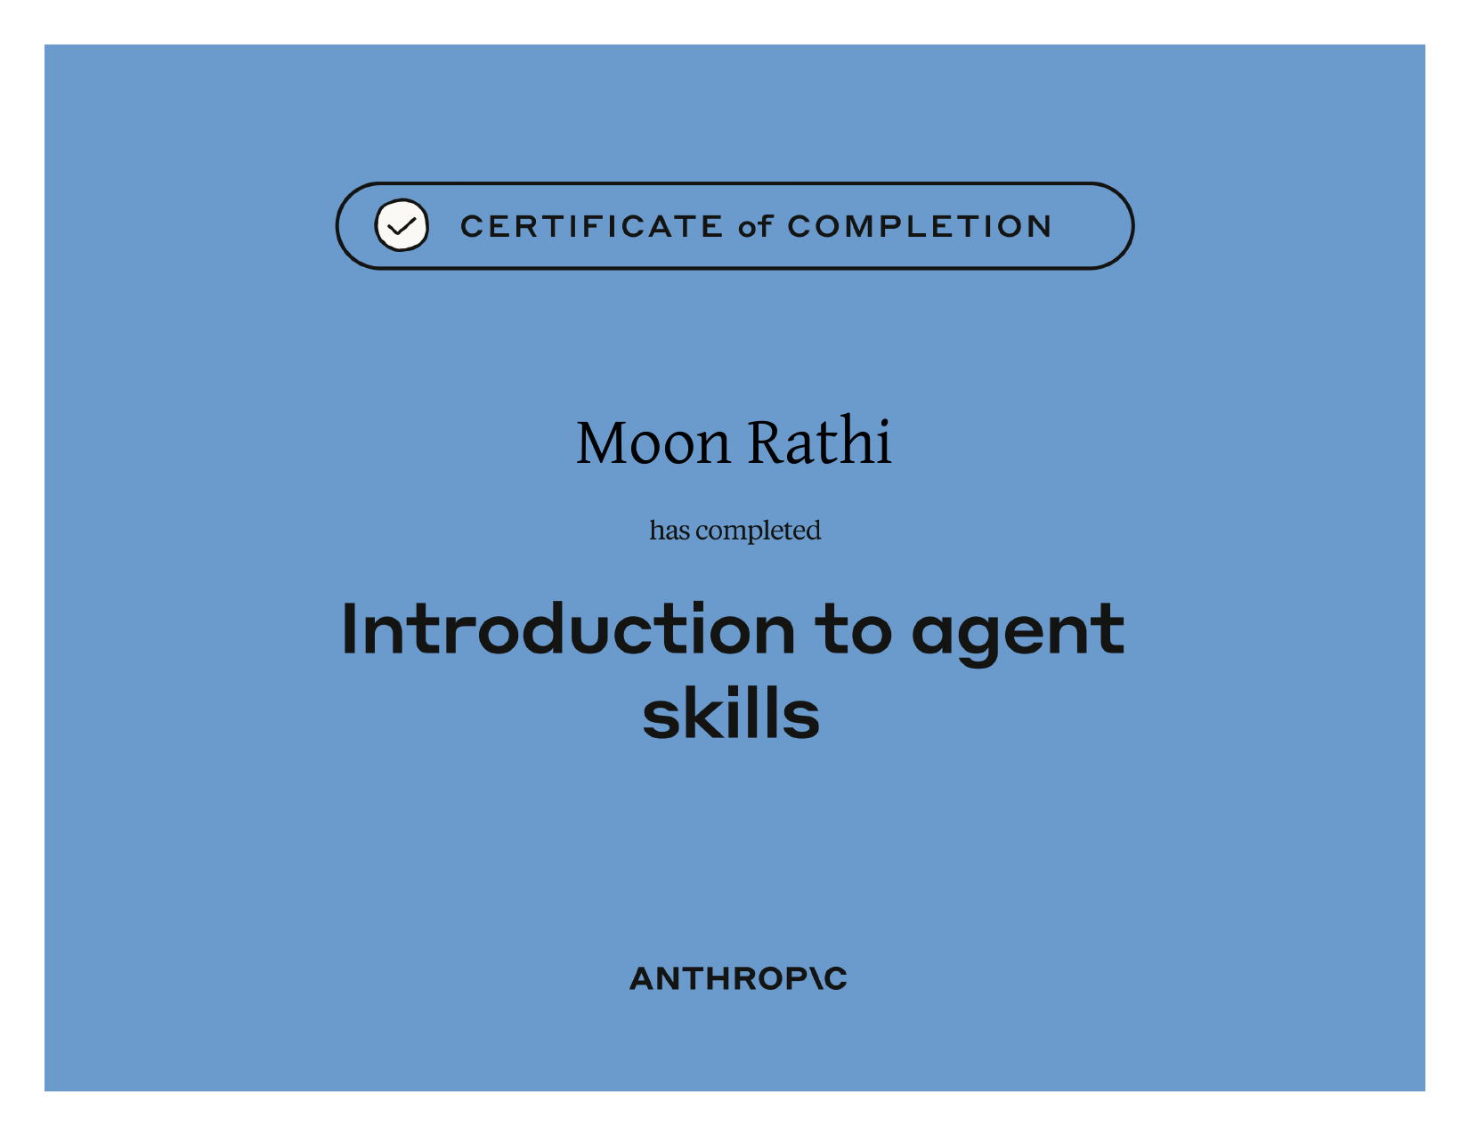
Fig 3.3c — Introduction to Agent Skills

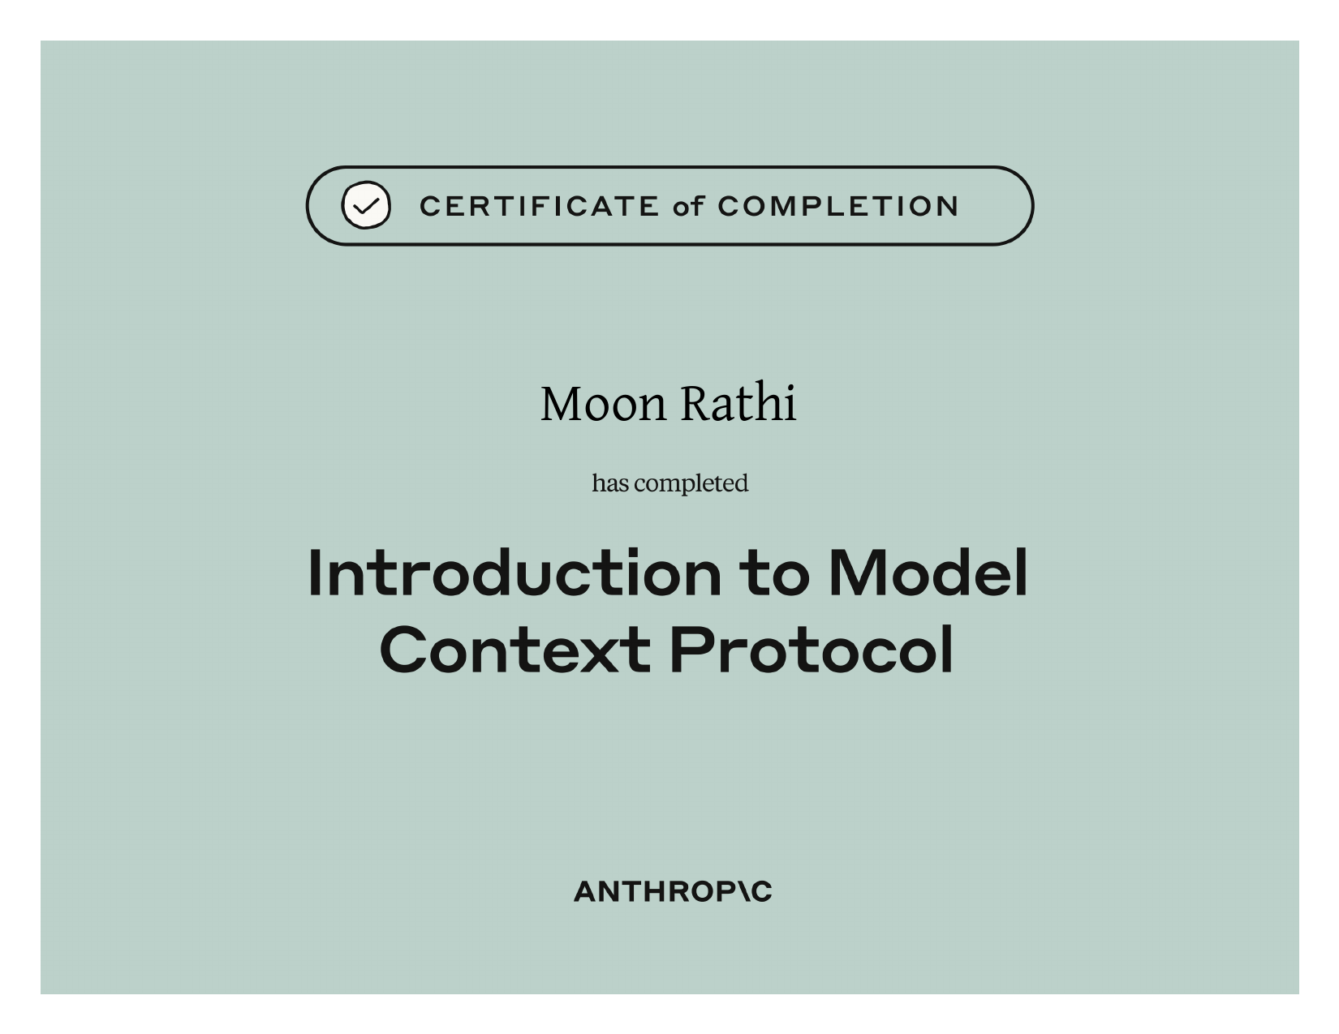
Fig 3.3d — Introduction to Model Context Protocol
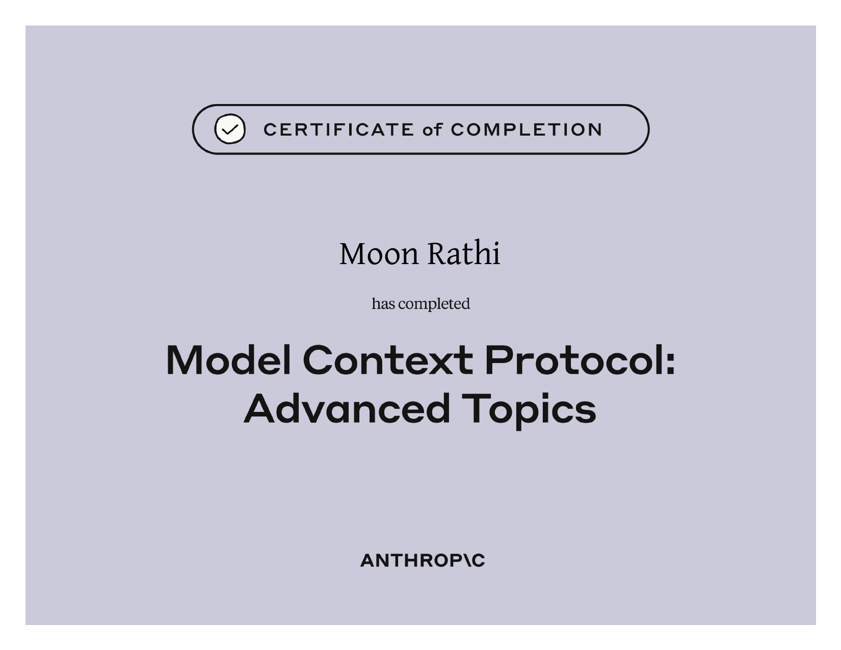
Fig 3.3e — Model Context Protocol: Advanced Topics

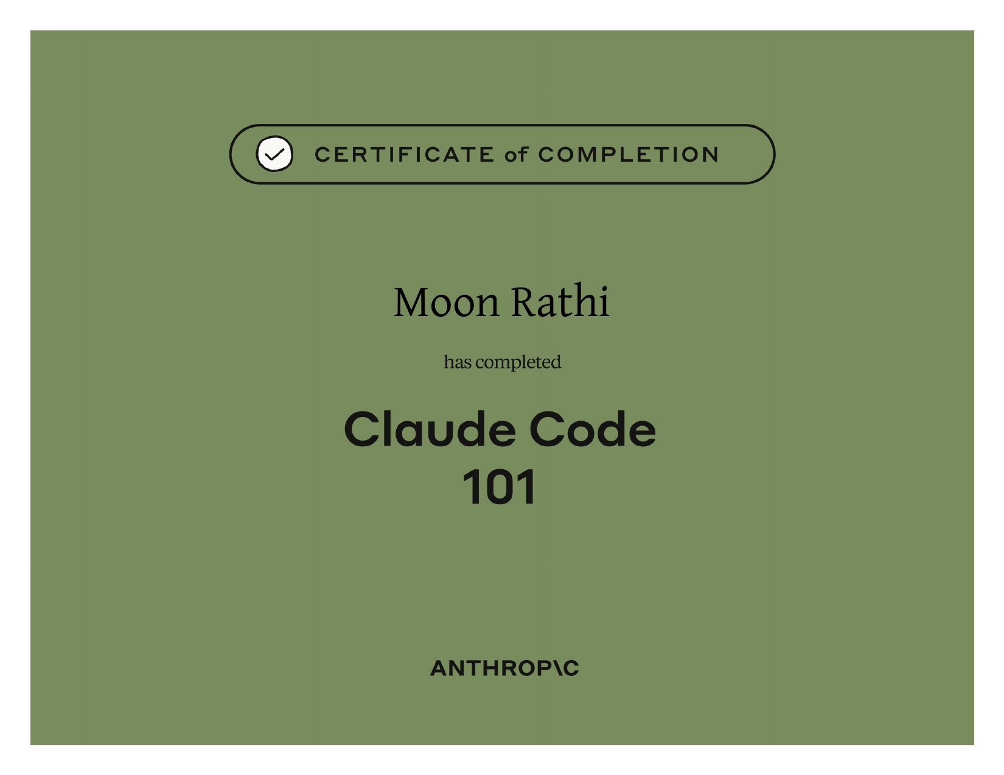
Fig 3.3f — Claude Code 101
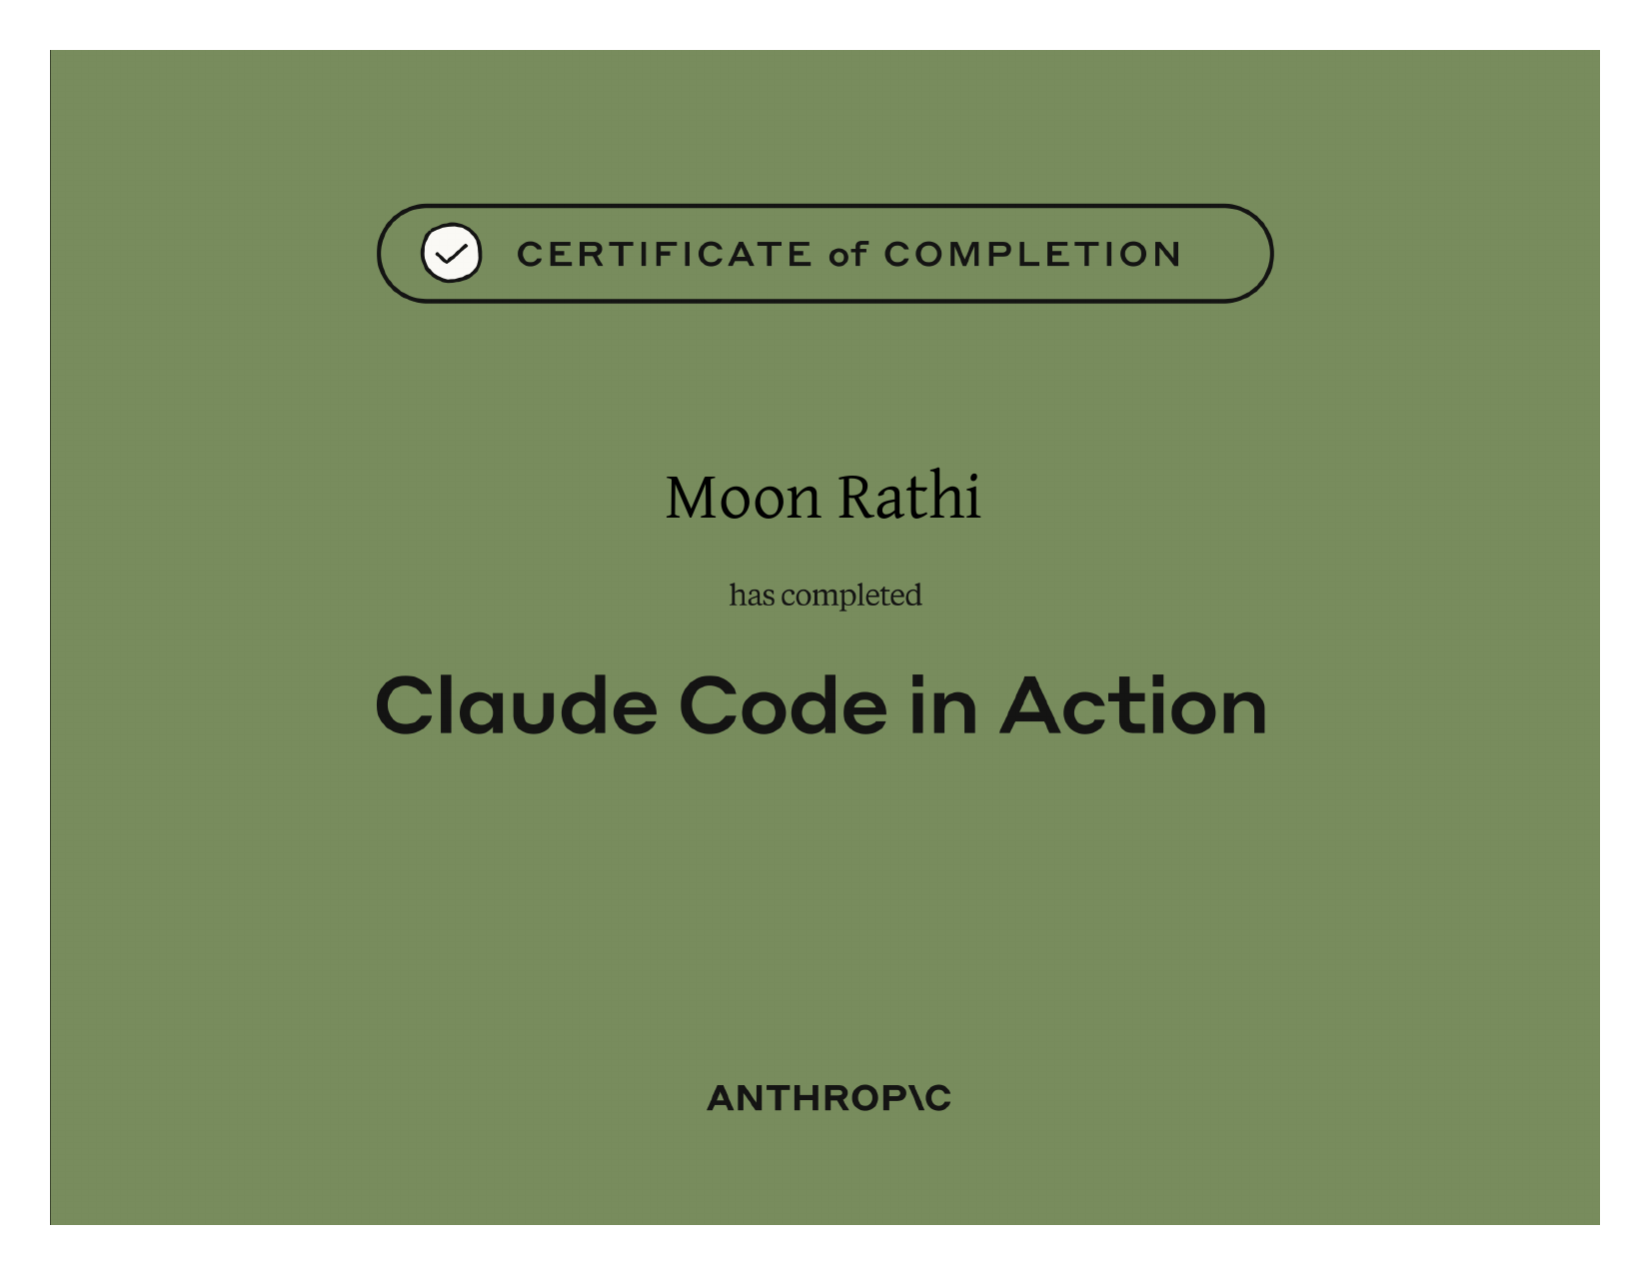
Fig 3.3g — Claude Code in Action

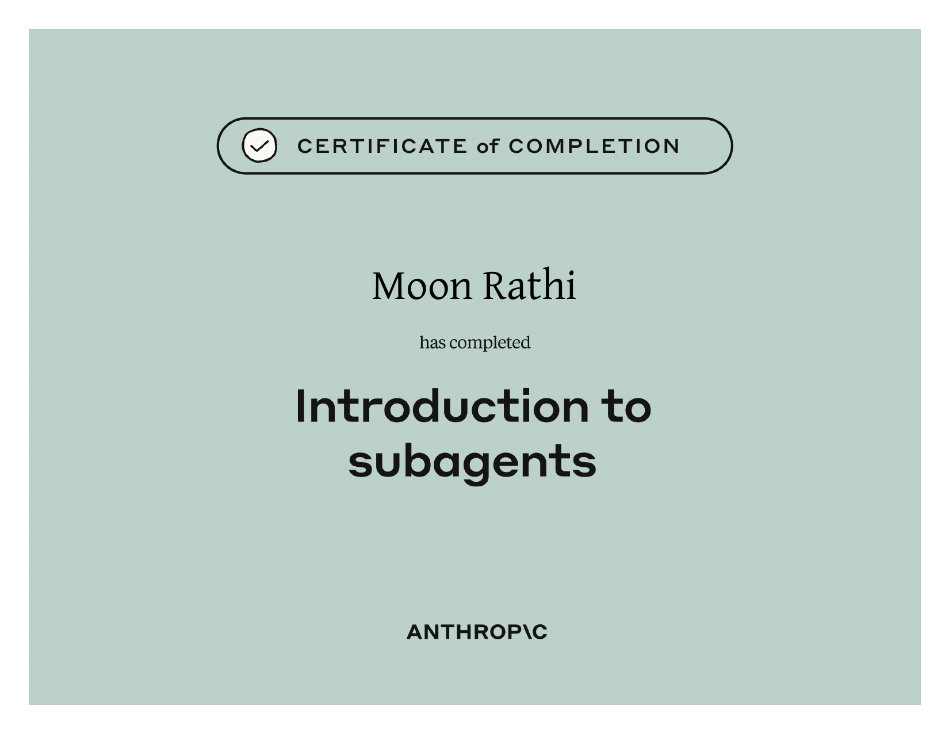
Fig 3.3h — Introduction to Subagents

3.4 Snowflake SPN Certificates (Project 3 Deliverable, Earned During Internship)
The following certificates were earned during the internship period and confirm completion of Snowflake's SPN learning modules undertaken as part of Project 3, spanning foundational AI/ML through to Advanced Generative AI, all issued on August 11, 2026:
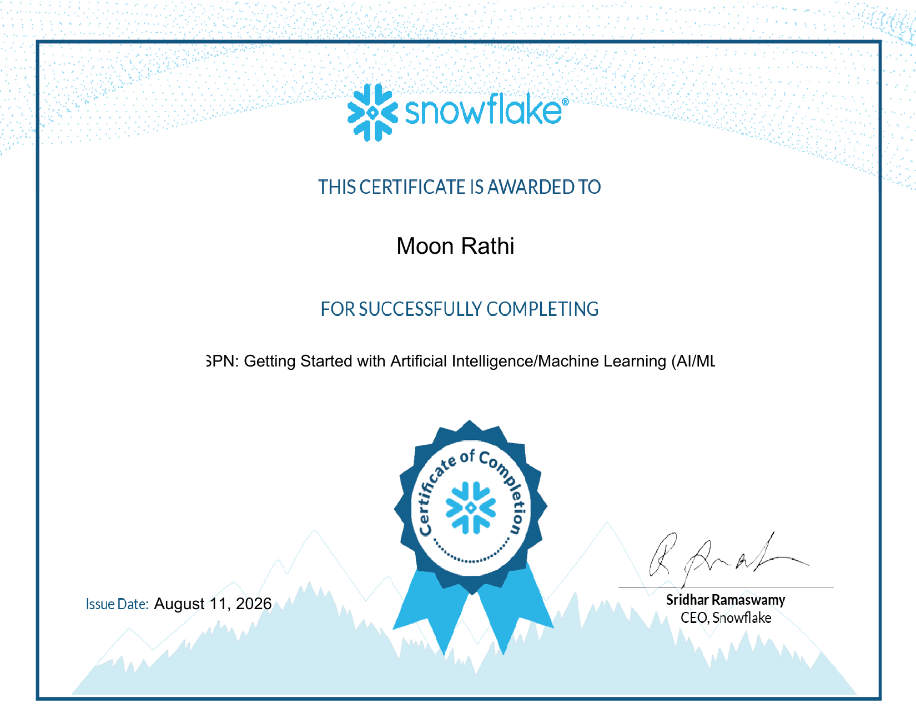
Fig 3.4a — Getting Started with Artificial Intelligence/Machine Learning (AI/ML)
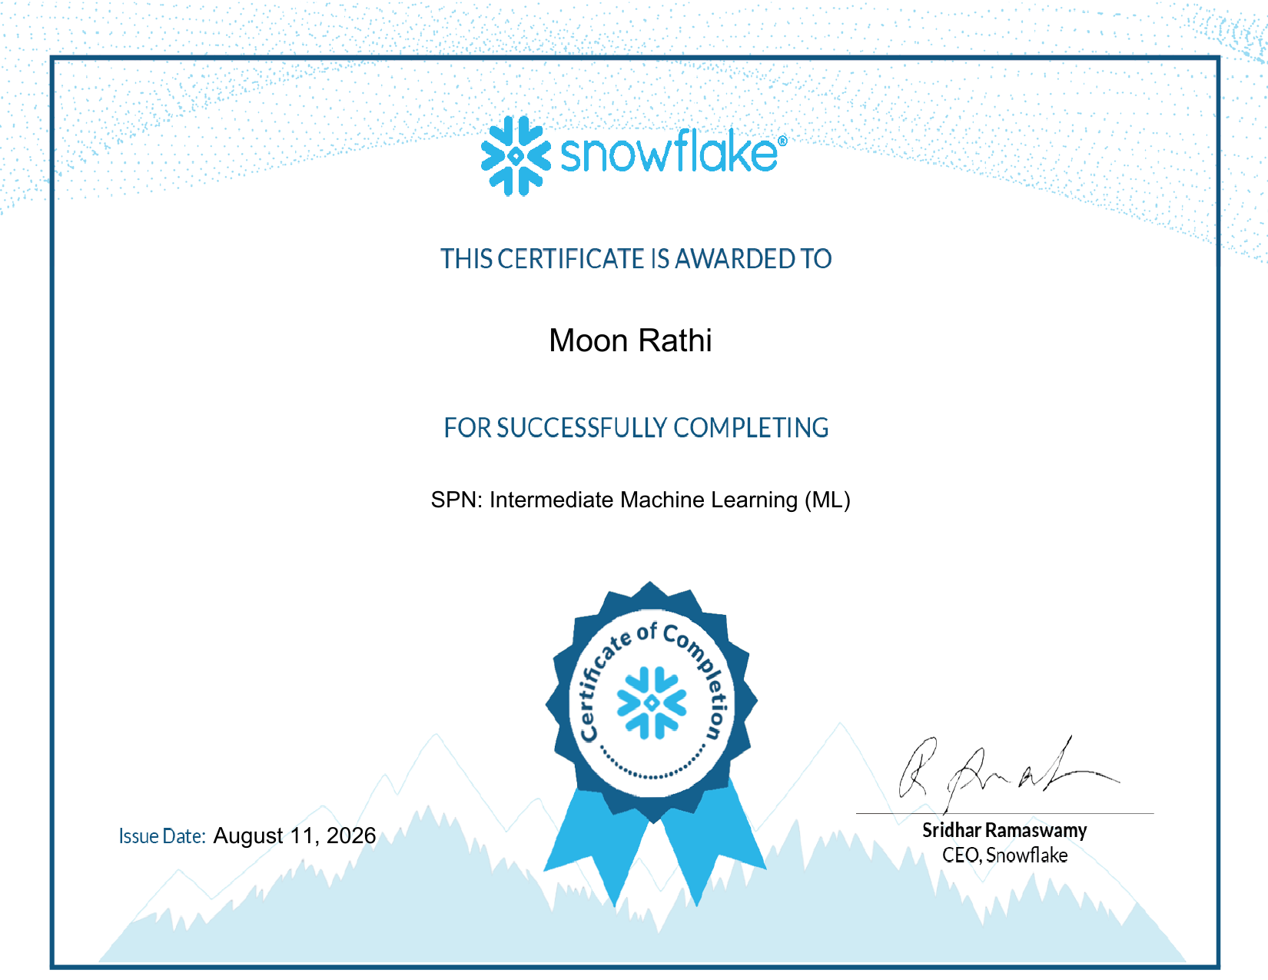
Fig 3.4b — Intermediate Machine Learning (ML)
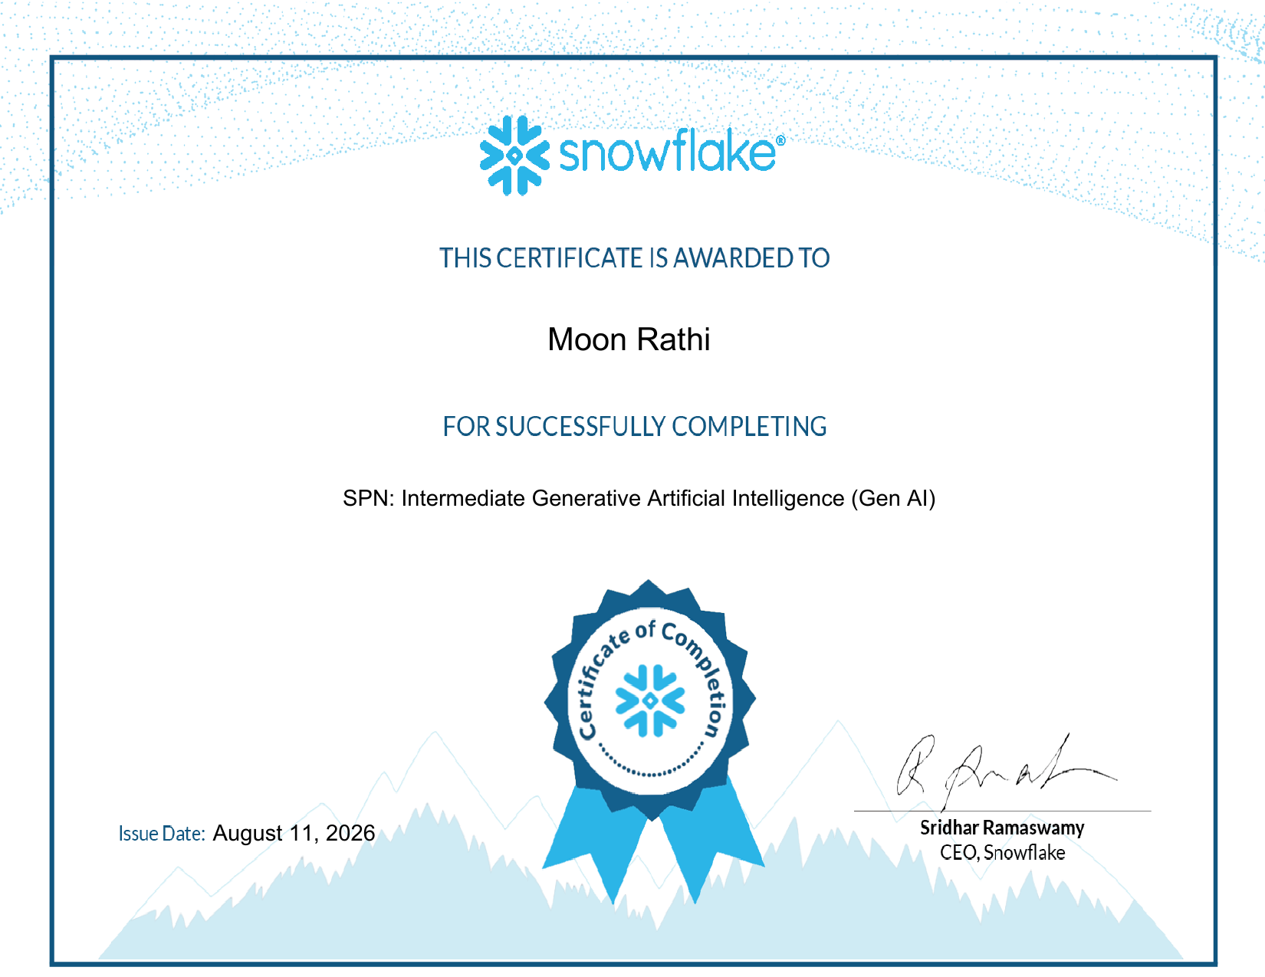
Fig 3.4c — Intermediate Generative Artificial Intelligence (Gen AI)
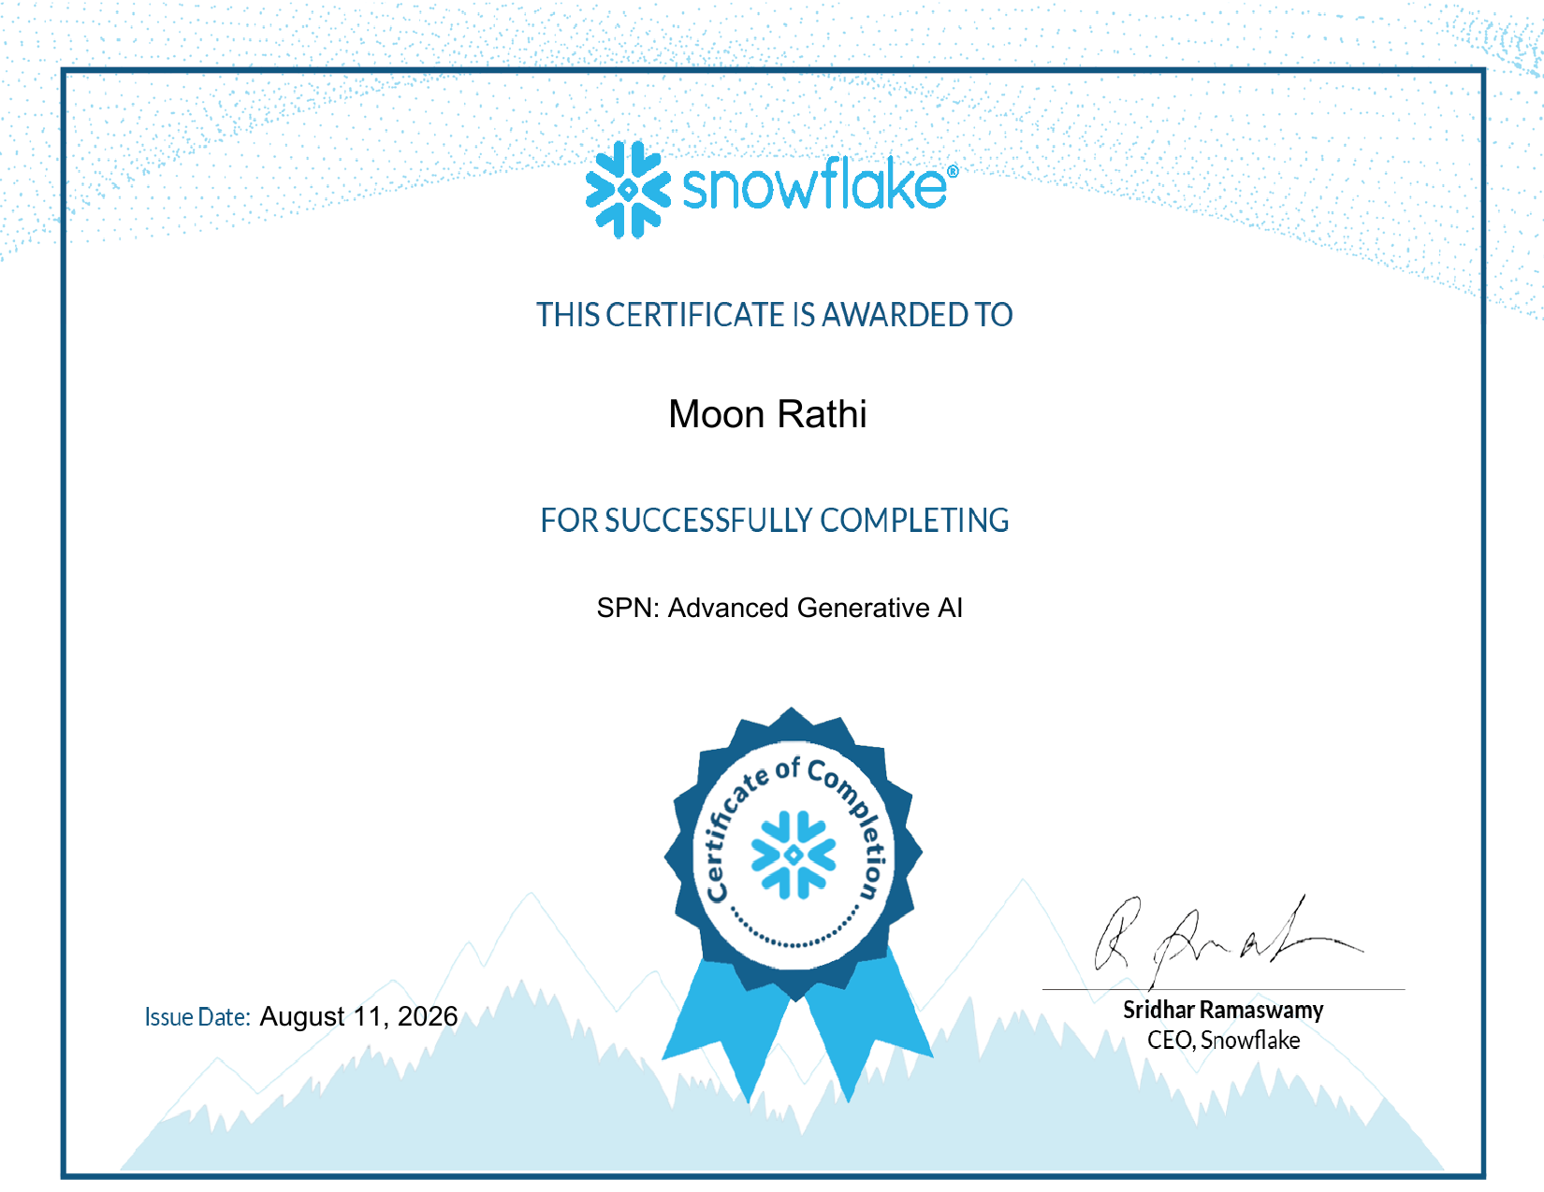
Fig 3.4d — Advanced Generative AI

3.5 Final Internship Completion Certificate (To Be Issued at Internship End — Pending)
The formal Internship Completion Certificate is a separate document from both the Offer Letter (Section 3.1) and the project credentials above (Sections 3.2–3.4). It will be issued by Mactores Cognition Private Limited only upon conclusion of the internship on September 17, 2026, and will be added to this report and the accompanying GitHub repository at that time. Till then the an official interim confirmation letter from HR confirming the ongoing status and satisfactory performance is being issued.
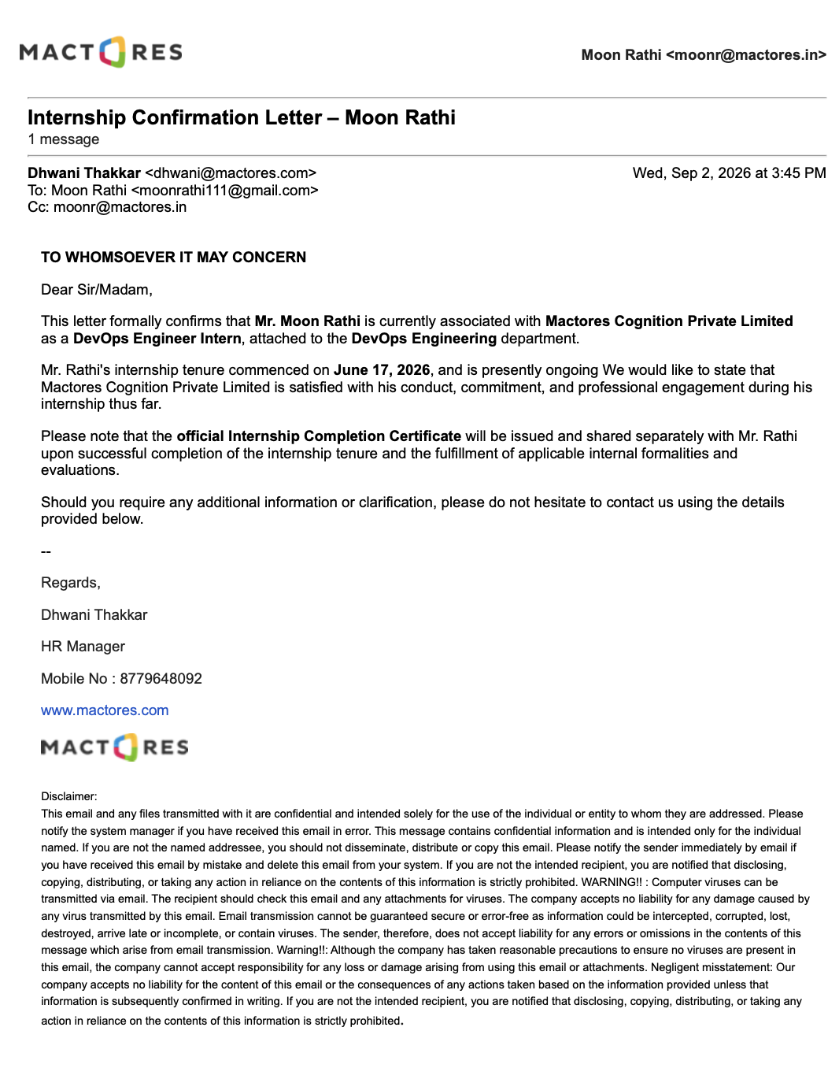

TABLE OF CONTENTS
Chapter No. | Chapter Name | Page Nos.
 | Cover Page | ---
1. | Candidate's Declaration | i
2. | Acknowledgment | ii
3. | Internship Certificate & Supporting Credentials | iii
4. | Project Description
 | 4.1 Introduction | 1
 | 4.2 Organization Profile | 1
 | 4.3 Problem Statement | 2
 | 4.4 Internship Objectives (Milestones) | 2
 | 4.5 Scope of the Internship | 3
 | 4.6 Technologies and Tools Used | 3
 | 4.7 Work Methodology | 4
 | 4.8 Project 1: Claude / Anthropic AI Platform Enablement | 5
 | 4.9 Project 2: Multi-Cloud Foundations Engineering (AWS & Azure) | 6
 | 4.10 Project 3: Snowflake Data & AI Platform Engineering | 7
 | 4.11 Quantified Outcomes Summary | 8
 | 4.12 Supporting Documentation and Communication Proof | 9
5. | Bibliography/References | 9

CHAPTER 4: PROJECT DESCRIPTION
4.1 Introduction
Modern DevOps engineering rarely happens inside a single vendor's ecosystem. This report documents a 3-month Summer Internship (June 17, 2026 – September 17, 2026) undertaken as a DevOps Engineer (Intern) at Mactores Cognition Private Limited, structured as three parallel engineering-enablement projects rather than one narrow deliverable: Project 1 targeting the Claude/Anthropic AI platform, Project 2 targeting multi-cloud administration across AWS and Azure, and Project 3 targeting the Snowflake cloud data platform. Each project was scoped with concrete milestones, executed through hands-on tooling rather than passive study, and closed out against a verifiable, external deliverable.
As of the date of this report, Project 1 and Project 3 have been completed in full, with all target deliverables achieved and verified; Project 2 is in active progress, with completion targeted before the internship concludes on September 17, 2026.
4.2 Organization Profile
Mactores Cognition Private Limited ("Mactores") is a technology consulting and data engineering company, founded in 2008 and headquartered in Bellevue, Washington, USA, with Indian operations based in Mumbai, Maharashtra. The company specialises in enterprise data platforms - data lakes, scalable databases and modern data warehouses - along with automated DataOps, MLOps and Generative AI solutions, and holds AWS Generative AI Competency and AWS Healthcare Competency status as a strategic AWS partner.
Corporate Office: Office No. 316, Neelkanth Corporate IT Park, Kirol Road, Vidyavihar (West), Mumbai - 400086, India. CIN: U72900MH2017PTC295824.
4.3 Problem Statement
A DevOps engineer fluent in only one cloud vendor is a liability on a modern infrastructure team: organisations increasingly run hybrid, multi-cloud workloads while simultaneously integrating LLM-based agentic tooling into their engineering pipelines. This internship targeted that exact gap through three bounded, deliverable-driven projects, each closing out with a verifiable credential rather than an open-ended study log.
4.4 Internship Objectives (Milestones)
- Milestone 1: Build applied, hands-on proficiency with the Claude API, Claude Code, Agent Skills and MCP, validated by clearing the Claude Certified Architect - Foundations examination (Project 1).
- Milestone 2: Reach 80%+ consistency across independent mock-assessment sources before attempting each project's final credentialing exam.
- Milestone 3: Build working competency in core AWS services (EC2, IAM, S3) and Azure administration (identity, storage, compute, networking), targeting the CLF-C02 and AZ-104 credentials (Project 2).
- Milestone 4: Deliver applied Snowflake AI/ML and Generative AI competency across all 4 SPN modules within a single project window (Project 3).
- Milestone 5: Document methodology, quantified outcomes and supporting evidence in a structured report and public GitHub repository.
4.5 Scope of the Internship
The scope spans three defined, bounded projects rather than a single client-facing deliverable, each targeting platform enablement and verified competency rather than production deployment at the host organisation. The report covers activity from June 17, 2026 to the date of submission, with Project 2 continuing through September 17, 2026.
4.6 Technologies and Tools Used
Category | Technology / Tool | Role & Technical Purpose
AI / Agentic Platform | Claude (Anthropic): API, Claude Code, MCP | Agentic reasoning, API-driven automation, tool-use workflows
Public Cloud (Compute/IAM) | Amazon Web Services (EC2, IAM, S3, CloudWatch) | Core compute, identity, storage and monitoring services
Public Cloud (Admin) | Microsoft Azure (Compute, Storage, Entra ID, Networking) | Cloud administration, identity and resource management
Cloud Data & AI Platform | Snowflake (SPN modules: ML, GenAI) | Data-platform-native Machine Learning and Generative AI workflows
Learning Infrastructure | Anthropic Academy, AWS Skills Builder, Microsoft Learn | Structured, vendor-authored technical coursework
Validation / Practice | Udemy, YouTube, ExamTopics, ExamHeist, CertSafari, GitHub Q&A banks | Mock assessment and iterative self-evaluation prior to each deliverable
Credentialing | Credly, Anthropic, Snowflake, AWS, Microsoft | Issuance and verification of industry-recognised credentials
Version Control | GitHub (public repository) | Version-controlled submission of report, presentation and supporting evidence

4.7 Work Methodology
A consistent four-stage methodology was applied across all three projects:
- Foundational Study: Vendor-authored coursework and official documentation (Anthropic Academy, AWS Skills Builder, Microsoft Learn, Snowflake SPN modules).
- Applied Practice: Direct, hands-on use of platform tools - the Claude API, Claude Code, and cloud consoles/SDKs.
- Validation: Independent mock-assessment sources (YouTube Q&A, Udemy, ExamTopics, ExamHeist, CertSafari, GitHub community question banks), tracked across 1st and 2nd attempts to quantify improvement before each final exam.
- Deliverable Sign-off: A concrete, externally verifiable outcome per project - an issued credential for Projects 1 and 3, and exam readiness for Project 2.
PROJECT 1: CLAUDE / ANTHROPIC AI PLATFORM ENABLEMENT
4.8.1 Objective
Build applied engineering proficiency in the Claude/Anthropic platform - the Claude API, Claude Code, Agent Skills and MCP - sufficient to evaluate, integrate and reason about Claude-based agentic workflows in a DevOps context.
4.8.2 Work Undertaken
Work combined 9 Anthropic Academy modules (~16.5 hours of structured coursework) with direct, hands-on use of the Claude API and Claude Code, followed by six independent rounds of mock assessment before attempting the final exam. Scores improved measurably across attempts - for example, the YouTube "Zero to CCA" question set rose from an initial pass to 75%, and the GitHub community question bank was cleared at 29/33 (87%):
Learning Path | Content Type | Time Taken | Status | 1st Attempt | 2nd Attempt
Claude 101 | Learning Video | ~1 hr | Completed | - | -
Building with the Claude API | Learning Video | ~8.1 hrs | Completed | - | -
Claude Platform 101 | Learning Video | ~1 hr | Completed | - | -
Introduction to Agent Skills | Learning Video | ~30 min | Completed | - | -
Introduction to Model Context Protocol | Learning Video | ~1 hr | Completed | - | -
MCP Advanced Topics | Learning Video | ~1.1 hrs | Completed | - | -
Claude Code 101 | Learning Video | ~1.5 hrs | Completed | - | -
Claude Code in Action | Learning Video | ~1 hr | Completed | - | -
Introduction to Subagents | Learning Video | ~30 min | Completed | - | -
YT - Zero to Claude Certified Architect | Solved Q&A (12 Qs) | ~12 min | Completed | - | 75%
YT - CCA: Exam Questions Solved | Solved Q&A (12 Qs) | ~1 hr | Completed | - | 83%
Udemy - CCA Foundations (6 Practice Exams) | Practice Test | - | Completed | 81% | 83.5%
CCA - Foundations (CCA-F) Practice Test | Practice Test | - | - | 860 | -
GitHub - Solved CCA Exam Questions | Solved Q&A (33 Qs) | - | - | 29/33 | 87%
ExamHeist | Solved Q&A (40 Qs) | - | - | 34/40 | 85%
CertSafari | Sample Questions | - | - | - | 86%

4.8.3 Outcome / Deliverable (Quantified)
- Claude Certified Architect - Foundations issued by Anthropic via Credly on August 26, 2026 (valid through August 26, 2027).
- 9 of 9 planned Anthropic Academy modules completed (100% completion rate).
- Final pre-exam mock scores of 87%, 85% and 86% across three independent question banks (GitHub, ExamHeist, CertSafari).
- Udemy 6-exam practice series improved from 81% to 83.5% between first and second attempts.
PROJECT 2: MULTI-CLOUD FOUNDATIONS ENGINEERING (AWS & AZURE)
4.9.1 Objective
Build working, hands-on competency in core AWS and Microsoft Azure services - compute, storage, identity, networking and administration - to support infrastructure and DevOps tasks across either public cloud provider.
4.9.2 Work Undertaken
AWS preparation is structured around the "Ultimate AWS Certified Cloud Practitioner (CLF-C02)" Udemy course, a supplementary YouTube course, and hands-on labs via AWS Skills Builder. Azure preparation is grounded in Microsoft's own AZ-104 documentation, cross-validated against three independent question-bank sources - ExamTopics, Examsnet and Secexams - to reduce reliance on any single source.
4.9.3 Outcome / Deliverable (Target)
- Target: AWS Certified Cloud Practitioner (CLF-C02) - exam scheduled before September 17, 2026.
- Target: Microsoft Azure Administrator Associate (AZ-104) - exam scheduled before September 17, 2026.
- Applied readiness already built across core compute, storage, identity and networking tasks on both platforms through coursework completed to date.
PROJECT 3: SNOWFLAKE DATA & AI PLATFORM ENGINEERING
4.10.1 Objective
Build applied understanding of Snowflake as a cloud data platform, with particular focus on its native Machine Learning and Generative AI capabilities.
4.10.2 Work Undertaken
Work progressed sequentially through 4 Snowflake SPN learning modules - "Getting Started with AI/ML", "Intermediate Machine Learning", "Intermediate Generative AI" and "Advanced Generative AI" - each assessed and certified before progressing to the next, all completed within a single project window on August 11, 2026.
4.10.3 Outcome / Deliverable (Quantified)
- 4 of 4 planned Snowflake SPN modules completed (100% completion rate), from foundational AI/ML through Advanced Generative AI.
- All 4 certificates issued on a single date (August 11, 2026), confirming a continuous, focused delivery window.
- Directly complements the AI-engineering skills built in Project 1 with a data-platform-native perspective.
4.11 Quantified Outcomes Summary
The table below consolidates the deliverables produced across all three projects to date:
Project | Quantified Outcome | Status
Project 1: Claude | Claude Certified Architect - Foundations achieved; final practice-bank accuracy of 87% (29/33), 85% (34/40) and 86% prior to sitting the exam | Achieved - Aug 26, 2026
Project 1: Claude | 9 Anthropic Academy modules completed across ~16.5 hours of structured coursework | Completed
Project 2: AWS | CLF-C02 coursework and labs completed via Udemy, YouTube and AWS Skills Builder | In progress
Project 2: Azure | AZ-104 documentation and 3 independent question-bank sources (ExamTopics, Examsnet, Secexams) in active use | In progress
Project 3: Snowflake | 4 SPN modules delivered end-to-end, from AI/ML foundations to Advanced Generative AI, in a single sitting window (Aug 11, 2026) | Completed - Aug 11, 2026

Taken together, the three projects deliver a cross-platform engineering profile - an AI/agentic platform (Claude), the two leading public clouds (AWS, Azure) and a modern cloud data platform (Snowflake) - directly aligned with how contemporary DevOps teams operate.
4.12 Supporting Documentation and Communication Proof
Full-resolution copies of the Internship Offer Letter, the Claude Certified Architect - Foundations certificate, all 9 Anthropic Academy course certificates, and all 4 Snowflake SPN certificates are embedded in Chapter 3 of this report and are also uploaded in PDF format to the project's public GitHub repository. The formal Internship Completion Certificate from Mactores Cognition Private Limited, along with the completed AWS and Azure credentials from Project 2, will be added to the repository upon conclusion of the internship on September 17, 2026.
CHAPTER 5: BIBLIOGRAPHY / REFERENCES
[1] Anthropic, "Anthropic Academy: Claude Courses and Documentation," 2026. [Online]. Available: https://www.anthropic.com/learn
[2] Anthropic, "Claude Certified Architect - Foundations," Credly Digital Badge, 2026. [Online]. Available: https://www.credly.com/badges/9c44e645-6d11-43c4-bef1-290b3795247f
[3] Amazon Web Services, "AWS Skills Builder," 2026. [Online]. Available: https://explore.skillbuilder.aws
[4] Udemy, "Ultimate AWS Certified Cloud Practitioner CLF-C02," 2026. [Online]. Available: https://www.udemy.com
[5] Microsoft, "AZ-104: Microsoft Azure Administrator - Certifications," Microsoft Learn, 2026. [Online]. Available: https://learn.microsoft.com/en-us/credentials/certifications/azure-administrator/
[6] ExamTopics, "AZ-104 Practice Questions," 2026. [Online]. Available: https://www.examtopics.com/exams/microsoft/az-104/view/
[7] Snowflake Inc., "SPN Learning Certificates: AI/ML Foundations, Intermediate ML, Intermediate and Advanced Generative AI," 2026. [Online]. Available: https://www.snowflake.com
[8] Mactores, "Company Overview," 2026. [Online]. Available: https://www.mactores.com

