Name:Manikyolla Ravi kumar
Roll No: 2503B05111
Set No:1

Set 1
Q1. Write a Python function to calculate the factorial of a number. Use a coding assistant and document how you refine your prompt to ensure the function handles negative input and zeros.
(Each question carries 5 marks)
Prompt : Generate a Python factorial function that returns 1 for 0 and raises clear errors for negative or non-integer inputs.
Write a Python function to calculate the factorial of a number.
The function must:
- return 1 when the input is zero,
- raise a clear error when the input is negative,
- compute factorial correctly for positive integers,
Code:
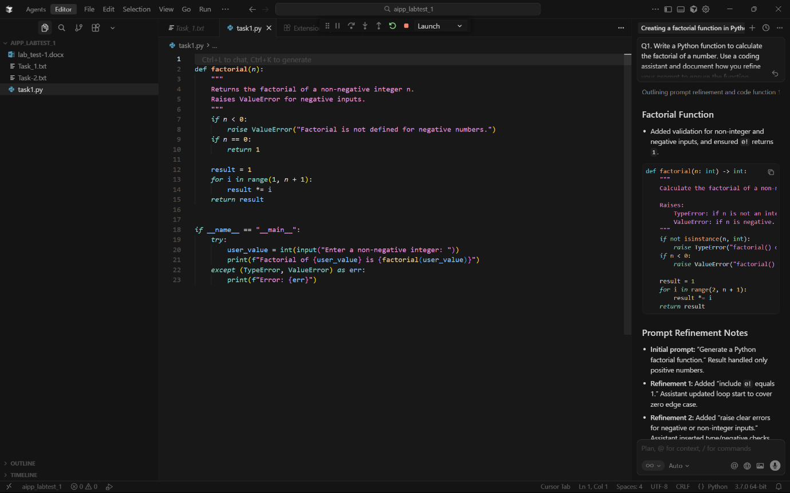
OUTPUT:
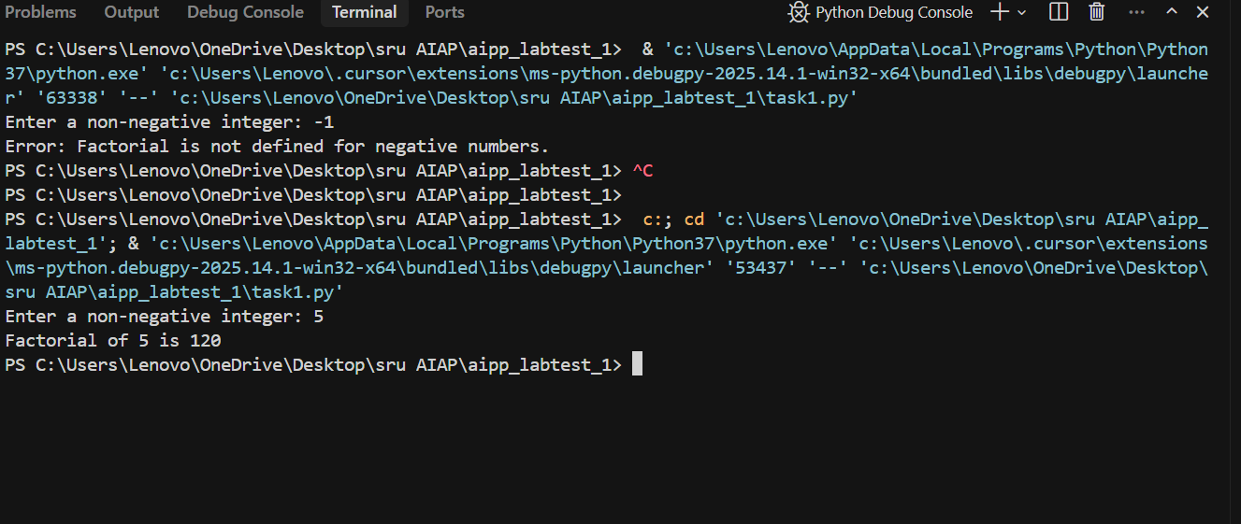

Q2. Given a list of student marks, compute the mean and list all students above the mean. Demonstrate zero-shot, one-shot, and few-shot prompts to guide an AI tool to solve this. Summarize the differences in approach.
(Each question carries 5 marks)
PROMPT:

ZERO-SHOT PROMPT
Given a list of (student_name, marks) pairs, write Python code to:
1. Compute the mean of the marks.
2. List all students whose marks are strictly above the mean.
Return both the mean and the above-mean list.
ONE-SHOT PROMPT
Example:
Input: [("A", 10), ("B", 20)]
Output: mean = 15.0, above = [("B", 20)]

Task:
Write a Python function that:
- takes a list of (name, mark)
- computes the mean
- returns all students strictly above the mean
- raises an error if the list is empty
FEW-SHOT PROMPT
Examples:
1) [("A",10),("B",20)] → mean=15.0, above=[("B",20)]
2) [("X",50),("Y",50)] → mean=50.0, above=[]
3) [("P",30.5),("Q",40.5),("R",35)] → mean=35.33..., above=[("Q",40.5)]

Task:
Write a Python function that:
- computes the mean of student marks
- returns (mean, list_of_students_above_mean)
- "above mean" means strictly greater than mean
- raises ValueError for empty list
- show example using:
[("Alice",85),("Bob",72),("Charlie",90),("Diana",60),("Ethan",78)]
CODE:
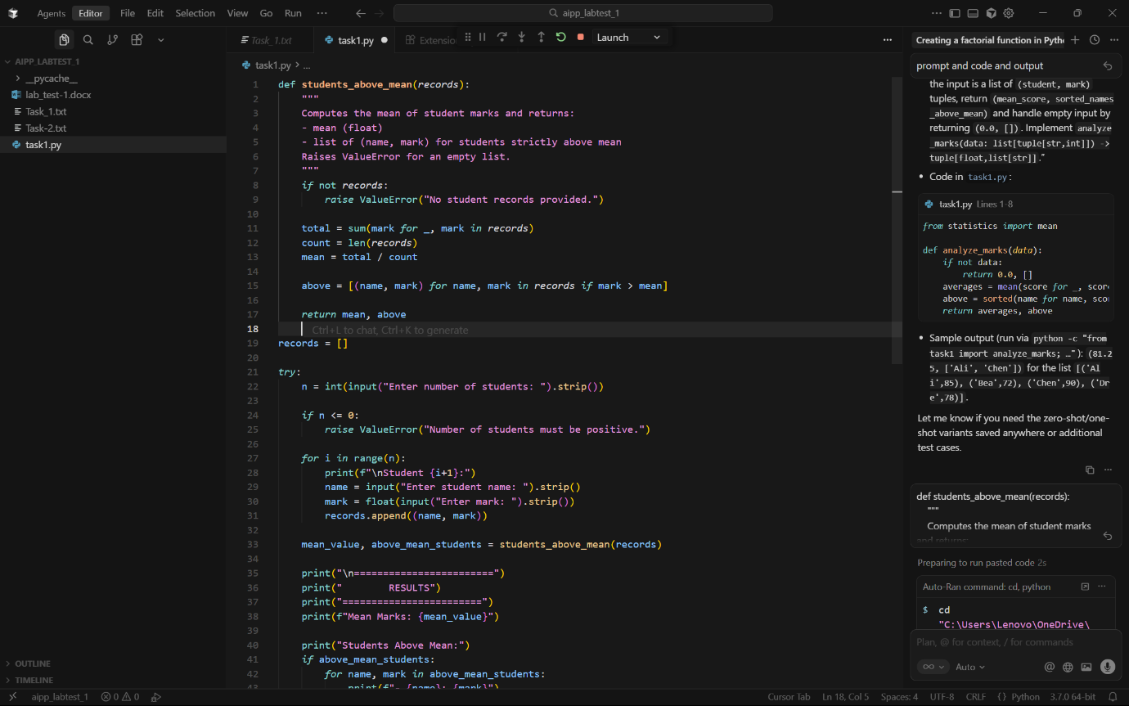
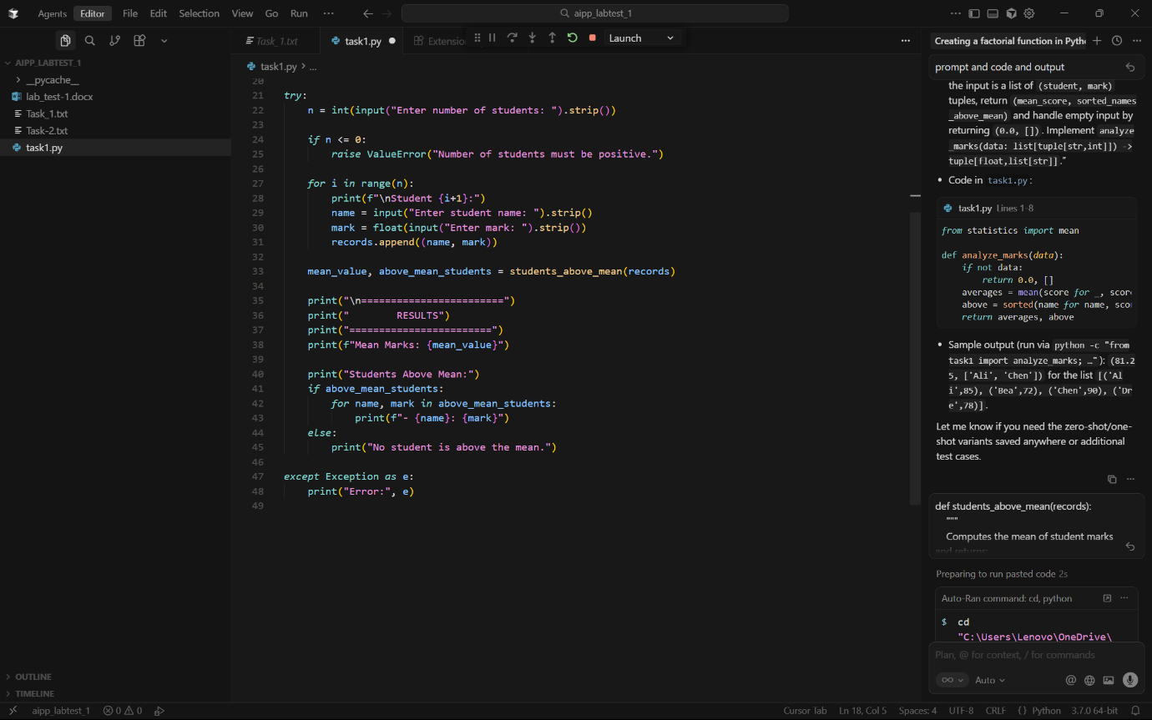

OUTPUT:
