EKART

**BUSINESS MODEL :**

1. We have implemented an Ecommerce Web Application using

* Asp.Net Core Web API (Business Layer)
* Angular (Presentation Layer)
* Databases- SQL Server and MongoDB (Data Layer)

1. Implemented Role based authentication using JWT (Auth Guard and Interceptors), implemented CQRS Dependency Injection.
2. Passing all the APIS in Gateway Ocelot.json and exposing it to the Angular.
3. Tested for all APIs using MOQ Framework.

**FLOW OF THE PROJECT**

1. **HOME PAGE**

When a visitor visits the website, he will be able to view all the products.

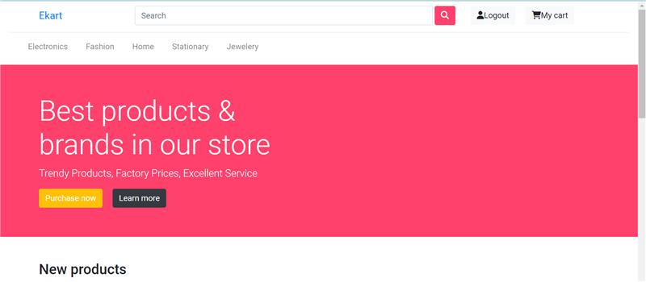

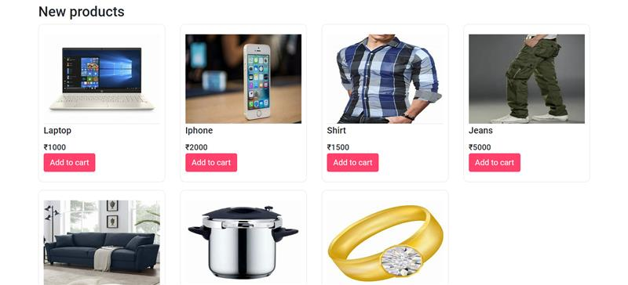

**ADMIN MODULE**

1. **SIGN IN**

After entering the sign in credentials like user email and user password. He will be redirected to admin dashboard.

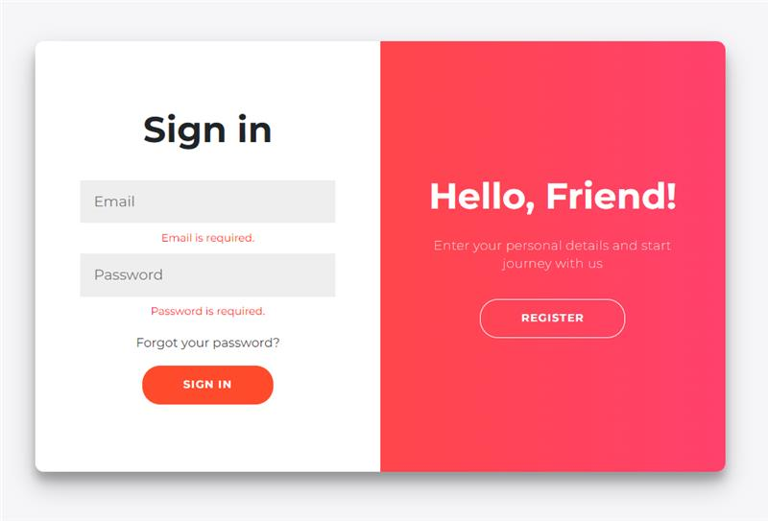

1. **ADMIN DASHBOARD**

Admin will be able to perform crud on products,users,order and transaction details.

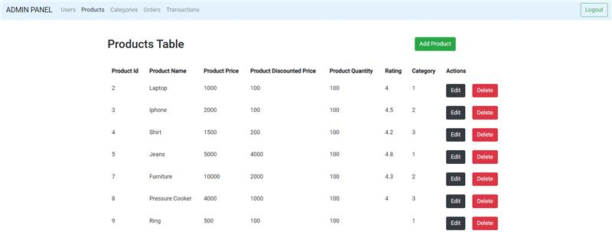

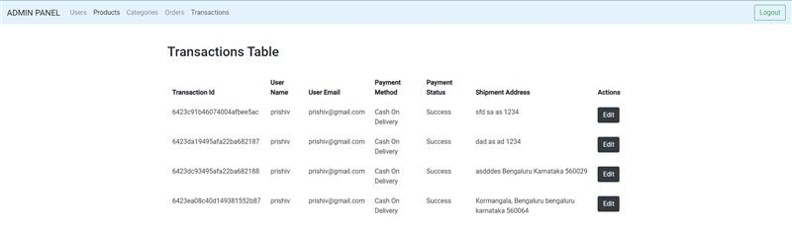

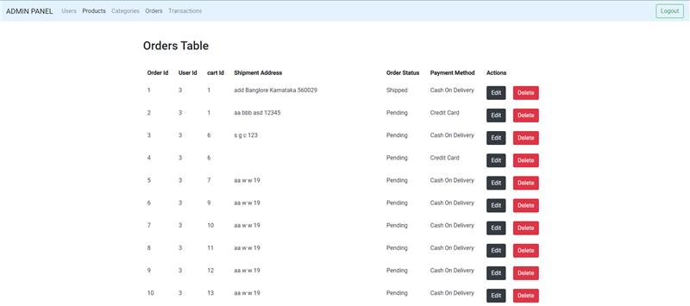

**USER MODULE**

1. **SIGN IN**

After entering the sign in credentials like user email and user password. He will be redirected to user dashboard.



1. **REGISTER PAGE**

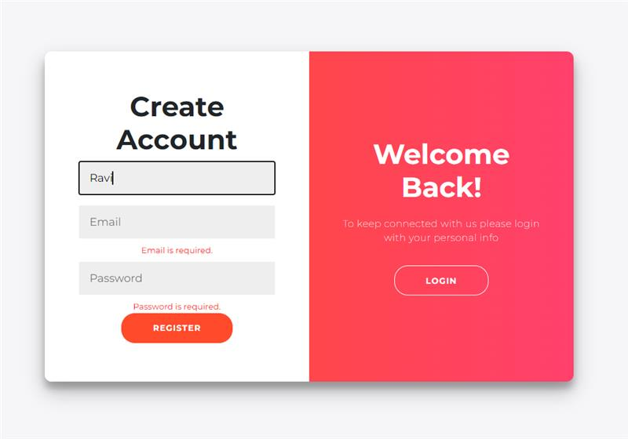

1. **USER DASHBOARD**
2. User will be able to view the product.

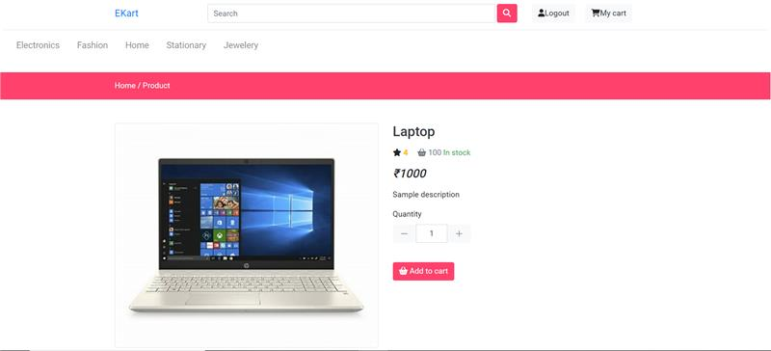

1. User will be able to add the product to the cart.
2. User will be able to remove the product from the cart.
3. User will be able to increment and decrement the product quantity.
4. 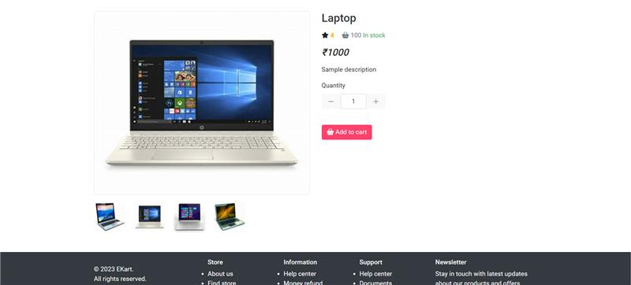
5. **CHECKOUT PAGE**

Once the user clicks on place order, he will be getting the summary of the order.

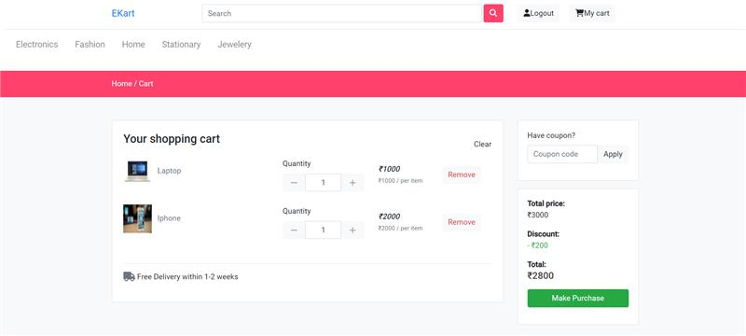

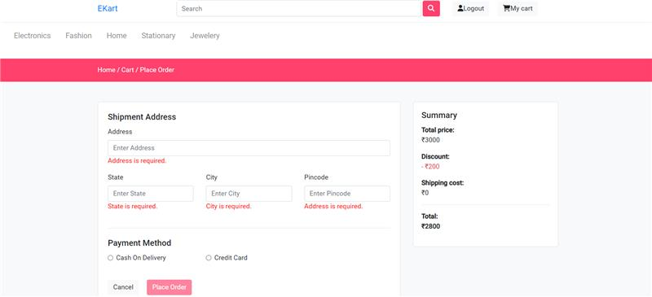

1. **ORDER SUCCESSSFUL**

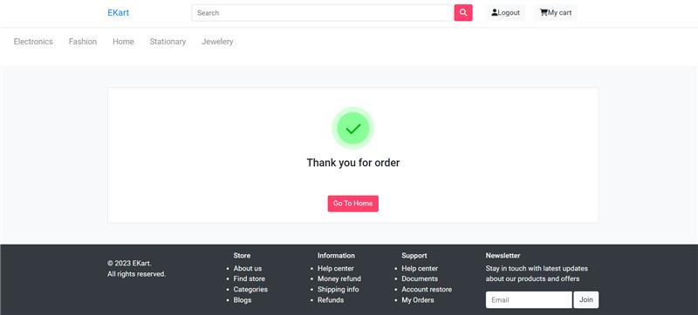

**MOCK TEST CASES**

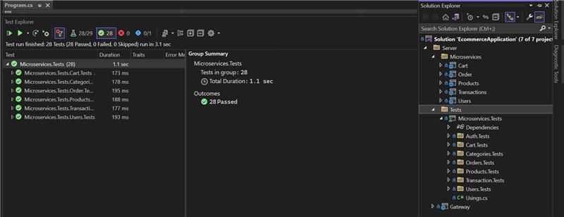

**DATABASE STRUCTURE**

1. **SQL SERVER**

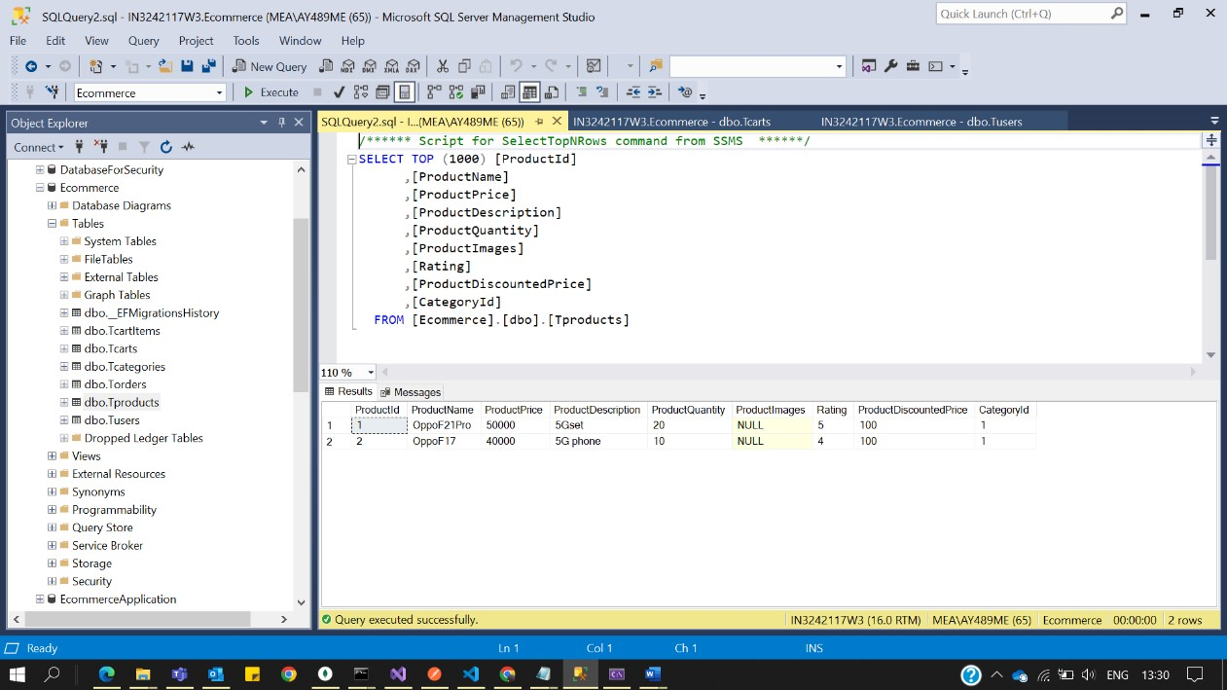

1. **MONGODB**

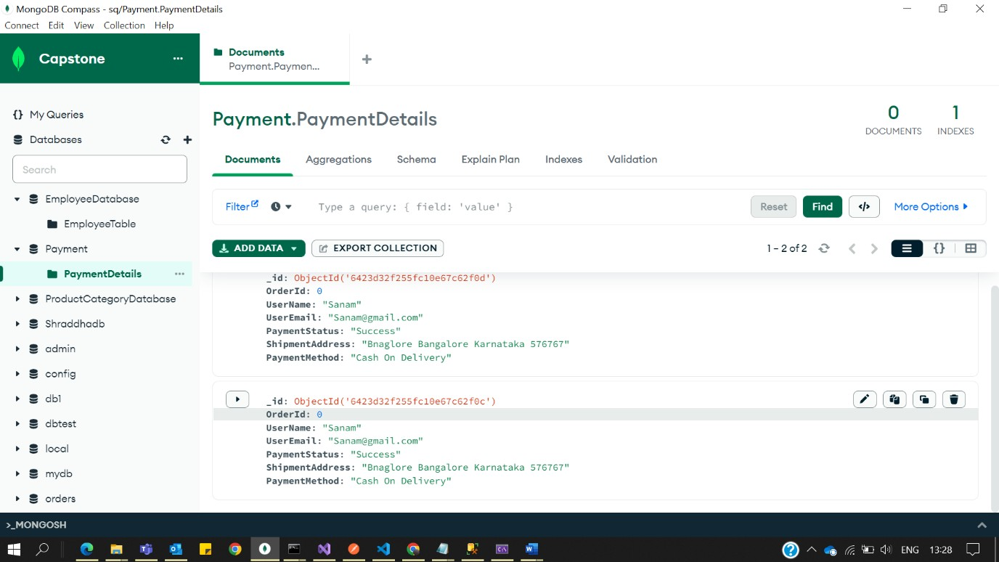

1. **USER**

* UserId
* UserName
* UserEmail
* UserPhoneNumber
* UserAddress
* UserPassword
* UserRole (Admin/User)
* CartId

1. **PRODUCT**

* ProductId
* ProductName
* ProductImage
* ProductPrice
* ProductDescription
* ProductRating
* ProductQuantity
* Category

1. **CATEGORY**

* CategoryId
* CategoryName
* CategoryImage

1. **ORDERS**

* OrderId
* UserId
* CartId
* ShipmentAddress
* OrderStatus (Pending/Shipped/Delivered)
* DateOfPurchase

1. **CART**

* CartId
* Discount
* TotalCost

1. **PAYMENT**

* PaymentId
* OrderId
* PaymentMethod
* PaymentStatus

1. **CART ITEM**

* Id
* CartId
* ProductId
* ProductQuantity

**APIS**

**USER**

1. GetAllUsers
2. GetUserById
3. EditUsers
4. DeleteUser
5. CreateUser
6. LoginUser
7. Forgot Password

**PRODUCTS**

1. GetAllProducts
2. GetProductById
3. AddProduct
4. UpdateProduct
5. DeleteProduct

**CATEGORIES**

1. GetAllCategories
2. GetCategoryById
3. AddCategory
4. UpdateCategory
5. DeleteCategory

**CART**

1. GetAllCartItems
2. AddItemToCart
3. EditCart

**ORDERS**

1. PlaceOrder
2. CancelOrder
3. GetAllOrders
4. GetOrderById
5. DeleteOrder
6. EditOrder

**PAYMENT**

1. GetAllTransactions
2. GetTransactionById
3. DeleteTransaction
4. UpdateTransaction
5. AddTransaction