Android Mobile Applications 1

Task 1
Practical Assignment
Submitted By:
Reham Mummar
Student ID:
2320250038
Submitted To:
Mr.Ibrahim
Submission Date:
30 October 2026

1-BirthdayCard-LightMode
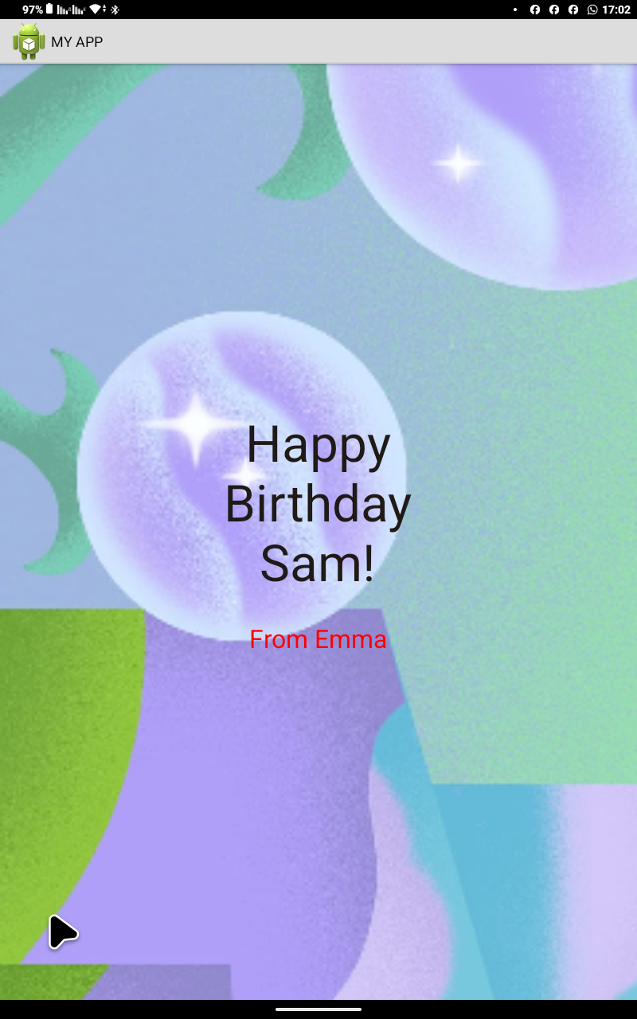

1-BirthdayCard-DarkMode
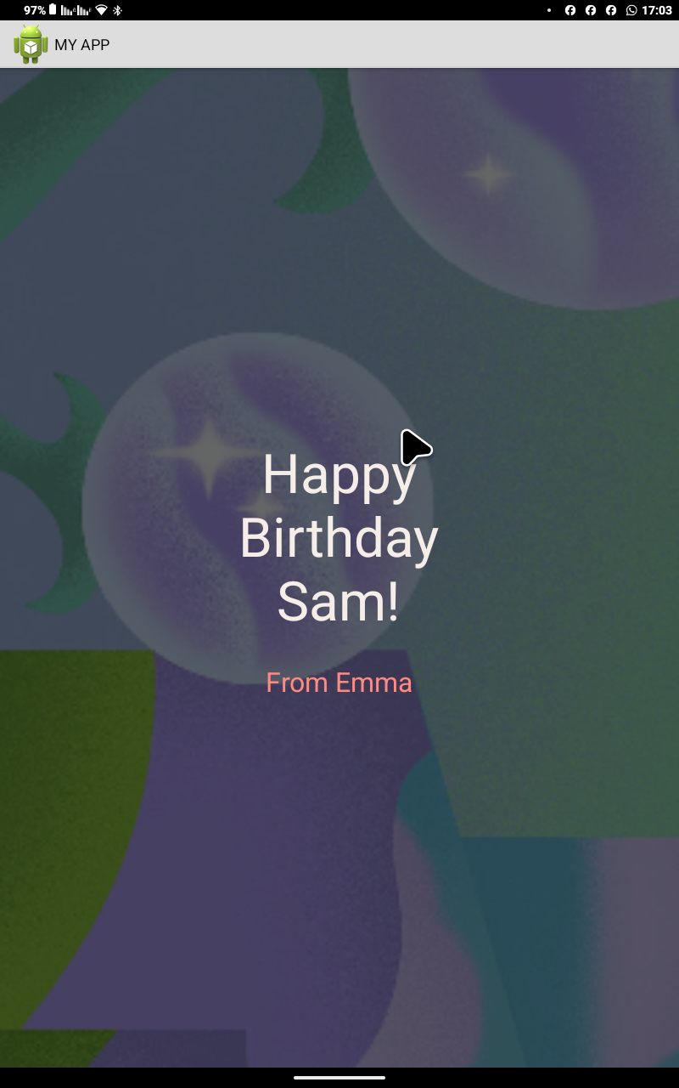

2-TaskDone-LifhtMode
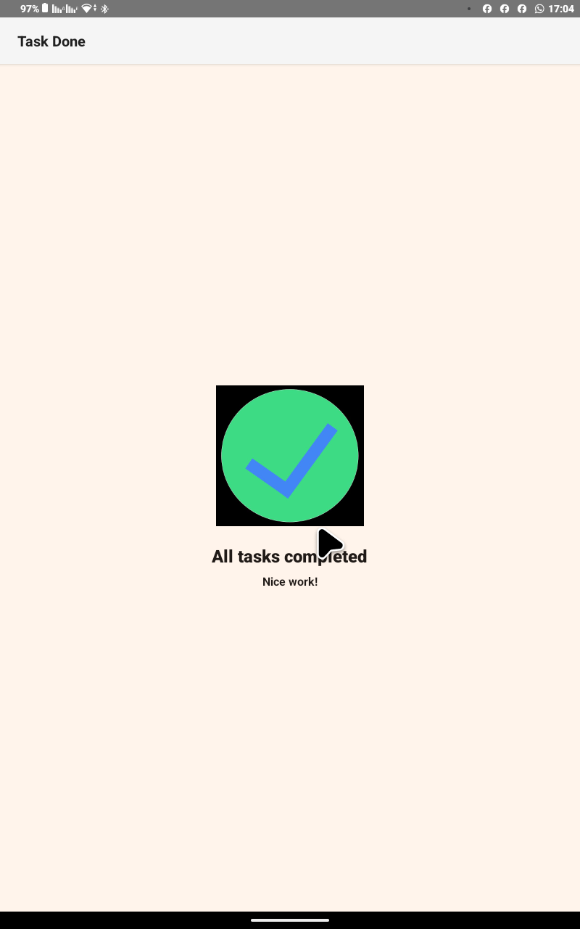

2-TaskDone-DarkMode
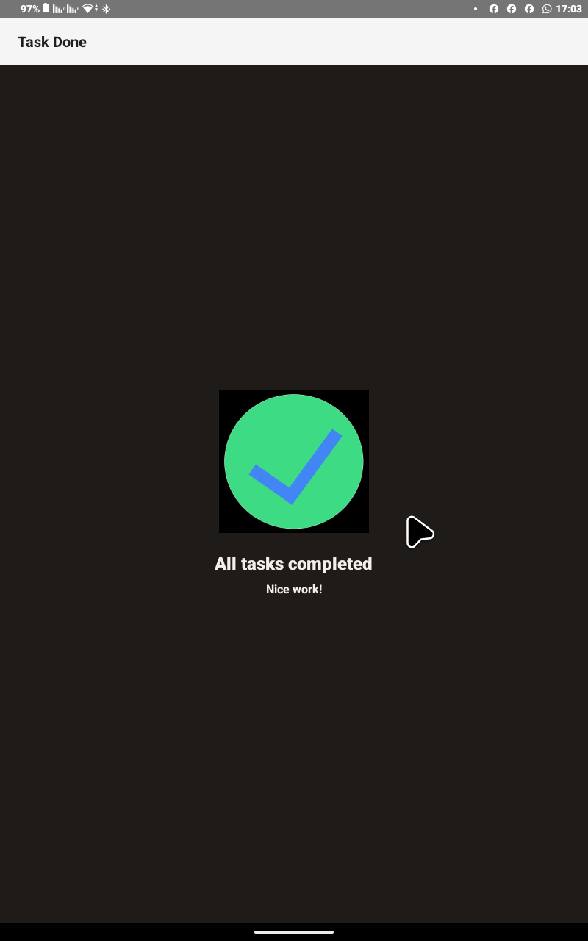

3-Quadrant-LightMode
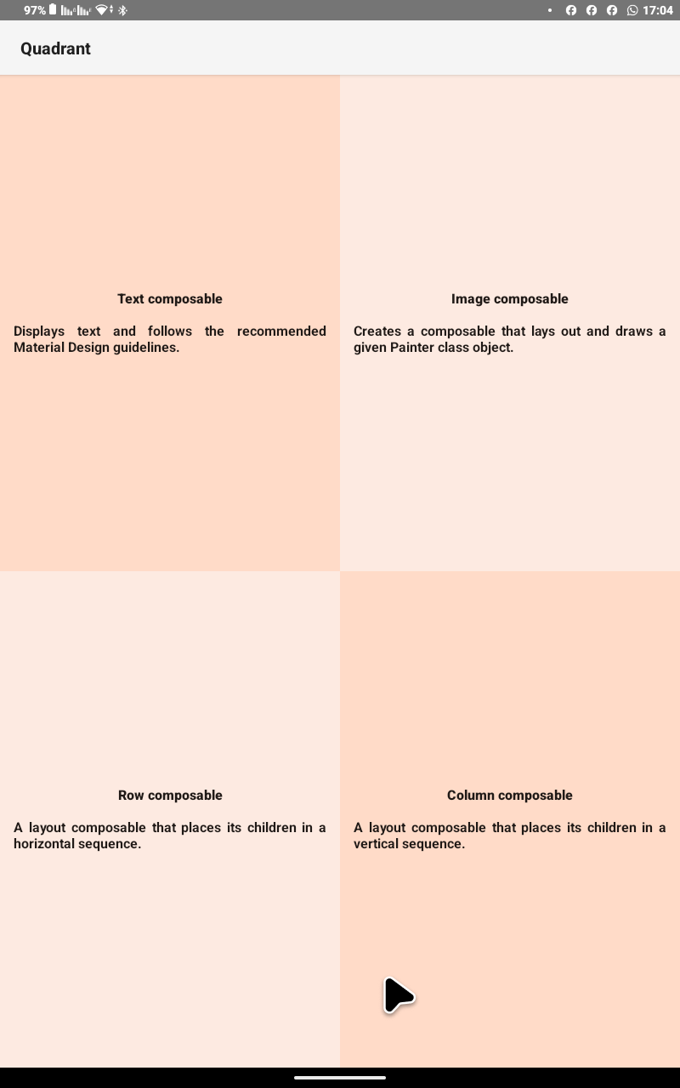

3-Quadrant-DarkMode
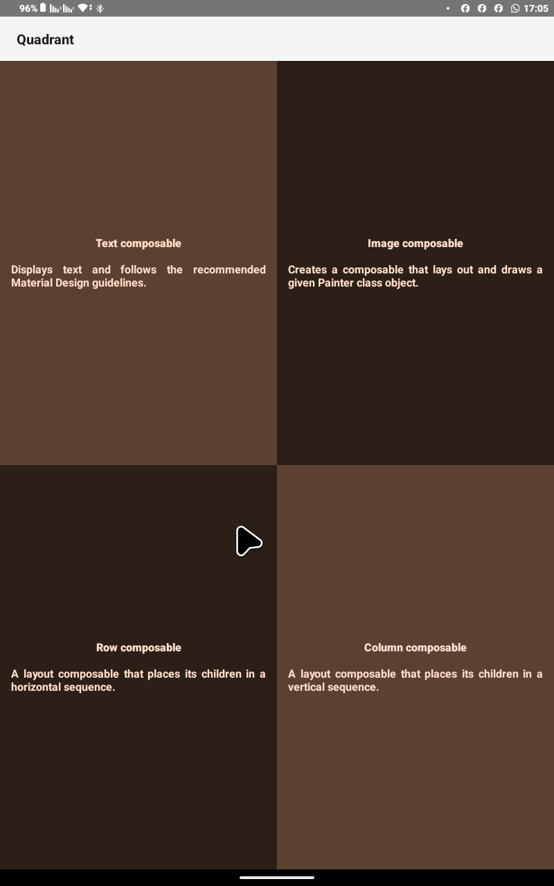

4-Article-LightMode
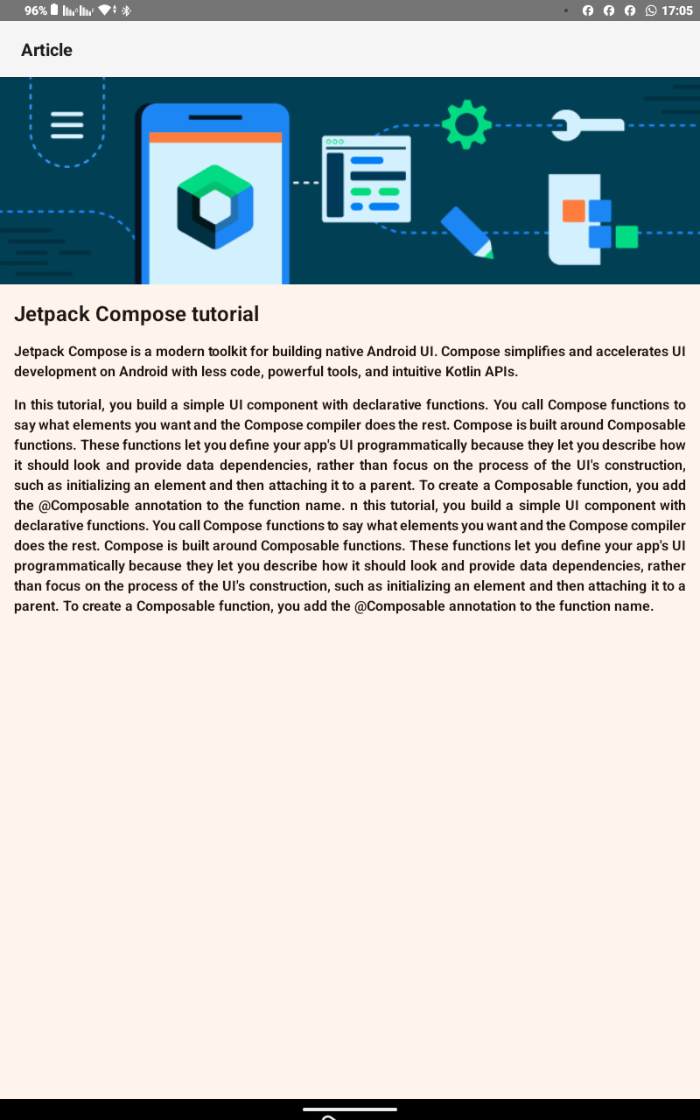
4-Article-LifhtMode
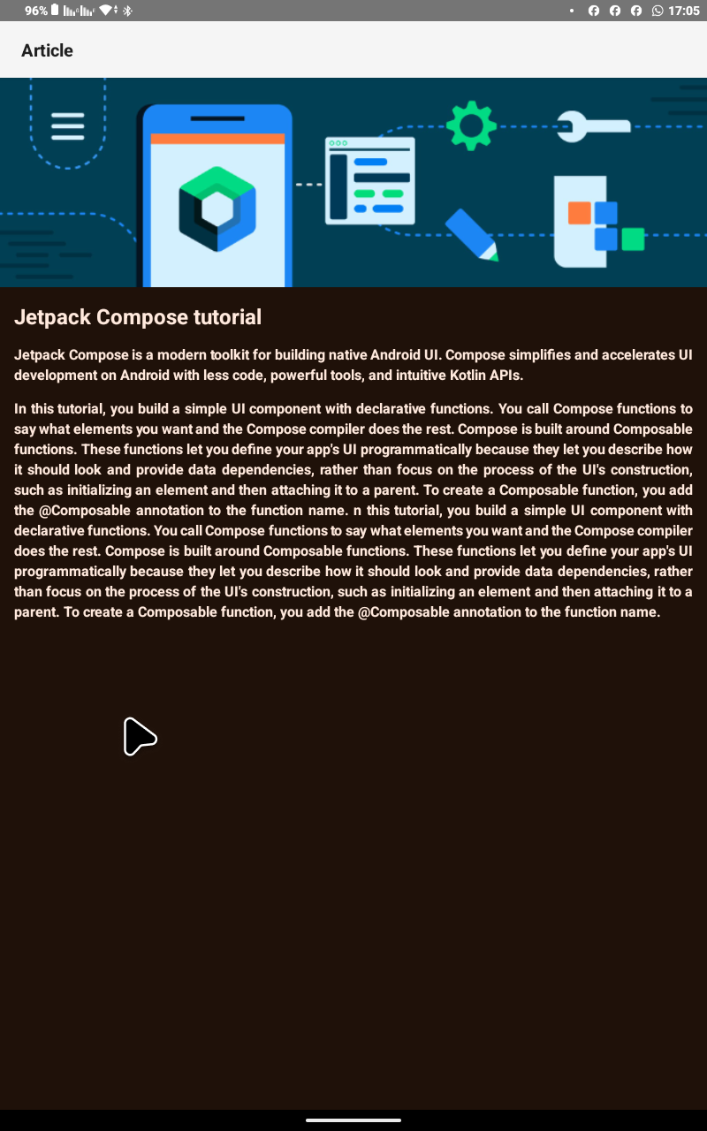
5-BusinessCard-LightMode & DarkMode that same


