**LAPORAN**

**TEKNIK DIGITAL**



**NAMA : Muhammad Rifqi Athallah**

**NIM : 202031234**

**KELAS : Informatika F**

**NAMA DOSEN : Max Teja Ajie Cipta W S.KOM**

**LABORATORIUM EMBEDDED SYSTEM**

**INSTITUT TEKNOLOGI PLN**

**2021**

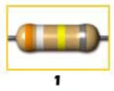**Gambar 1**

- Gelang 1 (Orange) = 3

- Gelang 2 (Putih) = 9

- Gelang 3 (Kunig) = 4 atau

- Gelang 4 (Abu-abu) = 8 = ± 0,05%

Nilai resistansi = 39 x dengan toleransi ± 0,05%

= 390.00 ohm =39 mega ohm dengan toleransi ± 0,05%

Nilai resistansi = 39 x± 0,05%

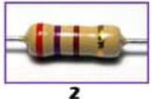**Gambar 2**

- Gelang 1 (Merah) = 2

- Gelang 2 (Ungu) = 7

- Gelang 3 (Coklat) = 1 atau 10 Ω

- Gelang 4 (Emas) = ± 5%

Nilai resistansi = 27 x 10 ± 5 Ω

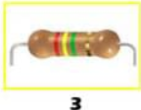**Gambar 3**

- Gelang 1 (Merah) = 2

- Gelang 2 (Kuning) = 7

- Gelang 3 (Hijau) = 5 atau 10 Ω

- Gelang 4 (Emas) = ± 5%

Nilai resistansi = 24 x ± 5 Ω

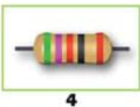**Gambar 4**

- Gelang 1 (Merah) = 5

- Gelang 2 (Kuning) = 7

- Gelang 3 (Hijau) = 0 atau atau 1 ohm

- Gelang 4 (Emas) = ± 5%

- Gelang 5 (Merah) = ± 2%

Nilai resistansi = 5.720 ± 2% Ω

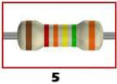**Gambar** 5

- Gelang 1 (Coklat) = 1

- Gelang 2 (Merah) = 2

- Gelang 3 (Orange) = 3

- Gelang 4 (Kuning) = 4 atau

- Gelang 5 (Hijau) = 0,5%

-Gelang 6 (Orange ) = 15 PPM /°**C**

Nilai resistansi = 123 x =123 x 10.000

**=** 1230000 ohm

=12,3 kilo ohm dengan toleransi sebesar 0,5% dan koefisien sebesar 15 PPM/°**C**

**Latihan Soal**

1. Sinyal Digital dari inputan data 101110010

Jawab :

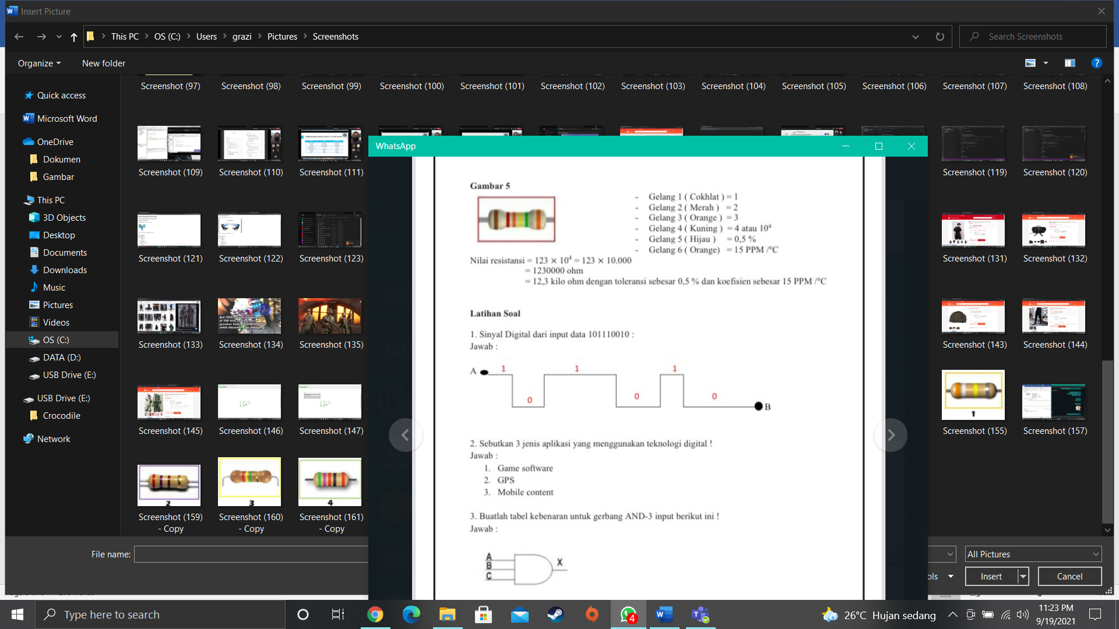

1. Sinyal Digital dari input data 101110010 :

Jawab :

* Game Software
* GPS
* Mobile Content

1. Buatlah tabel kebenaran untuk gerbang AND-3 input berikut !

Jawab :



|  |  |  |  |
| --- | --- | --- | --- |
| Tabel Kebenaran | | | |
| A | B | C |  |
| 0 | 0 | 0 | 0 |
| 1 | 0 | 0 | 0 |
| 0 | 1 | 0 | 0 |
| 1 | 1 | 0 | 0 |
| 0 | 0 | 1 | 0 |
| 1 | 0 | 1 | 0 |
| 0 | 1 | 1 | 0 |
| 1 | 1 | 1 | 1 |

1. Buatlah tabel kebenaran untuk gerbang NOR-4 input berikut

Jawab :

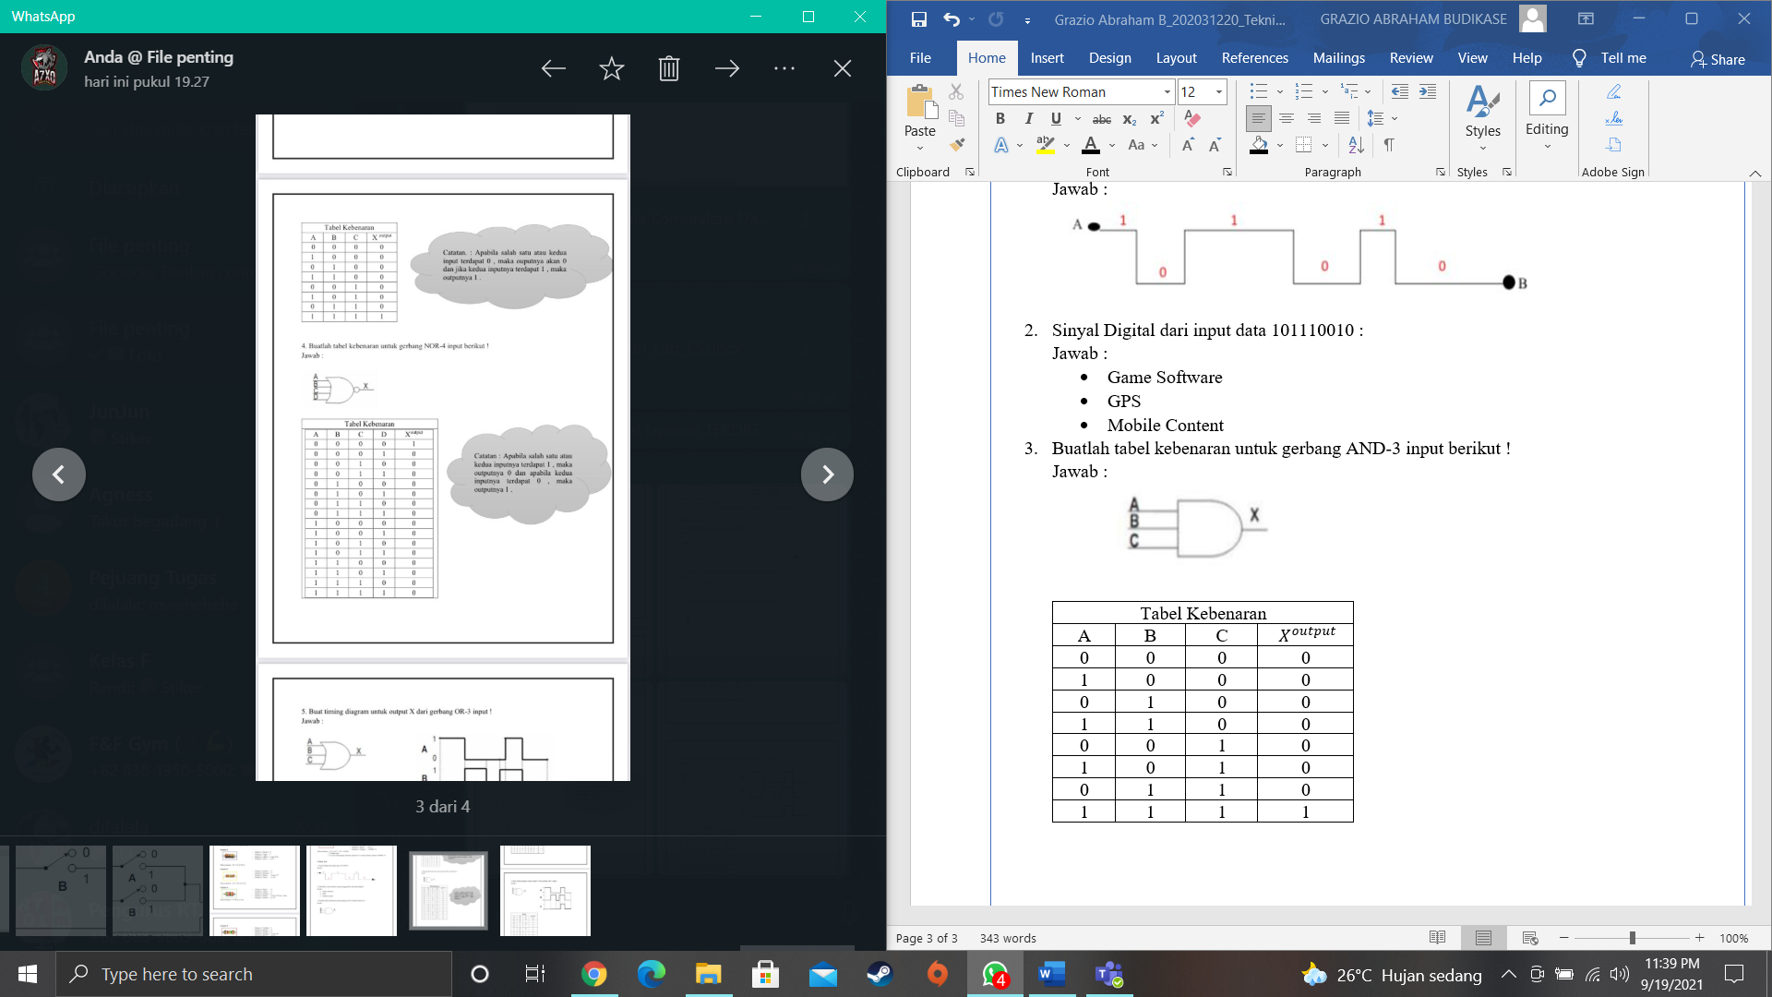

|  |  |  |  |  |
| --- | --- | --- | --- | --- |
| Tabel Kebenaran | | | | |
| A | B | C | D |  |
| 0 | 0 | 0 | 0 | 1 |
| 0 | 0 | 0 | 1 | 0 |
| 0 | 0 | 1 | 0 | 0 |
| 0 | 0 | 1 | 1 | 0 |
| 0 | 1 | 0 | 0 | 0 |
| 0 | 1 | 0 | 1 | 0 |
| 0 | 1 | 1 | 0 | 0 |
| 0 | 1 | 1 | 1 | 0 |
| 1 | 0 | 0 | 0 | 0 |
| 1 | 0 | 0 | 1 | 0 |
| 1 | 0 | 1 | 0 | 0 |
| 1 | 0 | 1 | 1 | 0 |
| 1 | 1 | 0 | 0 | 0 |
| 1 | 1 | 0 | 1 | 0 |
| 1 | 1 | 1 | 0 | 0 |
| 1 | 1 | 1 | 1 | 0 |

1. Buatlah Timing diagram untuk output X dari gerbang OR-3 input !

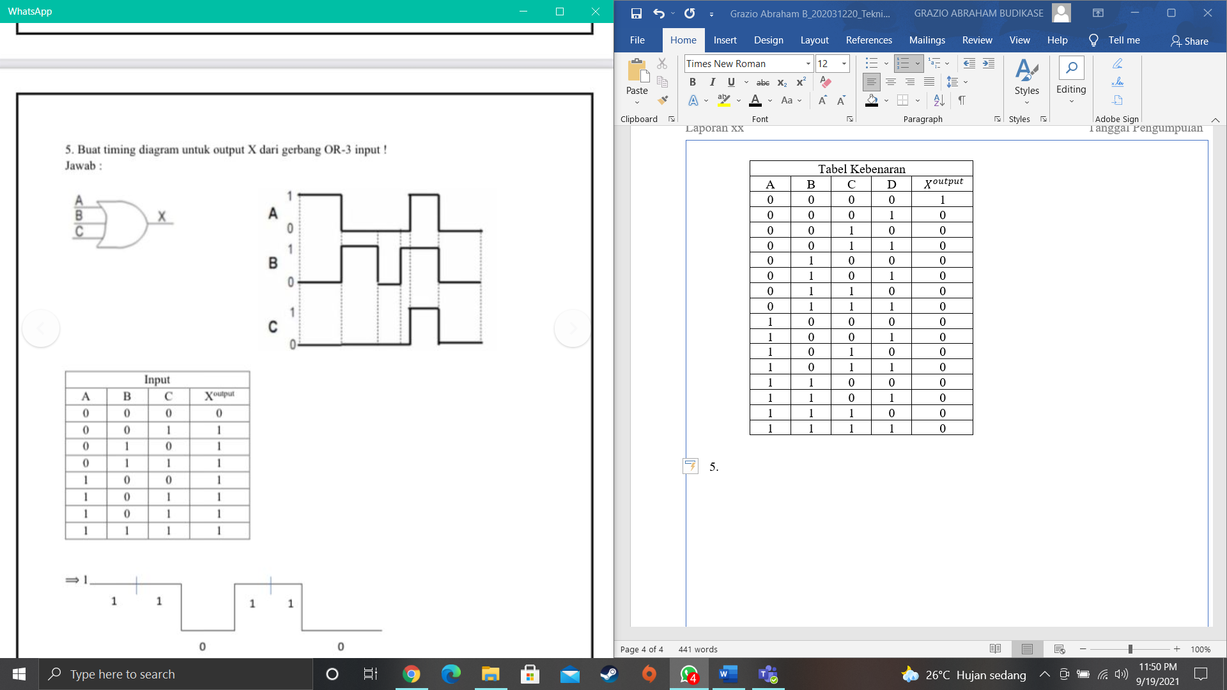Jawab:



|  |  |  |  |
| --- | --- | --- | --- |
| Input | | | |
| A | B | C |  |
| 0 | 0 | 0 | 0 |
| 0 | 0 | 1 | 1 |
| 0 | 1 | 0 | 1 |
| 0 | 1 | 1 | 1 |
| 1 | 0 | 0 | 1 |
| 1 | 0 | 1 | 1 |
| 1 | 0 | 1 | 1 |
| 1 | 1 | 1 | 1 |



**Hasil Screenshoot seri dan pararel**

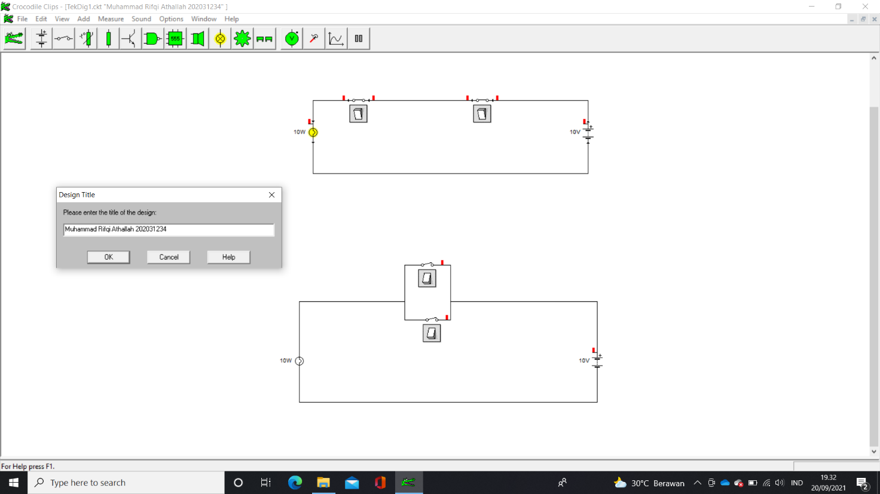

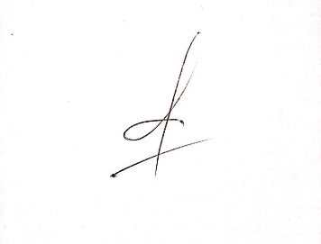

Muhammad Rifqi Athallah