Group: Sven and Dragos

1. Make a SWOT analysis of CHC’s situation BEFORE implementing the new IT-system.

**Strength:** Reputation amongst travelling agencies. Well established position with a well defined market niche.

**Weaknesses:** Bureaucratic business procedures. Unable to prevent quarrels amongst customers due to

undeveloped booking system

**Opportunities:**

**Threats:** Other high end hotels in the area competing on the service and quality. Customers wanting cheaper hotels due to the financial crisis.

2. Which purpose is the IT-system intended to have for the company seen from a business point of view? Formulate a vision and make a list of business goals. (Remember goals must be SMART)

**increased efficiency in the booking system:** The IT-system is intended to have the purpose of providing better service for the customers and to decrease the payload of the employees. By improving the booking system of both the rooms and the services under the customers stay, the company will be able to down on the time the receptionists use and will also decrease the chance of human error in the bookings.

The new IT-system will provide the receptionist with all the data she needs to determine whether or not any rooms is available for booking without having to scroll through a large and heavy excel file.An indicator of whether or not the system will work as intended is the amount of time spent for the receptionist arranging bookings of rooms. The results should be immediate after the new system has been implemented and the receptionist has been taught how to do it.

**Improve customer happiness:** The company wants a high degree of customers satisfaction and the new IT-system will be able to help the customers with the booking of the sports facilities and thereby decrease the doubt of who's turn it is. This will help the with the overall satisfaction of customers as the doubt about the bookings will decrease and the goal is to have the disappear entirely.

It is realistic to expect that this problem can be solved entirely as a computer nearby the sports facility easy and objectively will be able to tell who has booked the facilities and when their turn ends.

The results should be immediate after the implementation of the new booking system and customer happiness can be tested by asking the customers and have them rate the system after and prior to implementation.

**Optimization of profit:** The purpose of the new IT-system will also be to optimize profits on the reservation of sport facilities. So long as there is doubt about who's turn it is and so long as people argue over it at the facilities, some may be inclined to not want to pay when time has been wasted, or perhaps not pay in full. Wasted time is wasted money, and this new IT-system will be able to decrease the amount time where the sport facilities is not in use due to disagreements etc.

3. Make a Domain Model.

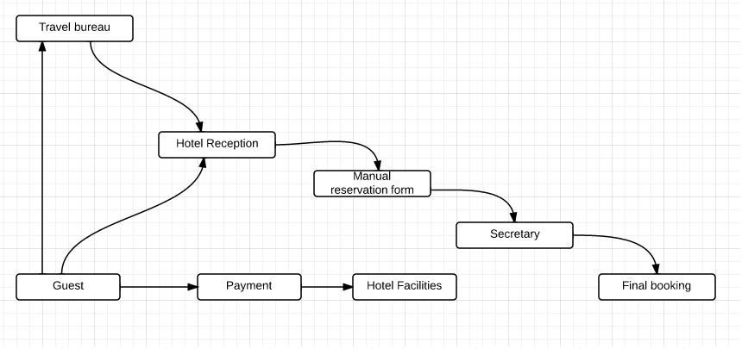

4. Describe central business processes by means of activity diagrams, use of swim lanes are expected. The diagrams must describe the processes AS-IS 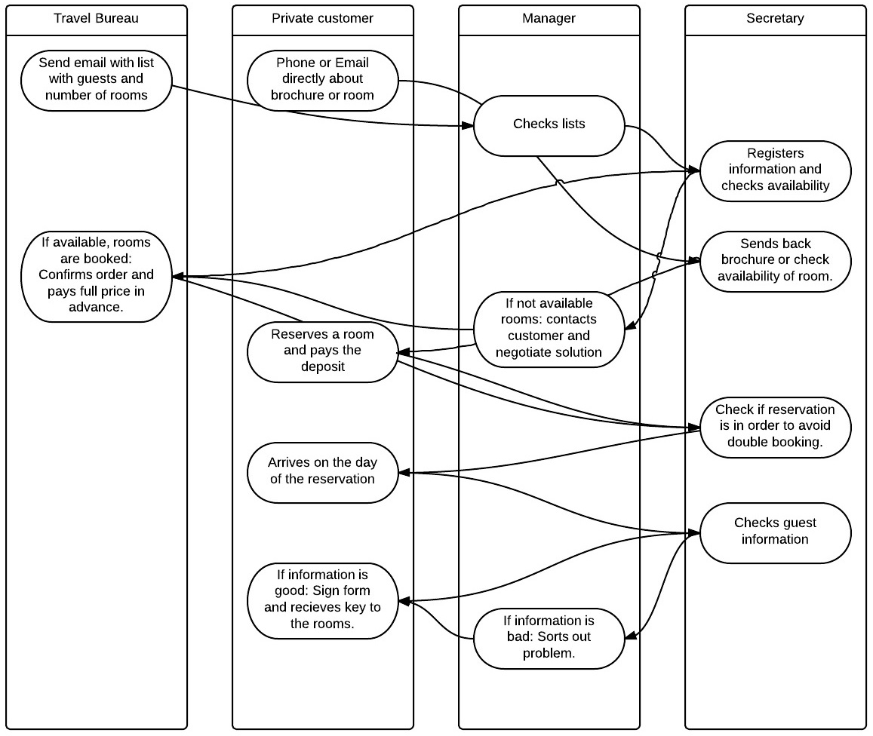

5. Make a list of the features you expect in the new IT-system. Make quality-check (vision-goal- features) by means of the traceability-model. 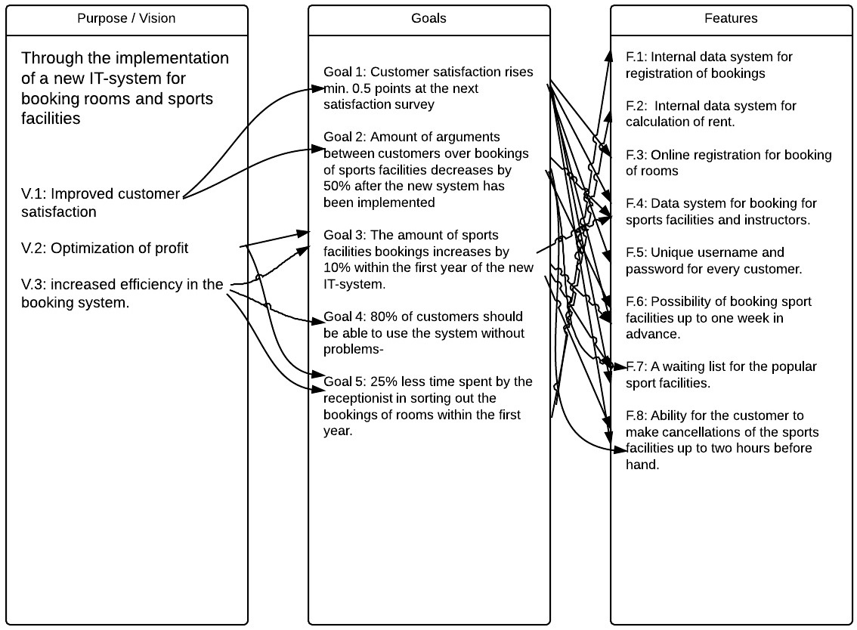

6. Describe central business processes by means of activity diagrams, use of swim lanes are expected. The diagrams must describe the processes after implementing the new IT-system (TO-BE)

