UNIVERSITY OF INFORMATION TECHNOLOGY AND SCIENCES (UITS)
Simulation & Modeling Lab · Section 7C · Autumn-2026
PROJECT REPORT
Simulation and Optimization of Traffic Signal Timing at a Dhaka Intersection
Team Number: 16
Student ID | Student Name
432320005101168 | Mahathir Ullah Yafi
432320005101173 | Sadiqur Rahman Apon
432320005101174 | SM Sabbir Hossin
432320005101187 | Nazib Mahmud

Submitted to: Afroja Ahmed Smrity
Submission date: 2 November 2026
GitHub: https://github.com/MRsabbir18/SIM-Project-Trafic_signal

Table of Contents
Abstract 3
1. Introduction 3
2. Literature Review 3
3. Dataset and Feature Details 4
4. Methodology 5
Block diagram 6
Equations 6
5. Pseudocode 7
6. Result Analysis and Discussion 8
7. Limitations and Validation Plan 11
8. Conclusion and Future Work 11
References 11
GitHub Repository 12

Abstract
Vehicle delay at signalized intersections is a daily problem in Dhaka, and signal timing is one of the few levers that costs little to change. This study builds a discrete-event simulation of a signalized intersection in Python (SimPy) to test whether changing green times reduces waiting time. Vehicles arrive as a Poisson process from each approach, and five vehicle types discharge at different headways. A grid search over green times from 15 to 60 seconds, with five replications per plan, compares each plan against a baseline. In a scenario built from published Dhaka counts, the best plan (NS 30 s, EW 25 s) cut average waiting time from about 58 s to about 24 s, roughly 59% lower. These figures come from a simplified model on literature data, and the next step is validation against our own field observations.

1. Introduction
Traffic congestion in Dhaka wastes commuters' time every day, and much of that delay builds up at signalized intersections where vehicles queue for the next green. Changing signal timing costs far less than building new roads, so it is a practical first place to look for improvement.
Testing a new signal plan on a real road is risky and slow. A computer simulation lets us try many plans on a model of the intersection and compare them under the same conditions before anything is changed in the field.
Objectives
1. Build a discrete-event simulation of a signalized intersection in Dhaka.
2. Measure the average waiting time and queue length under the current signal plan (baseline).
3. Search for green-time settings that reduce waiting time, and report the uncertainty of the result.
4. Validate the model against our own field observations (planned next step).
Intersection studied. The model uses published counts from Intersection 2 on Abdul Gani Road, Dhaka (three approaches: North, East, South). Our own field counts at a Dhaka intersection will replace these inputs in the next step.

2. Literature Review
Published work on Dhaka's signalized intersections is limited, and we found two sources useful for this project.
A study of two intersections on Abdul Gani Road, beside the Bangladesh Secretariat [1], extracted vehicle types and counts by hand from video recorded on a Monday morning peak. It reports vehicle counts and green times for each approach and validates a simulation model against exit volumes. We use its Intersection 2 counts as the input scenario.
A second paper, "Towards Intelligent Traffic Signaling in Dhaka City" [2], tests a camera-based adaptive signal system at the five-way Palashi intersection. It shows that Dhaka's mixed traffic can be sensed and that signal plans can be adjusted automatically, but it does not publish arrival rates or signal timings we could reuse.
Gap. Neither source gives a simple, reproducible simulation that a student team can rerun with its own field counts. Our project fills that gap with a small open Python model that takes arrival rates, vehicle mix and signal times as inputs.

3. Dataset and Feature Details
Data source. The main dataset is the vehicle arrival count for each approach. We use published counts for Intersection 2 on Abdul Gani Road, Dhaka, extracted by hand from video recorded on a Monday morning peak [1, Table 1]. The paper does not state the counting duration consistently, so we assume one hour. All values used are listed in the repository file data/project_dataset.xlsx.
Approach | Vehicles counted | Rate (vehicles/min) | Green time in paper (s)
North | 667 | 11.1 | 42
South | 614 | 10.2 | 41
East | 583 | 9.7 | 58
West | none (3-way intersection) | 0 | none

Simulated records. Each run creates one record per vehicle: approach, vehicle type, arrival time, departure time and waiting time. The results are computed from these records.
Features (model inputs).
Feature | Symbol | Value used | Source
Arrival rate per approach | λ | N 11.1, S 10.2, E 9.7, W 0 vehicles/min | Published counts ÷ 60 (one hour assumed)
Vehicle type share | p | Car 30%, Bus 10%, CNG 20%, Rickshaw 20%, Bike 20% | Assumed
Headway per vehicle type | h | 2.0, 3.5, 2.0, 2.5, 1.2 s (same order) | Assumed
North-South green time | g_NS | Baseline 42 s; searched 15 to 60 s | Paper; grid search
East-West green time | g_EW | Baseline 58 s; searched 15 to 60 s | Paper; grid search
Lost time per phase change | L | 6 s | Assumed
Run length | T | 3,600 s | Chosen
Replications per plan | R | 5 | Chosen

Outputs. Average waiting time per vehicle (s), number of vehicles left in the queue at the end of the run, and the 95% confidence interval of the average wait.
Our own data (planned). We also prepared an Excel template (data/field_data_template.xlsx) to record, per approach, vehicle counts by type for each minute (about 10 minutes per approach) and several timed signal cycles. Its Summary tab computes the average vehicles per minute and the vehicle mix that go straight into the model settings.

4. Methodology
The model is a discrete-event simulation written in Python with the SimPy library. One simulation run covers 3,600 seconds (one hour).
Arrivals. Vehicles arrive on each approach as a Poisson process, so the gaps between arrivals are exponentially distributed. The rate for each approach is its vehicle count per minute.
Vehicle types. Each arriving vehicle is a car, bus, CNG, rickshaw or bike, drawn with fixed probabilities. Each type needs a different time to leave the stop line (headway).
Vehicle type | Share of traffic (assumed) | Headway (s, assumed)
Car | 30% | 2.0
Bus | 10% | 3.5
CNG | 20% | 2.0
Rickshaw | 20% | 2.5
Bike | 20% | 1.2

Signal. A fixed-time, two-phase cycle: North-South green, all-red, East-West green, all-red. Each phase change costs 6 seconds of lost time (yellow, all-red and start-up delay). During green, each approach releases one vehicle at a time, one headway apart.
Input scenario. Arrival rates come from the Abdul Gani Road Intersection 2 counts (North 667, South 614, East 583 vehicles; no West approach), divided by 60 minutes. The baseline signal is North-South 42 s and East-West 58 s, simplified from the paper's per-approach green times.
Performance measures. Average waiting time per vehicle, counting vehicles still queued at the end of the hour, and the number of vehicles left in the queue.
Optimization. We simulate every combination of NS and EW green times from 15 s to 60 s in 5 s steps, five replications each (different random seeds), and report the mean with a 95% confidence interval. The plan with the lowest mean waiting time is the best plan.
Assumptions.
- The paper's counts cover one hour (the paper is not consistent about the duration).
- Vehicle shares and headways are our assumptions, not measured values.
- Each approach is a single queue with no turning movements, pedestrians or lane changes.

Block diagram
Stages 1 to 4 simulate one hour of traffic for one signal plan. Stages 5 and 6 repeat that five times and summarise the waiting time. Stages 7 and 8 repeat the whole chain for every green-time pair and pick the best.
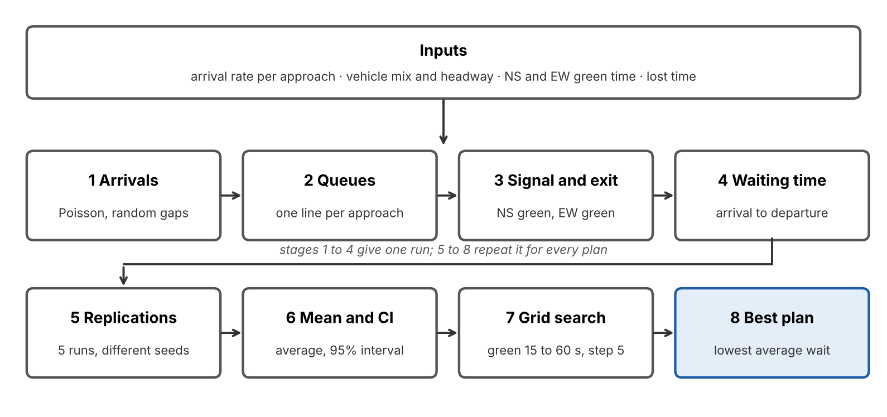
Figure 1: Block diagram of the simulation (8 stages).

Equations
Arrivals. If N_d vehicles are counted per hour on approach d, the arrival rate is λ_d per second and the gap T between two vehicles is exponentially distributed (a Poisson arrival process). We sample it from a uniform random number U.
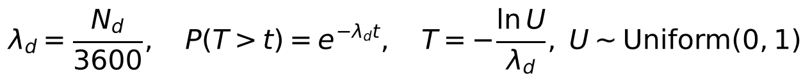
Vehicle type. Each vehicle is of type k with probability p_k and needs headway h_k seconds to leave the stop line.
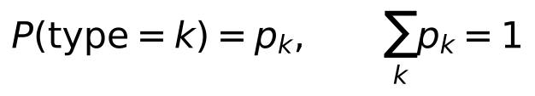
Signal cycle. With NS green g_NS, EW green g_EW and lost time L at each of the two phase changes:
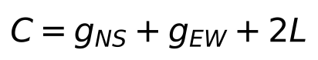
Waiting time. For vehicle i that arrives at t_arr and leaves at t_dep, in a run of length T = 3600 s. Vehicles still queued at the end are counted with the wait they have had so far.
Replications and confidence interval. Run r gives the mean wait over its N_r vehicles. Over R = 5 runs we report the mean x̄ and a 95% confidence interval.
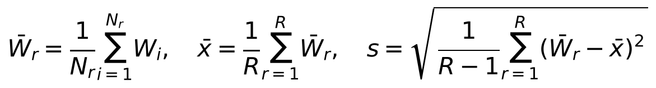
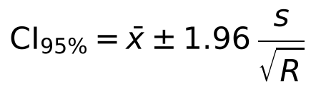
Optimization. The best plan is the green-time pair with the lowest mean wait over the grid; the reduction compares it with the baseline.
Note on the interval. We used the normal value 1.96. With only R = 5 runs, the t value 2.776 (4 degrees of freedom) is more exact and widens each interval by about 42%. The baseline would be about 38 to 78 s and the best plan about 22 to 26 s, so the two intervals still do not overlap.

5. Pseudocode
Algorithm 1 simulates one hour of traffic for one signal plan. Its three processes run at the same time inside the simulation clock.
ALGORITHM 1: simulate(g_NS, g_EW, seed)
INPUT: arrival rates lambda_d, type shares p_k, headways h_k,
lost time L, run length T
OUTPUT: average wait, number of vehicles left in the queue

set random seed; clock t = 0; waits = empty list
for each approach d: queue[d] = empty
START these three processes together:

SIGNAL:
repeat forever:
phase = NS ; wait g_NS seconds
phase = ALL-RED ; wait L seconds
phase = EW ; wait g_EW seconds
phase = ALL-RED ; wait L seconds

ARRIVALS(d):
if lambda_d = 0: stop
repeat forever:
wait a random time drawn from Exponential(lambda_d)
k = random vehicle type using probabilities p
add (t, k) to the back of queue[d]

DISCHARGE(d):
repeat forever:
if phase = group(d) and queue[d] is not empty:
(t_arr, k) = remove the first vehicle of queue[d]
add (t - t_arr) to waits
wait h_k seconds
else:
wait 0.5 seconds

run the clock until t = T
for each vehicle still in any queue: add (T - t_arr) to waits
return mean(waits), number of vehicles still in queues

Algorithm 2 repeats the simulation five times per plan and searches the green-time grid.
ALGORITHM 2: optimize()
baseline = evaluate(42, 58)
best = none
for g_NS in 15, 20, ..., 60:
for g_EW in 15, 20, ..., 60:
result = evaluate(g_NS, g_EW)
if best is none or result.mean < best.mean:
best = result
return baseline, best

evaluate(g_NS, g_EW):
for r = 0 to R-1:
(W_r, left_r) = simulate(g_NS, g_EW, seed = r)
mean = average of W_r
s = standard deviation of W_r
CI = 1.96 * s / sqrt(R)
return mean, CI, average of left_r

6. Result Analysis and Discussion
The best signal plan (NS 30 s, EW 25 s) lowered average waiting time from about 58 s to about 24 s, a reduction of roughly 59%, and cut the vehicles left in the queue from about 39 to about 11.
Plan | NS green (s) | EW green (s) | Avg wait (s), mean ± 95% CI | Vehicles left in queue
Baseline | 42 | 58 | 58.4 ± 14.1 | 39
Best plan | 30 | 25 | 23.8 ± 1.3 | 11

The two confidence intervals do not overlap, so the difference is not explained by random variation across the five replications. The baseline interval is wide because its long red phases make waiting time swing from run to run.
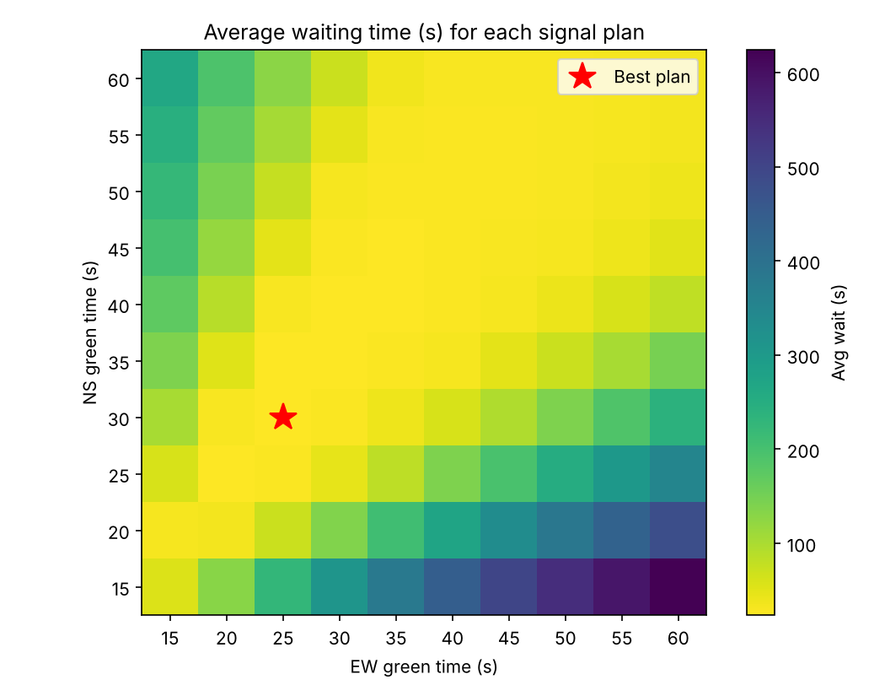
Figure 2: Average waiting time for every NS and EW green-time pair. The star marks the best plan (NS 30 s, EW 25 s).
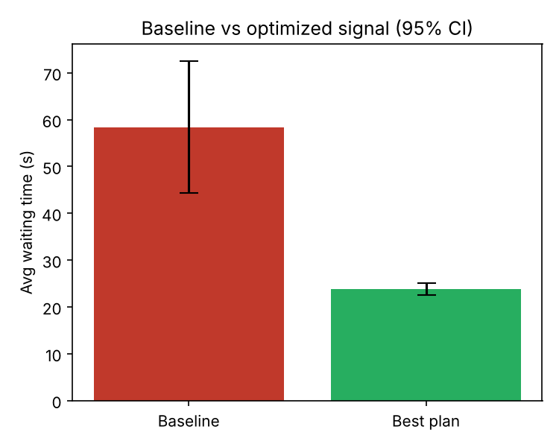
Figure 3: Baseline versus best plan, with 95% confidence intervals.
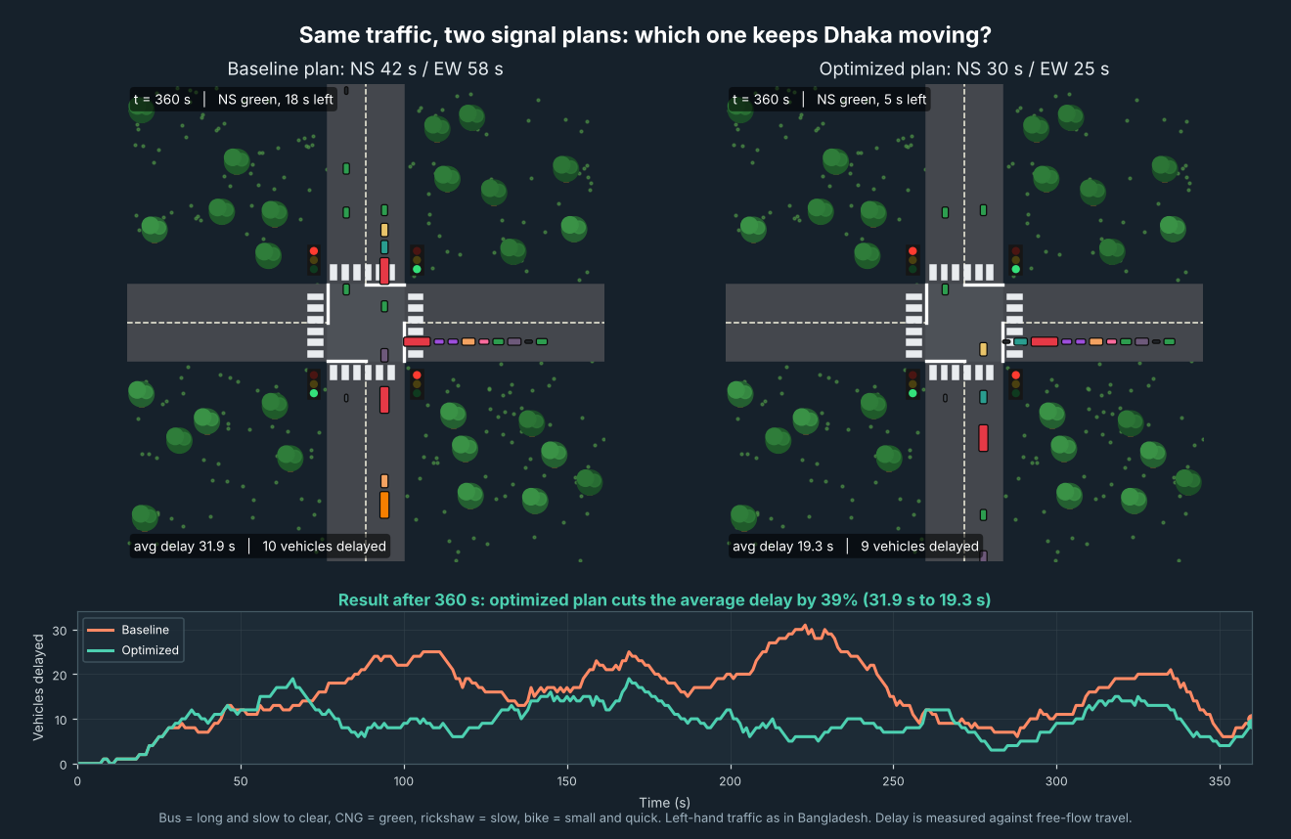
Figure 4: Final frame of our traffic animation (notebook in the repository). Both panels carry the same simulated traffic. In this 6-minute demo the optimized plan cut the average delay from 31.9 s to 19.3 s (39%). The demo uses a shorter window and measures delay against free-flow travel, so its numbers differ from the one-hour results in Figures 2 and 3.
Sensitivity to demand. To test how much the result depends on our assumed arrival rates, we scaled all arrival rates to 80%, 100% and 120% and re-ran the baseline and the best plan found at 100% (NS 30 s, EW 25 s). The best plan beat the baseline at every level.
Arrival rate | Baseline avg wait (s) | Best plan avg wait (s) | Reduction
80% | 29.5 ± 1.1 | 17.5 ± 0.7 | 41%
100% | 58.4 ± 14.1 | 23.8 ± 1.3 | 59%
120% | 193.3 ± 24.1 | 68.4 ± 7.0 | 65%

At 120% the baseline wait rises sharply because queues keep growing through the hour. Values are mean ± 95% confidence interval over 5 runs.
The large gain is partly a feature of this scenario. Demand is light compared with what a green phase can discharge, so shorter cycles shorten the red wait for everyone. Section 7 explains why the real-road gain would likely be smaller.
Discussion. Shorter cycles help here because each approach can release about 29 vehicles per minute of green (the average headway is about 2.1 s), while demand is about 10 to 11 vehicles per minute per approach. Vehicles therefore spend most of their wait on red, and a shorter red means a shorter wait. Mixed traffic matters: buses (3.5 s) and rickshaws (2.5 s) lengthen the average headway, and a plan that ignored them would overstate capacity. The sensitivity test shows the baseline is fragile, because at 120% demand its queues keep growing, while the optimized plan stays far lower. For Dhaka, the practical message is that retiming a signal is a low-cost step worth testing, provided pedestrian crossing time and minimum green rules are added, since they are not in our model.

7. Limitations and Validation Plan
The result is a model finding on literature data, not a measured improvement on a road. The main limits are:
- Input data. Counts come from another intersection, and their duration is uncertain. If the counts cover two hours, arrival rates halve.
- Assumed parameters. Vehicle shares, headways and the 6 s lost time are our assumptions.
- Simplified signal. Two phases only, no pedestrian crossing time, no minimum green rule, no turning movements.
- Short experiment. Five replications per plan, one simulated hour, no warm-up period.
Validation plan. We will count vehicles per approach and per type at our chosen intersection for about 10 minutes per approach, and time several signal cycles with a stopwatch. We will then run the model with those inputs and compare its average queue and waiting time against a sample of vehicles timed in the field. Sensitivity analysis will repeat the experiment with arrival rates raised and lowered by 20%.

8. Conclusion and Future Work
In a simulation built from published Dhaka counts, retiming the signal from 42 s / 58 s to 30 s / 25 s reduced average vehicle waiting time by about 59%. The result shows that green-time choice matters at this scale of demand, and that a small SimPy model is enough to compare plans with confidence intervals.
Future work
1. Replace the literature scenario with our own field counts and signal times, and validate the model.
2. Run sensitivity analysis on arrival rate (±20%) and on the assumed headways.
3. Add pedestrian time, a minimum green rule and turning movements.
4. Compare peak and off-peak scenarios.
5. Test an adaptive signal that changes green time with queue length, and compare it against SUMO.

References
[1] Hoque, I. (2025). Exploration of the effects of heterogenous vehicle composition on urban arterial traffic flow attributes. EngrXiv preprint, posted 17 March 2025. https://engrxiv.org/preprint/view/4440 (counts and green times from Table 1).
[2] Azam, K. A., Masum, H., Rahaman, M., & Islam, A. B. M. A. (2025). Towards intelligent traffic signaling in Dhaka City based on vehicle detection and congestion optimization. arXiv:2510.16622. https://arxiv.org/abs/2510.16622

GitHub Repository
Repository link: https://github.com/MRsabbir18/SIM-Project-Trafic_signal
The repository holds everything needed to rerun the project:
- README.md: project summary, results, data source, how to run
- notebooks/Traffic_Signal_Simulation_Team16.ipynb: the full simulation as a Google Colab notebook, step by step
- notebooks/Traffic_Animation_Team16.ipynb: side-by-side traffic animation of the baseline and optimized plans
- src/traffic_sim.py: the same model as a Python script
- src/traffic_animation.py: the animation as a Python script
- data/project_dataset.xlsx: the dataset, features and results used in this report
- results/: the two graphs from the latest run
- requirements.txt: simpy, numpy, pandas, matplotlib
To rerun, upload the notebook to Google Colab and choose Runtime → Run all, or run pip install -r requirements.txt and python src/traffic_sim.py.

