Matt Rumschlag

Java applications II

3/28/2015

Lab 1.1

Question 1

Log.i(TAG, "I've found " + activities.size() + " activities.");

Question 2

60

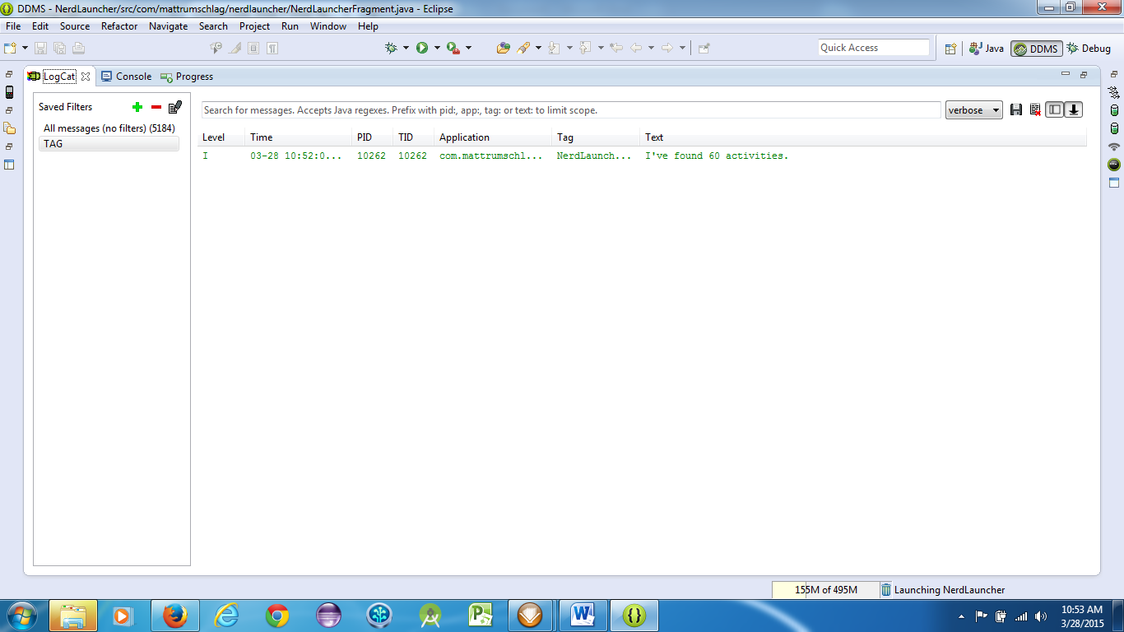

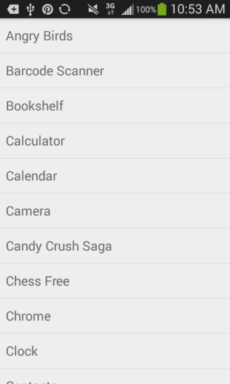

Question 3

Package name and Class name

Question 4

Yes

Question 5

It shows nerdlauncher but no new tasks

Question 6

