Matt Rumschlag

SD2650

5/6/15

Lab 4.1

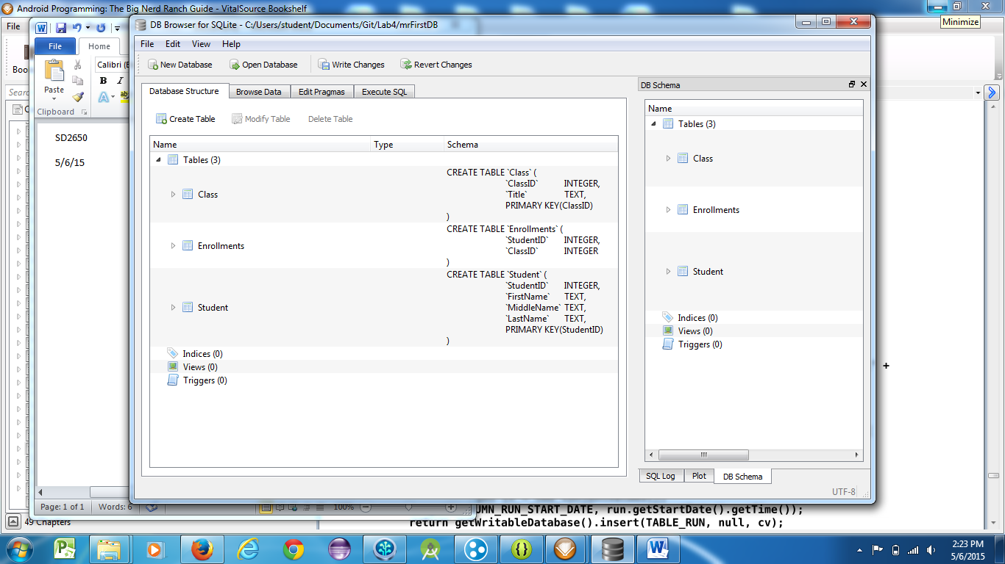

Question 1:

ClassID is a foreign key in the Enrollments table. It has not been set up as a foreign key yet though.

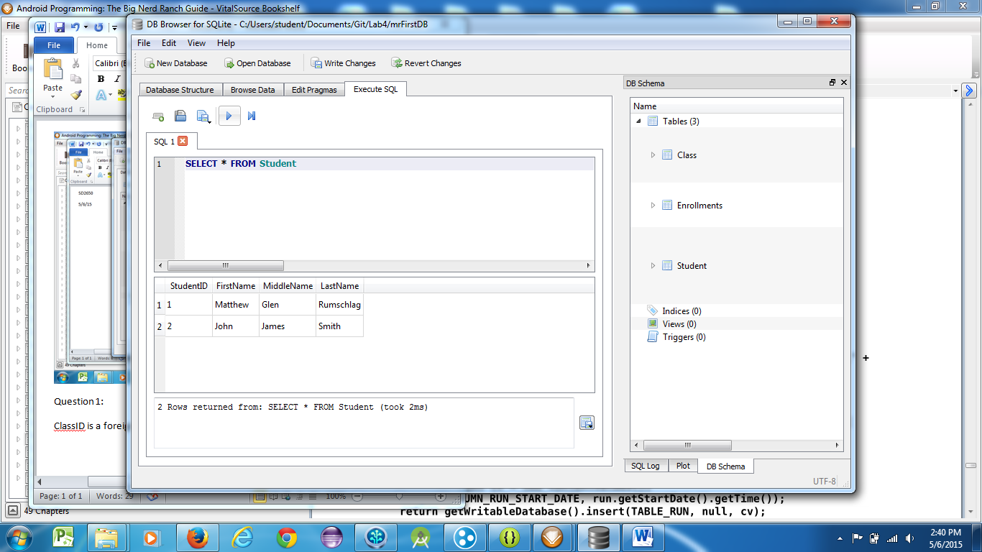

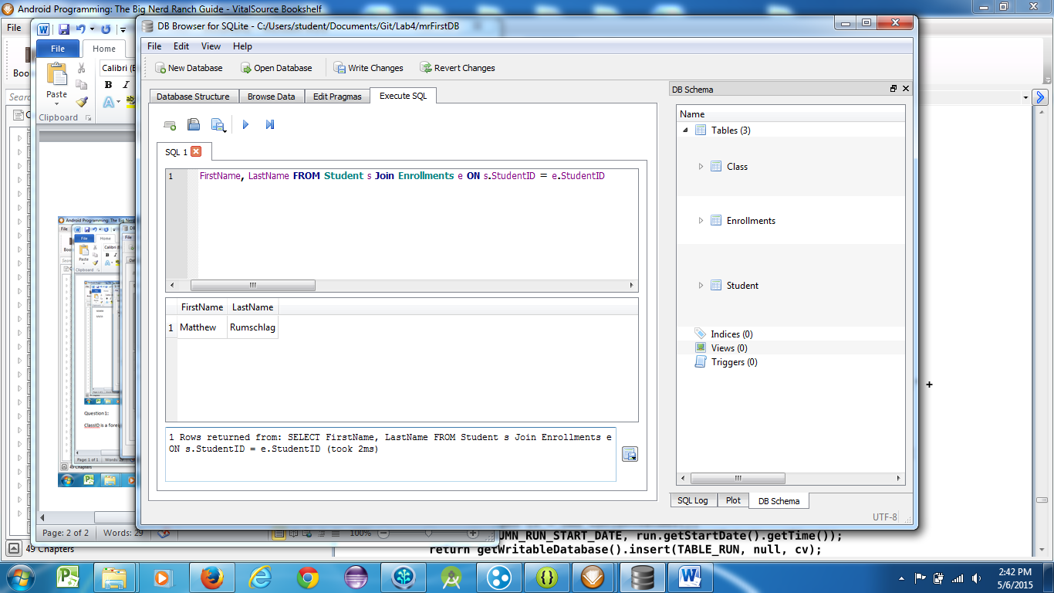

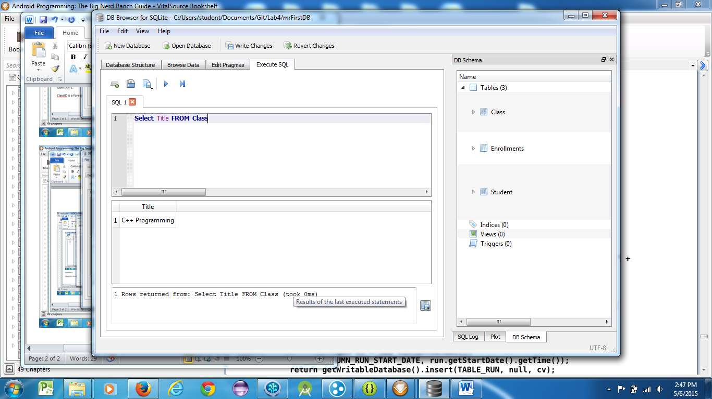

Question 2:

It marks the transaction as successful and ready to move on to endTransaction().