Matt Rumschlag

SD2650

5/24/2015

Lab 6.1



Question 1:

BoxDrawingView

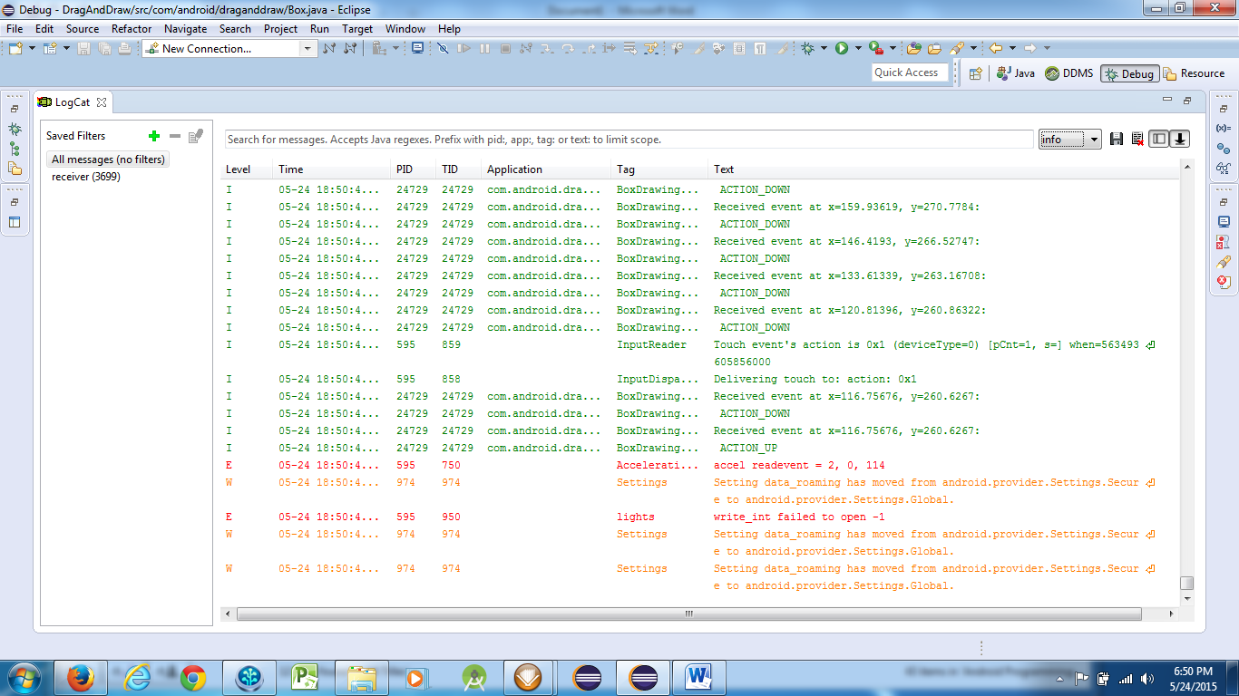

Question 2:

Calling invalidate() causes the screen to be updated as the box is changed.

Question 3:

It sets the maximum distance for the box on the bottom or right sides.

