
UNIVERSITY OF ENGINEERING AND TECHONOLOGY, PESHAWAR
JALOZAI CAMPUS

COURSE TITLE
Introduction To AI Programming
Assignment : 02
SUBMITTED BY
Muhammad Saad
Reg no : 24JZELE0577
SUBMITTED TO
Sir Irasdullah
DEPARTMENT OF ELECTRICAL ENGINEERING
UNIVERSITY OF ENGINEERING AND TECHONOLOGY,
PESHAWAR, JALOZAI CAMPUS

- Load the CSV manually
  - Use the csv module
  - Store each column separately:
    - days = []
    - hours = []
    - consumptions = []
- Group consumption by hour (manual group-by)
Create a dictionary like:
{ 1: [200, 700, 800, 500],
2: [300, 600, 700, 400],
3: [500, 400, 600, 650] }
  - Compute average consumption per hour
  - Compute peak consumption per hour
  - Print results in a neat format
- Group consumption by day
  - Create a dictionary like:
{ 7: [200,300,500,700,600,400],
8: [800,700,600,500,400,650] }
  - Compute total consumption per day
  - Compute daily average.

Program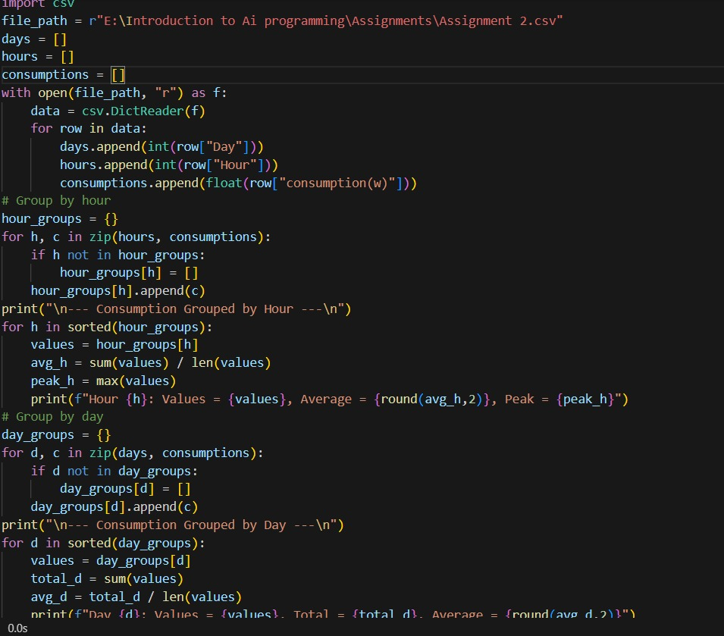

Output

