
UNIVERSITY OF ENGINEERING AND TECHONOLOGY, PESHAWAR
JALOZAI CAMPUS

COURSE TITLE
Introduction To AI Programming
Assignment : 03
SUBMITTED BY
Muhammad Saad
Reg no : 24JZELE0577
SUBMITTED TO
Sir Irasdullah
DEPARTMENT OF ELECTRICAL ENGINEERING
UNIVERSITY OF ENGINEERING AND TECHONOLOGY,
PESHAWAR, JALOZAI CAMPUS

- Load both CSVs.
- Store loads and prices into lists.
- Write a function to compute.
  - Hourly bill
  - Total bill

Program:

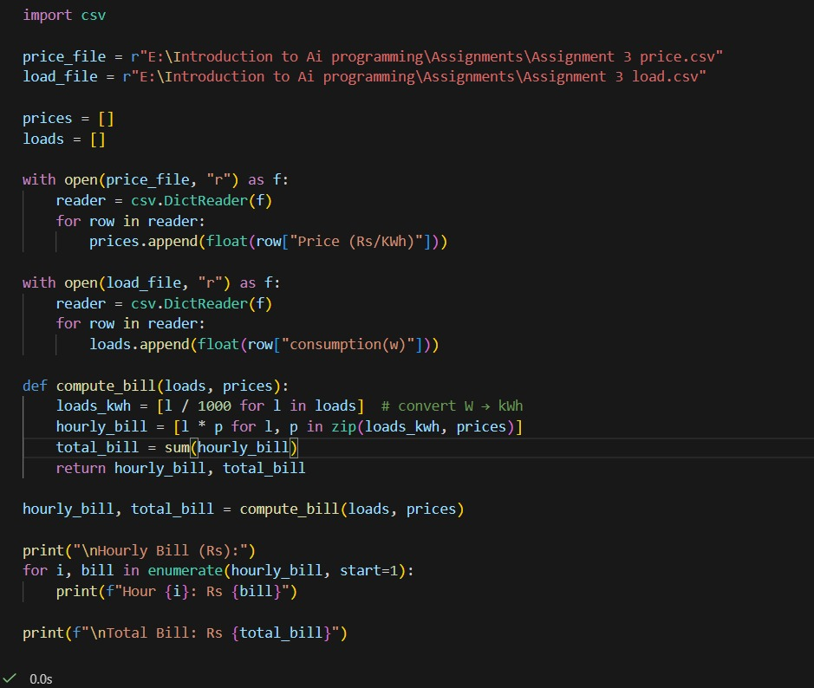

OutPut

