Table of Contents

Lightning-Indexer Sort Precision Reduction: Feasibility Report
GLM-5.1 / DSA path on vLLM 0.19, 8× H200. Capture run: 6,547 prompts from LiveCodeBench / AIME / GPQA Diamond.

1. Summary
The lightning indexer in GLM-5.1’s DSA path performs a top-k=2048 sort over per-(query, key) scores at every layer of every forward step. We evaluated whether this sort can be performed at lower precision — either using a smaller numeric format (FP16, FP8) or a top-bits radix sort — without altering top-k membership.
We instrumented vLLM to record, for every query token at every layer, the relative gap between the 2048th and 2049th sorted scores. This gap is the smallest comparison whose outcome determines top-k membership; if any candidate format’s quantization noise exceeds it, that format would shuffle the selected key set.

Findings
- The 1st-percentile relative gap across all 78 layers is approximately 1.0 × 10⁻⁵ — three to four orders of magnitude smaller than the smallest resolvable difference of any candidate format.
- Maximum top-2048 winner magnitudes reach 328. FP16 and FP8 e5m2 have ample headroom; FP8 e4m3 uses 73 % of its representable range, putting it at marginal saturation risk.
- The current FP8 indexer kernel already produces boundary ties (some rows have gap = 0). The model has been trained against this baseline.

Recommendation
The gap analysis indicates that all candidate formats would introduce additional boundary shuffling beyond what the current kernel already produces. Whether this additional shuffling degrades downstream task accuracy cannot be determined from the histogram analysis alone.
Proposed next step: run end-to-end accuracy comparisons on FP8 e5m2 and 4-bit radix sort (the two cheapest candidates that pass the range test) against the BF16 baseline, using AIME, GPQA Diamond, and LiveCodeBench. FP8 e4m3 is not recommended due to its combined resolution and range risk.

2. The indexer and the top-k operation
GLM-5.1 uses sparse attention: at every layer, each query token attends only to a learned subset of key tokens rather than all of them. The subset is chosen by a small auxiliary network (the indexer), which:
- Computes a score for every candidate key (potentially thousands).
- Sorts the scores and retains the top 2,048 keys.
- Passes those 2,048 indices to the sparse attention computation. The scores themselves are discarded.
The sort runs at every one of 78 layers, for every token, at every forward step, across 8 GPUs — producing on the order of millions of sort operations per second.

3. Candidate formats
The current implementation runs the sort in BF16. Two classes of cheaper alternatives are under evaluation: lower-precision floating-point formats, and a top-bits radix sort.
The “smallest difference each can resolve” column is derived as follows. For a floating-point format with M mantissa (precision) bits, two adjacent representable values differ by a relative amount of 1 / 2^M. For a radix sort that inspects only the top K bits of each value, the sort can distinguish at most 2^K distinct buckets, giving a resolution of 1 / 2^K.
Candidate | Description | Precision bits | Smallest resolvable difference
BF16 (baseline) | 16-bit floating-point | 7 mantissa bits | 0.78 % (1 / 128)
FP16 | Alternative 16-bit | 10 mantissa bits | 0.1 % (1 / 1,024)
FP8 e4m3 | 8-bit, higher precision / narrower range | 3 mantissa bits | 12.5 % (1 / 8)
FP8 e5m2 | 8-bit, lower precision / wider range | 2 mantissa bits | 25 % (1 / 4)
4-bit radix sort | Sort inspects top 4 bits | 4 bits | 6.25 % (1 / 16)
8-bit radix sort | Sort inspects top 8 bits | 8 bits | 0.4 % (1 / 256)
Smaller values denote higher precision. FP16 is the most precise; FP8 e5m2 is the least. Each cheaper format trades precision for sort throughput.

4. Methodology
For the cheaper sort to preserve top-k membership, the relative gap between the 2048th and 2049th sorted scores must exceed the candidate format’s smallest resolvable difference. If the boundary gap is smaller than the format’s resolution, the two values can round to the same representation and their relative order becomes undefined under noise.
Per query token, we record the minimum relative gap within a window of ±8 positions around the rank-2048 boundary, normalized by the magnitude at rank 2048. We accumulate this into per-layer histograms across the workload. The 1st percentile of each layer’s distribution serves as the safety floor for that layer.
For each candidate format F, the format is classified as:
- Safe if the worst-layer 1st percentile exceeds 3 × ε(F)
- Marginal if the ratio is between 1 and 3
- Unsafe if the ratio is below 1
Two secondary measurements provide range-check context: the full distribution of all indexer scores, and the range of top-2048 winners specifically.
The normalization convention (using |x_k| as the denominator rather than the strict |x_k + x_{k+1}|) makes the test conservative by approximately a factor of 2 — a format that passes the threshold sits well below the actual failure boundary.

5. Capture details
Stream | Quantity recorded | Diagnostic
A | Per-layer histogram of the boundary relative gap | Resolution test
B | Per-layer histogram of all valid indexer scores | Range and saturation
C | Per-layer mean / std / min / max of top-2048 winners | Range of values that matter most
All reductions occur on-GPU; raw [N_q, N_k] logits are never materialized to host memory. Each per-layer histogram is 4,096 bins; total on-disk artifact is ~10 MB per worker per run.
Run configuration:
- vLLM 0.19, GLM-5.1 with FP8 weights, 8× H200, tensor-parallel = 8
- 6,547 prompts processed at time of capture (run was 65 % through a planned 10,000-prompt sweep)
- Sampling: with replacement from a 1,283-prompt pool (LiveCodeBench, AIME 2024, GPQA Diamond)
- max_tokens = 512, temperature = 0.7, concurrency = 16
Rows accumulated: Stream A prefill 1,392,768; Stream A decode 1,131,312; Stream B prefill 370 B pairs; Stream B decode 1.3 T pairs; Stream C 5 B winner samples. Histograms are well past stabilization.

6. Results
All figures reference data in /mnt/remote/guangtaow/figures/run02_inflight_6547/.

6.1 Per-layer relative gap (primary result)
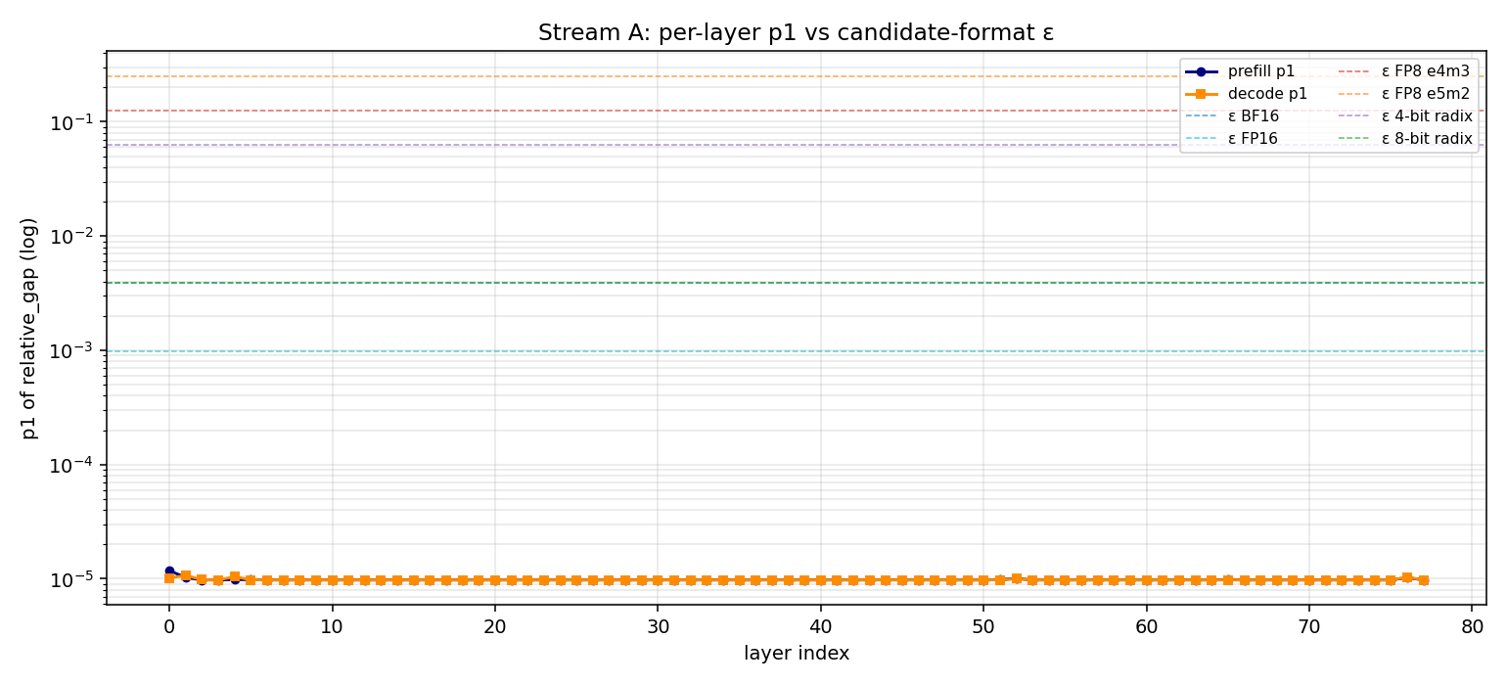
Per-layer 1st-percentile gap vs candidate format thresholds
For each of the 78 layers, the 1st-percentile of the relative-gap distribution is plotted on a log axis. Prefill (blue) and decode (orange) curves both remain near 1.0 × 10⁻⁵ across all layers, exhibiting no layer-to-layer structure. The horizontal dashed lines mark each candidate format’s resolution threshold. All candidate thresholds lie 3 to 4 orders of magnitude above the measured floor; no layer satisfies the safety condition for any candidate format.

6.2 Per-layer relative-gap histograms
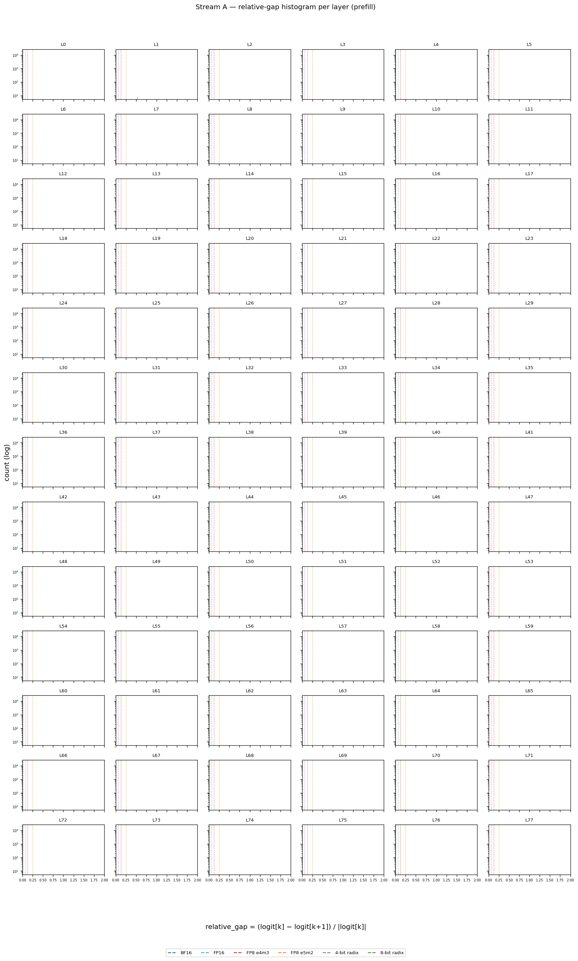
Stream A histograms, prefill
Per-layer histograms of the relative-gap distribution (prefill phase). Vertical dashed lines mark candidate format thresholds. In every layer, the probability mass concentrates in the leftmost bin (gap < 10⁻³), well below all candidate thresholds. The histogram shape confirms that the low 1st percentile is not driven by isolated outliers — the bulk of the distribution sits below the safety threshold.
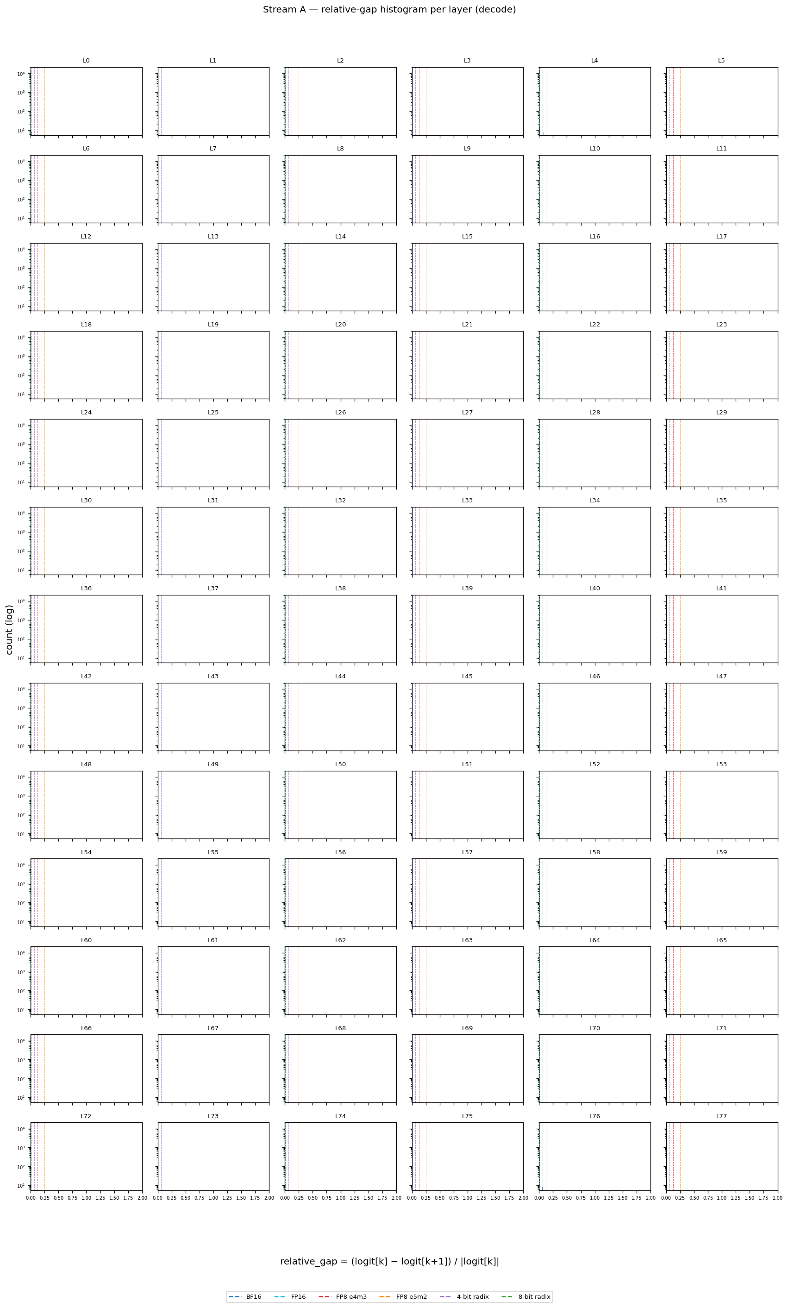
Stream A histograms, decode
Same per-layer histograms for the decode phase. The distribution shape is consistent across phases; the resolution failure is independent of whether the indexer runs during prompt processing or token generation.

6.3 Raw score distribution (range diagnostic)
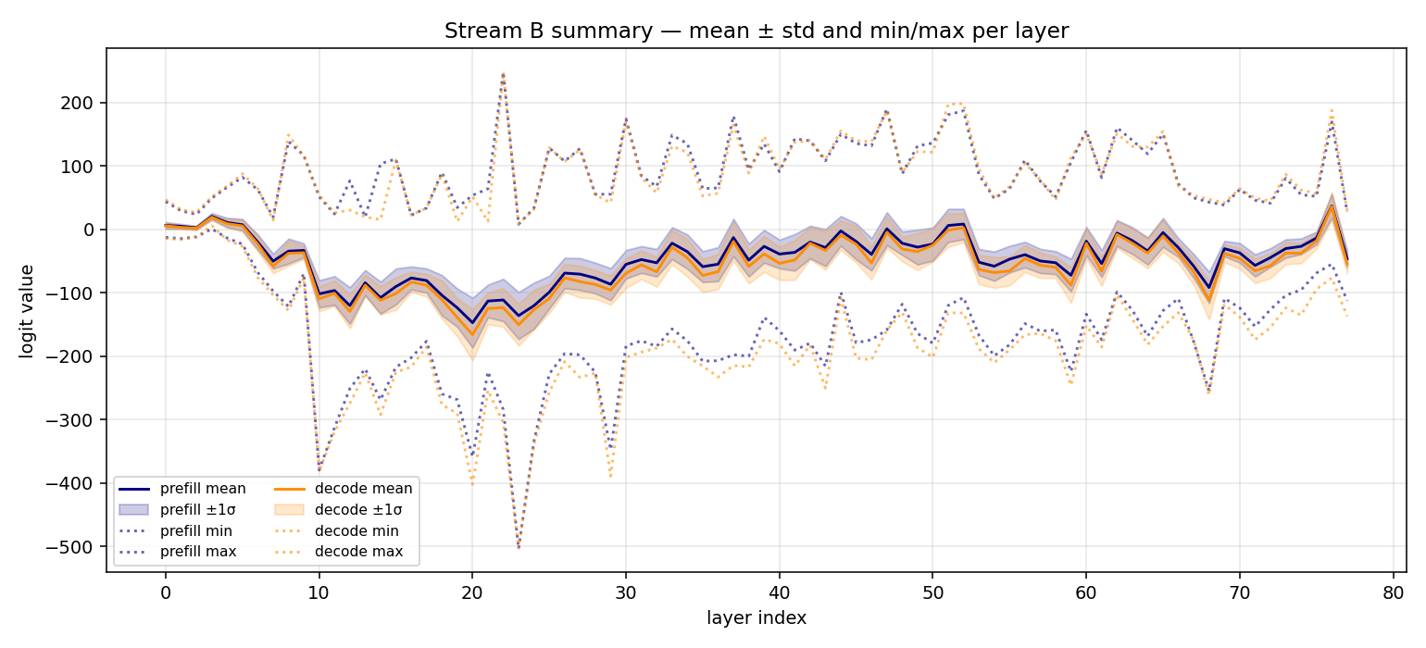
Score range per layer
Per-layer mean ± 1σ (shaded band) and min/max (dotted) of all valid indexer scores, prefill (navy) and decode (orange). The distribution is tightly concentrated around zero, with extremes within ±30. All candidate formats can represent this range without saturation in the bulk distribution.
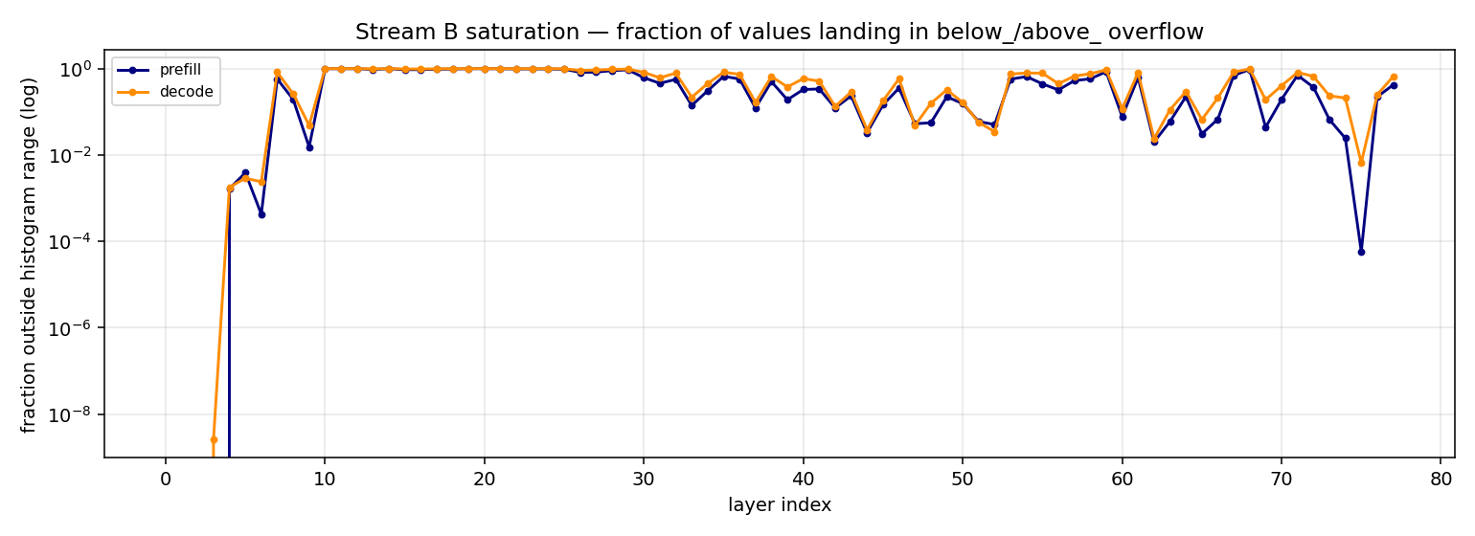
Score saturation
Fraction of scores falling outside the histogram clamp range [-50, 50], per layer (log axis). All values are below 10⁻⁶, confirming the histograms capture the full distribution; no data is lost to clipping.
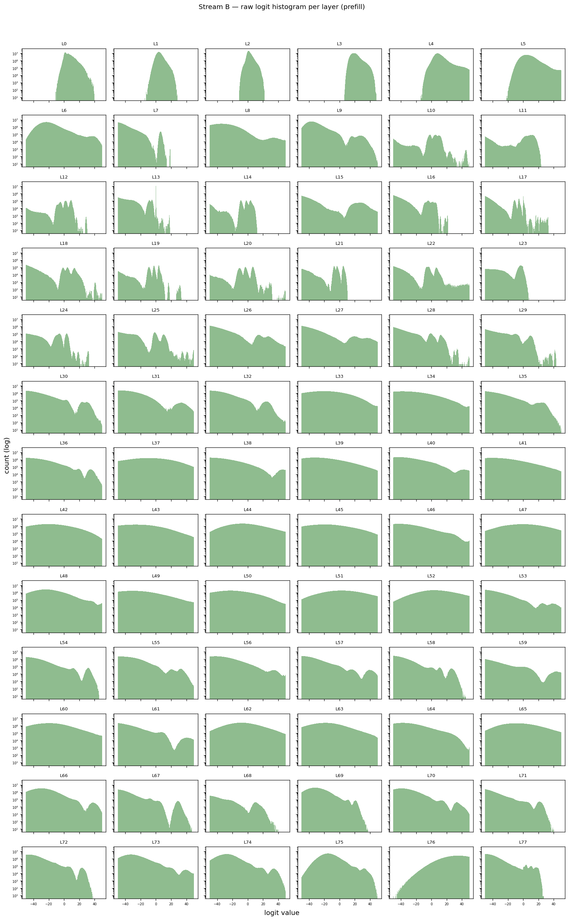
Per-layer score histograms, prefill
Per-layer raw-score distributions during prefill. Distributions are smooth, single-peaked, and well-formed — no spurious spikes or bimodalities, confirming the capture and masking-out of invalid keys is correct.
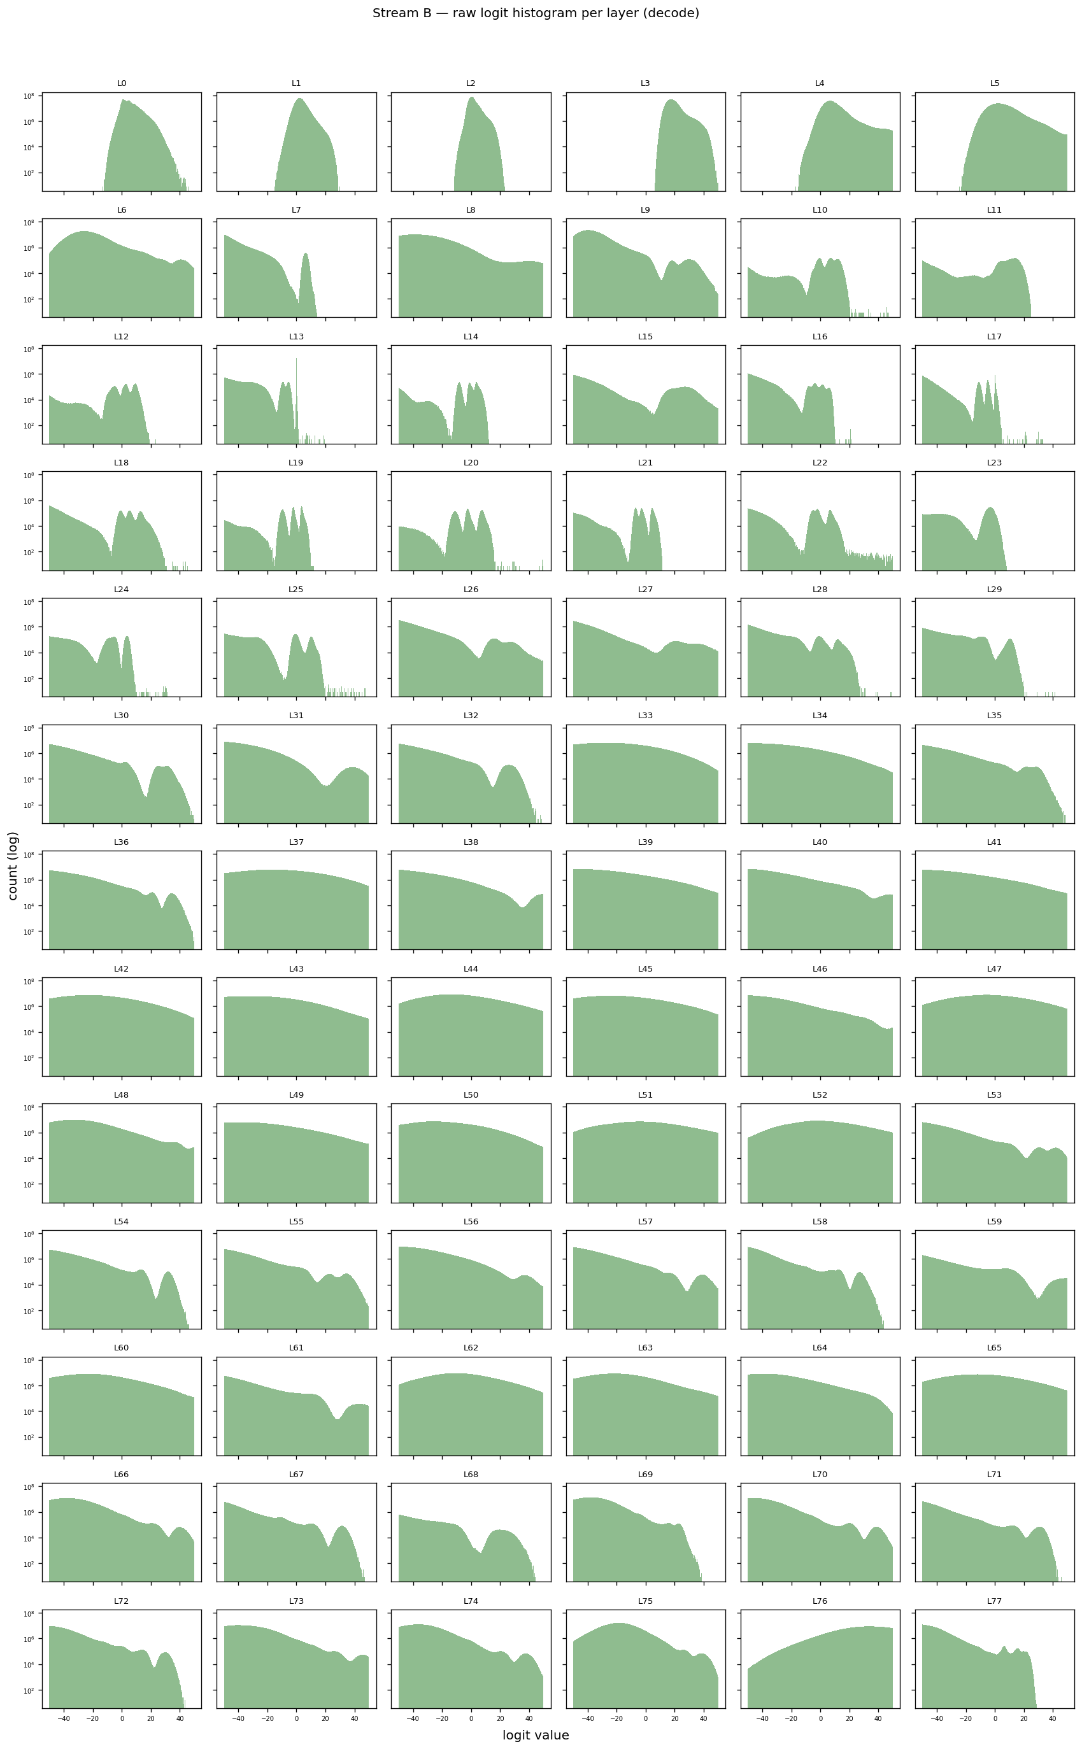
Per-layer score histograms, decode
Same distributions for decode. Slightly wider than prefill, consistent with the indexer scoring an increasingly diverse cached key set.

6.4 Top-2048 winner range (range diagnostic for the values that matter)
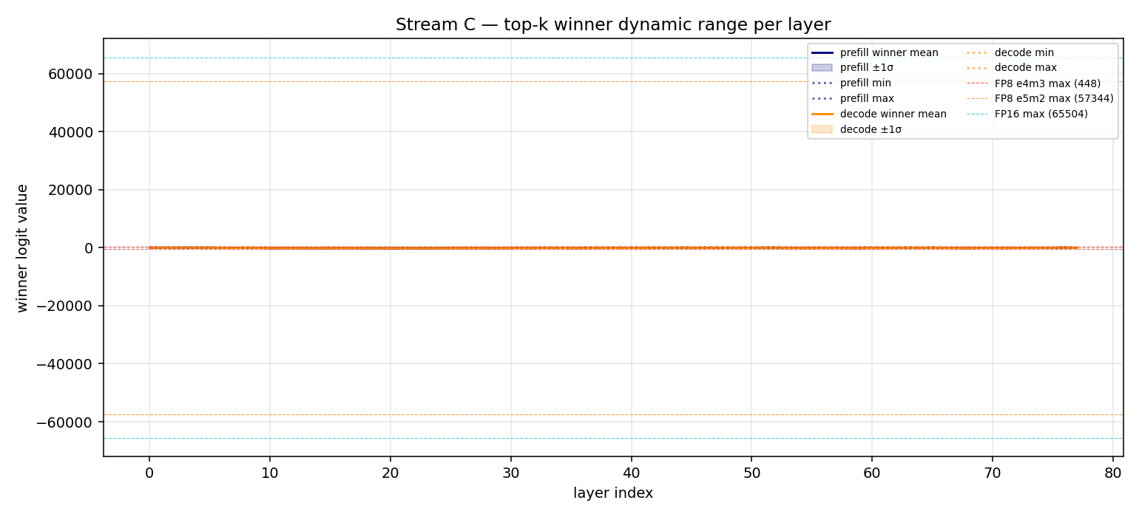
Winning score range per layer
Per-layer range statistics for the top-2048 winners only: mean ± 1σ (shaded band) and min/max (dotted), prefill vs decode. Horizontal dashed lines mark the maximum representable values for FP8 e4m3 (448), FP8 e5m2 (57,344), and FP16 (65,504).
Maximum winner magnitudes reach approximately 256 in prefill and 328 in decode. FP16 and FP8 e5m2 have substantial headroom. FP8 e4m3 uses 57 % of its range (prefill) and 73 % (decode) — marginal but not actively saturating. The combination of resolution failure (Section 6.1) and range marginality places FP8 e4m3 at elevated risk relative to FP8 e5m2.

7. Quantitative summary

Prefill
p1 of relative gap across layers
min = 9.77 × 10⁻⁶ (worst layer: 3)
median = 9.77 × 10⁻⁶
max = 1.18 × 10⁻⁵
Format Resolution p1_min / ε Verdict
BF16 7.8 × 10⁻³ 1.3 × 10⁻³ UNSAFE
FP16 9.8 × 10⁻⁴ 1.0 × 10⁻² UNSAFE
FP8 e4m3 0.125 ~0 UNSAFE
FP8 e5m2 0.25 ~0 UNSAFE
4-bit radix 0.063 ~0 UNSAFE
8-bit radix 3.9 × 10⁻³ 2.5 × 10⁻³ UNSAFE
Winner magnitude (max) = 256
FP8 e4m3 (max 448) MARGINAL (57 % of headroom used)
FP8 e5m2 (max 57,344) SAFE
FP16 (max 65,504) SAFE

Decode
p1 of relative gap across layers
min = 9.77 × 10⁻⁶ (worst layer: 3)
median = 9.77 × 10⁻⁶
max = 1.07 × 10⁻⁵
Format Resolution p1_min / ε Verdict
BF16 7.8 × 10⁻³ 1.3 × 10⁻³ UNSAFE
FP16 9.8 × 10⁻⁴ 1.0 × 10⁻² UNSAFE
FP8 e4m3 0.125 ~0 UNSAFE
FP8 e5m2 0.25 ~0 UNSAFE
4-bit radix 0.063 ~0 UNSAFE
8-bit radix 3.9 × 10⁻³ 2.5 × 10⁻³ UNSAFE
Winner magnitude (max) = 328
FP8 e4m3 (max 448) MARGINAL (73 % of headroom used)
FP8 e5m2 (max 57,344) SAFE
FP16 (max 65,504) SAFE
Prefill and decode produce identical worst layers (layer 3) and identical p1 floors. The verdict is invariant to phase.

8. Interpretation
The “UNSAFE for every format” verdict does not imply that any of these formats would break the model. The current indexer kernel already operates in FP8 for the matrix multiplication that produces the scores, and the captured data shows the kernel already produces boundary ties (rows with gap exactly zero). The model was trained against this baseline.
The histogram analysis quantifies additional boundary shuffling that would be introduced by each candidate format. Whether such additional shuffling degrades downstream task accuracy is an empirical question that requires an end-to-end evaluation; it cannot be answered from gap statistics alone.

9. Open questions
- Proceed with the current 6.5K-sample capture, or extend to the planned 10K and to long-context (max_tokens ≥ 3,000) before deciding?
- Which (format, benchmark) combinations should be included in the end-to-end accuracy evaluation?
- If both candidate formats (FP8 e5m2, 4-bit radix) show measurable accuracy regression, is the speedup worth a small quality cost, or do we retain the BF16 baseline?
- Is per-head capture worth adding, or is layer-level granularity sufficient for the optimization decision?

