Lab Worksheet 01

CTEC 22043 Object Oriented Programming

Faculty of Computing and Technology

University of Kelaniya

Student Number – CT/2021/011

Q1.

Code

***package Q_01;***

***import javax.swing.*;***

***public class Q1 {***

***public static void main(String[] args) {***

***JFrame frame = new JFrame();***

***frame.setSize(800,600);***

***frame.setTitle("Welcome to Java");***

***frame.setVisible(true);***

***frame.setDefaultCloseOperation(JFrame.EXIT_ON_CLOSE);***

***}***

***}***

Output

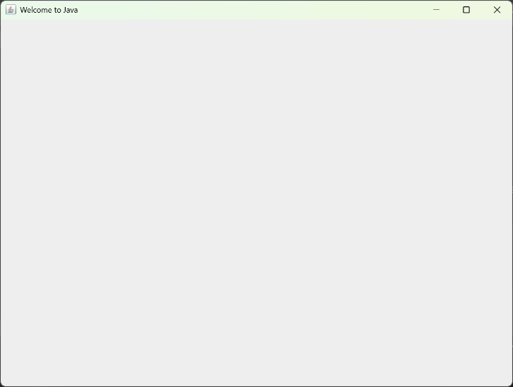

Q2.

Code

***package Q_02;***

***import javax.swing.*;***

***import java.util.Scanner;***

***public class Q_02 {***

***public static void main(String[] args) {***

***Scanner scanner = new Scanner(System.in);***

***System.out.println("Enter first name: ");***

***String fName = scanner.next();***

***System.out.println("Enter last name: ");***

***String lName = scanner.next();***

***JFrame frame = new JFrame();***

***frame.setSize(350,250);***

***frame.setTitle(fName+" "+lName);***

***frame.setVisible(true);***

***frame.setDefaultCloseOperation(JFrame.EXIT_ON_CLOSE);***

***}***

***}***

Output

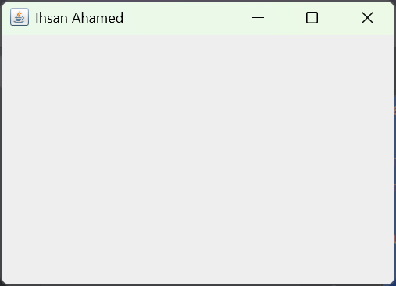 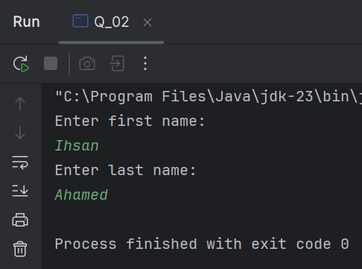

Q3.

Code

***package Q_03;***

***import java.util.Scanner;***

***public class Q_03 {***

***public static void main(String[] args) {***

***Scanner scanner = new Scanner(System.in);***

***System.out.println("Enter first name: ");***

***String fName = scanner.next();***

***System.out.println("Enter middle name: ");***

***String mName = scanner.next();***

***System.out.println("Enter last name: ");***

***String lName = scanner.next();***

***String middleInitial = mName.substring(0,1);***

***System.out.println(fName+" "+middleInitial+". "+lName);***

***}***

***}***

Output

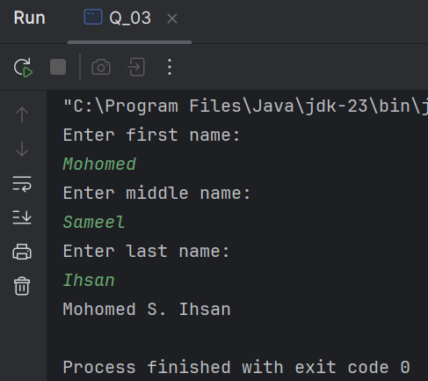

Q4.

Code

***package Q_04;***

***import java.text.SimpleDateFormat;***

***import java.util.Date;***

***public class Q_04 {***

***public static void main(String[] args) {***

***Date today = new Date();***

***SimpleDateFormat sdf = new SimpleDateFormat("dd MMM yyyy");***

***System.out.println(sdf.format(today));***

***}***

***}***

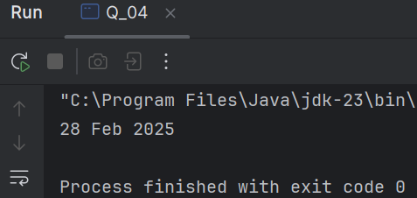Output

Q5.

Code

***package Q_05;***

***import java.text.SimpleDateFormat;***

***import java.util.Date;***

***public class Q_05 {***

***public static void main(String[] args) {***

***Date today = new Date();***

***SimpleDateFormat sdf = new SimpleDateFormat("EEEE, MMM dd, yyyy");***

***System.out.println(sdf.format(today));***

***}***

***}***

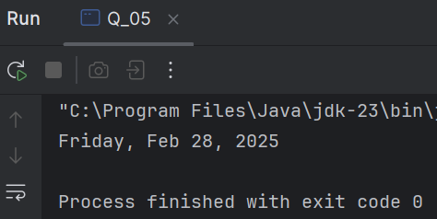 Output

Q6.

Code

***package Q_06;***

***import javax.swing.*;***

***import java.util.Scanner;***

***public class Q_06 {***

***public static void main(String[] args) {***

***Scanner scanner = new Scanner(System.in);***

***System.out.println("W: ");***

***int width = scanner.nextInt();***

***System.out.println("H: ");***

***int height = scanner.nextInt();***

***System.out.println("Enter the title: ");***

***String tName = scanner.next();***

***tName+=scanner.nextLine();***

***scanner.close();***

***JFrame frame = new JFrame();***

***frame.setSize(width,height);***

***frame.setTitle(tName);***

***frame.setVisible(true);***

***frame.setDefaultCloseOperation(JFrame.EXIT_ON_CLOSE);***

***}***

***}***

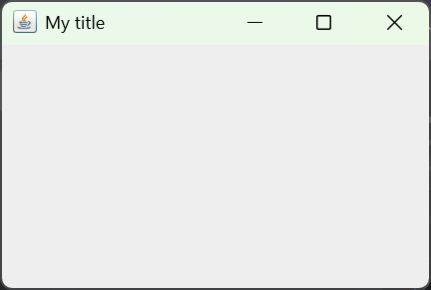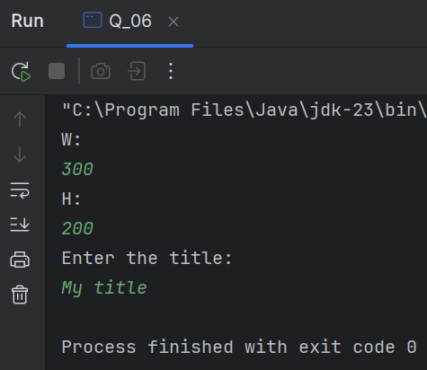 Output

Q7.

Code

***package Q_07;***

***import javax.swing.*;***

***import java.text.SimpleDateFormat;***

***import java.util.Date;***

***public class Q_07 {***

***public static void main(String[] args) {***

***JFrame frame = new JFrame();***

***Date today = new Date();***

***SimpleDateFormat sdf = new SimpleDateFormat("hh:mm:ss a");***

***String title = sdf.format(today);***

***frame.setSize(300,200);***

***frame.setTitle(title);***

***frame.setVisible(true);***

***frame.setDefaultCloseOperation(JFrame.EXIT_ON_CLOSE);***

***}***

***}***

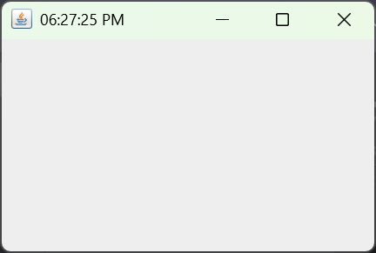 Output

Q8.

Code

***package Q_08;***

***import java.util.Scanner;***

***public class Q_08 {***

***public static void main(String[] args) {***

***Scanner scanner = new Scanner(System.in);***

***System.out.println("Enter the sentence with exclamation mark: ");***

***String word = scanner.nextLine();***

***int exclamationIndex = word.indexOf('!');***

***String firstString = word.substring(0,exclamationIndex).trim();***

***String secondString = word.substring(exclamationIndex+1).trim();***

***System.out.println("Before exclamation mark: "+firstString);***

***System.out.println("After exclamation mark: "+secondString);***

***}***

***}***

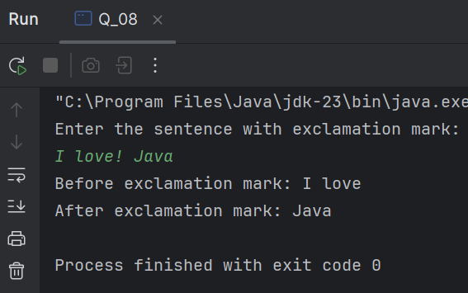 Output

Q9.

Code

***package Q_09;***

***import java.util.Scanner;***

***public class Q_09 {***

***public static void main(String[] args) {***

***Scanner scanner = new Scanner(System.in);***

***System.out.println("Enter the sentence: ");***

***String input = scanner.nextLine();***

***int count = input.length();***

***String firstChar = input.substring(0,1);***

***String lastChar = input.substring(count-1,count);***

***System.out.print("Number of characters of your sentence: "+count+"\n");***

***System.out.println(firstChar);***

***System.out.println(lastChar);***

***}***

***}***

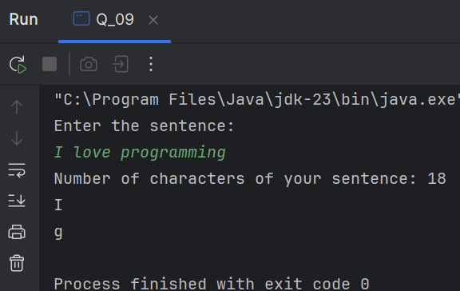 Output

Q10.

Code

***package Q_10;***

***import java.util.Scanner;***

***import java.lang.*;***

***public class Q_10 {***

***public static void main(String[] args) {***

***Scanner scanner = new Scanner(System.in);***

***System.out.println("Enter an odd-length word: ");***

***String input = scanner.nextLine();***

***int numOfChar = input.length();***

***int indexOfMiddle = numOfChar/2;***

***String middleChar = input.substring(indexOfMiddle,indexOfMiddle+1);***

***System.out.println(middleChar);***

***}***

***}***

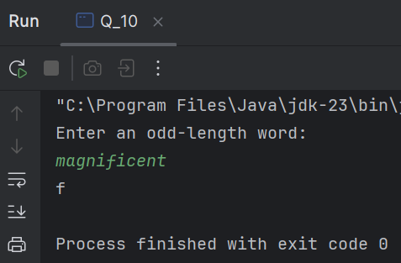Output

Q11.

Code

***package Q_11;***

***import java.util.Scanner;***

***import java.lang.*;***

***public class Q_11 {***

***public static void main(String[] args) {***

***Scanner scanner = new Scanner(System.in);***

***System.out.println("Enter your full name: ");***

***String firstName = scanner.next();***

***String middleName = scanner.next();***

***String lastName = scanner.next();***

***String middleLetter = middleName.substring(0,1);***

***System.out.println(lastName+", "+firstName+" "+middleLetter);***

***}***

***}***

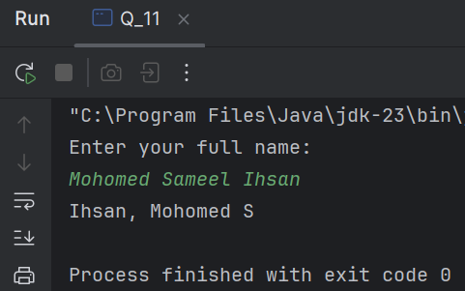 Output

Q12.

Code

***package Q_12;***

***import javax.swing.*;***

***import java.awt.*;***

***public class Q_12 {***

***public static void main(String[] args) {***

***JFrame frame = new JFrame();***

***frame.setSize(300,200);***

***frame.setTitle("My First Frame");***

***frame.setVisible(true);***

***frame.setLocation(100,50);***

***frame.setDefaultCloseOperation(JFrame.EXIT_ON_CLOSE);***

***}***

***}***

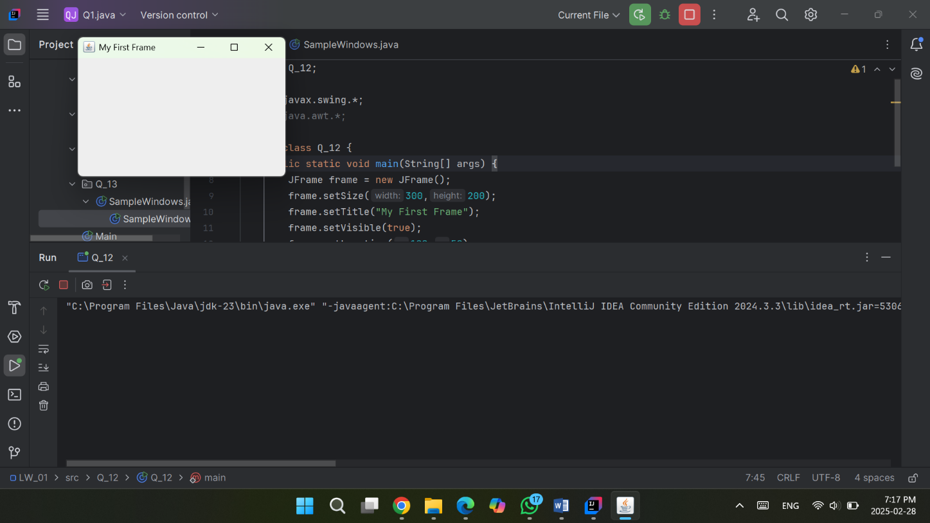 Output

Q13.

Code

***package Q_13;***

***import javax.swing.*;***

***class SampleWindow {***

***public static void main(String[] args) {***

***JFrame myWindow;***

***myWindow = new JFrame();***

***myWindow.setSize(500, 250);***

***myWindow.setTitle("UOK");***

***myWindow.setVisible(true);***

***try {Thread.sleep(500);} catch(Exception e) { }***

***myWindow.setVisible(false);***

***try {Thread.sleep(500);} catch(Exception e) { }***

***myWindow.setVisible(true);***

***myWindow.setDefaultCloseOperation(JFrame.EXIT_ON_CLOSE);***

***}***

***}***

Output

