Lab Worksheet 02

CTEC 22043 Object Oriented Programming

Faculty of Computing and Technology

University of Kelaniya

Student Number – CT/2021/011

Q1.

Code

***package Q_01;***

***import java.lang.*;***

***public class Q_01 {***

***public static void main(String[] args) {***

***int A=2, B=3,C=4,X=5,Y=6;***

***System.out.println("A=2, B=3,C=4,X=5,Y=6");***

***double squreRoot1 = Math.sqrt((Math.pow(B,2)+(4*A*C)));***

***System.out.println("The squre root of (B^2+4AC): "+squreRoot1);***

***double squreRoot2 = Math.sqrt((X+4*Math.pow(Y,3)));***

***System.out.println("The square root of (X+4Y^3): "+squreRoot2);***

***double cubeRoot = Math.cbrt(X*Y);***

***System.out.println("The cube root of the product of X and Y: "+cubeRoot);***

***final double PI = 3.14;***

***int radius = B;***

***double areoOfCircle = PI*B*B;***

***System.out.println("The area of a circle which radius is 3: "+areoOfCircle);***

***}***

***}***

Output

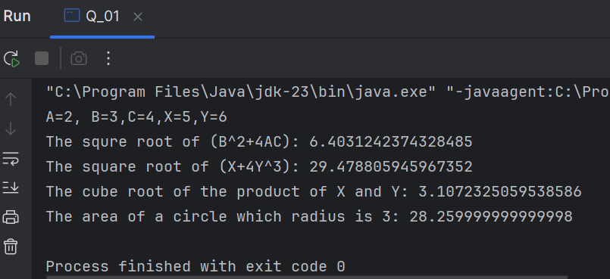

Q2.

Code

***package Q_02;***

***import java.text.DecimalFormat;***

***import java.util.Scanner;***

***public class Q_02 {***

***public static void main(String[] args) {***

***Scanner scanner = new Scanner(System.in);***

***System.out.println("Enter the value in centimeters: ");***

***double cm = scanner.nextDouble();***

***double totalInches = cm / 2.54;***

***int feets = (int)(totalInches / 12);***

***double inches = totalInches % 12;***

***DecimalFormat df = new DecimalFormat("0.00");***

***System.out.println(cm+" cm is equal to "+feets+" feets and "+df.format(inches)+" inches");***

***}***

***}***

Output

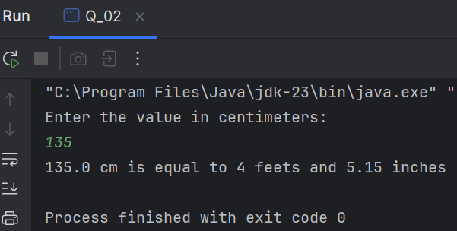

Q3.

Code

***package Q_03;***

***import java.text.DecimalFormat;***

***import java.util.Scanner;***

***public class Q_03 {***

***public static void main(String[] args) {***

***Scanner scanner = new Scanner(System.in);***

***System.out.println("Enter temperature in Celsius: ");***

***double temCelsius = scanner.nextDouble();***

***double temFahrenheit = (1.8 * temCelsius) + 32;***

***DecimalFormat df = new DecimalFormat("0.00");***

***System.out.println("Temperature in Fahrenheit: "+df.format(temFahrenheit));***

***}***

***}***

Output

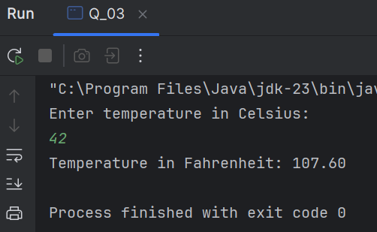

Q4.

Code

***package Q_04;***

***import java.util.Scanner;***

***public class Q_04 {***

***public static void main(String[] args) {***

***Scanner scanner = new Scanner(System.in);***

***System.out.println("Enter body weight in pounds: ");***

***double bodyWeight = scanner.nextDouble();***

***double calories = bodyWeight * 19;***

***System.out.println("You need "+calories+" calories in one day");***

***}***

***}***

Output

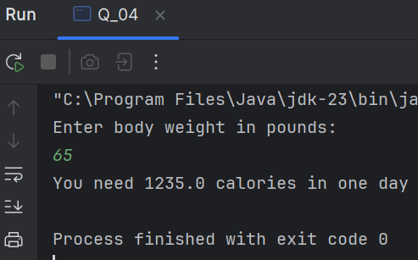

Q5.

Code

***package Q_05;***

***import java.text.DecimalFormat;***

***import java.util.Scanner;***

***public class Q_05 {***

***public static void main(String[] args) {***

***Scanner scanner = new Scanner(System.in);***

***System.out.println("Enter temperature in Fahrenheit: ");***

***double temFahrenheit = scanner.nextDouble();***

***double temCelsius = (temFahrenheit - 32)/(9/5.0);***

***DecimalFormat df = new DecimalFormat("0.00");***

***System.out.println("Temperature in Celsius: "+df.format(temCelsius));***

***}***

***}***

Output

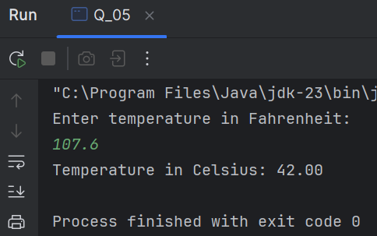

Q6.

Code

***package Q_06;***

***import java.util.Calendar;***

***import java.util.GregorianCalendar;***

***import java.util.Scanner;***

***public class Q_06 {***

***public static void main(String[] args) {***

***Scanner scanner = new Scanner(System.in);***

***System.out.println("Enter year of born: ");***

***int birthYear = scanner.nextInt();***

***GregorianCalendar cal = new GregorianCalendar();***

***int currentYear = cal.get(Calendar.YEAR);***

***int currentAge = currentYear - birthYear;***

***System.out.println("You were born in "+birthYear+" and will be (are) "+currentAge+" this year.");***

***}***

***}***

Output

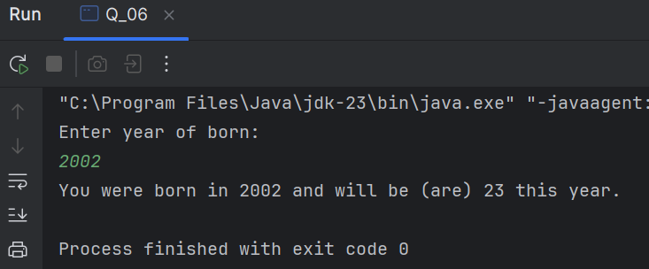

Q7.

Code

***package Q_07;***

***import java.text.DecimalFormat;***

***import java.util.Scanner;***

***public class Q_07 {***

***public static void main(String[] args) {***

***Scanner scanner = new Scanner(System.in);***

***System.out.println("Enter your weight in Kg: ");***

***int weight = scanner.nextInt();***

***System.out.println("Enter your height in cm: ");***

***int height = scanner.nextInt();***

***double BMI = weight / Math.pow((height /100.0),2);***

***DecimalFormat df = new DecimalFormat("0.00");***

***System.out.println("BMI: "+df.format(BMI));***

***}***

***}***

Output

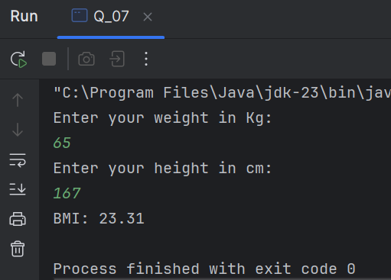

Q8.

Code

***package Q_08;***

***import java.text.DecimalFormat;***

***import java.util.Scanner;***

***public class Q_08 {***

***public static void main(String[] args) {***

***final double PI = 3.14;***

***Scanner scanner = new Scanner(System.in);***

***System.out.println("Enter the radius of the sphere: ");***

***double radius = scanner.nextDouble();***

***double volume = (4.0 / 3.0) * PI * Math.pow(radius, 3);***

***DecimalFormat df = new DecimalFormat("0.00");***

***System.out.println("Volume of the sphere is: "+df.format(volume));***

***}***

***}***

Output

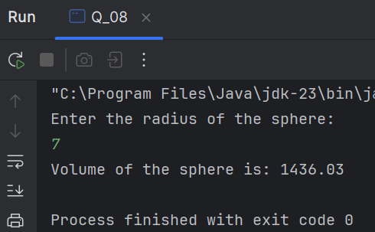

Q9.

Code

***package Q_09;***

***import java.text.DecimalFormat;***

***import java.util.Scanner;***

***public class Q_09 {***

***public static void main(String[] args) {***

***Scanner scanner = new Scanner(System.in);***

***System.out.println("Enter invest amount in dollars: ");***

***double invest = scanner.nextDouble();***

***System.out.println("Enter interest rate compounded annually: ");***

***double interestRate = scanner.nextDouble();***

***System.out.println("Enter number of years: ");***

***double years = scanner.nextDouble();***

***double amountEarned = invest * Math.pow((1 + (interestRate / 100)),years);***

***DecimalFormat df = new DecimalFormat("0.00");***

***System.out.println("The amount of money earned after "+(int)(years)+" years: "+df.format(amountEarned)+" $");***

***}***

***}***

Output

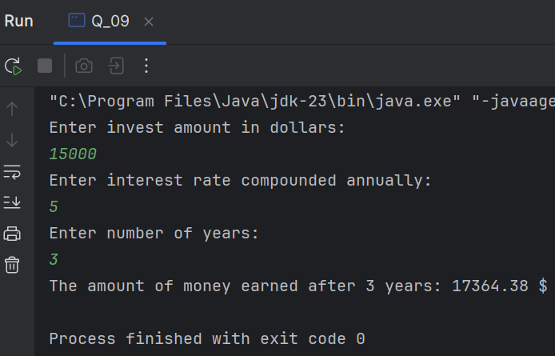

Q10.

Code

***package Q_10;***

***import java.text.DecimalFormat;***

***import java.util.Scanner;***

***public class Q_10 {***

***public static void main(String[] args) {***

***Scanner scanner = new Scanner(System.in);***

***final int MONTHS_IN_YEAR = 12;***

***System.out.println("Enter the loan amount: ");***

***double loanAmount = scanner.nextDouble();***

***System.out.println("Enter the annual interest rate: ");***

***double annualInterestRate = scanner.nextDouble();***

***System.out.println("Enter the loan period in years: ");***

***double loanPeriod = scanner.nextDouble();***

***double monthlyInterestRate = annualInterestRate / 100.0 / MONTHS_IN_YEAR;***

***double numberOfPayments = loanPeriod * MONTHS_IN_YEAR;***

***double monthlyPayment = (loanAmount * monthlyInterestRate) / (1 - Math.pow(***

***1 /(1 + monthlyInterestRate), numberOfPayments) );***

***double totalPayment = monthlyPayment * numberOfPayments;***

***DecimalFormat df = new DecimalFormat("0.00");***

***System.out.println("Monthly payment amount: "+df.format(monthlyPayment));***

***System.out.println("Total payment amount: "+df.format(totalPayment));***

***}***

***}***

Output

