Lab Worksheet 03

CTEC 22043 Object Oriented Programming

Faculty of Computing and Technology

University of Kelaniya

Student Number – CT/2021/011

Q1.

Code

***package Q_01;***

***import java.util.Scanner;***

***public class Main {***

***public static void main(String[] args) {***

***Scanner scanner = new Scanner(System.in);***

***System.out.print("Enter temperature in Celsius: ");***

***double inputCelsius = scanner.nextDouble();***

***Temperature temp = new Temperature(inputCelsius);***

***System.out.println("Temperature in Fahrenheit: " + temp.toFahrenheit());***

***scanner.close();***

***}***

***}***

***package Q_01;***

***public class Temperature {***

***private double celsius;***

***public Temperature() {***

***this.celsius = 0.00;***

***}***

***public Temperature(double celsius) {***

***this.celsius = celsius;***

***}***

***public double toFahrenheit() {***

***return celsius * 9.0 / 5.0 + 32;***

***}***

***public double toCelsius() {***

***return celsius;***

***}***

***public void setFahrenheit(double fahrenheit) {***

***this.celsius = (fahrenheit - 32) * 5.0 / 9.0;***

***}***

***public void setCelsius(double celsius) {***

***this.celsius = celsius;***

***}***

***}***

Output

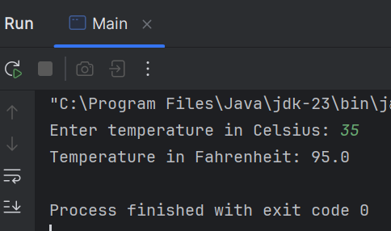

Q2.

Code

***package Q_02;***

***import Q_01.Temperature;***

***import java.util.Scanner;***

***public class Q_02 {***

***public static void main(String[] args) {***

***Scanner scanner = new Scanner(System.in);***

***System.out.print("Enter temperature in Fahrenheit: ");***

***double inputFahrenheit = scanner.nextDouble();***

***Temperature temp = new Temperature();***

***temp.setFahrenheit(inputFahrenheit);***

***System.out.println("Temperature in Celsius: " + temp.toCelsius());***

***scanner.close();***

***}***

***}***

Output

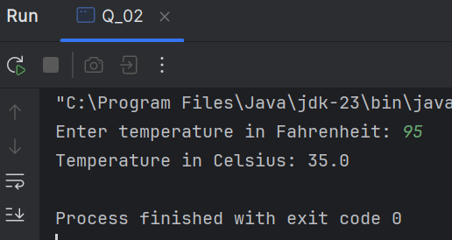

Q3.

Code

***package Q_03;***

***import java.util.Scanner;***

***public class Main {***

***public static void main(String[] args) {***

***double innerCircleRadius;***

***double outerCircleRadius;***

***Scanner scanner = new Scanner(System.in);***

***System.out.println("Enter the inner circle radius: ");***

***innerCircleRadius = scanner.nextDouble();***

***System.out.println("Enter the outer circle radius: ");***

***outerCircleRadius = scanner.nextDouble();***

***Circle innerCircle = new Circle(innerCircleRadius);***

***Circle outerCircle = new Circle(outerCircleRadius);***

***double innerCircleArea = innerCircle.computeArea();***

***double outerCircleArea = outerCircle.computeArea();***

***double shadedArea = outerCircleArea - innerCircleArea;***

***System.out.println("The Area of shaded area: "+shadedArea);***

***}***

***}***

***package Q_03;***

***public class Circle {***

***private double radius;***

***public Circle(double radius) {***

***this.radius = radius;***

***}***

***public double getRadius() {***

***return radius;***

***}***

***public void setRadius(double radius) {***

***this.radius = radius;***

***}***

***public double computeArea(){***

***double area = Math.PI * radius * radius;***

***return area;***

***}***

***public double computeCircumference(){***

***double circumference = 2 * Math.PI * radius;***

***return circumference;***

***}***

***}***

Output

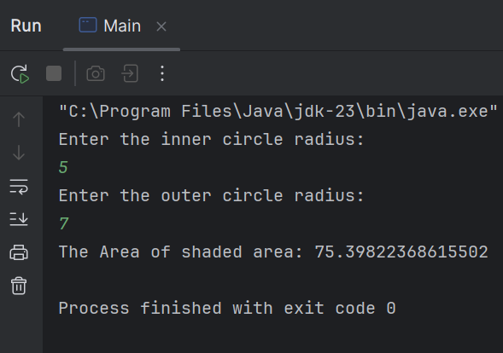

Q5.

Code

***package Q_05;***

***public class Course {***

***//Data members***

***private String courseName;***

***private String getCourseCode;***

***private Lecturer lecturer;***

***//getter method for CourseName***

***public String getCourseName() {***

***return courseName;***

***}***

***//setter method for CourseName***

***public void setCourseName(String courseName) {***

***this.courseName = courseName;***

***}***

***//getter method for CourseCode***

***public String getCourseCode() {***

***return getCourseCode;***

***}***

***//setter method for CourseCode***

***public void setCourseCode(String getCourseCode) {***

***this.getCourseCode = getCourseCode;***

***}***

***//getter method for Lecturer***

***public Lecturer getLecturer() {***

***return lecturer;***

***}***

***//setter method for lecturer***

***public void setLecturer(Lecturer lecturer) {***

***this.lecturer = lecturer;***

***}***

***}***

***package Q_05;***

***public class Lecturer {***

***private String lecturerName;***

***private String courseTeaching;***

***public String getLecturerName() {***

***return lecturerName;***

***}***

***public void setLecturerName(String lecturerName) {***

***this.lecturerName = lecturerName;***

***}***

***public String getCourseTeaching() {***

***return courseTeaching;***

***}***

***public void setCourseTeaching(String courseTeaching) {***

***this.courseTeaching = courseTeaching;***

***}***

***}***

***package Q_05;***

***public class Student {***

***private String studentName;***

***private String degreeName;***

***private String courseFollowing;***

***public String getStudentName() {***

***return studentName;***

***}***

***public void setStudentName(String studentName) {***

***this.studentName = studentName;***

***}***

***public String getDegreeName() {***

***return degreeName;***

***}***

***public void setDegreeName(String degreeName) {***

***this.degreeName = degreeName;***

***}***

***public String getCourseFollowing() {***

***return courseFollowing;***

***}***

***public void setCourseFollowing(String courseFollowing) {***

***this.courseFollowing = courseFollowing;***

***}***

***}***

Output

***package Q_05;***

***public class Main {***

***public static void main(String[] args) {***

***Course oop = new Course();***

***oop.setCourseName("Object oriented programming");***

***oop.setCourseCode("CTEC 22043");***

***Lecturer kumar = new Lecturer();***

***kumar.setLecturerName("Kumar");***

***kumar.setCourseTeaching("Object oriented programming");***

***Student sanga = new Student();***

***sanga.setStudentName("Sanga");***

***sanga.setDegreeName("ICT");***

***sanga.setCourseFollowing("Object oriented programming");***

***oop.setLecturer(kumar);***

***System.out.println("Student details: ");***

***System.out.println("Student Name: "+sanga.getStudentName());***

***}***

***}***

