

**WEATHER APPLICATION**

**A Mini Project**





**2020-2021**

**DEPARTMENT OF COMPUTER ENGINEERING**

**ZEAL College Of engiNeering and research, savitribai phule pune university**



CERTIFICATE

2020-2021

This is to certify that,

TANOJ HANDAL (T211021)

ATHARV WAGHMARE(T211083)

SHUBHAM SOMSE (T211075)

Of Class T.E. ‘A’ COMPUTER; Have Successfully Completed Their Mini Project Work On ***“*WEATHER APPLICATION’’** at ***ZEAL College of Engineering and Research, Pune*** the Partial Fulfilment of the Graduate Degree Course in T.E at the Department of **Computer Engineering**, in the academic Year 2020-2021 Semester – I as Prescribed by the **Savitribai Phule Pune University.**

**Dr. SUNIL M SANGVE**

*Head of the Department*

*(Department of Computer Engineering*)

|  |  |  |  |
| --- | --- | --- | --- |
|  |  |  | |
| **Sr. No.** | **TOPIC** | **PAGE NO** | |
| **1** | **INTRODUCTION** | **3** | |
| **2** | **OBJECTIVE 4** | |  | |
| **3** | **REGISTRATION PAGE 5** | |  | |
| **4** | **LOGIN PAGE** 6 | |  | |
| 5 | **WEATHER PAGE 7** | |  | |
| **6** | **SOFTWARE REQUIREMENTS 8** | |  | |

**CONTENTS**

**7 HARDWARE REQUIREMENTS 9**

**8 REFERENCES 10**

**9 ENTITY RELATIONSHIP MODEL 11**

**INTRODUCTION**

* **Knowing what the day will bring is one good way of making a perfect plan for each day.**
* **sometimes this is usually a difficult one for all of us because nobody really knows for certain what is likely to happen in the nearest minutes.**
* **Even in the area of the weather, this is paramount.**
* **This weather App enables you make better preparation for the day in relation to giving accurate daily weather forecast.**

OBJECTIVE

1. **Accurate detailed forecasts which Ideally should contain not only data on air temperature, but also reports on different meteorological conditions**

**2.A person travelling in bus /train /flight may need to check weather in his destination city so with this app he will be able to get its weather very fast.**

**3. some travelers may need to know details about weather such as conditions , temperature, humidity, wind speed so with this app he will able to get it very fast.**

**REGISTRATION PAGE**

* **It consists of fields like –** 
  + - * + **1] first name**
        + **2] last name**
        + **3]Email id**
        + **4]password**
        + **5]phone number**
        + **6]state**
* **It consists of register which stores user information in MYSQL database and helps in validations of data through database and email id verification.**
* **It also consists of the BACK button which helps you to return to the login page.**
* **This page helps new user with registering with our application.**
* **Whenever user keeps any of input field empty he will receive error message.**

**LOGIN PAGE**

* It consists of two input fields –

1] username

2] password

* Login button in login page verify the user information from the MYSQL database
* After clicking on Login button user also receives welcome email on his registered email id.
* Register button takes new users to registration page where user can create new id and register.
* Clear button clears the username and password fields.
* Whenever user keeps both or any of fields of username and password user receives the message box with error message.

**WEATHER PAGE**

* Here user have to enter either city name, country name, country code or pin code of any region whose climate conditions user wants to know.
* When user clicks search button after entering region name user gets the climate conditions on output screen.
* Here the climate conditions are imported in the program through the live API .

**Software Requirements**

* Python 3.7 64 bit – For preparing estimator object and training the model.
* PyCharm IDE v2020.2.5 -For Coding and Implementation of The Project

HARDWARE SPECIFICATION

* Min. 4GB RAM/ Recommended 8 GB RAM
* Min. Intel Pentium Quad-Core or Ryzen Equivalent /Recommended Intel Pentium i3-7th Gen or Ryzen Equivalent Any Laptop or Desktop

Reference

* **OPEN WEATHER API :-**

[**https://api.openweathermap.org/data/2.5/weather**](https://api.openweathermap.org/data/2.5/weather)

Backend API Module To Fetch Current Weather Data Across The Globe On Single Click.

* **MYSQL Workbench 8.0 CE :-**

To Successfully Store User’s Login Information as well, To Retrieve Data Whenever User Try to Log-In Again.

* **PyCharm v2020.2.5 IDE :-**
* **TKINTER TOOLKIT -**

For Binding Python InterfaceWith Standard Graphical User Interface (GUI).

* **MySQL Connector –**

To Connect Log-In Information Database With Mainframe.

ENTITY RELATIONSHIP MODEL -

* 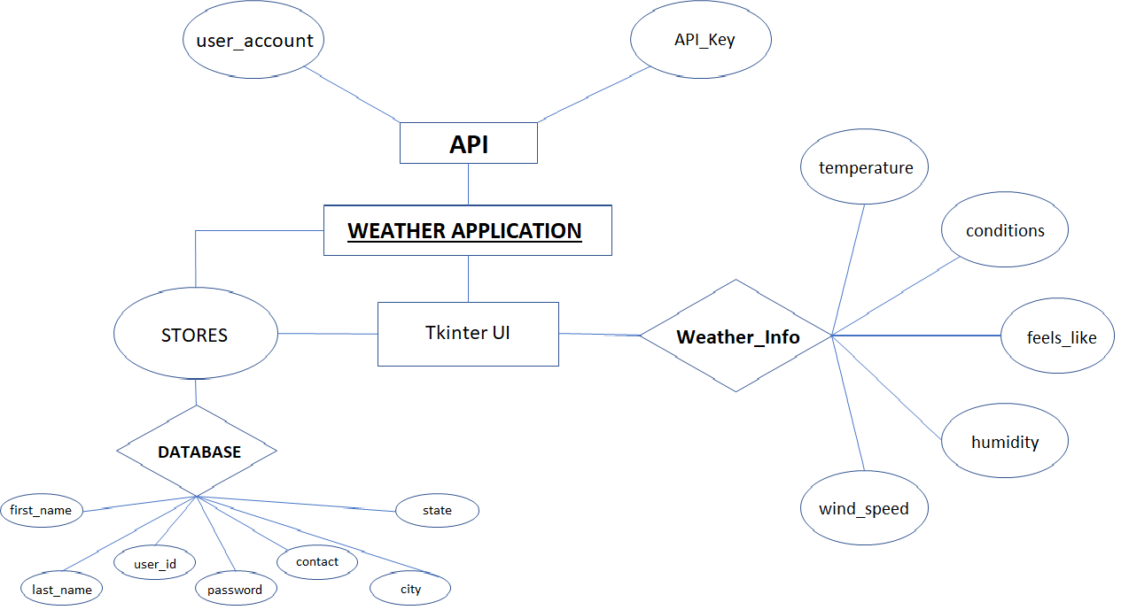

LOGIN PAGE

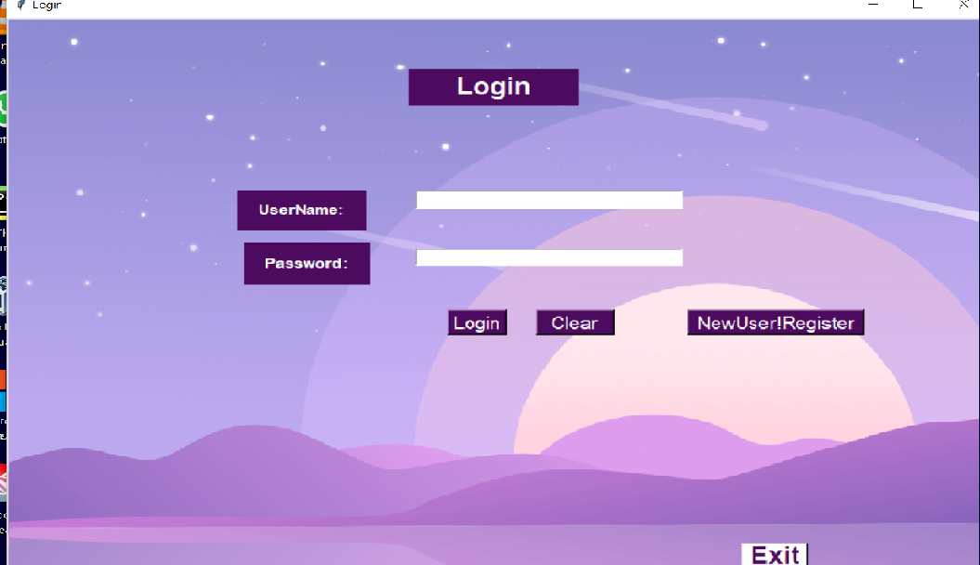

REGISTRATION PAGE

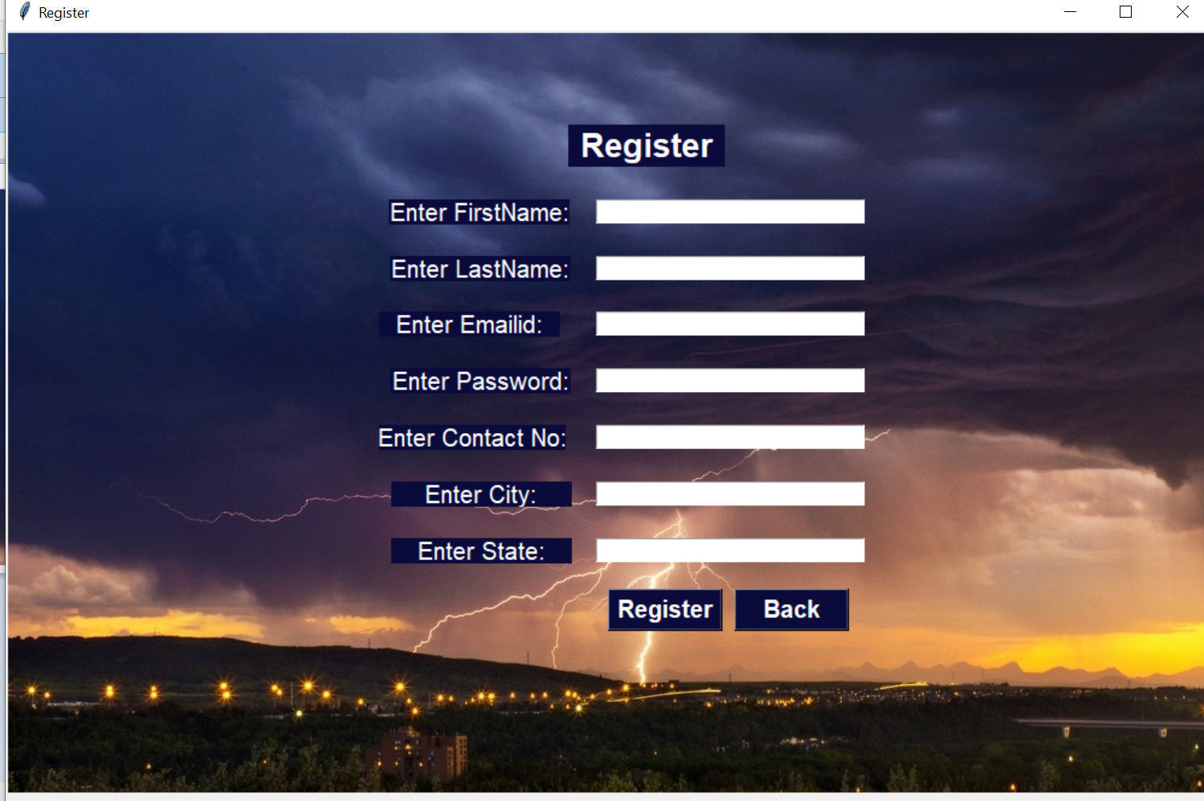

**WEATHER PAGE**

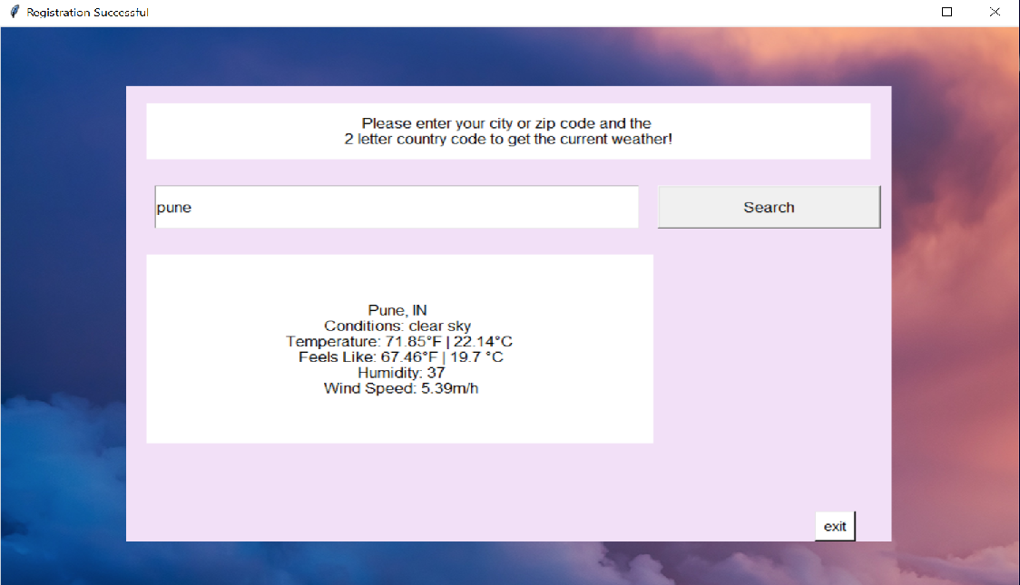

THANK YOU