A Mini Project Report
on
WEATHER APPLICATION
by

TANOJ HANDAL (T211021)
ATHARV WAGHMARE(T211083)
SHUBHAM SOMSE (T211075)

Under the guidance of
Prof . ATUL KATHOLE



Department of Computer Engineering
ZEAL College of Engineering and Research, SAVITRIBAI PHULE PUNE UNIVERSITY
2020-2021
Department of Computer Engineering
ZEAL College of Engineering and Research,

Date:

CERTIFICATE

This is to certify that,
TANOJ HANDAL (T211021)
ATHARV WAGHMARE(T211083)
SHUBHAM SOMSE (T211075)

of class T.E COMP; have successfully completed their mini project work on “WEATHER APPLICATION’’ at ZEAL College of Engineering and Research, Pune the partial fulfillment of the Graduate Degree course in T.E at the department of Computer Engineering, in the academic Year 2020-2021 Semester – I as prescribed by the Savitribai Phule Pune University.

Dr. Sunil M. Sangve
Guide Head of the Department
(Department of Computer Engineering)

Acknowledgement
We feel great pleasure in submitting this project report on “Weather Application”. We wish to express true sense of gratitude towards our Project Guide and Head-of-Department Mr. Sunil M. Sangve sir, who at very discrete step in study of this project contributed their valuable guidance to solve every problem that arose.
We wish to thank our H.O.D. for opening the doors of the department towards the realization of the Project report.
Last but not the least, we also express our sincere gratitude to all the staff members of COMPUTER Department.

TANOJ HANDAL (T211021)
ATHARV WAGHMARE(T211083)
SHUBHAM SOMSE (T211075)

Contents

Sr. No. | Topic |  | Page No.
1 | INSTRUCTION 5
2 | OBJECTIVE 6
3 | LOGIN PAGE 7
4  5 | REGISTRATION PAGE 8  WEATHER PAGE 9
6 | ADVANTAGES 10
7 | SOFTWARE SPECIFIATIONS |  | 11
8 | HARDWARE SPECIFICATIONS |  | 12
9 |  | APPLICATIONS | 13
10 |  | ENTITY RELATIONSHIP MODEL | 14
11 |  | REFERENCES | 15

INTRODUCTION

- Knowing what the day will bring is one good way of making a perfect plan for each day.
- sometimes this is usually a difficult one for all of us because nobody really knows for certain what is likely to happen in the nearest minutes.
- Even in the area of the weather, this is paramount.
- This weather App enables you make better preparation for the day in relation to giving accurate daily weather forecast.

OBJECTIVE

1. Accurate detailed forecasts which ideally should contain not only data on air temperature, but also reports on different meteorological conditions
2.A person travelling in bus /train /flight may need to check weather in his destination city so with this app he will be able to get its weather very fast.
3. some travelers may need to know details about weather such as conditions, temperature, humidity,
wind speed so with this app he will able to get it very fast.

REGISTRATION PAGE

- It consists of fields like - 1] first name
2] last name
3]Email id
4]password
5]phone number
6]state
- It consists of register which stores user information in MYSQL database and helps in validations of data through database and email id verification.
- It also consists of the BACK button which helps you to return to the login page.
- This page helps new user with registering with our application.
- Whenever user keeps any of input field empty he will receive error message.

LOGIN PAGE

- It consists of two input fields – 1] username
2] password
- Login button in login page verify the user information from the MYSQL database
- After clicking on Login button user also receives welcome email on his registered email id.
- Register button takes new users to registration page where user can create new id and register.
- Clear button clears the username and password fields.
- Whenever user keeps both or any of fields of username and password user receives the message box with error message.

WEATHER PAGE

- Here user have to enter either city name, country name, country code or pin code of any region whose climate conditions user wants to know.
- When user clicks search button after entering region name user gets the climate conditions on output screen.
- Here the climate conditions are imported in the program through the live API .
ADVANTAGES

- Instant information availability about climate conditions at any location.
- Easy flow of information.
- Free availability.
- Accurate weather and climate details in just one click.
- While travelling user can check the current climate conditions of the destination user is travelling to.
- It provides user-friendly UI design.

SOFTWARE SPECIFICATION

- PYCHARM v2020.2.5 IDE:
    - 1.Tkinter Toolkit-
        - for binding python interface with standard graphical user interface.
  - 2.Mysql connector-
        - To connect login information database with Main frame.
- MYSQL WORKBENCH-
    - To successfully store users login information as well , to retrieve data whenever user try to login again.

Hardware SPECIFICATION

- Min. 4GB RAM/ Recommended 8 GB RAM
- Min. Intel Pentium Quad-Core or Ryzen Equivalent / Recommended Intel Pentium i3-7th Gen or Ryzen Equivalent
- Any Laptop or Desktop

APPLICATION

- Free to use for everyone.
- Used to determine the climate conditions of any city, country or town by just entering the city name, country name or pin code respective region.
- Useful for travellers to determine detect climate and weather conditions of proposed destination.
- Can be used for daily purpose applications.
- ENTITY RELATIONSHIP MODEL

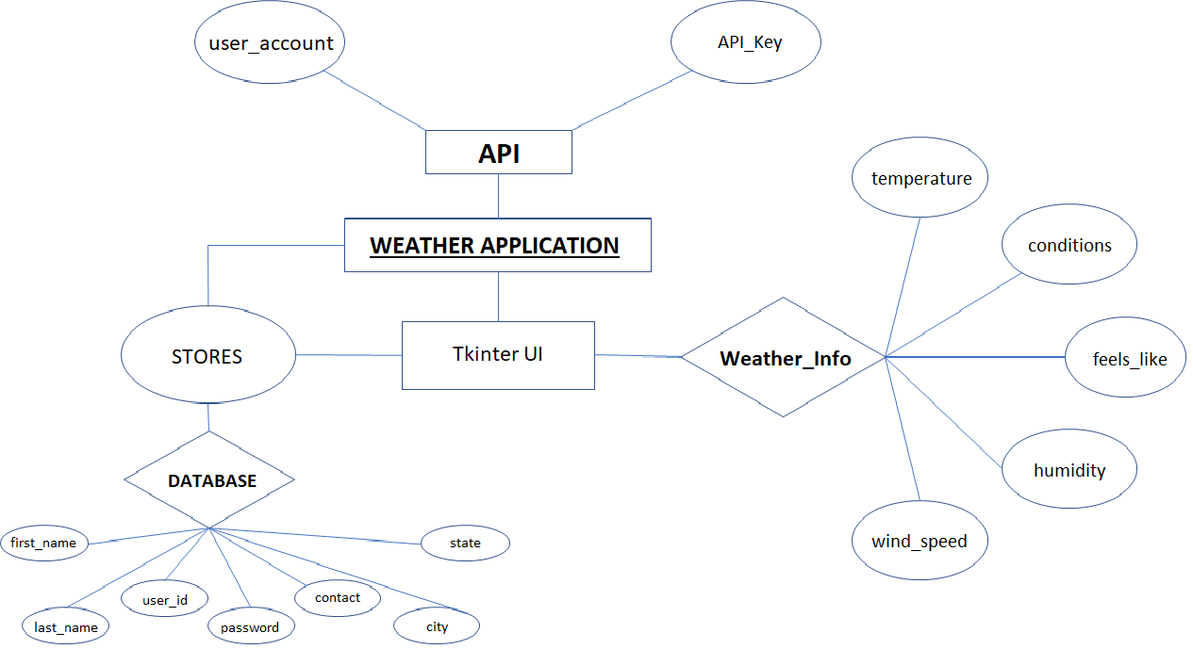

References

- OPEN WEATHER API :-

--https://api.openweathermap.org/data/2.5/weather

--Backend API Module to Fetch Current Weather Data Across the Globe on Single Click.
- Python Cookbook: Recipes for Mastering Python
-- By Brian K. Jones and David M. Beazley

