**Topics: Descriptive Statistics and Probability**

1. Look at the data given below. Plot the data, find the outliers and find out $$μ, σ, σ^{2}$$

|  |  |
| --- | --- |
| **Name of company** | **Measure X** |
| Allied Signal | 24.23% |
| Bankers Trust | 25.53% |
| General Mills | 25.41% |
| ITT Industries | 24.14% |
| J.P.Morgan & Co. | 29.62% |
| Lehman Brothers | 28.25% |
| Marriott | 25.81% |
| MCI | 24.39% |
| Merrill Lynch | 40.26% |
| Microsoft | 32.95% |
| Morgan Stanley | 91.36% |
| Sun Microsystems | 25.99% |
| Travelers | 39.42% |
| US Airways | 26.71% |
| Warner-Lambert | 35.00% |

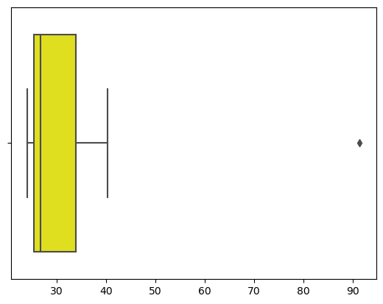

Mean=33.271

Var=287.14

Std=16.94



Answer the following three questions based on the box-plot above.

1. What is inter-quartile range of this dataset? (please approximate the numbers) In one line, explain what this value implies.

ANS. Inter-quartile range(IQR)=(Third Quantile value)Q3-(First quantile value)Q1=12-7=5

Value implies that maxinum data (approx 50%) lies between IQR

1. What can we say about the skewness of this dataset?

ANS.Right skewed (median is toward the left side)

1. If it was found that the data point with the value 25 is actually 2.5, how would the new box-plot be affected?

ANS. Here there will no outliers and positive skewness will reduce,

Median value will remain same but interquartile will change.



Answer the following three questions based on the histogram above.

1. Where would the mode of this dataset lie?

ANS. Between 5 to 10

1. Comment on the skewness of the dataset.

ANS.Right skewed

1. Suppose that the above histogram and the box-plot in question 2 are plotted for the same dataset. Explain how these graphs complement each other in providing information about any dataset.

ANS.Dataset is right skewed and and outliers,

In histogram mode is visible,and in box plot median is visible.

1. AT&T was running commercials in 1990 aimed at luring back customers who had switched to one of the other long-distance phone service providers. One such commercial shows a businessman trying to reach Phoenix and mistakenly getting Fiji, where a half-naked native on a beach responds incomprehensibly in Polynesian. When asked about this advertisement, AT&T admitted that the portrayed incident did not actually take place but added that this was an enactment of something that “could happen.” Suppose that one in 200 long-distance telephone calls is misdirected. What is the probability that at least one in five attempted telephone calls reaches the wrong number? (Assume independence of attempts.)

ANS. X= probability od 1 call misdirected out of 200

=Probability of occuring of X=1/200

=P(X)=1/200

Probability of having atleast one successful call will be

=1-P(X)=1-1/200=199/200=0.967

As every event is independent of other event the probability will be

=0.02475

The probability that atleast one in five attempted telepohone calls reaches the wrong number is 0.02475 ie.2%.

1. Returns on a certain business venture, to the nearest $1,000, are known to follow the following probability distribution

|  |  |
| --- | --- |
| x | P(x) |
| -2,000 | 0.1 |
| -1,000 | 0.1 |
| 0 | 0.2 |
| 1000 | 0.2 |
| 2000 | 0.3 |
| 3000 | 0.1 |

1. What is the most likely monetary outcome of the business venture?

ANS.$2000 as it has highest probability

1. Is the venture likely to be successful? Explain

ANS. P(x>0)=p(x>1000)+p(x>2000)+p(x>3000)=0.2+0.2+0.3+0.1=0.8

It shows that there are 80% chances to make profit.

1. What is the long-term average earning of business ventures of this kind? Explain

ANS.long term avg earning = sum(x*P(x))=$800

1. What is the good measure of the risk involved in a venture of this kind? Compute this measure

ANS.var=3500000

Std=1870.83

Std along with the avg returns of $800 indicates that this venture is highly risky.