**WorkBridge: High Level Design**

Team: **WorkBridge Development Team**

Members: Shai Yona, Maor Sapo, Roy Har Ziyon

1. **System Components Overview**  
     
   The system is composed of the following key components:  
     
   1. **Authentication & User Management Service**  
    - Handles user login, registration.  
    - Manages user roles and permissions.  
     
   2. **Feed Service (Posts & Comments)**  
    - Manages organizational feed posts, comments, and reactions.  
    - Implements filters by keyword, date, or tags.  
     
   3. **Chat Service (Real-time Messaging**(   
    - Supports private and group chats.  
     
   4. **Storage Service**  
    - Manages profile images, file uploads, and post attachments.  
     
   5. **Frontend Application (React.js)**  
    - User-friendly UI for interacting with the platform.  
     
   6. **Kubernetes Infrastructure**   
    - Manages containerized microservices.

This is a high-level overview of the main components that your system will be composed:



Media Service

Storage

Clients

Storage

User Service

Cache

Clients

Chat Service

Storage

1. **User Flow & Use Cases**  
     
   1. **User Authentication**   
    - Users log in ,Upon login, they access their personalized feed and chat.  
     
   2. **Posting in the Organizational Feed**   
    - Users can create posts, add images, and interact via likes/comments.   
     
   3. **Chat Messaging**   
    - Users can initiate private or group chats.   
     
   4. **Managing Profile Information**  
    - Users update profile details and work status.

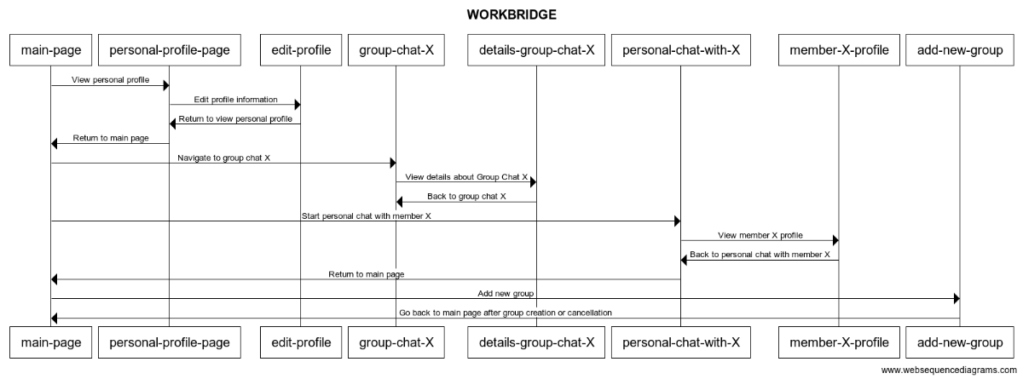

1. **Frontend Technology**  
   - The frontend is built using **React.js**
2. **Mockups for Main Pages**  
     
   1. **Dashboard (Homepage)**  
   - Displays the organizational feed with the latest updates.  
   - Provides quick access to chat, notifications, and profile settings.

Main page screen:

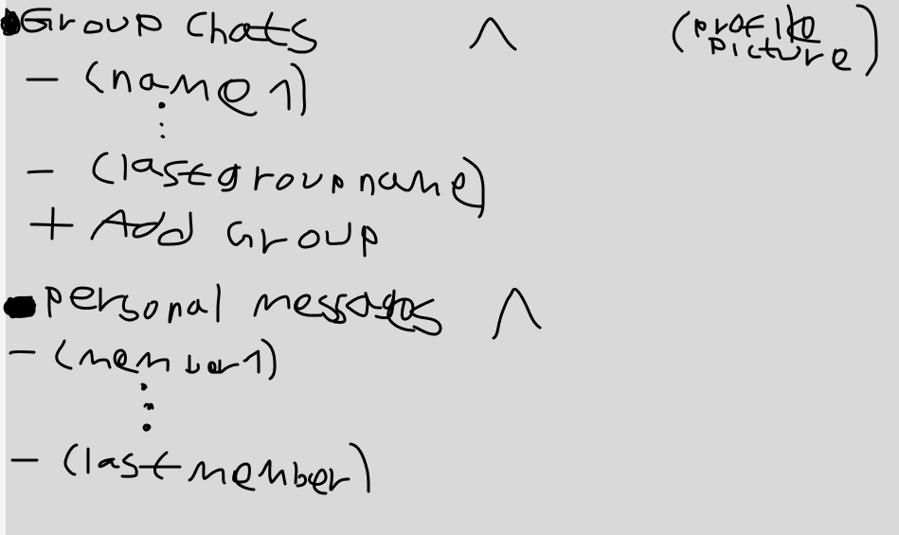  
  
2. **Group Chat**  
- Real-time messaging with file sharing.

Group chat screen:

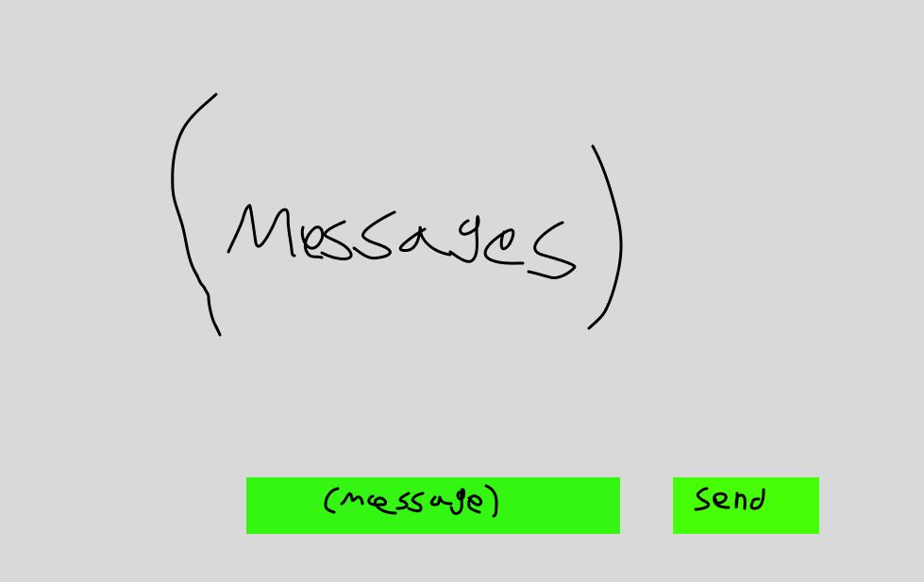

Add new group screen:

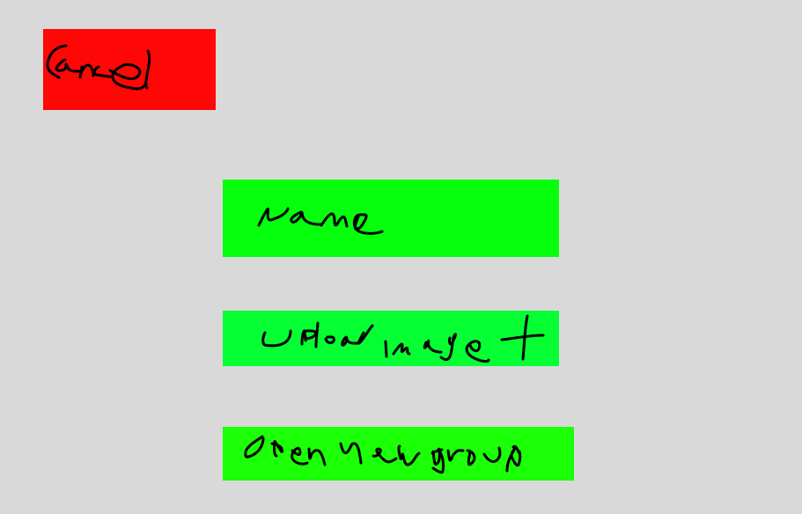

3. **Chat Details**  
- Displays group details

Chat details screen:  
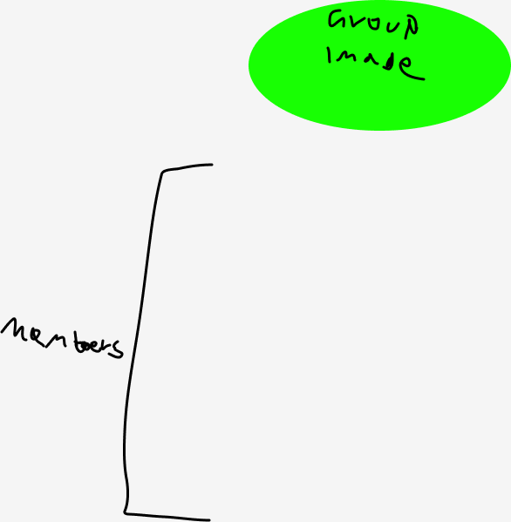  
  
4. **User Profile Page**  
- Displays user's profile, name, role, and activity history.  
Member-x-profile screen:  
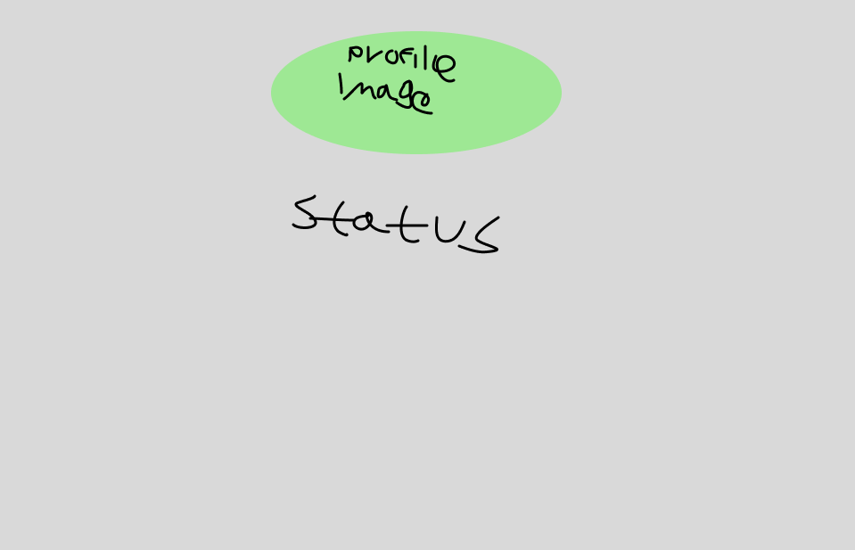

Personal profile page screen:  
