Steps to setup project

* 1. Create/Identify the storage account where customer files will be stored for their download.
  2. Gather the storage account's connection string:

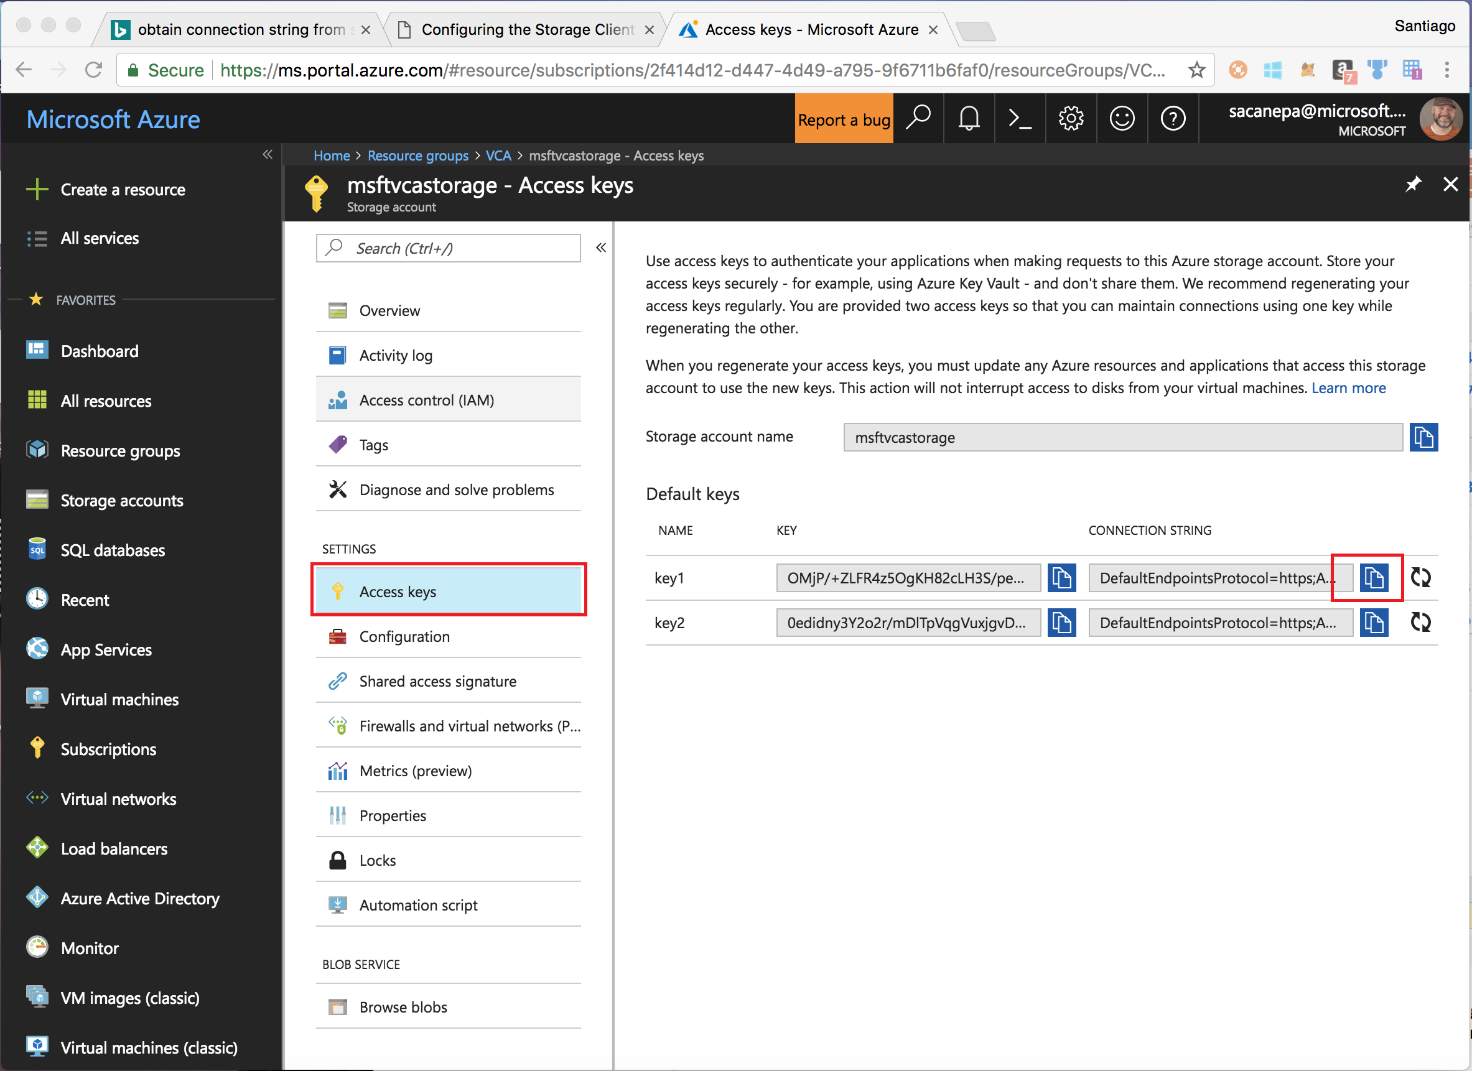

* 1. Create a KeyVault and add a secret to it: <https://docs.microsoft.com/en-us/azure/key-vault/key-vault-get-started#vault>
     1. The secret has an associated URI. Take note of the URI for the secret

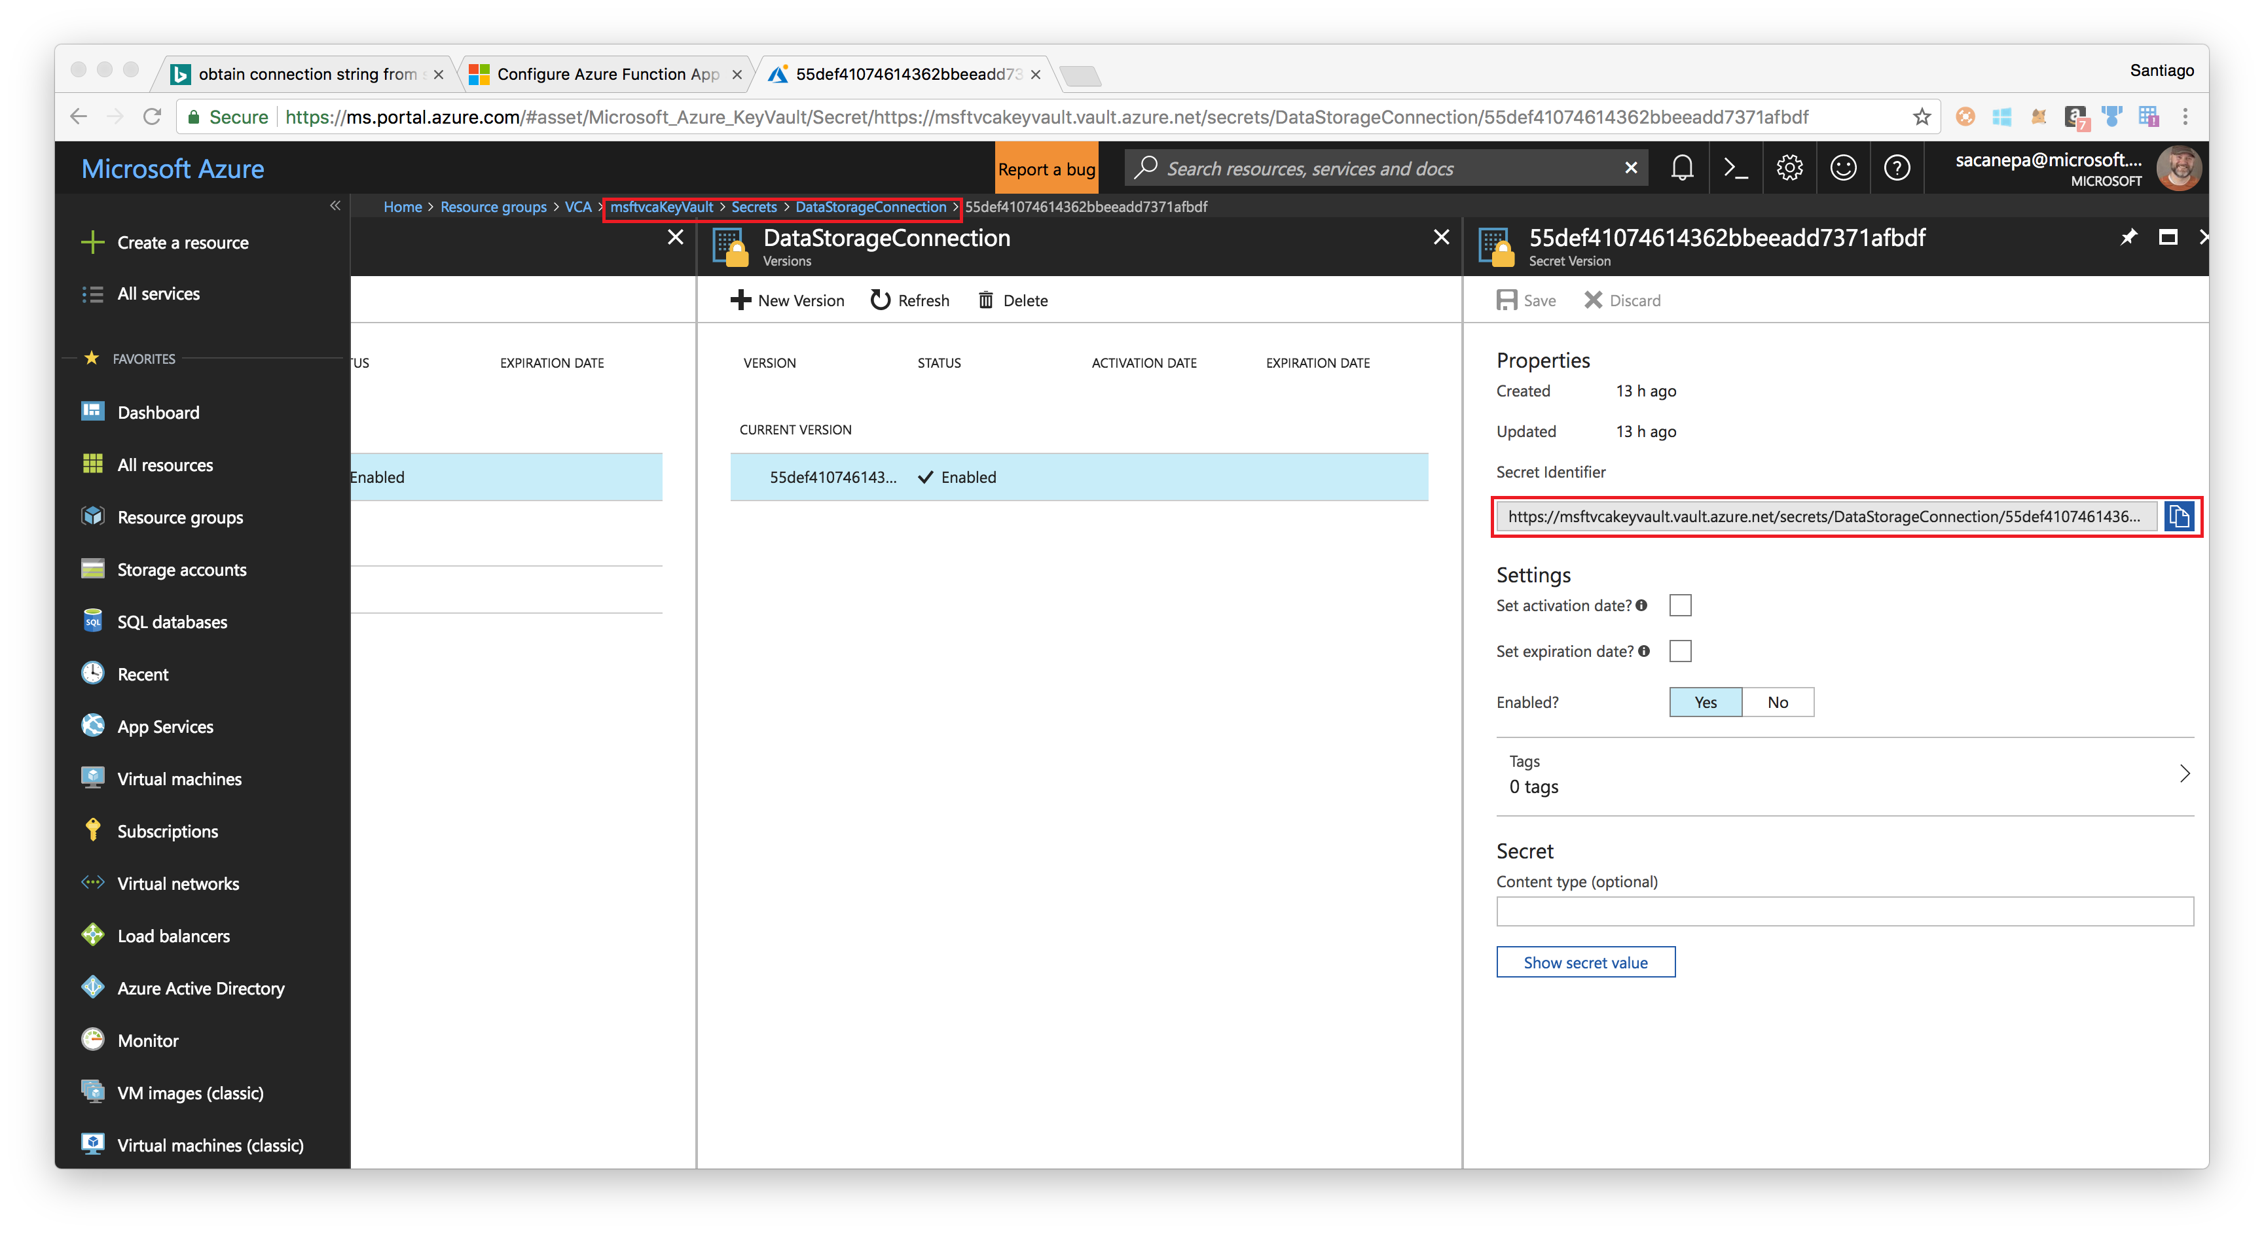

* 1. Create a Function Application
     1. Configure Functions to use MSI <https://docs.microsoft.com/en-us/azure/app-service/app-service-managed-service-identity>
     2. Configure Application settings. Add a setting called DataStorageConnection, and use the URI to the secret you saved in step 3.a: <https://docs.microsoft.com/en-us/azure/azure-functions/functions-how-to-use-azure-function-app-settings#settings>