Analysis Report Template

Student Full Name | Santosh Manoharadas | Student ID No. | w1954095/20220967
Case Study Title
Case Study (A): Predicting Clients Loan Status. [Total 43 Marks]
Research Question: Does machine learning have the potential to assist banker and finance analysts in predicting which client can be approved a loan?

Task (1) – Domain Understanding: Classification
The financial risk analysts decided that classification modelling is required. Indicate in the table below for each of the listed
variables in your data which ones you should RETAIN and can be included in the classification modelling of loan approval status, and the variables you should DROP (REMOVE). Justify your decision logically and/or by research (for any research, include in-text citation using
the Harvard style) [3 Marks]
Variable Name | RETAIN or DROP | Brief justification for retention or dropping with in-text citation.
ID | DROP | Unique identifiers carry no predictive value and can introduce noise  into the model (Géron, 2019).
Sex | DROP | Excluded to prevent algorithmic bias and adhere to ethical,  non-discriminatory lending practices.
Age | RETAIN | A numeric indicator of demographic risk and financial maturity.
Education Qualifications | DROP | Excluded to reduce dimensionality, as income already captures similar socioeconomic information, making this variable redundant in the feature set
Income | RETAIN | A primary financial metric indicating the borrower's capacity to repay  debt.
Home Ownership | RETAIN | Categorical indicator of financial stability and potential collateral assets.
Employment Length | RETAIN | Demonstrates job stability, which strongly correlates with a reliable  income stream.
Loan Intent | RETAIN | The purpose of the borrowing directly influences the risk profile of the loan.
Loan Amount | RETAIN | A fundamental factor in assessing the scale of risk and affordability for  the bank
Loan Interest Rate | RETAIN | Reflects the cost of borrowing and the initial risk assessment assigned  to the client.
Loan-to-Income Ratio (LTI) | RETAIN | A standard lending metric used to evaluate financial stress and  repayment capacity.
Payment Default on File | RETAIN | Historical credit behavior is a strong predictor of future default risk.
Credit History Length | RETAIN | A longer history provides a more reliable assessment of long-term  financial habits.
Loan Approval Status | RETAIN | This must be kept as it is the target variable (the class label) for the  classification models.
Maximum Loan Amount | DROP | Including this would cause data leakage, as it is the target variable for  the future regression task (Géron, 2019).
Credit Application Acceptance | DROP | Redundant variable that overlaps with the target 'Loan Approval Status
References
Géron, A. (2019) Hands-On Machine Learning with Scikit-Learn, Keras, and TensorFlow: Concepts, Tools, and Techniques to Build Intelligent Systems. 2nd edn. Sebastopol, CA: O’Reilly Media.

Task (2) – Exploring and Understanding Your Dataset
With the aid of your Final Python Notebook 1, for your RETAINED input variables and your class “Target” variable, produce 1)basic descriptive stats and 2)variable scale type, then 3)plot the distribution of your target variable. (Paste the three screenshots of code OUTPUTS ONLY for evidence of these elements).

1).Basic descriptive stats
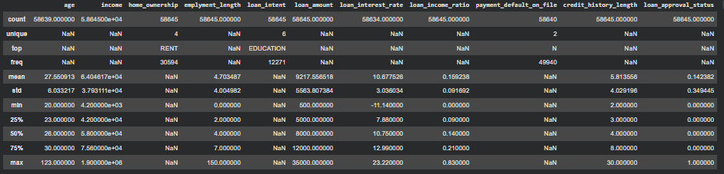
2).Variable scale type
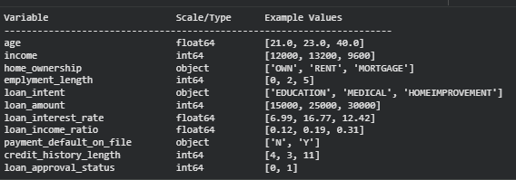
3).Plot the distribution of your target variable
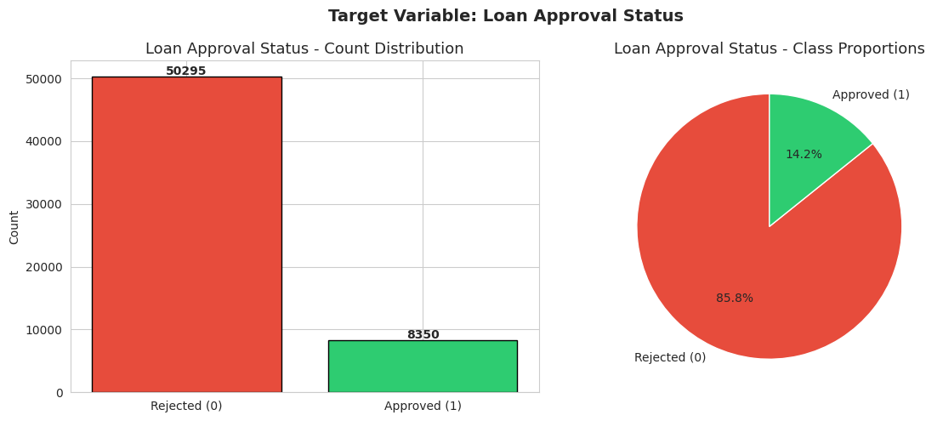
[2 Marks]
Task (3) – Data Preparation: Cleaning and Transforming your data
a) With the aid of your Final Python Notebook 1, when you first explored your retained variables in the loan dataset, you may have found some issues. 1) Report any issues you found in your retained dataset variables. Based on the issues you found in your data, 2)suggest a suitable possible method to fix each of these issues and 3)provide your justification for using your suggested fix method. Use the table below to organise your findings and analysis, and add more rows if needed
[4 Marks]
 | Variable Name | Issue found | Proposed fix | Justification for used fix method
1 | age | 6 missing values (NaN) found in the dataset. | Impute with the median age. | Age is numeric; median imputation is robust to skewness and extreme outliers, unlike the mean (Géron, 2019).
2 | age | One unrealistic outlier was identified in the age variable, where a value exceeded 100 years. | Replace with the median age. | These are highly likely data entry errors. Replacing them prevents these extreme outliers from skewing distance-based algorithms.
3 | loan_interest_rate | 11 missing values (NaN) found. | Impute with the median interest rate. | Preserves the central tendency of the interest rate distribution without being distorted by extremely high or low existing rates.
4 | payment_default_on_file | 5 missing values (NaN) found. | Impute with the mode ('N'). | For categorical data, using the most frequent value maintains the typical case profile of the dataset.
5 | payment_default_on_file | Data is in a binary string format ('Y' / 'N') | Binary Encode to 1 and 0. | Scikit-learn machine learning algorithms require numeric inputs to process relationships algebraically (Géron, 2019).
6 | home_ownership | Data is in a multi-category text format (Rent, Own, etc.) | Apply Label Encoding. | Converts text categories into a machine-readable numeric format required by the classifiers.
7 | loan_intent | Data is in a multi-category text format (Medical, Education, etc.). | Apply Label Encoding. | Converts text categories into a machine-readable numeric format required by the classifiers.
8 | All numeric features | Features are on vastly different mathematical scales (e.g., Age vs. Income). | Apply StandardScaler to normalize. | Distance-based algorithms (like KNN) and gradient optimization (like LR) are highly sensitive to feature scales and require normalization to perform accurately.

Task (3) – Data Preparation: Cleaning and Transforming your data
b) With the aid of Python packages and your Final Python Notebook 1, implement your suggested fixes of issues in the previous Task 3-a in your final Python Notebook1.
1) Show evidence (before and after) of implementing your suggested fix to the problems you identified for your dataset in Task 3-a.
To show your evidence, paste screenshots of your relevant code OUTPUTS ONLY (Do not paste the code).
2) Indicate and annotate the issue and the fix in each of your provided evidence screenshots.
[4 Marks]
Output screenshot of the issue before the fix | Output screenshot after fixing the issue
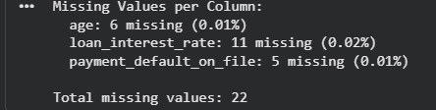  Missing values were identified in the variables age, loan_interest_rate and payment_default_on_file. These were handled using median imputation for numerical variables and mode imputation for the categorical variable, ensuring no missing values remained in the dataset | 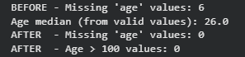
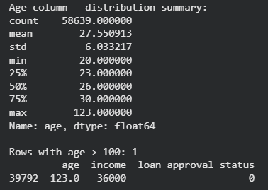  An extreme outlier was found in the age variable (value above 100), which is unrealistic. This was treated as a data entry error and replaced with the median value, removing the outlier and improving data reliability. | 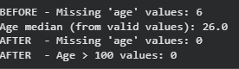
Categorical variables such as home_ownership, loan_intent and payment_default_on_file were originally in text format. These were converted into numerical values using encoding techniques so they could be used effectively by machine learning models. | 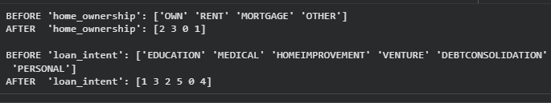

Task (4) – Classification Modelling of Clients Loan Approval Status
a) In your Final Python Notebook 2, you built THREE different models to predict loan approval status: Logistic Regression (LR), K Nearest Neighbour (KNN) and Naïve Bayes (NB). These algorithms are a mix of parametric and non-parametric algorithms.
1) Note down the type of each algorithm (parametric vs non-parametric),
2) name any learnable parameters, and
3) list any strategic hyperparameters for each algorithm which you want to consider tuning. Organise your answer in the table below:
[3 Marks]
Algorithm Name | Algorithm Type | Learnable Parameters | Some Strategic Hyperparameters
Naïve Bayes (NB) | Parametric | Feature means, feature variances, class prior probabilities | var_smoothing
Logistic Regression (LR) | Parametric | Weights (coefficients), Bias (intercept) | C (regularization strength), penalty (l1/l2), solver
K-Nearest Neighbour (KNN) | Non-parametric | None (Lazy learner / instance-based) | n_neighbors (K), weights, metric

Task (4) – Classification Modelling of Clients Loan Approval Status
b) With the aid of your Final Python Notebook 2, use the training–test split approach with your retained applicable input features only and the target output feature to build your predictive classification models.
[3 Marks]
i. Screenshot
1) the list of all feature names used for building your classification models and the corresponding
2) data shape function output. (Paste screenshots of the relevant code output only; do not paste the Python code).

List of all feature names :

Data shape function output:
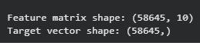

ii. In less than 150 words, research and justify (defend) your choice of the training-test split ratio and provide an in-text citation.

A 70/30 training–test split was selected as it provides a good balance between model learning and evaluation. Allocating 70% of the data to training allows the models to capture underlying patterns effectively, which is particularly important given the class imbalance in the dataset. The remaining 30% is used as unseen test data to assess how well the model generalises and to detect potential overfitting. With over 45,000 records in the dataset, both subsets are large enough to produce statistically meaningful and stable results. As noted by Géron (2019), a 70/30 or 80/20 split is commonly used in machine learning as it offers a practical balance between training performance and evaluation reliability.
References

Géron, A. (2019) Hands-On Machine Learning with Scikit-Learn, Keras, and TensorFlow. 2nd edn. O’Reilly Media.

iii. Provide as evidence the code block line and code output from your Final Python Notebook 2 that ensures two conditions:
1) all your models were tested on the same test instances (clients) in your dataset;
2) the labels ratio of approval Status “Accept” to “Reject” is the same in the training and test subsets.
3) State the training-test split function parameters in your code line that are responsible for meeting both conditions.
4) In less than 150 words, research and justify (defend) your decision to implement both conditions in your Python Notebook 2 notebook with in-text citations where possible.

1)
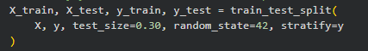

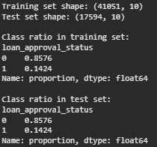
2)
The class distribution of loan approval status is identical in both the training and test sets. The proportion of rejected (0) and approved (1) cases remains consistent, confirming that stratified sampling was correctly applied. This ensures that both subsets accurately reflect the original dataset distribution, leading to a fair and reliable model evaluation.

3)
The parameters responsible for meeting both conditions are random_state=42 and stratify=y. The random_state ensures that the same training and test instances are used consistently across all models, while stratify=y maintains the same class distribution of approval status in both the training and test subsets.

4)
random_state=42 pins the split so every model trains and tests on identical data without this, you can't fairly compare scores since different models would have seen different clients. stratify=y handles the class imbalance issue; if you split randomly, you could easily end up with a test set that has very few approved cases, which would skew results. Géron (2019) highlights that reproducibility and representative splits are both necessary for valid evaluation, which is why both parameters were used here.

References with in-text citation
Géron, A. (2019) Hands-On Machine Learning with Scikit-Learn, Keras, and TensorFlow. 2nd edn. O’Reilly Media.
Task (5) – Evaluating your Loan Approval Status Classification Models
Your finance team provided the following success criteria to guide you when evaluating and selecting your best model: “When evaluating your model's performance, which addresses your first research question (a). The model is expected to misclassify clients’ applications. Thus, the model should aim to predict as many “Reject” status for clients as many as possible to decrease the risk of future defaulted loan payments. However, the model should demonstrate that its high “Reject” prediction rate is mainly due to a larger number of correctly detected (predicted) rejected loan applications.”

a) With the aid of Final Python Notebook 2, for each of your models (Logistic Regression LR, Naive Bayes NB and K-Nearest Neighbours KNN)
1) paste the test confusion matrix,
2) the classification report and
3) the AUC-ROC curve graphs
as screenshots from the output of your Python code.
[3 Marks]

1) Screenshot of the test confusion matrix for (NB, LR, and KNN); make sure you title each matrix with its algorithm name
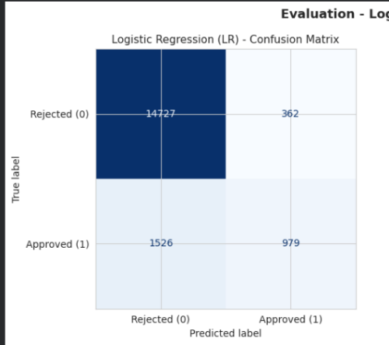
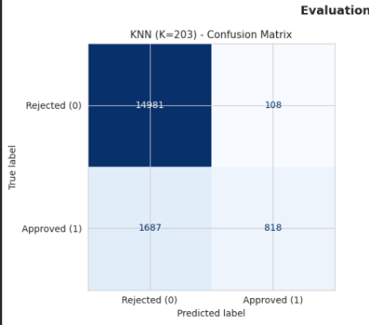
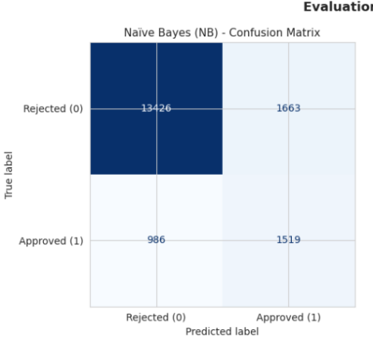

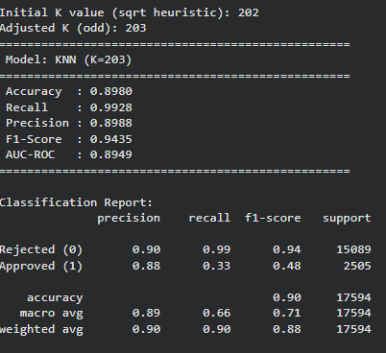
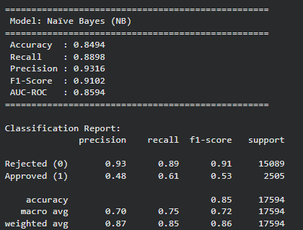
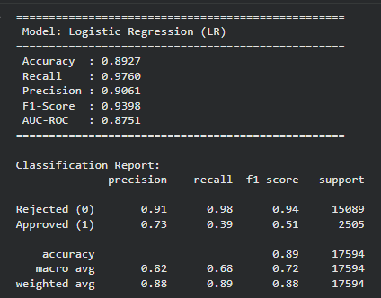
2) Screenshot of the classification report for (NB, LR, and KNN); make sure you title each classification report with its algorithm name

3) Screenshot of the AUC-ROC Curve for (NB, LR, and KNN); make sure you title each graph with its algorithm name
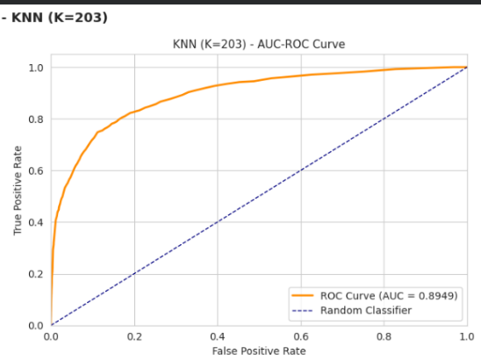
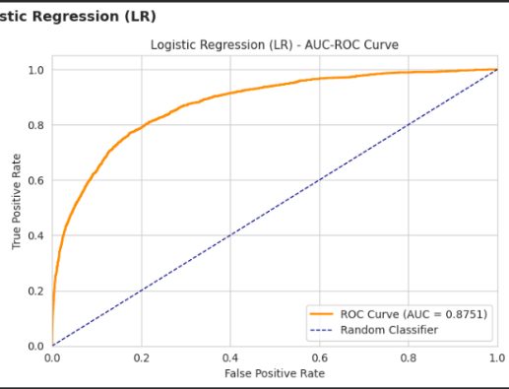
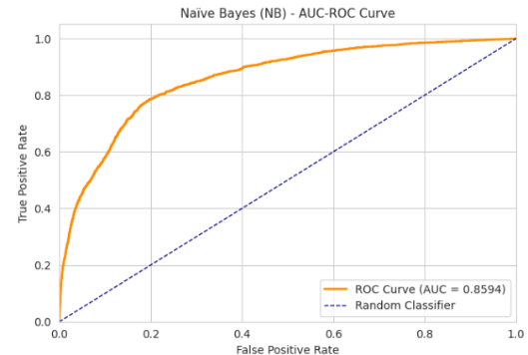

Task (5) – Evaluating your Loan Approval Status Classification Models
b) Five different classification evaluation metrics are calculated in your Final Python Notebook 2.
1) State which evaluation metric/metrics to “USE or “DO NOT USE” to closely interpret the above success criteria.
2) For justification, explain how closely your choice of “USE” or “DO NOT USE” for a metric interprets the given success criteria.
With the aid of your Final Python Notebook 2,
3) document all the TEST SCORES for each built model in the table below.
[7 Marks]
Metric | 1) USE or DO NOT USE | 2) Justification for choosing “USING” or “NOT USING” this metric in relation to the success criteria | Model | 3) Metric Test Score
Accuracy | DO NOT USE | Not used. A model that blindly predicts every application as Rejected would still score around 77% accuracy given the class imbalance, making this metric unreliable for measuring true discriminative performance. | NB | 0.8494
 |  |  | LR | 0.8927
 |  |  | KNN (k=203) | 0.8980
Recall | USE | Measures the proportion of actual rejected applications that are correctly identified by the model, which directly aligns with the finance team’s objective of minimising default risk. | NB | 0.8898
 |  |  | LR | 0.9760
 |  |  | KNN (k=203) | 0.9928
Precision | USE | Measures how many predicted rejected applications are truly rejected, ensuring that the model does not unnecessarily reject low-risk clients | NB | 0.9316
 |  |  | LR | 0.9061
 |  |  | KNN (k=203) | 0.8988
F1-score | USE | Provides a balanced evaluation by considering both recall and precision, ensuring the model captures high-risk applicants while maintaining reliability in its predictions. | NB | 0.9102
 |  |  | LR | 0.9398
 |  |  | KNN (k=203) | 0.9435
AUC-Roc | USE | Evaluates the model’s ability to distinguish between approved and rejected applications across all classification thresholds, providing a more comprehensive view of performance beyond a single decision boundary. | NB | 0.8594
 |  |  | LR | 0.8751
 |  |  | KNN (k=203) | 0.8949

Task (5) – Evaluating your Loan Approval Status Classification Models
c) Suggest a single best approval status classification model based on the ‘USED’ performance metrics scores you identified in Task (5-b). In less than 100 words, briefly describe how well your best model satisfies the needs of your finance team.
[2 Marks]
The K-Nearest Neighbours (KNN) model is the most suitable choice based on the results. Since the main objective is to correctly identify rejected applications, recall is the most important metric, and KNN achieved the highest recall for the Reject class (99%), making it highly effective at identifying high-risk applicants. It also maintains strong precision and F1-score, indicating that its predictions are both reliable and consistent. A recall of 99% means the model correctly flags nearly all high-risk applications, directly reducing the bank's exposure to loan defaults while still maintaining reliable precision.

Task (5) – Evaluating your Loan Approval Status Classification Models
d) To enhance your selected best model/s performance (from Task 5-c), tune some of its possible hyperparameters, which you indicated in Task (4-a) for that specific algorithm. With the aid of Final Python Notebook 2, Re-train and test the best algorithm again with GridSearchCV
[5 Marks]
i. With the aid of your Final Python Notebook 2,
1) Paste into this report the line of code which shows evidence of specifying a parameters grid and applying the GridSearchCV function to rebuild your selected best model.
2) Then, document the estimated best hyperparameters for the optimised model.

1)
param_grid_knn = {
'n_neighbors': [5, 11, 21, 31, 51],
'weights': ['uniform', 'distance'],
'metric': ['euclidean', 'manhattan']
}
grid_search_knn = GridSearchCV(
KNeighborsClassifier(),
param_grid=param_grid_knn,
cv=StratifiedKFold(n_splits=5, shuffle=True, random_state=42),
scoring='recall',
n_jobs=-1,
verbose=1
)
grid_search_knn.fit(X_train_scaled, y_train)

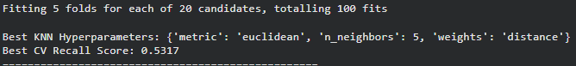

2) The optimal hyperparameters identified using GridSearchCV for the KNN model were: number of neighbours (n_neighbors) = 5, weighting method = 'distance', and distance metric = 'euclidean'. These values were selected because they produced the highest recall score during cross-validation under the implemented GridSearchCV setup. In this implementation, recall was used as the optimisation metric to favour sensitivity during model selection, although it did not explicitly optimise reject-class recall. After testing the tuned model using the coursework evaluation metrics, precision and F1-score improved, but reject recall decreased from 0.9928 to 0.9745. Since the finance team prioritised identifying as many rejected applications as possible, the original untuned KNN remained the more suitable model for this task.

ii. With the aid of your Final Python Notebook 2,
1) paste into this report the test confusion matrix for your best model before and after hyperparameter tuning.
2) Also, document the new score/s of the “USED” performance metric/s of your choice to interpret the success criteria indicated in Task (5.b) before and after tuning.
3) Comment on whether the tuning of hyperparameters of your best model improved its positive predictive ability in line with the success criteria.

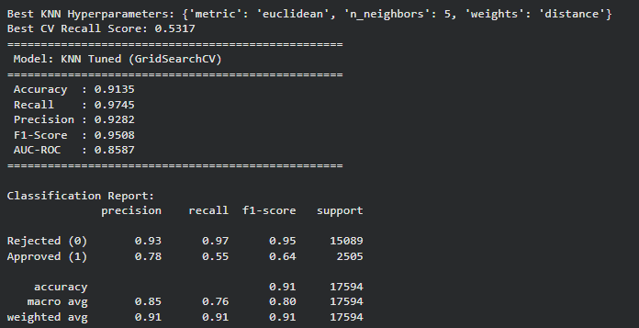
Before:


After

2) Performance Metrics Comparison
Before tuning, the KNN model achieved a recall of 0.9928, precision of 0.8988, and F1-score of 0.9435.
After hyperparameter tuning, the model achieved a recall of 0.9745, precision of 0.9282, and F1-score of 0.9508.

3) Evaluation of Tuning Effect
Although hyperparameter tuning improved precision and F1-score, the recall decreased from 0.9928 to 0.9745. Since recall is the most important metric based on the success criteria, the original KNN model remains more effective at identifying rejected applications. Since the primary objective is to catch as many risky applicants as possible, the pre-tuning KNN remains the stronger option for this use case despite the trade-off in precision.

Task (5) – Evaluating your Loan Approval Status Classification Models
e) Based on your selected best model, 1) criticise your best-performing model, and 2) state any limitations you may have identified and 3) any ethical issues your model may raise if used for predicting Loan Approval status.
[2 Marks]
Although KNN performs well in identifying rejected applications, it has a few limitations. KNN's main weakness is its sensitivity to how the data is scaled and which value of k is chosen both were tuned carefully here, but in a live system they would need ongoing monitoring. Because it works purely on distance, noisy or irrelevant features can quietly pull predictions in the wrong direction. The bigger issue for a banking context though is interpretability there is no clear decision path to show a rejected applicant, which creates practical and legal problems.

From an ethical perspective, this lack of transparency could be problematic, as applicants may not receive clear reasons for decisions. In addition, if the training data contains hidden biases, the model may unintentionally favour or disadvantage certain groups, leading to unfair outcomes

Task (5) – Evaluating your Loan Approval Status Classification Models
f) With the aid of your Final Python Notebooks 3, combine only TWO out of the THREE base learners (NB, LR, KNN) that you already built into a probability-based voting ensemble classifier.
[5 Marks]
i. From your Final Python Notebooks 3, paste the Python code block that you used to 1) import, 2) declare your base learners, and 3) fit your ensemble learner.
1)
from sklearn.ensemble import VotingClassifier
from sklearn.linear_model import LogisticRegression
from sklearn.naive_bayes import GaussianNB
2)
# Declare base learners
base_lr = LogisticRegression(max_iter=1000, random_state=42, C=1, penalty='l2', solver='liblinear')
base_nb = GaussianNB()

# Declare probability-based voting ensemble (soft voting)
ensemble_model = VotingClassifier(
estimators=[
('lr', base_lr),
('nb', base_nb)
],
voting='soft'
)
3)
# Fit the ensemble model
ensemble_model.fit(X_train_scaled, y_train)

ii. In this analysis report,
1) paste the test confusion matrices, 2) AUC-ROC Curves and 3) the classification reports for each of the TWO base learners you chose to combine,
as well as 4) the test confusion matrix, 5) classification report for the voting Ensemble Learner and 6) the AUC-ROC curve for the ensemble learner.
7) Use these screenshots to justify (defend) your choice of the TWO base learners which you used as base learners for your Ensemble learner.

1) Paste the test confusion matrices for each base learn er (2 x matrices )
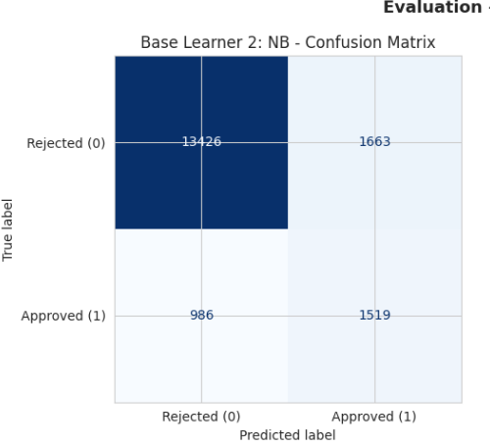
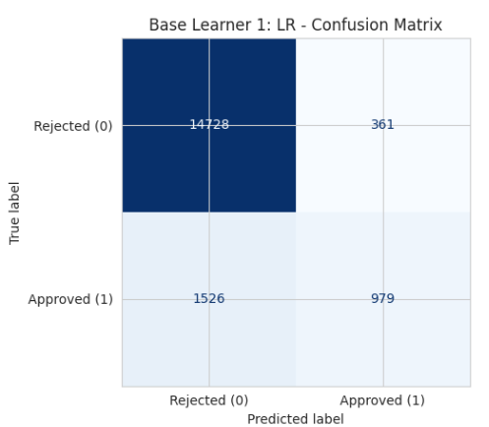

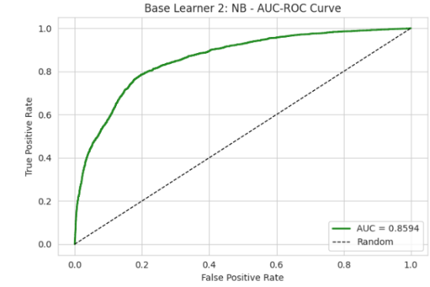
2) Paste the AUC-ROC for each Base learner (2 x AUC-ROC grap hs)
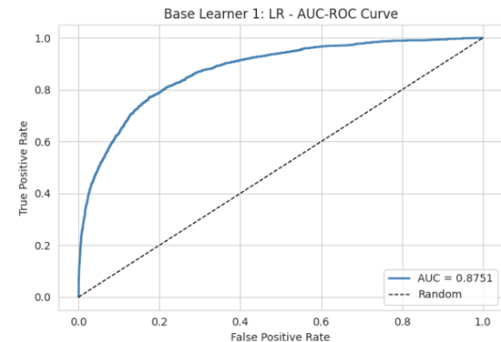
3) Paste the Classification report for each base learner (2 x classification reports)
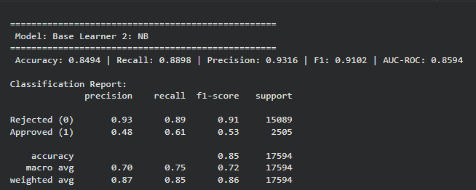
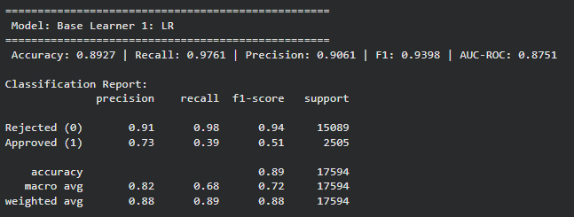
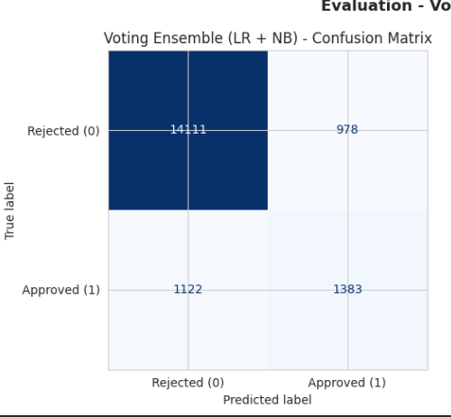
4) Paste the test confusion matrix for the ensemble learner (1 x confusion matrix)

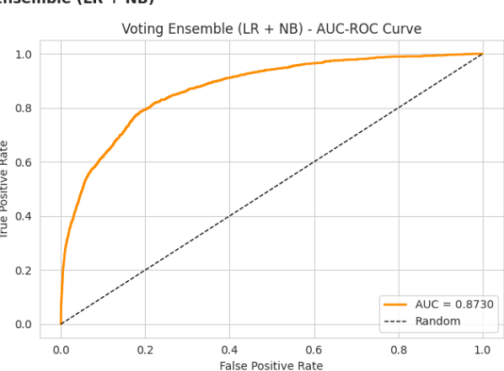
5) Paste the AUC-ROC for the ensemble learner (optional) (1 x AUC-ROC graph)

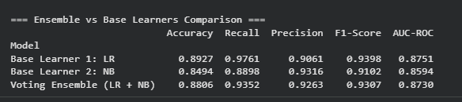
6) Paste the Classification report for the ensemble learner (1 x classification report)

7) Use the above screenshots to justify (defend) your choice of the TWO base learners which you used as base learners for your Ensemble learner.
Logistic Regression and Naïve Bayes were selected as base learners for the ensemble as both models demonstrated strong performance across the evaluation metrics. Logistic Regression achieved a high recall (0.9761) for the Reject class, making it effective at identifying high-risk applicants, which aligns with the finance team’s objective. It also maintained a strong precision (0.9061) and F1-score (0.9398), indicating reliable predictions.

Naïve Bayes, while having a lower recall (0.8898), showed higher precision (0.9316), meaning its reject predictions were more accurate. This provides a complementary strength to Logistic Regression.

By combining these two models using soft voting, the ensemble leverages both high recall and high precision, resulting in a more balanced and stable prediction performance compared to relying on a single model.

iii. Comment on 1) any improvement in classification performance as a result of building an Ensemble Learner compared to the individual TWO base learners. 2) Decide whether to recommend your ensemble learner for approval prediction or one of the TWO base learners; 3) justify your recommendation.

The ensemble model shows a slight improvement in precision (0.9263) compared to Logistic Regression (0.9061), indicating more accurate reject predictions. However, its recall (0.9352) is lower than Logistic Regression (0.9761), meaning it identifies fewer high-risk applicants. Since the finance team prioritises, maximising correctly identified rejected applications, recall remains the most important metric.

The ensemble trades some recall for better precision, but since the finance team's priority is catching as many risky applicants as possible, a small drop in recall is a real cost. Logistic Regression, with its higher recall of 0.9761, is the stronger fit for this objective and is recommended as the final model.

Case Study Title
Case Study (B): Predicting Maximum Loan Amount.
Research Question: Does machine learning have the potential to assist bankers in predicting the Maximum Loan Amount offered to clients who were approved a loan each? [Total 36 Marks]

Task (1) – Domain Understanding and Designing Your Regression Experiments
The bankers decided that regression modelling is required to predict Maximum Loan Amount for those who are approved a loan. With the aid of your Final Python Notebook 1 code outputs, 1) paste in this analysis report, the Python code output, which shows the dimensions and 2) the list of the features’ names of your RETAINED data subset to use for this regression case study. [2 Marks]

1) Dimensions (Code Output): Your feature matrix contains 50,292 records (rows) and 10 features (columns).
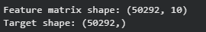
2) Retained Features List: The following 10 features have been retained for the regression model to predict the Maximum Loan Amount:
- age
- income
- home_ownership
- emplyment_length
- loan_intent
- loan_amount
- loan_interest_rate
- loan_income_ratio
- payment_default_on_file
- credit_history_length

Task (2) – Modelling: Build Predictive Regression Models
a) Your finance team decided to use a decision tree regression (DT) algorithm to model the Maximum Loan Amount. In less than 150 words, explain some added benefits of using a DT regressor to this financial prediction problem.
[2 Marks]
A Decision Tree (DT) regressor is well suited to this financial prediction problem because it can model complex, non-linear relationships between client attributes and loan amounts without requiring strict assumptions about the data. It is also highly interpretable, allowing bankers to understand how different factors such as income, credit history, and loan intent influence the predicted maximum loan amount. This transparency is important in financial decision-making, where explanations are often required. Additionally, DT models can handle both numerical and categorical variables effectively, making them flexible for real-world banking datasets. Without pruning, however, a fully grown tree risks memorising training data rather than learning generalisable patterns a limitation that becomes evident when comparing DT-1 and DT-2 in this study (Géron, 2019).
References with in-text citation
Géron, A. (2019) Hands-On Machine Learning with Scikit-Learn, Keras, and TensorFlow. 2nd edn. O’Reilly Media.

Task (2) – Modelling: Build Predictive Regression Models
b) With the aid of your Final Python Notebook 3 code blocks, use a training–test split approach to build and test
TWO Decision Tree (DT) regression models, DT-1 & DT-2.
[6 Marks]
i. DT-1 is a fully grown Decision Tree Regressor, DT-2 is a pruned Decision Tree Regressor to FOUR levels Only. 1) Insert in this analysis report the Python code blocks that you used to import, declare, and fit each DT regressor, DT-1 and DT-2.
from sklearn.tree import DecisionTreeRegressor

# Declare DT-1: Fully Grown Decision Tree Regressor (no depth constraint)
# No max_depth - tree grows until all leaves are pure or contain min_samples_split records
dt1 = DecisionTreeRegressor(random_state=42)
dt1.fit(X_reg_train, y_reg_train)

print(f"DT-1 (Fully Grown) - Tree Depth: {dt1.get_depth()}")
print(f"DT-1 - Number of Leaves: {dt1.get_n_leaves()}")

# Declare DT-2: Pruned Decision Tree Regressor constrained to max 4 levels depth
# max_depth=4 implements pre-pruning (top-down constraint on tree growth)
dt2 = DecisionTreeRegressor(max_depth=4, random_state=42)
dt2.fit(X_reg_train, y_reg_train)

print(f"DT-2 (Pruned max_depth=4) - Tree Depth: {dt2.get_depth()}")
print(f"DT-2 - Number of Leaves: {dt2.get_n_leaves()}")

ii. Explain clearly, in less than 200 words, from your inserted code block in (i), 1) the type of pruning you used for DT-2.
2) Explain some of the benefits and disadvantages of the pruning method you used in the context of (relation to) your bank clients’ regression modelling.
For DT-2, pre-pruning was applied by limiting the maximum depth of the tree using the parameter max_depth=4. This means the tree stops growing once it reaches four levels, preventing it from becoming overly complex.

Limiting the depth to four levels forces the model to focus on the most significant splits, which reduces the risk of fitting noise in the training data and makes predictions more stable for new applicants. It also makes the model more interpretable, as a smaller tree is easier for analysts to understand and explain when justifying loan decisions.

However, pre-pruning can also introduce underfitting, as restricting the tree depth may prevent the model from capturing more complex relationships between variables such as income, credit history, and loan amount. As a result, the predictions may be less accurate compared to a fully grown tree, especially when dealing with diverse client profiles.

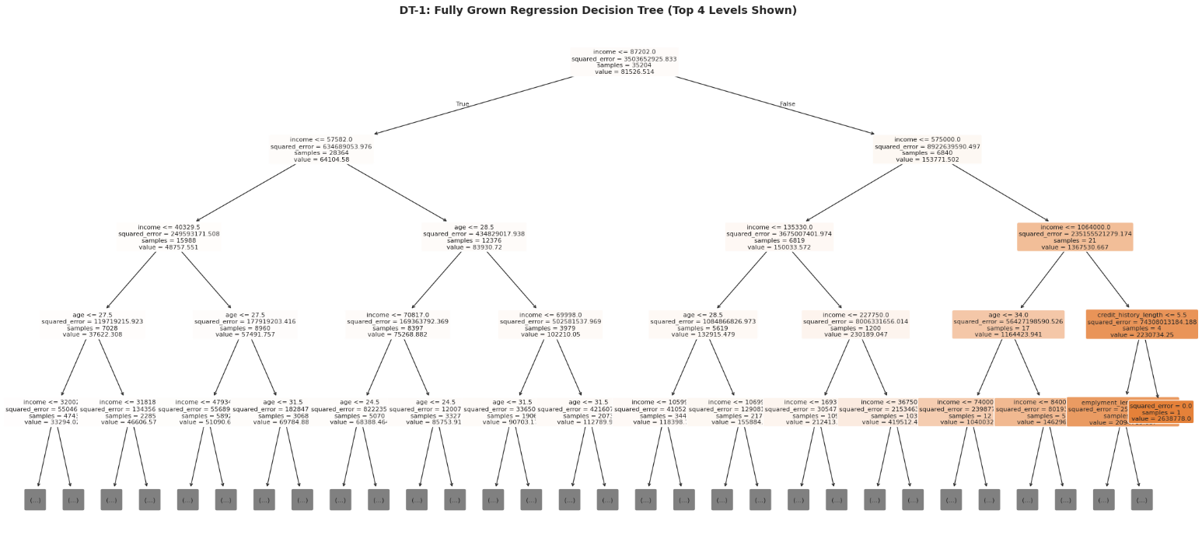
Task (2) – Modelling: Build Predictive Regression Models
c) With the aid of your Final Python Notebook 3 code outputs, visualise your regression Decision Trees DT-1 and DT-2.
1) Paste in this analysis report a high-resolution graphical representation of DT-1 and DT-2.
[4 Marks]
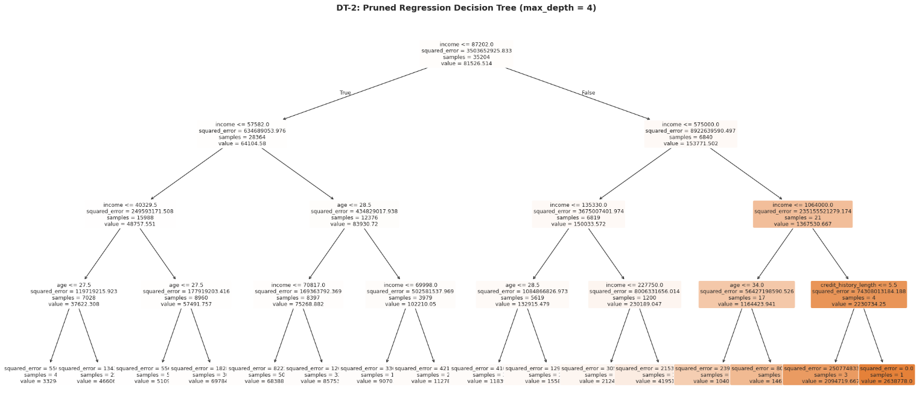

Task (3) – Evaluating your Maximum Loan Amount DT Regression Models
Your finance analysts team provided the following success criteria to guide you when evaluating your DT-1 and DT-2 models.
“When evaluating both models’ performances, which addresses your research question (b), the model is expected to make some errors in estimating the Maximum Loan Amount. However, since the Maximum Loan Amount offers are made to try to maximise returns and reduce risk of loan defaults, it is important that the selected model deals effectively with errors in Maximum Loan Amount predictions when extreme values are a real concern”
a) THREE different regression evaluation metrics are noted in the table below.
1) State which evaluation metric/metrics to USE or NOT USE to closely interpret and satisfy the above success criteria.
2) Justify (Defend) your choice of USE or DO NOT USE for each metric.
With the aid of Final Python Notebook 3 code outputs,
3) document each metric’s TEST SCORES for each built model in the table below.
[8 Marks]
Metric | 1) USE or DO NOT USE | 2) Justification for choosing “USING” or “NOT USING” this metric in relation to the success criteria | Model | 3) Metric Test Score
MSE | DO NOT USE | MSE squares the errors, making it highly sensitive to extreme values. This can exaggerate the impact of a few large prediction errors and provide a misleading assessment of model performance in a financial context where extreme loan values may exist. | DT-1 (Fully Drown) | 125,939,300
 |  |  | DT-2 (Pruned) | 456,252,700
MAE | USE | MAE is more robust to extreme values as it does not square errors. It provides a clear and interpretable average error in monetary terms (£), helping the finance team understand the expected deviation in loan predictions while managing risk. | DT-1 (Fully Drown) | £1,435.40
 |  |  | DT-2 (Pruned) | £11,645.95
R-Square | USE | R² measures how well the model explains the variance in loan amounts. A higher R² indicates the model captures key patterns in client data, supporting more reliable financial decision-making alongside MAE. | DT-1 (Fully Drown) | 0.9592
 |  |  | DT-2 (Pruned) | 0.8521

Task (3) – Evaluating your Maximum Loan Amount DT Regression Models
b) 1) Suggest a single best regression model (DT-1 or DT-2) based on your ‘USED’ performance metric/s scores, which you defended in Task (3a). 2) Explain how your suggested model fulfils the success criteria.
[4 Marks]
DT-1 (Fully Grown) is the best regression model based on the selected performance metrics (MAE and R²). DT-1 achieved a significantly lower MAE (£1,435.40) compared to DT-2 (£11,645.95), indicating more accurate predictions in terms of average error. It also produced a higher R² value (0.9592 vs 0.8521), showing that it explains a greater proportion of the variance in loan amounts.

This model fulfils the success criteria by handling prediction errors more effectively, particularly in the presence of extreme values. Since MAE was chosen as the most appropriate metric for evaluating performance under such conditions, DT-1’s substantially lower error demonstrates its ability to provide more reliable and consistent loan estimates. Given that MAE was the primary metric, DT-1's error of just £1,435 on average makes it the clear choice for informing real lending decisions.

Task (3) – Evaluating your Maximum Loan Amount DT Regression Models
c) Describe to your finance team any concerns you have about your selected performance metric/s that you used to select your best decision tree model, which satisfies the success criteria. [200 words maximum] with in-text citation.
[4 Marks]
MAE was chosen for its resistance to extreme values, but it is not without drawbacks. MAE is a non-directional metric, meaning it measures the average size of errors but does not indicate whether the model is overestimating or underestimating loan amounts. In lending, this matters if the model consistently over-predicts loan amounts, clients may be offered more than they can safely repay, which directly increases default risk.

Additionally, the high R² value (0.9592) achieved by DT-1, combined with its large tree depth, raises concerns about overfitting. As noted by Géron (2019), highly complex decision trees tend to capture noise in the training data rather than general patterns, resulting in poor performance on unseen data. Therefore, while the metrics suggest strong performance, the model’s reliability in real-world scenarios may be limited.

References with in-text citation
Géron, A. (2019) Hands-On Machine Learning with Scikit-Learn, Keras, and TensorFlow. 2nd edn. O’Reilly Media.

Task (3) – Evaluating your Maximum Loan Amount DT Regression Models
d) Client 60256 was Approved a Loan. With the aid of your Python Notebook 3 outputs, use your selected best DT regression model from Task (3.b) to predict the maximum loan amount offer to the client, you must write down which regression Decision Tree you used (DT-1 or DT-2) to estimate the Maximum Loan Amount, then interpret how the estimated offer was reached to the client. Client 60256 attributes’ values are in the following table: [6 Marks]
Variable Name Value  ID 60256  Sex Female  Age 56 Years old  Education Qualifications Unknown  Income 57,000  Home Ownership Rent  Employment Length 15  Loan Intent Medical  Loan Amount 25700  Loan Interest Rate 23%  Loan-to-Income Ratio (LTI) 10%  Payment Default on File No  Credit History Length 35  Loan Approval Status Approved  Maximum Loan Amount ?  Credit Application Acceptance 0 | 1) Model Selection for Prediction  DT-1 (Fully Grown Decision Tree) was used to predict the Maximum Loan Amount for Client 60256 because it was the best-performing model in Task (3.b), with lower MAE and higher R² than DT-2.  2) Predicted Maximum Loan Amount  The predicted Maximum Loan Amount for Client 60256 is:  £83,701.00  3) Interpretation of the Decision Path  The prediction was made using the DT-1 decision path. The main variables influencing the result were income, age, loan-to-income ratio, and loan amount. The client’s income of £57,000 placed them within a middle-income branch, while the age value of 56 repeatedly moved the path toward an older applicant group. The loan-to-income ratio of 0.10 indicated manageable borrowing relative to income, and the requested loan amount of £25,700 also influenced the final branch taken. These combined conditions led the model to Leaf Node 18691, where the predicted Maximum Loan Amount was £83,701.00.

