RTK1010Board Building Manual

Website: https://github.com/MS71/RTK1010Board

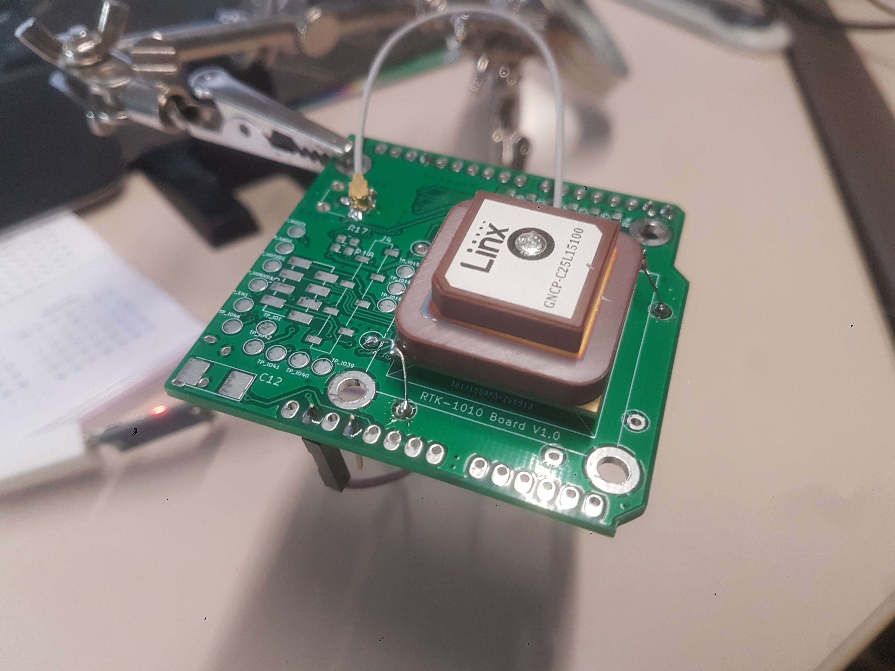

Tools
- Digital Microscope DM4(eBay)
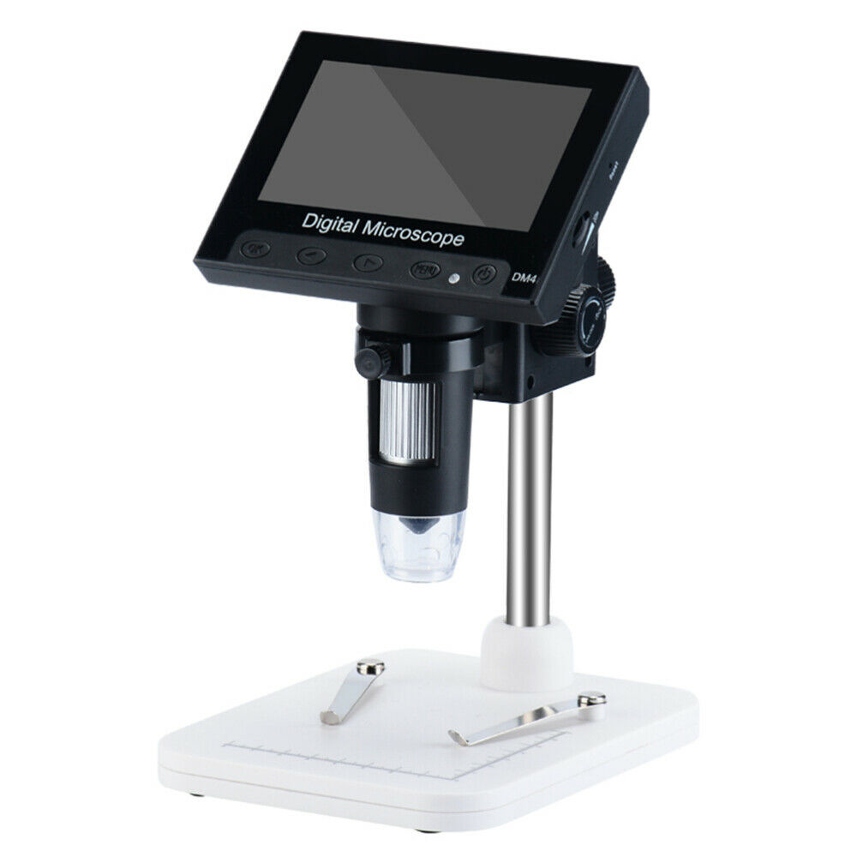
- ...

Variant A) Minimum RTK-1010 receiver with arduino form factor
- just RTK-1010 to RX/TX arduino pin
- SMA or IPEX connected
- LNA power by rtk-1010
- My active GPS antenna. (Linx:NT-GNCP-C25L15100)
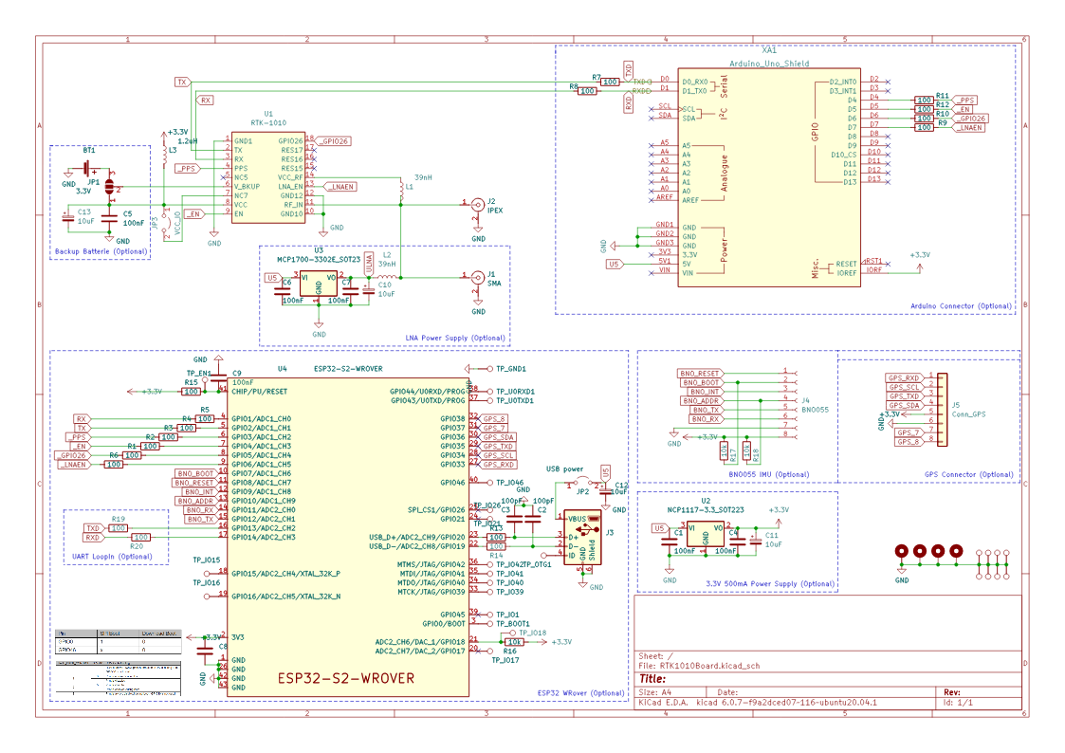
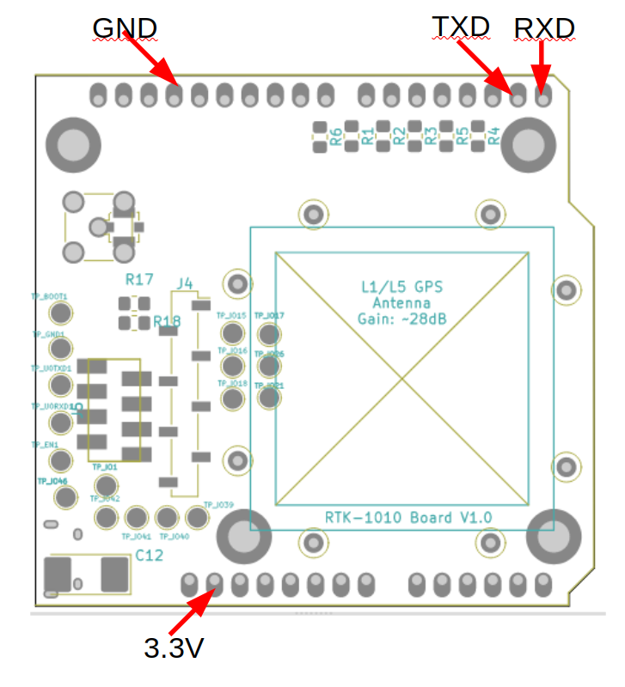
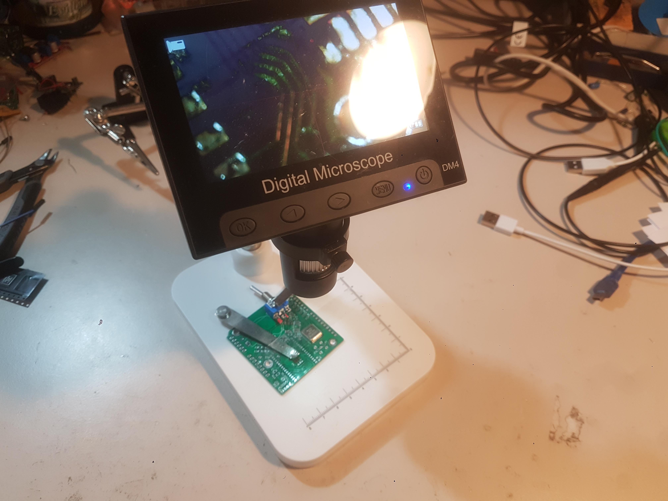

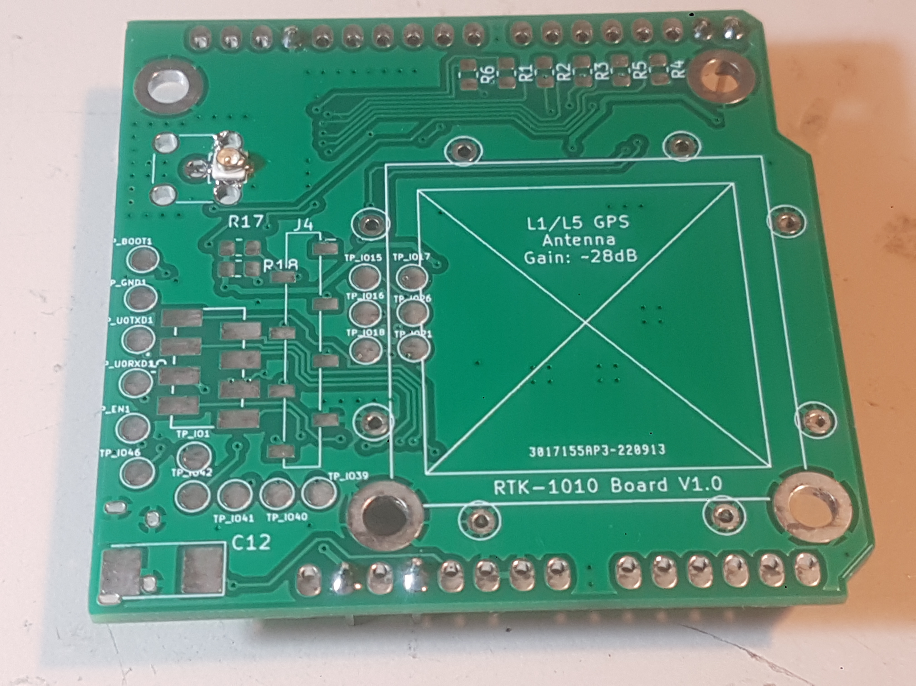
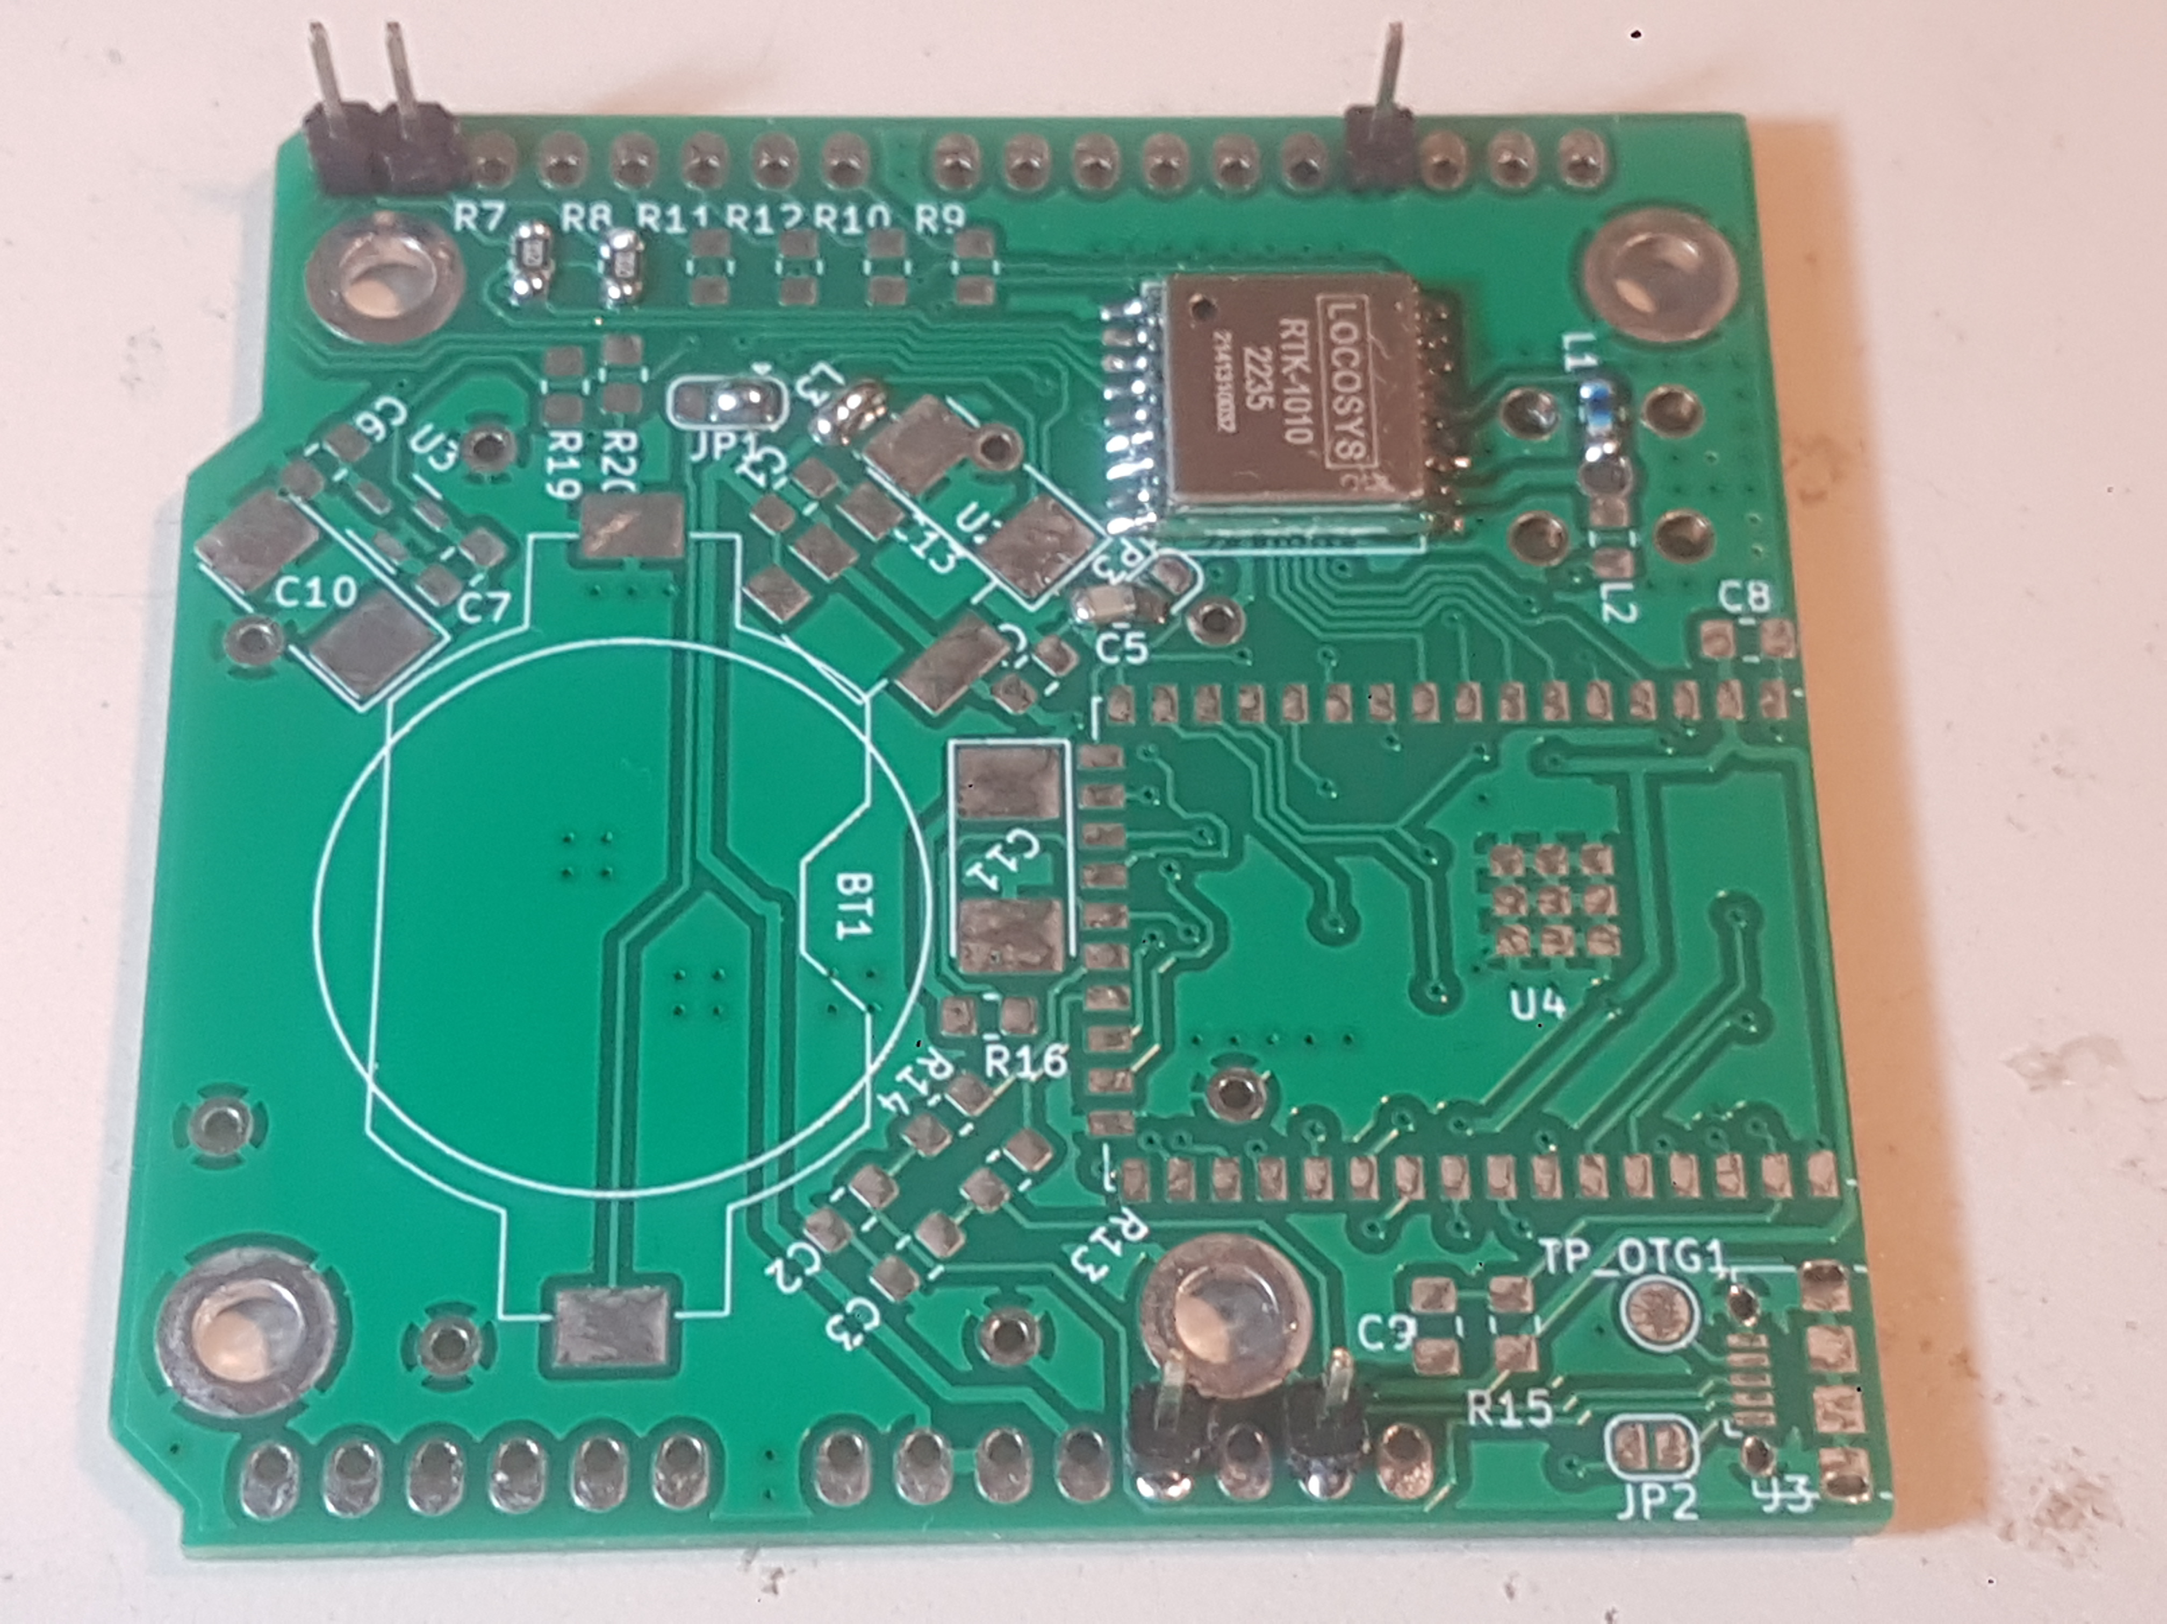

Reichelt:
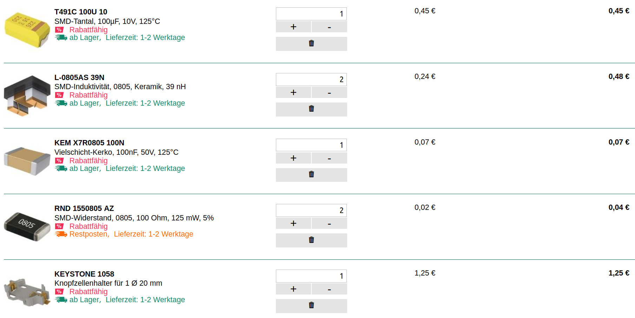

U1 RTK-1010
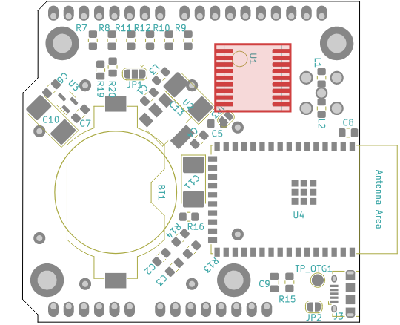

L1 Coil 39nH
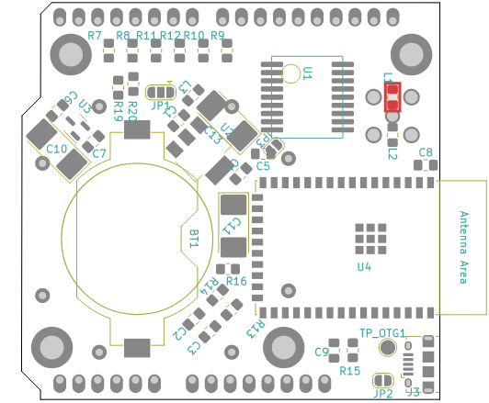

C5 100nF
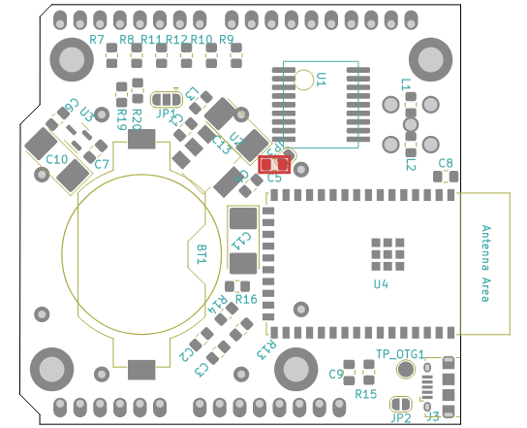

J2 IPEX Connector
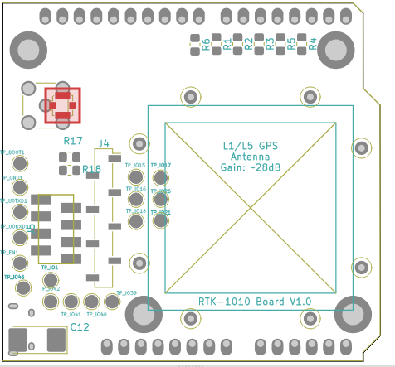

L3 400mA Filter Coil
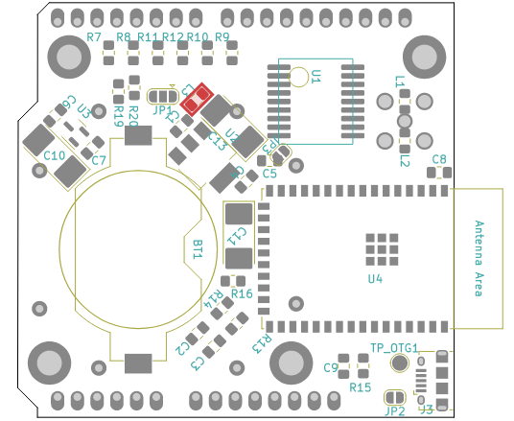

JP1 Connect V_BKUP with VCC
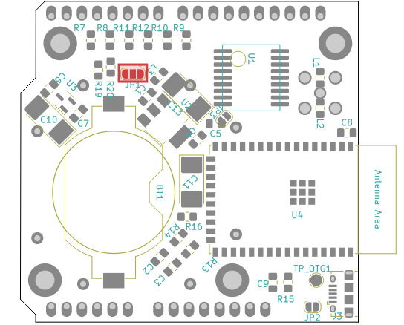
X

R6/R7 RX/TX Resistor


