How to Login

# How to Login?

You must install Analyze in Excel Updates from links provided in the Power BI service. Power BI detects the version of Excel you have on your computer, and automatically downloads the appropriate version (32-bit or 64-bit). The Power BI service runs in a browser. You can sign in to the Power BI using the following link:

* [Sign in to Power BI](https://app.powerbi.com)

If you don’t have a Power BI account, you can sign up with your own account for free from the above link. Once you’ve signed in and the Power BI service is running in your browser, click the down arrow in the upper-right corner and then click Analyze in Excel updates as in Figure @ref(fig:pbi1). This menu item applies to new installations of updates of Analyze in Excel.

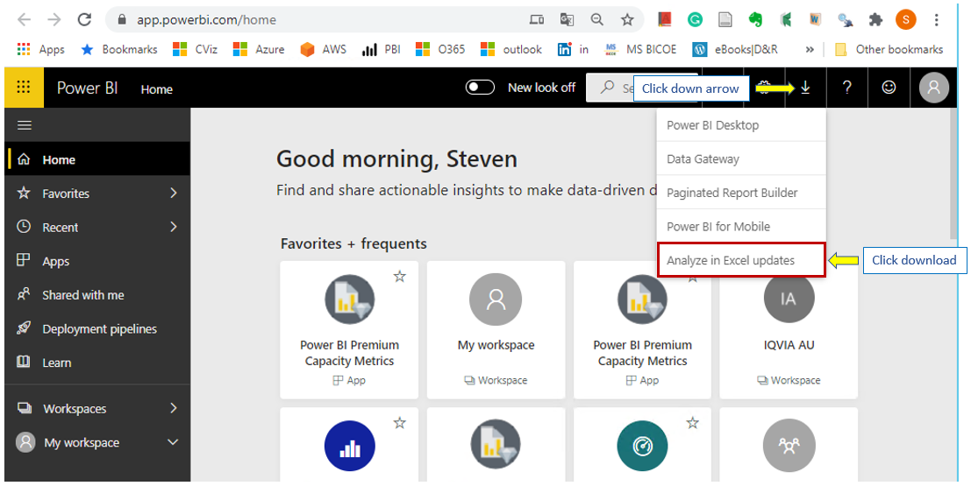

Power BI Analyze un Excel Updates download

You need to install the download on your local computer. ***If you don’t have permission to install this updates, please seek help from your IT support.***

IQVIA will supply a preconfigured Excel workbook for you to connect to your dataset from IQVIA cloud space.

When first time the IQVIA Excel connector workbook is opened, it will display an error message same as the below:

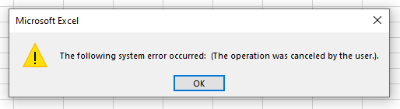

Excel Error Message

If you click OK, it will be prompted for a user name and password to log into the on cloud data service. If the prompt does not appear, please click anywhere inside the pivottable area **or close the workbook reopen it again.**

Fill in a user name as in Figure @ref(fig:login1): 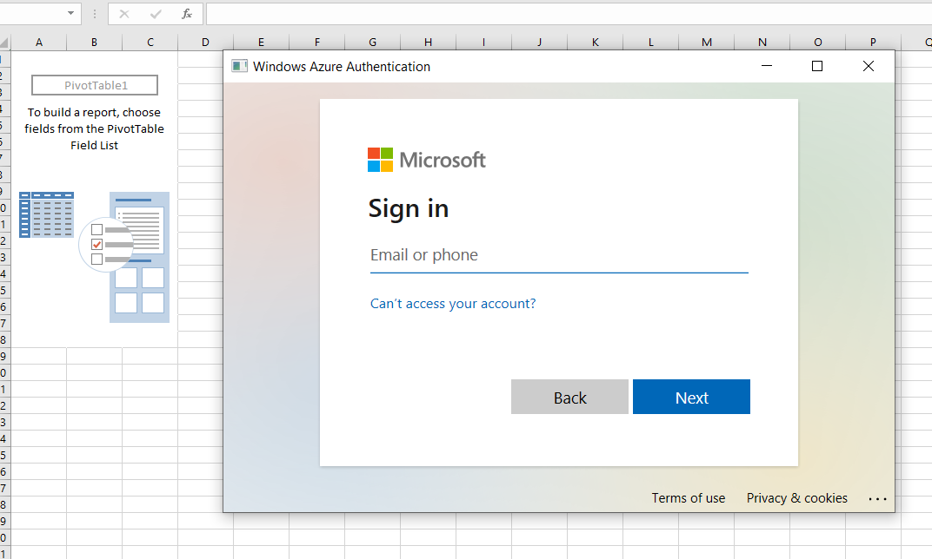

Fill in a password as in Figure @ref(fig:login2): 