Co-occurrence Analysis

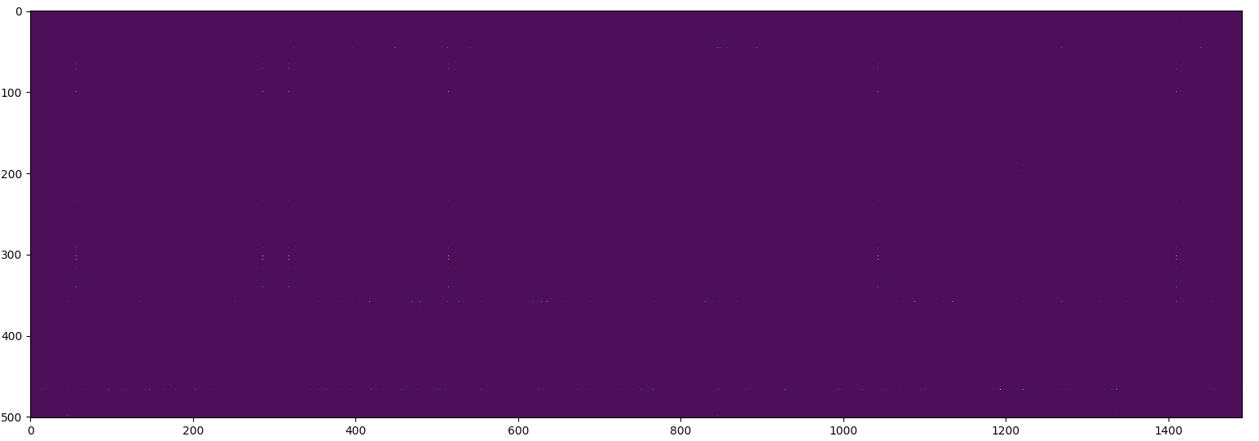

Figure 1: Rows are genes columns are HPO terms. The brighter the more co-occurrences. This is the full heat map, (very small pixels that probably look like dust on your screen are peaks).

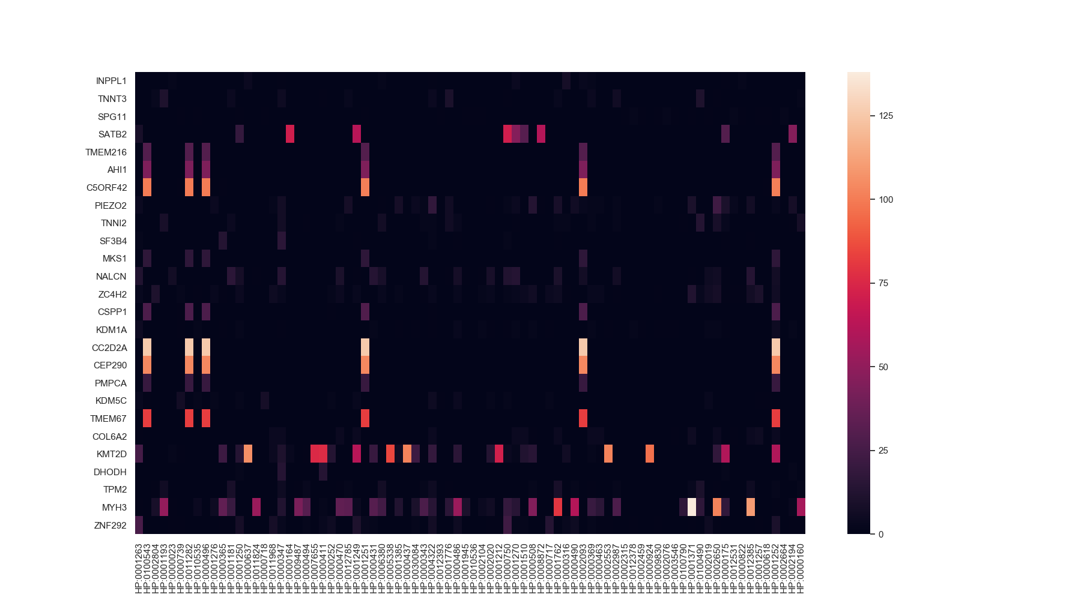

Figure 2: Filtered Heat Map, rows and columns with sums lower than 100 have been removed - 475 rows and 1411 columns were dropped. Interestingly there are several HPOs with very similar gene co-occurrences. Table 1 has an itemized list of the top 20 peaks.

|  |  |  |  |  |
| --- | --- | --- | --- | --- |
| MYH3 | embryonic skeletal muscle | HP:0001371 | Flexion contracture | 138 |
| CC2D2A | oiled-coil and calcium binding domain | HP:0001252 | Muscular hypotonia | 126 |
| CC2D2A | “ | HP:0002093 | Respiratory insufficiency | 126 |
| CC2D2A | “ | HP:0001251 | Ataxia | 126 |
| CC2D2A | “ | HP:0000496 | Abnormality of eye movement | 126 |
| CC2D2A | “ | HP:0011282 | Abnormality of hindbrain morphology | 126 |
| CC2D2A | “ | HP:0100543 | Cognitive impairment | 126 |
| MYH3 | embryonic skeletal muscle | HP:0012385 | Camptodactyly | 110 |
| KMT2D | lysine-specific methyltransferase | HP:0000637 | Long palpebral fissure | 106 |
| CEP290 | Unknown abundant protein | HP:0001252 | Muscular hypotonia | 104 |
| CEP290 | “ | HP:0002093 | Respiratory insufficiency | 104 |
| CEP290 | “ | HP:0001251 | Ataxia | 104 |
| CEP290 | “ | HP:0000496 | Abnormality of eye movement | 104 |
| CEP290 | “ | HP:0011282 | Abnormality of hindbrain morphology | 104 |
| CEP290 | “ | HP:0100543 | Cognitive impairment | 104 |
| MYH3 | embryonic skeletal muscle | HP:0002650 | Scoliosis | 102 |
| KMT2D | lysine-specific methyltransferase | HP:0002553 | Highly arched eyebrow | 102 |
| KMT2D | “ | HP:0000437 | Depressed nasal tip | 102 |
| C5ORF42 | lysine-specific methyltransferase | HP:0001252 | Muscular hypotonia | 101 |
| C5ORF42 | “ | HP:0001251 | Ataxia | 101 |

Table 1: Gene HPO Term pairs with highest co-occurrence counts. These correspond with the brightest points in Figure 2.

Top HPO Terms

|  |  |
| --- | --- |
| HP:0001252 | Muscular hypotonia |
| HP:0001251 | Ataxia |
| HP:0100543 | Cognitive impairment |
| HP:0002093 | Respiratory insufficiency |
| HP:0000496 | Abnormality of eye movement |
| HP:0011282 | Abnormality of hindbrain morphology |

Tops Genes

|  |  |
| --- | --- |
| MYH3 | embryonic skeletal muscle myosin heavy chain 3 |
| KMT2D | lysine |
| CC2D2A | coiled-coil and calcium binding domain protein that appears to play a critical role in cilia formation |
| CEP290 | Abundant but unknown protien |
| C5ORF42 | transmembrane protein |
| SATB2 | protein that helps control the development of certain body systems |
| TMEM67 | gene localizes to the primary cilium and to the plasma membrane |
| PIEZO2 | large transmembrane proteins |
| ZNF292 | Zinc Finger Protein |
| ZC4H2 | C-terminal zinc finger |