My Gene 2 Analysis

**Greedy Community Detection**: 11-14 Communities (depending on seed)

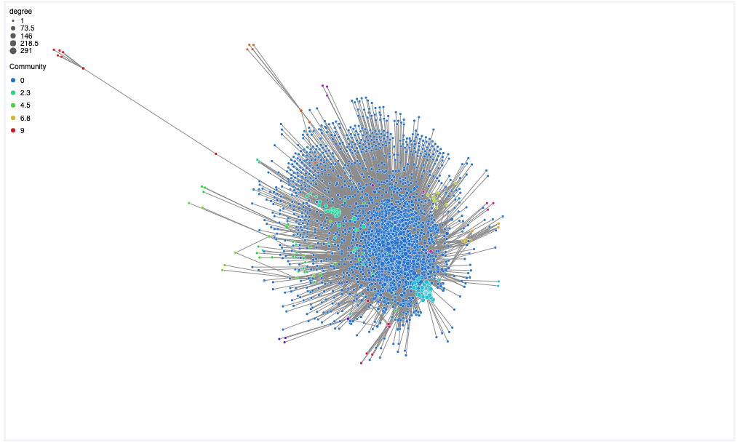

**Traversing up the HPO tree**

Mean Distance from HPO root: 6.55

Boxplot of distance from HPO root ‘All’, HP:0000001. N=1485

Shift up: 2 minimum: 2. Largest Community Removed

Shift 3 Min 6, Excluding Largest

Shift 5 Min 6, Excluding Largest

