The Variance Visualizer

By Michael Bradshaw

**Introduction**

The influx of NGS in the past decade and a half has revolutionized the use of DNA in the study of all forms of life. One technique that has become made possible by NGS is DNA barcoding, also referred to as a DNA fingerprint 1. Barcoding “uses standardized 500- to 800-bp sequences to identify species of all eukaryotic kingdoms”2. In the past, species have been distinguished from one another using key anatomical structures but distinguishing small insects, plants and fungi based solely on physical appearance can be difficult and ambiguous. For example see the three different species of vegetable leaf miners below:

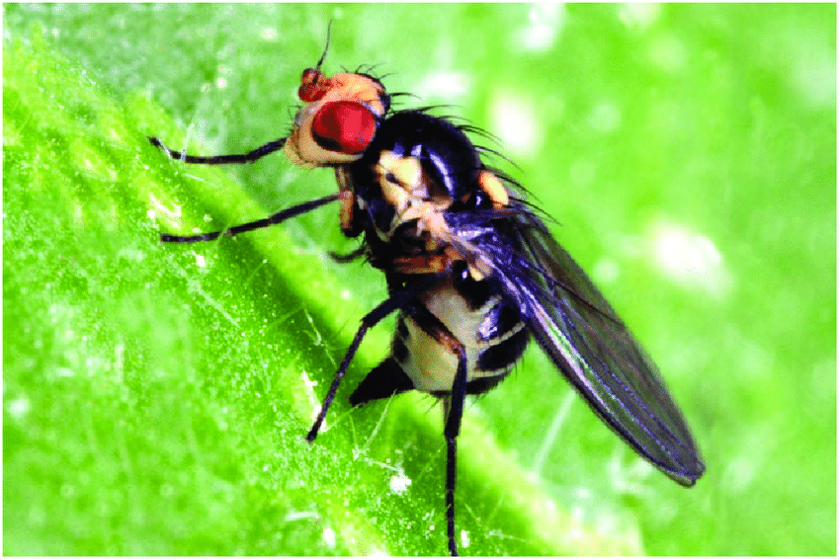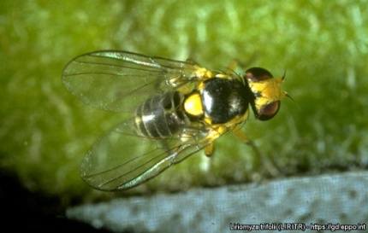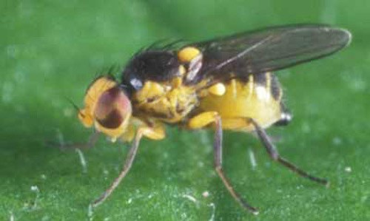

Liriomyza huidobrensis - Liriomyza trifolii - Liriomyza sativae

Morphologically extremely similar, these three species are often mistaken for each other on quick examination3. But why is it important to tell these 3 insects apart? Well, one of these insects has spread from the Americas to Asia and has begun to destroy tomato plants in India, the second largest producer of tomatoes in the world. When visual identification failed, researchers were able to determine which species of leaf miner it was terrorizing these tomatoes using DNA barcoding3.

Identifying insects visually is difficult enough, even for trained professionals. Now imagine trying to identify lichen forming fungi visually.

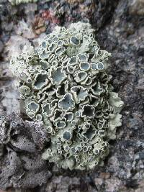 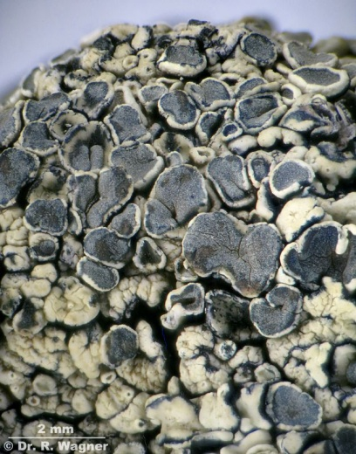 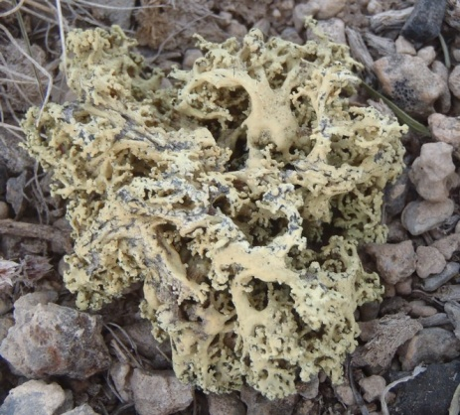

The first two images are the same species, Rhizoplaca melanophthalma the second is Rhizoplaca haydenii. As forms of life get smaller our ability to accurately classify them becomes more and more difficult. This mandates the use of more precise methods than visual comparison.

Barcoding has proven itself to be a useful tool in numerous fields. But not all species have universally accepted barcoding. Fungus for instance, the second largest kingdom of life, still has some ongoing debate concerning the barcoding sequence. One of the problems of choosing a barcoding sequence for all bacteria is finding a region that is present in all species that is unique enough to identify closely related species from each other. For fungus the ITS region of the rDNA has been proposed as the barcoding region2.

Prior to proposing the ITS region as the fungal barcode, several other sequences were investigated. Because of its ease of PCR amplification and initial success in species identification, the ITS region was identified as a strong candidate for the fungal barcode2.

There are potential problems with using the ITS region as the barcode. The rDNA cistron (which contains the ITS region) is an abundantly repeated region of the genome and there is concern that the cistron may be subject to intragenomic variation4. Too much intragenomic variation could invalidate the ITS region as a viable barcoding sequence. In order to confirm if the ITS region can be useful for barcoding an investigation of its intragenomic variation is needed; this is the question this project aims to address.

Most of the analytical tools for gathering and analyzing the information about intragenomic variation already exist. First NGS reads need to be aligned to a reference sequence. A number of software tools already exist for accomplishing this. The most effective algorithms out there currently use implementations of the Burrows Wheeler transformation for both fast and accurate read alignments5,6. Two such implementations widely used today are BowTie7 and BWA6. After alignment, reads need to be indexed and put into a more usable format to reveal coverage and base pair consistency. This can largely be accomplished with Samtools8. The last step needed for evaluation is to place this information in a human readable format. Many software tools have been created for visualizing alignments. However most of these tools have major dependency issues when installing them and are not compatible with modern operating system versions. One large exception to these generalizations is Integrative Genomics Viewer (IGV) by the Broad Institue9. IGV is easy to install, simple to use and works on the current Mac and Windows operating systems. But IGV lacks the functionality to visualize intragenomic variation. Additionally the IGV source code does not appear to have been built in a way that supports easy extension by external developers. Because of this, visualizing the information necessary to answer the ITS variation question requires a new, previously non-existent tool.

The purpose of this project is to create a tool, The Variance Visualizer (VV) for visualizing a sequence of DNA and its intragenomic variation. VV will be useful in answering the question of whether or not the ITS region is consistent, unique, and not overly variant within an individual. The accuracy of this tool will be validated in two ways. The first way will compare the sequence image it creates to a handmade image displaying the intragenomic variation of the exact same data sets. The second way will compare the relative abundance of variation/sequencing error of Illumina and PacBio reads. Illumina reads are known to have a relatively low sequencing error, 1%10,11, while PacBio tends to be much higher, experiencing 22% sequencing error11,12.

**Proposed Materials and Methods**

*NGS Reads:*

Illumia reads from 31 individuals representing 7 different fungal species have been provided by Dr. Leavitt from the Biology Department at Brigham Young University. These are the samples that will be used to validate the software in comparison to PacBio reads (also provided by Dr. Leavitt). Additionally, these 31 samples will be used in the final evaluation of the ITS region as a barcoding region.

*Alignment:*

Alignment of NGS reads will be done using the BWA6 software. Due to its speed, accuracy, ease of installation and use, BWA appears to be an excellent candidate for this task.

*Data Formatting:*

The SAM files generated from BWA will be indexed and converted into a more useful file type using Samtools8. Specifically, Samtools will be used to generate pileup files, text files representing the alignment containing the coverage at each position and the base pair contained by each read at that position. Pileup files can then easily be parsed using an R script to gather and generate the relevant information.

*Visualization:*

One of the major problems I have encountered while trying to use software for visualizing sequences is simply getting it to install. The variance visualizer will avoid this problem entirely since it is a web based Shiny application. The sequence images themselves will be created as SVG images. Because SVGs are text based vector images, they can easily be generated and remain crystal clear regardless of how large or small the user chooses to make them. Additionally, if the user should desire to customize the output in unforeseen ways, SVGs provide a format in which similar elements can all be simultaneously changed relatively easily or converted into any other picture format such as .png, .jpeg or a .pdf.

I will be working on all parts of this alone. If pitfalls should occur I will tackle them with the help of Stack Overflow.

**Proposed Results:**

*Figure 1* will be the schematics diagram outlining the flow from user input to the final output.

*Figure 2* will include 2 multiple sequence alignments. The first will be from VV and the second will be from production software (like IGV or Geneious). This will serve as a way to show that base functionality of VV works.

*Figure 3* will include 2 aligned sets sequences displaying the variation of the sequences. The first set will be from VV and the second will be the handmade image displaying variance of the same samples.

*Figure 4* will be a comparison of Illumina sequencing reads vs PacBio reads. This will serve as the final figure validating the functionality of VV.

*Figure 5* will be a multiple sequence alignment displaying variance of the ITS1 region of the rDNA cistron for all provided specimens.

*Figure 6* will be a multiple sequence alignment displaying variance of the 18S region of the rDNA cistron for all provided specimens.

*Figure 7* will be a multiple sequence alignment displaying variance of the ITS2 region of the rDNA cistron for all provided specimens.

*Figures 5-7* will contain the 3 segments of the ITS region. Because of how long the entire ITS region is, I will break it up into its three sub sections for the ease of visualization on paper. These three figures are what will allow us to evaluate the ITS region’s level of intragenomic variation and subsequent use as barcoding region.

In the event that there are areas of consistent intragenomic variation we can compare these to the cross species diagnostic markers to check for overlap. In the event of overlap with key diagnostic markers we may be left to conclude the ITS region is not useful as a barcoding region.

References

1. Bi, Y. *et al.* Chloroplast genomic resources for phylogeny and DNA barcoding: A case study on Fritillaria. *Sci. Rep.* **8,** 1–12 (2018).

2. Schoch, C. L. *et al.* Nuclear ribosomal internal transcribed spacer (ITS) region as a universal DNA barcode marker for Fungi. *Proc. Natl. Acad. Sci.* **109,** 6241–6246 (2012).

3. Firake, D. M., Sankarganesh, E., Sharma, B., Firake, P. D. & Behere, G. T. DNA barcoding confirmed the occurrence of invasive vegetable leaf miner, Liriomyza sativae Blanchard (Diptera:Agromyzidae) in Northeast India. *J. Asia-Pacific Biodivers.* **11,** 56–60 (2018).

4. Bik, H. M., Fournier, D., Sung, W., Bergeron, R. D. & Thomas, W. K. Intra-Genomic Variation in the Ribosomal Repeats of Nematodes. *PLoS One* **8,** 1–8 (2013).

5. Burrows, M. & Wheeler, D. A block-sorting lossless data compression algorithm. *Algorithm, Data Compression* 18 (1994). doi:10.1.1.37.6774

6. Li, H. & Durbin, R. Fast and accurate short read alignment with Burrows-Wheeler transform. *Bioinformatics* **25,** 1754–1760 (2009).

7. Langmead, B., Trapnell, C., Pop, M. & Salzberg, S. L. Ultrafast and memory-efficient alignment of short DNA sequences to the human genome. *Genome Biol.* **10,** (2009).

8. Li, H. *et al.* The Sequence Alignment/Map format and SAMtools. *Bioinformatics* **25,** 2078–2079 (2009).

9. IGV (Integrative Genomic Viewer). Integrative Genomics Viewer. *Broad Inst.* **29,** 24–26 (2013).

10. Quail, M. A. *et al.* A tale of three next generation sequencingplatforms: comparison of Ion Torrent, PacificBiosciences and Illumina MiSeq sequencers. *BMC Genomics* **13,** 1–13 (2012).

11. Glenn, T. C. Field guide to next-generation DNA sequencers. *Mol. Ecol. Resour.* **11,** 759–769 (2011).

12. Ono, Y., Asai, K. & Hamada, M. PBSIM: PacBio reads simulator - Toward accurate genome assembly. *Bioinformatics* **29,** 119–121 (2013).