**Q**uantification of **l**idar (hardware) **unc**ertainty

**Qlunc**

Tags: wind lidar, lidar hardware uncertainty, OpenScience, OpenLidar

Author: Costa, Francisco[1]

Introduction

Qlunc, for **Q**uantification of **l**idar **unc**ertainty, is an open-source, freely available (<https://github.com/SWE-UniStuttgart/Qlunc>) python-based tool that aims to estimate the uncertainty of a wind lidar device, including hardware and data processing methods. Based on the OpenLidar architecture [1], it contains models of the uncertainty contributed by individual lidar components and modules, that are then combined to estimate the total uncertainty of the lidar device.

The code is meant to be as modular as possible, easily allowing lidar components’ (represented by python objects) interchangeability and outcomes’ repeatability. Furthermore, it allows to easily integrate different uncertainty methods or interface external codes. Qlunc has an objected-oriented structure taking advantage of python features; by using python objects and simulating real lidar components, the code puts all together in modules and, eventually builds up a lidar digital twin.

This, combined with the underlying open-source code attribute, defines an attractive scenario for sharing knowledge about lidar uncertainties estimation methods. It also encourages collaborations among lidar field experts aiming to characterize a common lidar architecture for different types of lidars, to assess lidar data processing methods or even helps to get a consensus for lidar terminology, giving place to a lidar ontology, which is a developing project driven by Nikola Vasiljevic and others [2] [3].

# Motivation

Measuring uncertainty means doubt about the validity of the result of a measurement [4] or, in other words, it represents the dispersion of the values attributed to a measurand. The importance of knowing uncertainty in measurements lies both, on the quality of the measurement as on the understanding of the results, and it can have a huge impact on the veracity of an experiment or measuring set up. In this sense, wind lidar measurement uncertainties assessment plays a crucial role, since it can determine decision-making processes and therefore the global performance of a wind facility.

The scope of this project is to create an open, common and collaborative reference numerical framework to describe unique lidar architectures, characterize lidar uncertainties and provide a tool for others to contribute within those frameworks. This is so, but following lines of OpenScience Principles, the underlying main motivation of this project is to create open and sharable tools and knowledge, to reinforce or promote new or existing links and to foster collaborations among research institutions and/or industry, within the wind energy community, but not limited to it.

# Qlunc available capabilities

Currently, Qlunc can perform both, VAD and scanning lidar patterns. For now, it can perform lidar hardware uncertainties from photonics module, including photodetector (with or without trans-impedance amplifier) and optical amplifier components, as well as optics module uncertainty including scanner pointing accuracy distance errors and optical circulator uncertainties. In the near future, uncertainties regarding other hardware components and data processing methods will be impemented in the model.

Output plots show different signal noise contributors of the photodetector components and estimates of scanning points distance uncertainty.

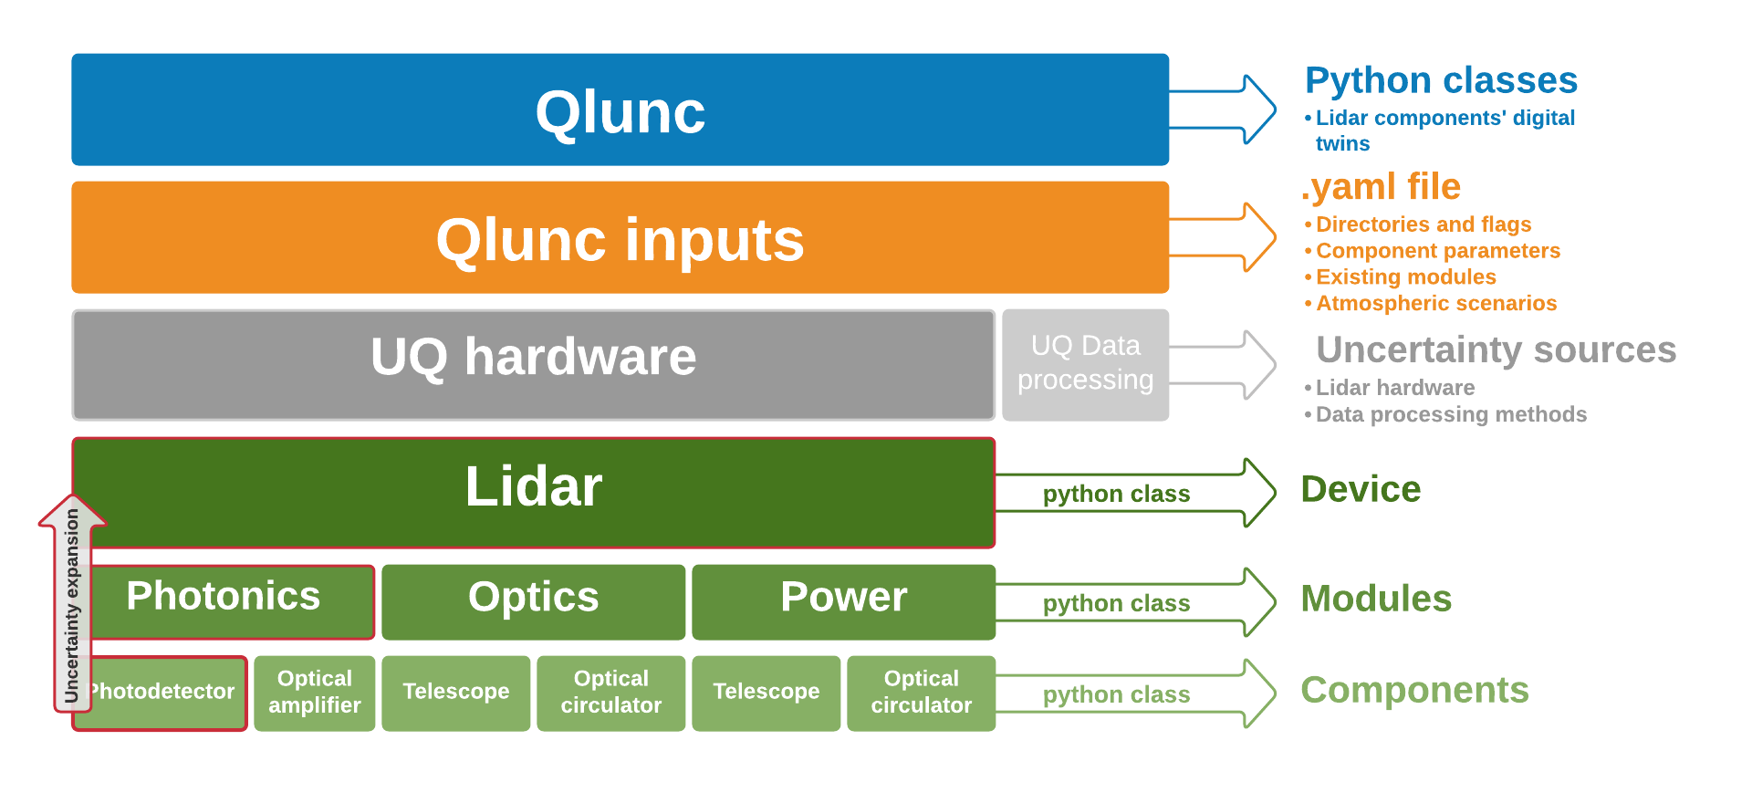

Figure 1. Qlunc basic structure

# Usage

## Creating a lidar digital twin

Each component, pertaining to the correspondent module (e.g. photodetector belongs to the photonics module) is created as a python object and enclosed in other python class, which represents the aforementioned module. Following this procedure these lidar modules are, in turn, included in the lidar python class, which gathers all classes corresponding to the different modules a lidar is made of, thus creating the lidar digital twin. Dot notation methodology is used to ask for lidar component properties.

## Uncertainty estimation model

All components are characterized by their technical parameters and their uncertainty functions, which are feed to the code via a yaml file. Combined uncertainties throughout components and modules are computed according to the Guide to the expression of Uncertainty in Measurement [4] ([GUM](https://www.bipm.org/utils/common/documents/jcgm/JCGM_100_2008_E.pdf)) model.

As mentioned above, the code claims flexibility and aims to foster collaboration, especially among researchers. To encourage both, flexibility and further collaborations each lidar module has its own uncertainty estimation function, which includes the components the module is made of. These stand-alone uncertainty estimation functions are easily exchangeable, just in case users want to use another uncertainty model.

# Working example and Tutorials: Do it yourself

Included in the Qlunc repository users can find Jupyter Notebooks-based tutorials ([https://‌github.com‌/SWE-UniStuttgart/‌Qlunc/‌tree/‌Qlunc-V0.9/‌Tutorials](https://github.com/SWE-UniStuttgart/Qlunc/tree/Qlunc-V0.9/Tutorials)) on how Qlunc works, providing a tool to help them get started with the software. Tutorials’ Binder badge is also provided to ease accessibility and reproducibility. Users can find more info about these tutorials in the readme file attached to the Qlunc repository.

Apart from the tutorials, the package includes a functional working example. More information about this working example is given in the readme, included in the Qlunc repository, where the process of creating a lidar digital twin is treated in depth.

# Conclusions

Putting all the above information together Qlunc will serve to increase confidence in lidar measurements by fostering collaboration among experts and institutions, providing a modular open-source python package, also usable for people interested in the present topic.

# Acknowledgements

Author want also to thank Andrew Clifton, Nikola Vasiljevic and Ines Würth for their support and valuable suggestions, feedback and insight.

This project has received funding from the *European Union's Horizon 2020 research and innovation programme* under grant agreement No 858358, within the frame of LIKE project.

# References

[1] A. Clifton, I. Würth, F. Haizmann, S. Raach, N. Vasiljevic, and J. F. Newman, “OpenLidar : A Collaborative Wind Lidar Platform.”

[2] N. Vasiljević, “OntoStack,” 2021. [Online]. Available: http://data.windenergy.dtu.dk/ontologies/view/en/. [Accessed: 14-Jan-2021].

[3] N. Vasiljević, “sheet2rdf,” *First release (version v0.1)*, 2021. [Online]. Available: https://zenodo.org/record/4432136#.YABPOhZ7nb0. [Accessed: 13-Jan-2021].

[4] Joint Committee For Guides In Metrology, “Evaluation of measurement data — Guide to the expression of uncertainty in measurement,” *Int. Organ. Stand. Geneva ISBN*, vol. 50, no. September, p. 134, 2008, doi: 10.1373/clinchem.2003.030528.

1. Stuttgart Wind Energy, Institute of Aircraft Design and Manufacture, University of Stuttgart, Stuttgart, Germany - costa@ifb.uni-stuttgart.de - <https://orcid.org/0000-0003-1318-9677>