Practical 10: Data Visualization with Power BI
Task 1: Import order data from an OData feed
You import data into Power BI Desktop from the sample Northwind OData feed at the following URL, which you can copy (and then paste) in the steps below: http://services.odata.org/V3/Northwind/Northwind.svc/
Step 1: Connect to an OData feed
1. From the Home ribbon tab in Query Editor, select Get Data.
2. Browse to the OData Feed data source.
3. In the OData Feed dialog box, paste the URL for the Northwind OData feed. 4. Select OK.

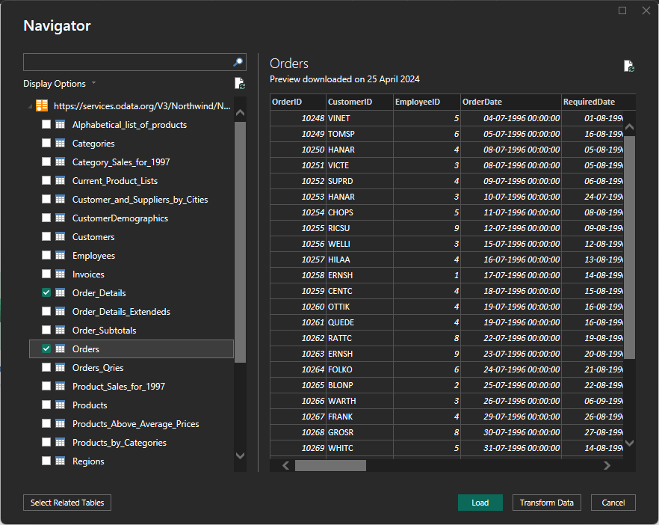

Step 2: Expand the Order_Details table
Expand the Order_Details table that is related to the Orders table, to combine the ProductID, UnitPrice, and Quantity columns from Order_Details into the Orders table.
The Expand operation combines columns from a related table into a subject table. When the query runs, rows from the related table (Order_Details) are combined into rows from the subject table (Orders).
After you expand the Order_Details table, three new columns and additional rows are added to the Orders table, one for each row in the nested or related table.
1. In the Query View, scroll to the Order_Details column.
2. In the Order_Details column, select the expand icon ().
3. In the Expand drop-down: a. Select (Select All Columns) to clear all columns.
Select ProductID, UnitPrice, and Quantity.
Click OK.
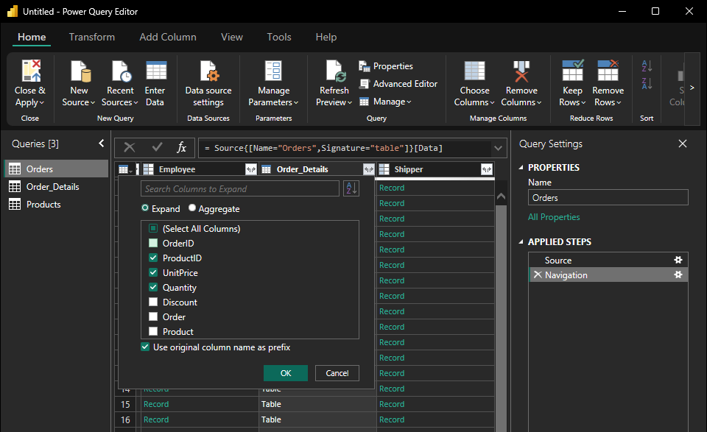

Step 3: Remove other columns to only display columns of interest
In this step you remove all columns except OrderDate, ShipCity, ShipCountry, Order_Details.ProductID, Order_Details.UnitPrice, and Order_Details.Quantity columns.
In the previous task, you used Remove Other Columns. For this task, you remove selected columns
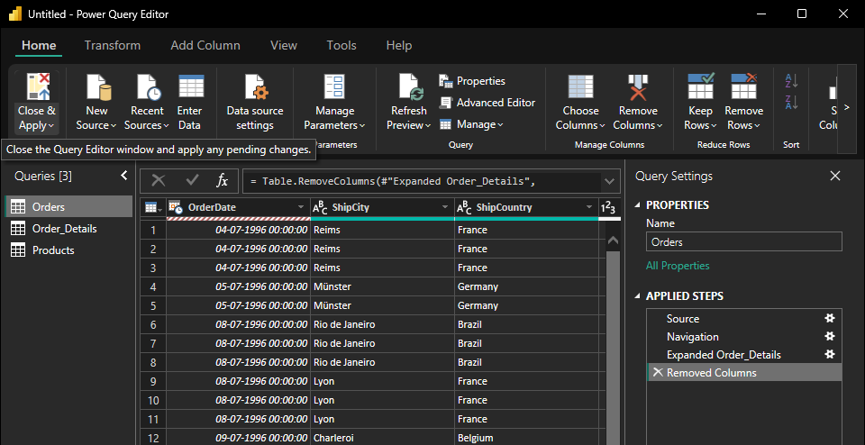

Step 4: Calculate the line total for each Order_Details row
Power BI Desktop lets you to create calculations based on the columns you are importing, so you can enrich the data that you connect to. In this step, you create a Custom Column to calculate the line total for each Order_Details row.
Calculate the line total for each Order_Details row:
1. In the Add Column ribbon tab, click Add Custom Column.
2. In the Add Custom Column dialog box, in the Custom Column Formula textbox, enter [Order_Details.UnitPrice] * [Order_Details.Quantity].
3. In the New column name textbox, enter LineTotal.
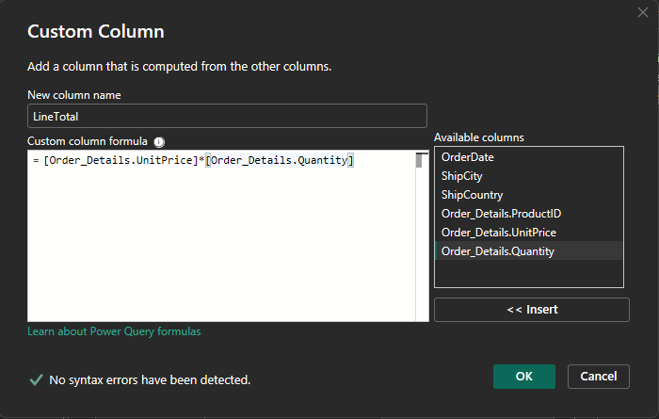
Step 5: Set the datatype of the LineTotal field
1. Right click the LineTotal column.
2. Select Change Type and choose Decimal Number.

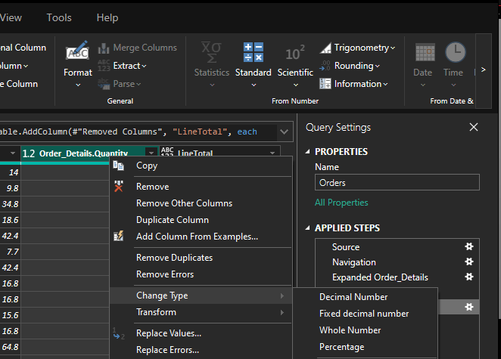

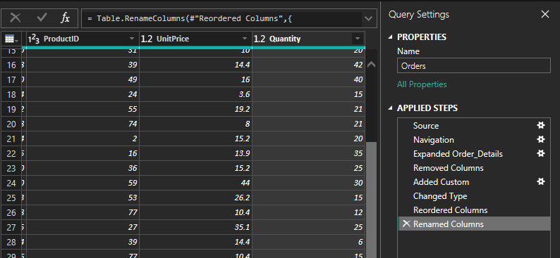
Step 6: Rename and reorder columns in the query
1. In Query Editor, drag the LineTotal column to the left, after ShipCountry.
2. Remove the Order_Details. prefix from the Order_Details.ProductID, Order_Details.UnitPrice and Order_Details.Quantity columns, by double-clicking on each column header, and then deleting that text from the column name.

Task 2: Combine the Products and Total Sales queries
1. Confirm the relationship between Products and Total sales
2. Power BI Desktop loads the data from the two queries
3. Once the data is loaded, select the Manage Relationships button Home ribbon
4. Select the New… button
5. When we attempt to create the relationship, we see that one already exists! As shown in the Create Relationship dialog (by the shaded columns), the ProductsID fields in each query already have an established relationship.
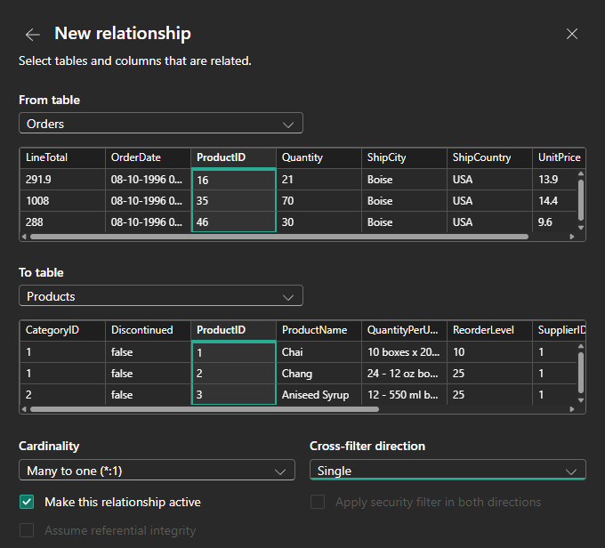
6. Select Cancel, and then select Relationship view in Power BI Desktop
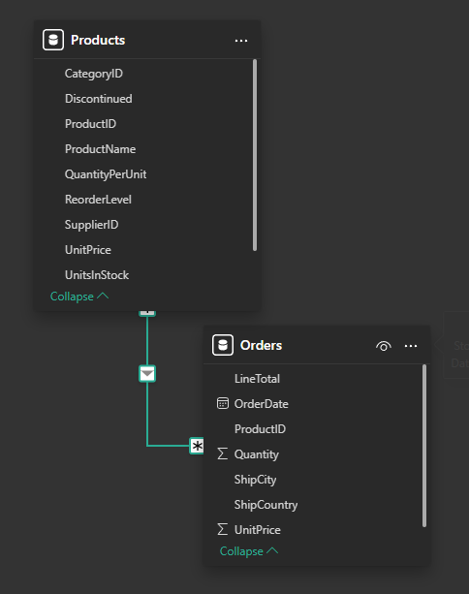
Task 3: Build visuals using your data
Step 1: Create charts showing Units in Stock by Product and Total Sales by Year
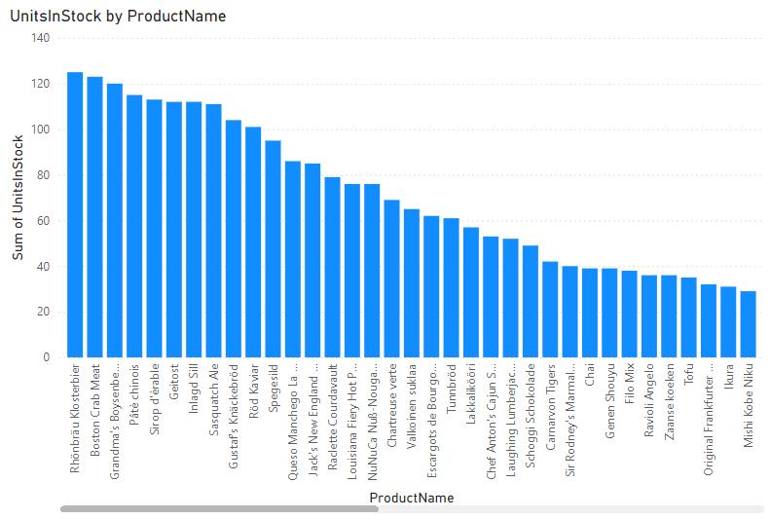
Step 2: Drag OrderDate to the canvas beneath the first chart , then drag LineTotal on to the visual, then Select Line chart. The following visaualization is created.

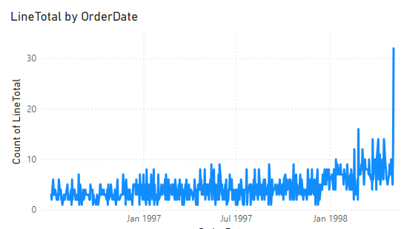

Step 3. Next, drag ShipCountry to a space on the canvas in the top right. Because you selected a geographic field, a map was created automatically. Now drag LineTotal to the Values field; the circles on the map for each country are now relative in size to the LineTotal for orders shipped to that country. 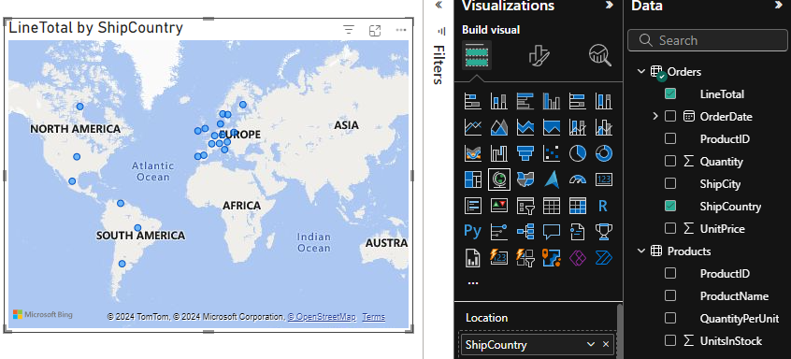

Step 4. Interact with your report visuals to analyse further

