# Activity page

This page should display full information for one selected activity. User can see following information:

* Type
* Rating
* Category
* Description
* Date start - Date end
* Location Start -Location End
* Available and total places
* Required skill, social group and stuff

## Different cases:

### Admin mode

In this mode all available fields should be editable by owner activity. Also form should provide a update button to confirm changes.

### User mode

If activity already finished, user can rate this activity and after this he can see a rating. If activity is not finished, anybody can see a total rating for this type and user.

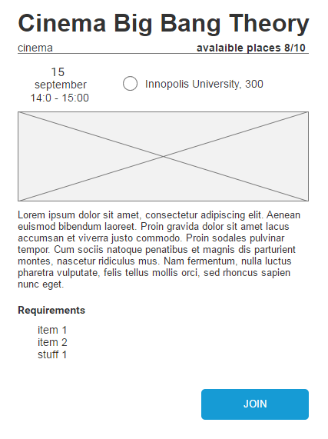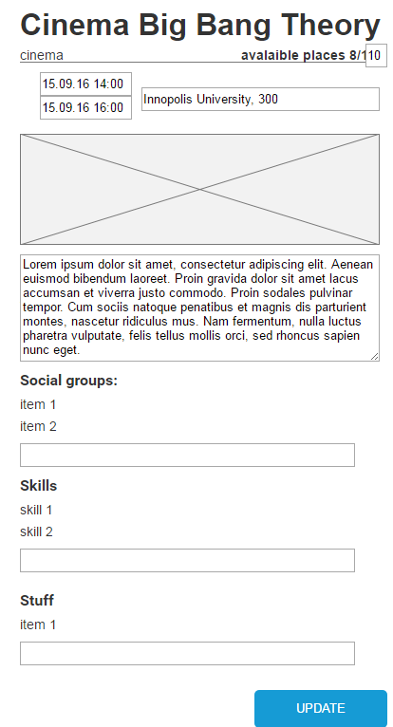

# Create Page

This page should provide a form for create new activity. Form should include all aspect above. Also, if user selects a date with specific type, system should be take a hint for best suitable time. Also, if user select a travelling activity (For instance, Kazan – Innopolis) a locations (from to end) should be calculate automatically.

## Different cases:

### Empty form

Organizer can start create new activity with empty form.

### From previous activity

Organizer can be able to create new activity from previously created activity and change some fields (date or places)

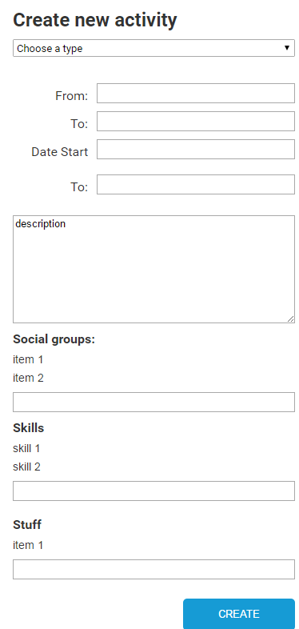

## My Activities

The main idea for this page is saving information about all activities, when user taking or take a participation as owner or as participant. Also this page should display all recommendation and subscription notification.

## Different cases:

For activities when user is owner, activity should be highlighted.

