# Main page

In this page people search activities what they are interested in.

## Different cases:

### Initial state(without search)

User just browsing activities

**Input:** User does not enter any data

**Output:** List of upcoming activities (any type of activity; time: today + 2days)

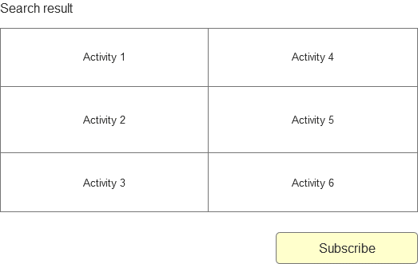

### Simple search

User knows what type of activities he wants to participate.

**Input:** Activity name

**Output:** List of upcoming activities (User’s type of activity; time: today + 2days)

If not any result user may subscribe to this type activities event

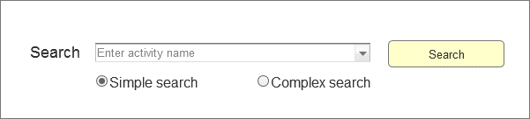



### Complex search

User knows what type of activities and time he wants to participate.

**Input:** Activity name, Date

**Output:** List of upcoming activities (User’s type of activity; User’s time)

If not any result user may subscribe to this type activities event

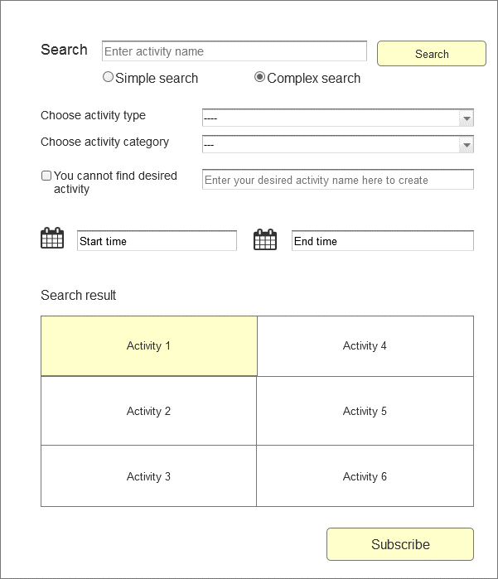

# CHAT PAGE

In this page participants may talk to each other by leaving comments in the activity’s page.

**Input:** Text - comment

**Output:** Comment is seen in the page; Comment is seen to every participant of the activity

# Log In page

In this page people log in into the system.

**Input:** Login/email, password

**Output:** User is able to join/subscribe activities

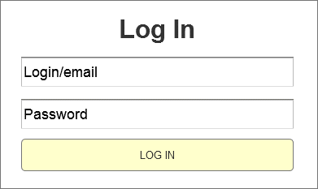

# Sign UP page

In this page people register in the system.

**Input:**

required**:** Login/email, password

optional: Full name, gender, Birth of date, phone #, Location may be confirmed

**Output:** New user in the system**;** User is able to join/subscribe activities

If already have an account, they go to “Log in” page

