贪吃蛇游戏游戏文档

游戏分析：

贪吃蛇游戏。首先绘制画布，生成地图。“苹果”在地图上随机产生，蛇在左右上下方向键的控制下移动，吃到“苹果”就长一截，每吃到一个“苹果”加20分，撞墙就死。蛇是由若干个圆形组成的，每个圆形都是有8个不同颜色的扇形组成，而且组成的顺序是随机的。游戏过程中可暂停或开始或 重新开始。

游戏设计：

第一步：实现页面排版、布局

设置画布大小宽高、样式；游戏边界；游戏开始界面。

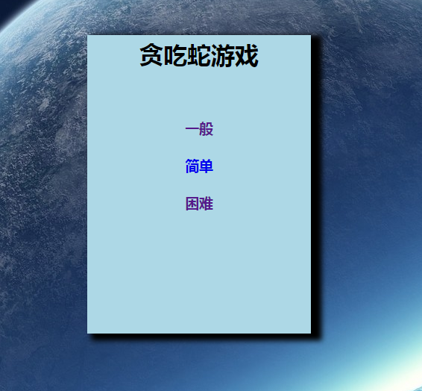

第二步：在游戏中“苹果”的随机产生，任意位置，不能在蛇身上；定义蛇的产生、移动。

第三步：游戏开始时设置定时器、分数以及蛇吃到“苹果”时的加分；

第四步：设置暂停\开始按钮，重新开始按钮。

第五步：设置游戏结束条件，撞墙结束、蛇首尾相连结束。

第六步：游戏结算。

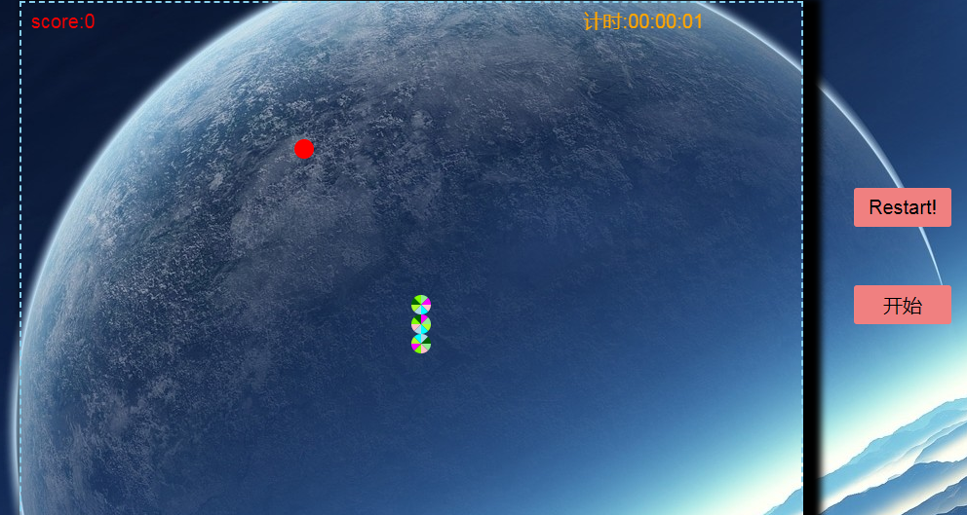

源码：

贪吃蛇.html

<!DOCTYPE html>

<html lang="en">

<head>

    <meta charset="UTF-8">

    <title>游戏</title>

    <style type="text/css">

       \*{

           margin: 0;

           padding: 0;

       }

       body{

           background-image: url("img/背景3.jpg");

       }

       .box{

           width: 300px;

           height: 400px;

           background-color: lightblue;

           margin: 0 auto;

           text-align: center;

           line-height: 50px;

           margin-top: 100px;

           box-shadow: 10px 5px 7px 4px black;

       }

       .a{

           text-decoration: none;

       }

</style>

</head>

<body>

    <div class="box">

        <div id="level">

            <h1>贪吃蛇游戏</h1>

            <br>

            <a href="haha.html" style="text-decoration: none;"><h3>一般</h3></a>

            <a href="haha" style="text-decoration: none;"><h3>简单</h3></a>

            <a href="haha.html"style="text-decoration: none;"><h3>困难</h3></a>

        </div>

    </div>

</body>

</html>

Haha.html

<!DOCTYPE html>

<html lang="en">

<head>

    <meta charset="UTF-8">

    <title>snake</title>

</head>

<style type="text/css">

    body {

        background-image: url("img/背景3.jpg");

    }

    canvas {

        display: block;

        margin: 0 auto;

        border: 2px dashed skyblue;

        box-shadow: 10px 5px 7px 8px black;

    }

    #btn{

        background-color:lightcoral;

        width: 100px;

        height: 40px;

        border-width: 0px;

        border-radius: 3px;

        cursor: pointer;

        outline: none;

        font-size: 20px;

        position: absolute;

        top: 300px;

        right: 120px;

    }

    #btn:hover{

        background: #5599FF;

    }

    #btn1{

        background-color:lightcoral;

        width: 100px;

        height: 40px;

        border-width: 0px;

        border-radius: 3px;

        cursor: pointer;

        outline: none;

        font-size: 20px;

        position: absolute;

        top: 200px;

        right: 120px;

    }

    #btn1:hover{

        background: #5599FF;

    }

</style>

<body>

<canvas id="canvas" width="800px" height="600px"></canvas>

<br>

<button id="btn">暂停</button>

<button id="btn1"  onclick="location.reload()">Restart!</button>

<!--

<button id="btn2">加速</button>

-->

<script src="https://apps.bdimg.com/libs/jquery/2.1.4/jquery.min.js"></script>

<script type="text/javascript">

    var context=document.getElementById("canvas").getContext("2d");

    var score=0;

    var Block=function(x,y,size){

        this.x=x;

        this.y=y;

        this.size=size;

        this.color=["pink","lightgreen","lightblue","fuchsia","cyan",

            "chartreuse","darkgreen","greenyellow"];

    }

    Block.prototype.draw=function(){

        color=ranReverseArray(this.color);

        var startPoint=0;

        for(var i=0;i<color.length;i++){

            context.fillStyle=color[i];

            context.beginPath();

            context.moveTo(this.x\*this.size+this.size/2,this.y\*this.size+this.size/2);

            context.arc(this.x\*this.size+this.size/2,this.y\*this.size+this.size/2,

                this.size/2,startPoint,startPoint+Math.PI/4,false);

            context.fill();

            startPoint+=Math.PI/4;

        }

    }

    function ranReverseArray(oldArray){

        var newArray=[];

        var len=oldArray.length;

        var ranNumber,flag;

        for(let i=0;i<oldArray.length;i++){

            while(true){

                ranNumber=Math.floor(Math.random()\*len);

                flag=true;

                for(let j=0;j<i;j++){

                    if (newArray[j]==oldArray[ranNumber]) {

                        flag=false;

                        break;

                    }

                }

                if (flag) break;

            }

            newArray[i]=oldArray[ranNumber];

        }

        return newArray;

    }

    var Snake={

        body:[new Block(20,21,20),new Block(20,22,20),new Block(20,23,20)],

        direction:"up"

    }

    Snake.draw=function(){

        $.each(this.body,function(key,value){

            value.draw();

        });

    }

    //移动

    Snake.move=function(){

        var head=this.body[0];

        var newHead;

        if (this.direction=="up"){

            newHead=new Block(head.x,head.y-1,head.size);

        }

        if (this.direction=="down"){

            newHead=new Block(head.x,head.y+1,head.size);

        }

        if (this.direction=="left"){

            newHead=new Block(head.x-1,head.y,head.size);

        }

        if (this.direction=="right"){

            newHead=new Block(head.x+1,head.y,head.size);

        }

        this.body.unshift(newHead);

        if (newHead.x<0||newHead.x>39){  //判断是否撞东西墙

            gameOver();

        }

        if (newHead.y<0||newHead.y>29){ //判断是否撞南北墙

            gameOver();

        }

        if (newHead.x==apple.x&&newHead.y==apple.y){  //判断是否吃到苹果

            score=score+20;

            while(true){  //产生新苹果，但新苹果不能在蛇身上

                apple.x=Math.floor(Math.random()\*40);

                apple.y=Math.floor(Math.random()\*30);

                let flag=true;

                $.each(this.body,function(key,value){ //苹果位置是否和蛇的某个块重合

                    if (value.x==apple.x&&value.x==apple.x)

                        flag=false;

                });

                if (flag) break;

            }

        }else{  //如果没吃到苹果，蛇身不能变。头前增加了一个块，末尾就得删除一个快

            this.body.pop();

        }

//判断蛇是否首尾相连了，如果是游戏失败

        if (newHead.x==this.body[this.body.length-1].x

            &&newHead.y==this.body[this.body.length-1].y){

            gameOver();

        }

    }

    var interval=setInterval(baginGame,200);

    //游戏结束

    function gameOver(){

        clearInterval(interval);

        context.font="80px Comic Sans Ms";

        context.fillStyle="Orange";

        context.shadowBlue=5;

        context.shadowOffsetX=5;

        context.shadowOffsetY=5;

        context.shadowColor="red";

        context.textAlign="center";

        context.textBaseline="middle";

        context.fillText("GAME OVER",300,200);

    }

    var apple={

        x:Math.floor(Math.random()\*40),

        y:Math.floor(Math.random()\*30),

        size:10,

        draw:function(){

            context.fillStyle="red";

            context.beginPath();

            context.arc(this.x\*2\*this.size+this.size,this.y\*2\*this.size+this.size,

                this.size,0,360,false);

            context.fill();

        }

    }

    var culTime=0;

    //游戏开始，开始计分

    function baginGame(){

        context.clearRect(0,0,800,600);

        culTime++;

        if (culTime==5){

            gameTime.second++;

            culTime=0;

            gameTime.show();

        }

        context.textBaseline="top";

        context.textAlign="left";

        context.font="20px Arial";

        context.fillText("score:"+score,10,10);

        gameTime.draw();

        Snake.draw();

        Snake.move();

        apple.draw();

    }

    /\*//添加刷新按钮

    refresh.onclick=function(){

        window.location.reload();

    };

    \*/

    $("body").keydown(function(event){

        if (event.keyCode==37&&Snake.direction!="right"){

            Snake.direction="left";

        }

        if (event.keyCode==39&&Snake.direction!="left"){

            Snake.direction="right";

        }

        if (event.keyCode==38&&Snake.direction!="down"){

            Snake.direction="up";

        }

        if (event.keyCode==40&&Snake.direction!="up"){

            Snake.direction="down";

        }

    });

    //以下代码设置游戏的“暂停”和“开始”

    $("#btn").click(function(){

        if ($(this).text()=="暂停"){

            clearInterval(interval);

            $(this).text("开始");

        }else{

            interval=setInterval(baginGame,200);

            $(this).text("暂停");

        }

    });

    //计时

    var MyTime=function(hour,minute,second){

         this.hour=hour;

         this.minute=minute;

         this.second=second;

         this.myTime="";

         this.show=function(){

             if (this.second==60){

                 this.second=0;

                 this.minute=this.minute+1;

             }

             if (this.minute==60){

                 this.minute=0;

                 this.hour=this.hour+1;

             }

             this.myTime="";

             if (this.hour<10){

                 this.myTime=this.myTime+"0"+this.hour+":";

             }else{

                 this.myTime=this.myTime+this.hour+":";

             }

             if (this.minute<10){

                 this.myTime=this.myTime+"0"+this.minute+":";

             }else{

                 this.myTime=this.myTime+this.minute+":";

             }

             if (this.second<10){

                 this.myTime=this.myTime+"0"+this.second;

             }else{

                 this.myTime=this.myTime+this.second+"";

             }

         };

         this.draw=function(){

             context.fillStyle="Orange";

             context.textBaseline="top";

             context.textAlign="right";

             context.font="20px Arial";

             context.fillText("计时:"+this.myTime,700,10);

         }

     }

     var gameTime=new MyTime(0,0,0);

</script>

</body>

</html>

总结部分：

本次游戏的制作，在原基础上进行了一下扩展：

1. 增加了计时功能
2. //计时
3. var MyTime=function(hour,minute,second){
4. this.hour=hour;
5. this.minute=minute;
6. this.second=second;
7. this.myTime="";
8. this.show=function(){
9. if (this.second==60){
10. this.second=0;
11. this.minute=this.minute+1;
12. }
13. if (this.minute==60){
14. this.minute=0;
15. this.hour=this.hour+1;
16. }
17. this.myTime="";
18. if (this.hour<10){
19. this.myTime=this.myTime+"0"+this.hour+":";
20. }else{
21. this.myTime=this.myTime+this.hour+":";
22. }
23. if (this.minute<10){
24. this.myTime=this.myTime+"0"+this.minute+":";
25. }else{
26. this.myTime=this.myTime+this.minute+":";
27. }
28. if (this.second<10){
29. this.myTime=this.myTime+"0"+this.second;
30. }else{
31. this.myTime=this.myTime+this.second+"";
32. }
33. };
34. this.draw=function(){
35. context.fillStyle="Orange";
36. context.textBaseline="top";
37. context.textAlign="right";
38. context.font="20px Arial";
39. context.fillText("计时:"+this.myTime,700,10);
40. }
41. }
42. var gameTime=new MyTime(0,0,0);

2、计分

//游戏开始，开始计分

    function baginGame(){

        context.clearRect(0,0,800,600);

        culTime++;

        if (culTime==5){

            gameTime.second++;

            culTime=0;

            gameTime.show();

        }

        context.textBaseline="top";

        context.textAlign="left";

        context.font="20px Arial";

        context.fillText("score:"+score,10,10)

3、设置重新开始按钮

<button id="btn1"  onclick="location.reload()">Restart!</button>

4、按空格键，加速。

5、一定时间段内，未达到规定分数，蛇身变短，当蛇身为两截时，GAME OVER!

6、游戏结束，结算，返回游戏开始界面。

7、访问地址为:https://msd119.github.io/tancishe/haha.html