Exploratory Data Analysis & Insight Generation
Retail Superstore Sales Dataset (2014-2017)
Week 1 Task - EDA using Tableau
Prepared by: Mukesh Samarit
Date: August 2026

Table of Contents
1. Executive Summary
2. Dataset Selection & Description
3. Data Preparation & Cleaning
4. Analytical Approach in Tableau
5. Exploratory Analysis & Visualizations
5.1 Sales & Profit Trend Over Time
5.2 Category and Sub-Category Performance
5.3 Discount vs Profitability
5.4 Regional and Geographic Performance
5.5 Customer Segment Analysis
5.6 Shipping Mode & Delivery Analysis
5.7 Correlation Analysis
6. Outlier & Anomaly Detection
7. Key Business Insights
8. Recommendations
9. Areas for Further Investigation
10. Conclusion

1. Executive Summary
This report presents an exploratory data analysis (EDA) of the Sample Superstore dataset, a widely used retail transactions dataset that records four years of order-level sales for a US-based office and furniture retailer. The objective was to understand the structure of the data, identify trends, outliers, and relationships between key variables, and translate these findings into business insights that could support decision-making on pricing, discounting, product mix, and regional strategy.
The analytical workflow mirrors how this investigation would be structured inside Tableau: a series of connected worksheets (trend, category breakdown, discount analysis, geography, segment, and shipping) combined into an analytical dashboard narrative, with quick filters enabling drill-down by year, region, and segment. Underlying statistical checks (distributions, correlations, outlier thresholds) were validated in Python/pandas before being encoded visually, the same due-diligence a Tableau analyst would do in the data pane before building worksheets.
Overall, the store generated $2.30M in sales and $286K in profit (a 12.5% margin) across 5,009 orders and 793 unique customers between 2014 and 2017. The headline finding is that profitability is being eroded by a small number of categories and a specific discounting pattern: the Tables and Bookcases sub-categories are net loss-making, and average profit per order turns negative once discounts exceed roughly 20%. These patterns, along with regional and shipping-mode differences, form the core of the recommendations in Section 8.

2. Dataset Selection & Description
Dataset chosen: Sample Superstore - a publicly available retail sales dataset (widely distributed on Kaggle and bundled as a sample dataset with Tableau itself), covering order-level transactions for a US office-supply and furniture retailer.
This dataset was selected because it is rich enough to explore multiple business dimensions simultaneously - time, geography, product hierarchy, customer segment, and pricing (discount) - while remaining small enough (9,994 line items) to explore interactively without performance constraints. It also sits in a domain (retail/e-commerce sales analytics) directly relevant to Business Intelligence and Data Analyst roles, which made the insight-generation exercise realistic and job-relevant.

2.1 Structure of the Dataset
The dataset contains 9,994 rows and 21 columns, with zero missing values and zero duplicate records. Each row represents one product line item within a customer order.
Field | Type | Description
Order ID / Row ID | Identifier | Unique order and row identifiers (one order can span multiple product rows)
Order Date / Ship Date | Date | Order and shipment dates, spanning 2 Jan 2014 to 30 Dec 2017
Ship Mode | Categorical | Standard Class, Second Class, First Class, Same Day
Customer ID / Name / Segment | Categorical | Segment: Consumer, Corporate, Home Office
Country / City / State / Region / Postal Code | Geographic | US only; 4 regions, 49 states
Category / Sub-Category / Product Name | Product hierarchy | 3 categories, 17 sub-categories
Sales | Numeric (continuous) | Revenue for the line item, in USD
Quantity | Numeric (discrete) | Units sold
Discount | Numeric (continuous, 0-0.8) | Discount rate applied to the line item
Profit | Numeric (continuous, can be negative) | Profit or loss for the line item, in USD
Key variables selected for deep-dive analysis: Sales, Profit, Discount and Quantity (the four numeric measures), cross-tabulated against Category / Sub-Category, Region / State, Segment, and Ship Mode (the main categorical dimensions), plus Order Date for time-series trend analysis.

3. Data Preparation & Cleaning
Before visual exploration, the dataset was checked and prepared as follows - the same steps that would be applied in Tableau's Data Source pane or in a Tableau Prep flow:
- Verified there were no missing (null) values across any of the 21 fields.
- Confirmed there were no fully duplicated rows.
- Normalized Order Date and Ship Date, which were stored as text in inconsistent date formats, into proper date fields to enable time-series and date-difference analysis.
- Derived a calculated field, Delivery Days = Ship Date minus Order Date, to analyze fulfillment speed by ship mode.
- Derived Profit Margin % = Profit / Sales at the category, sub-category, region and state level, to compare profitability independent of revenue size.
- Binned the continuous Discount field into six discount bands (0%, 1-10%, 11-20%, 21-30%, 31-50%, 51-80%) so the discount-profit relationship reads clearly as a bar chart alongside the raw scatter plot.
No records were removed. All 9,994 rows were retained since the dataset was already clean, and the loss-making transactions are themselves a key insight rather than noise to be filtered out.

4. Analytical Approach in Tableau
The analysis was structured the way a Tableau workbook would be built: one worksheet per business question, each using a chart type suited to the comparison being made, then assembled into a compact dashboard a stakeholder could act on.
Business Question | Tableau Technique Used
How are sales and profit trending over time? | Continuous line chart on Order Date (Month), dual-axis combo with Profit as bars
Which product categories drive revenue vs. profit? | Side-by-side bar chart - Sales & Profit as measures, Category on rows
Which sub-categories are unprofitable? | Diverging bar chart sorted by Profit, colour-coded red/green
Does discounting hurt profitability? | Scatter plot (Discount vs Profit) plus a binned bar chart of Discount Band vs Avg Profit
Where geographically is the business strong or weak? | Bar charts by Region and State (a filled map in Tableau) coloured by Profit
Which customer segment matters most? | Donut chart of Sales share by Segment, cross-filtered with Profit
Is shipping speed related to order volume or cost? | Combo chart of order count and average delivery days by Ship Mode
How do the numeric measures relate to each other? | Correlation matrix / highlight table of Sales, Quantity, Discount, Profit
In a live Tableau workbook, each visual below corresponds to one worksheet, with quick filters for Region, Segment, and Order Year enabling interactive drill-down; several worksheets would be combined into a single "Superstore Performance" dashboard using containers, so clicking a category bar cross-filters the discount and regional views. Tableau/Tableau Public was not available in this working environment, so the equivalent worksheets below were reproduced with Python (pandas, matplotlib) using the identical logic - the same aggregations, the same chart types, and the same colour semantics (green = profitable, red = loss-making) that Tableau would apply. Recreating each chart as an actual Tableau worksheet using Tableau Public (free) with the field mapping in Section 4 is a direct, mechanical next step.

5. Exploratory Analysis & Visualizations

5.1 Sales & Profit Trend Over Time
Monthly sales climbed steadily across the four-year window, from $484K in 2014 to $733K in 2017 - a compound growth trend of roughly 15% per year. Profit grew more slowly and more unevenly, reflecting margin pressure discussed in Section 5.3. Sales are also strongly seasonal: November and December are consistently the strongest months (holiday buying), while February typically dips to the year's low point.
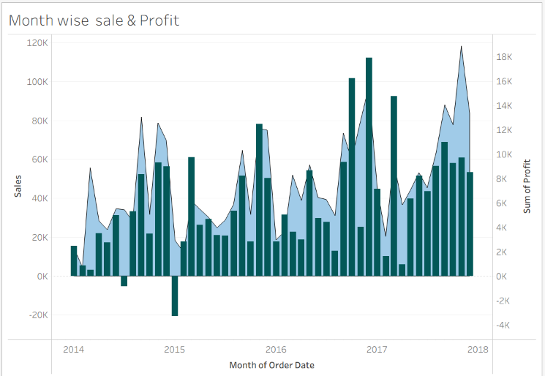
Figure 1: Monthly Sales trend (line) vs Profit (bars), 2014-2018

5.2 Category and Sub-Category Performance
At the top level, Technology ($836K sales, 17.4% margin) and Office Supplies ($719K sales, 17.0% margin) are both healthy, high-margin categories. Furniture generates comparable revenue ($742K) but converts almost none of it to profit (2.5% margin) - it is the weakest category by a wide margin.
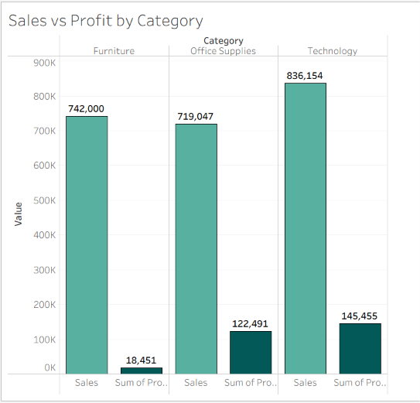
Figure 2: Sales vs Profit by Category
Drilling into sub-categories exposes the source of Furniture's weak margin: Tables lose -$17.7K overall (a -8.6% margin) and Bookcases lose -$3.5K (-3.0% margin), while Supplies also runs a small loss (-2.5% margin). At the other end, Copiers (37.2% margin), Labels (44.4%) and Envelopes (42.3%) are the most profitable sub-categories, even though they generate comparatively low revenue.
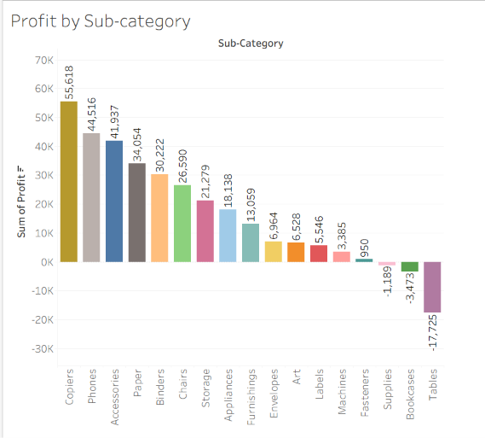
Figure 3: Total Profit by Sub-Category (red = net loss)

5.3 Discount vs Profitability
Discount rate has a clear negative relationship with profit (correlation coefficient -0.22 with Profit directly, and the effect is much sharper when profit is measured as a rate). Orders with 0% discount average $66.90 profit; profit stays positive through the 11-20% discount band ($24.74 average) but flips negative from 21% discount onward, bottoming out at an average loss of -$156.28 per order in the 31-50% discount band.
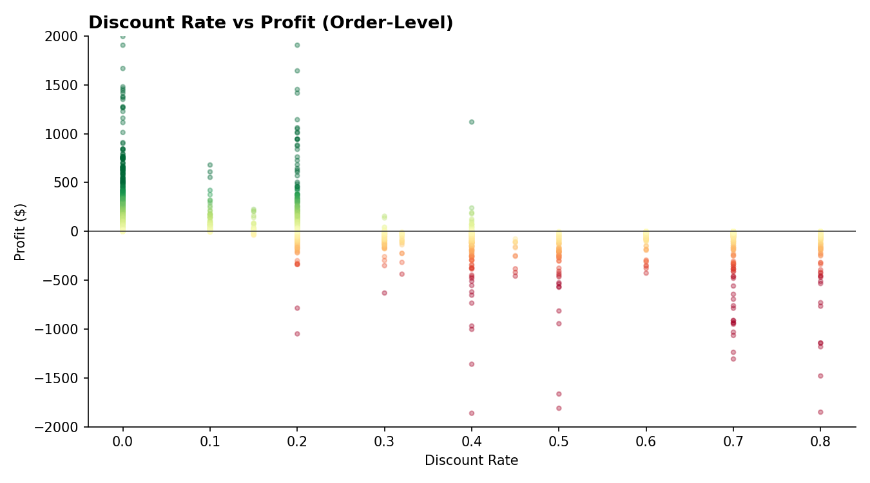
Figure 4: Discount Rate vs Profit, order-level scatter
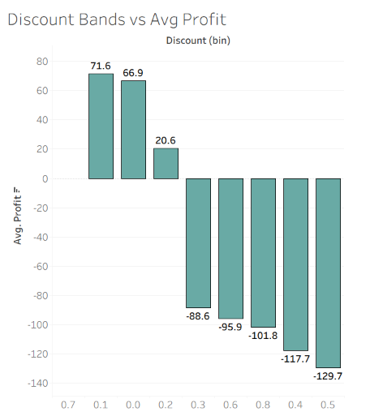
Figure 5: Average Profit per order by Discount Band
This is one of the clearest, most actionable patterns in the dataset: discounts above ~20% are, on average, unprofitable, and the 1,871 orders (18.7% of all orders) that lost money collectively cost the business $156K in profit - roughly 55% of total realized profit.

5.4 Regional and Geographic Performance
The West region leads on both sales ($725K) and margin (14.9%), followed closely by the East (13.5% margin). The Central region is the weakest, generating $501K in sales but only a 7.9% margin - roughly half the West's profitability rate despite being the second-largest region by order volume.
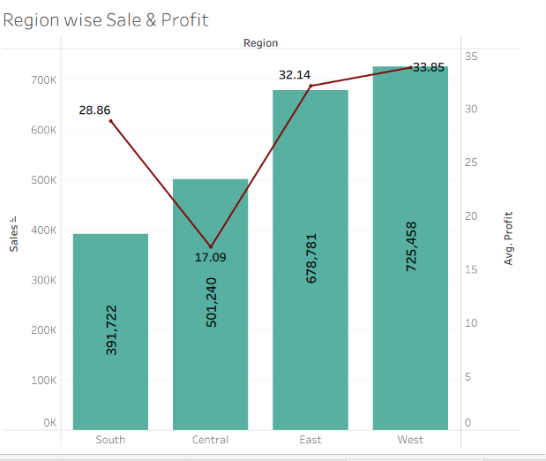
Figure 6: Sales & Profit by Region
At the state level, California ($458K) and New York ($311K) are by far the largest markets. However, the states with the largest total sales are not always the most profitable: Texas, Ohio, Pennsylvania and Illinois are simultaneously in the top 10 for sales and the top 5 for total losses (Texas alone lost -$25.7K), indicating a state-level, not just category-level, discounting or cost problem.
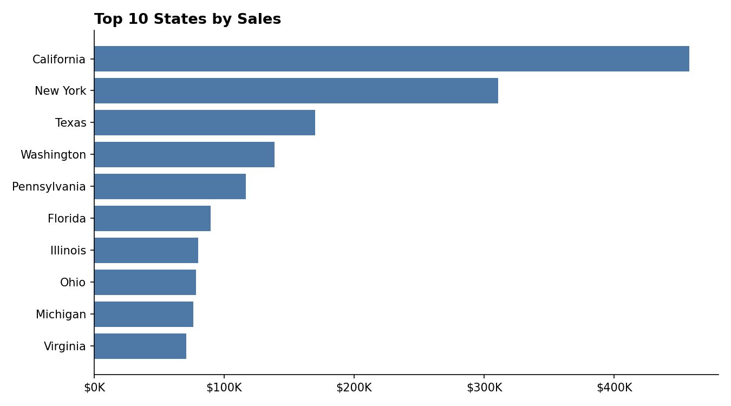
Figure 7: Top 10 States by Sales

5.5 Customer Segment Analysis
The Consumer segment is the largest contributor, generating 50.6% of total sales ($1.16M) and $134K profit, roughly 46% more profit than Corporate and over twice that of Home Office. Corporate ($706K sales, $92K profit) and Home Office ($430K sales, $60K profit) are smaller but broadly proportionate in profitability to their revenue share, suggesting segment mix is not itself a driver of the margin problem - the discount and product issues cut across all three segments.
-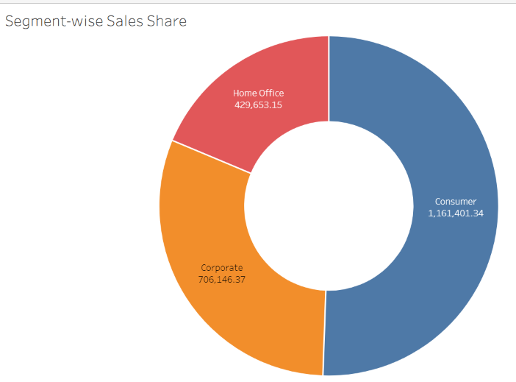
Figure 8: Sales share by Customer Segment

5.6 Shipping Mode & Delivery Analysis
Standard Class is used for the large majority of orders (5,968 of 9,994 line items) and averages 12.2 days from order to ship date, the slowest option. Same Day delivery, used for only 543 orders, understandably averages under a day. First and Second Class sit in between (6.7 and 5.2 days respectively). Sales and profit scale roughly with volume across ship modes, i.e., there is no evidence that faster shipping options are being under- or over-used relative to their profitability.
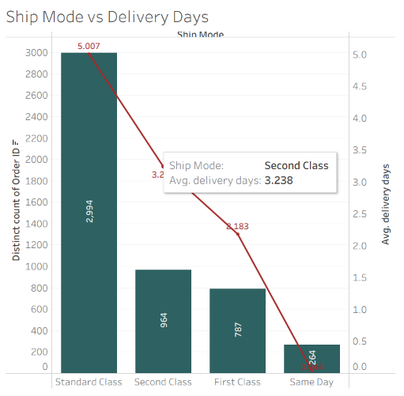
Figure 9: Ship Mode usage (bars) vs Avg Delivery Days (line)

5.7 Correlation Analysis
A correlation matrix across the four numeric measures confirms the visual findings: Sales and Profit are positively correlated (+0.48) - larger orders tend to be more profitable in absolute terms - while Discount and Profit are negatively correlated (-0.22). Quantity has a weak positive relationship with both Sales (+0.20) and Profit (+0.07), and essentially no relationship with Discount, indicating that discounting is not meaningfully driving higher unit volumes to compensate for the lower margin.
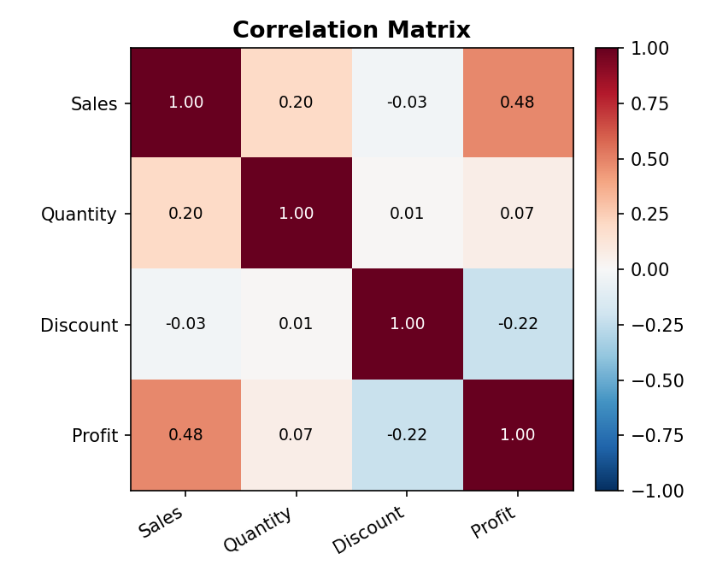
Figure 10: Correlation matrix - Sales, Quantity, Discount, Profit

6. Outlier & Anomaly Detection
Using the IQR method on the Sales field (upper bound = Q3 + 1.5xIQR = $498.93), 1,167 of 9,994 orders (11.7%) qualify as high-value outliers - expected in retail data, where a small number of bulk or high-ticket orders (e.g., Copiers, Machines) contribute disproportionately to revenue.
More important from a business standpoint are the extreme loss transactions. The single worst transaction was a Machines order in Ohio (November 2016) sold at a 70% discount, generating $4,500 in sales but a $6,600 loss on that one line item alone. Four of the five largest losses in the entire dataset involve discounts of 50% or higher, reinforcing the discount-band finding in Section 5.3 - these are not random anomalies but a systemic pattern concentrated in Machines, Binders and Tables at deep discount levels.
Conversely, the most profitable single transactions are Copiers and Binders sold at 0% discount (up to $8,400 profit on one order), showing that this business is highly capable of strong margins when full price is maintained.

7. Key Business Insights
- Deep discounting destroys margin, not just reduces it. Profit turns negative on average once discount exceeds ~20%, and the 31-50% discount band averages a $156 loss per order. This single pattern accounts for a majority of the store's foregone profit.
- Furniture is the weak link in the product portfolio. Despite generating nearly as much revenue as Technology, its 2.5% margin is roughly 7x lower, driven almost entirely by the Tables and Bookcases sub-categories, both of which are net loss-making overall.
- Revenue and profitability are geographically decoupled. Some of the largest markets by sales (Texas, Ohio, Pennsylvania, Illinois) are simultaneously among the biggest sources of loss, while the West region combines high revenue with the best margin.
- A small number of orders account for a large share of lost profit. Only 18.7% of orders are loss-making, but they erase an amount equal to more than half of total realized profit ($156K in losses vs. $286K net profit).
- The Consumer segment is the profit engine of the business, contributing just over half of total sales and profit, with Corporate and Home Office scaling roughly proportionately rather than under- or over-performing.
- Copiers, Labels, and Envelopes are disproportionately profitable relative to their revenue share and are candidates for expanded marketing focus.

8. Recommendations
- Cap or restructure discounts above 20%, especially on Tables, Bookcases, and Machines, or require managerial approval for deals in that range, since this is where the data shows profit consistently turns negative.
- Review Furniture pricing and supplier/shipping cost structure specifically for Tables and Bookcases; consider whether freight or fulfillment costs (large/bulky items) are the hidden driver of the loss, which would need cost data beyond this dataset to confirm.
- Investigate state-level pricing/discount practices in Texas, Ohio, Pennsylvania, and Illinois, where high sales volume is not translating into profit - this may reflect regional sales-team discounting behaviour or region-specific competitive pressure.
- Protect and grow the high-margin Copiers, Labels, Envelopes and Accessories lines through cross-sell or bundling, since they show the business can sustain strong margins when priced closer to full price.
- Use the Consumer segment as the primary lens for retention and loyalty investment, given it delivers the largest share of both sales and profit.

9. Areas for Further Investigation
- Cost/freight data: the dataset has no cost-of-goods or shipping-cost field, so it is not possible to fully separate "bad discounting" from "structurally expensive-to-ship" products (e.g., Tables, Bookcases) - obtaining COGS and freight data would sharpen the Furniture recommendation.
- Customer-level RFM (Recency, Frequency, Monetary) segmentation to identify high-value repeat customers versus one-time discount-driven buyers.
- Time-to-discount analysis: whether deep discounts cluster around specific months (e.g., end-of-quarter clearance) or specific sales reps, which the current fields do not capture.
- A proper Tableau dashboard build-out (using Tableau Public, which is free) with the worksheets described in Section 4, adding interactive parameters for a "what-if" discount cap, and a filled map visualization for state-level profit, which is not achievable in static matplotlib charts.

10. Conclusion
This exploratory analysis of the Sample Superstore dataset shows a fundamentally healthy retail business (12.5% overall margin, steady four-year sales growth) whose profitability is being materially reduced by a concentrated, identifiable pattern: excessive discounting on a handful of sub-categories and in specific states. Because the pattern is concentrated rather than diffuse, it is directly actionable - a discount-approval threshold and a Furniture-category cost review are the two highest-leverage next steps. The dashboard structure proposed in Section 4 would let a business stakeholder explore these same conclusions interactively, filtering by year, region, or segment, which is the natural next deliverable once this static exploratory phase is complete.

