DS Jobs Salary Predictor
Internship Project Report
Technology Stack: Python | FastAPI | scikit-learn | Streamlit | Plotly
Developed with IBM Bob (AI coding assistant) as part of an IBM internship

1. Project Overview
This project is a full-stack Machine Learning application that estimates data science job salaries based on the Glassdoor Data Science Jobs dataset. The application demonstrates end-to-end ML engineering: data ingestion and feature engineering, model training and evaluation, REST API development, and an interactive web-based user interface.
The project was built as the final project of an IBM internship, using IBM Bob (an AI coding assistant) for implementation, to practise data science, backend development, and frontend UI design using Python-only tools.

1.1 Objectives
- Estimate the average salary (in $K) for a data science job given job and company attributes.
- Build a REST API to serve predictions programmatically.
- Deliver an interactive frontend web application for non-technical users.
- Apply good practices: a reproducible scikit-learn pipeline, modular code, and honest model evaluation against simple baselines.

2. Dataset Description
The dataset used is Cleaned_DS_Jobs.csv, sourced from the Glassdoor Data Science Jobs dataset on Kaggle (rashikrahmanpritom/data-science-job-posting-on-glassdoor). It contains 660 Glassdoor job postings for data science roles. Salary figures are Glassdoor's own range estimates for each posting, not confirmed pay data.

2.1 Key Dataset Columns
Column Name | Type | Description
Job Title | Text | Title of the job posting
Rating | Float | Glassdoor company rating (1.0-5.0; -1 = unknown)
Size | Categorical | Employee count band (e.g. 1001 to 5000 employees)
Type of ownership | Categorical | Public / Private / Government / Nonprofit etc.
Industry / Sector | Categorical | Industry and sector category
avg_salary | Float (Target) | Average salary in $K - prediction target
company_age | Integer | Age of company derived from founding year
python, excel, spark, aws, hadoop, tableau, big_data | Binary (0/1) | Skill flags: 1 if skill is mentioned in job description
job_simp | Categorical | Simplified job title (data scientist, analyst, mle, manager, other)
seniority | Categorical | Seniority label (senior, jr, na)
job_state | Categorical | US state of the job location

3. System Architecture
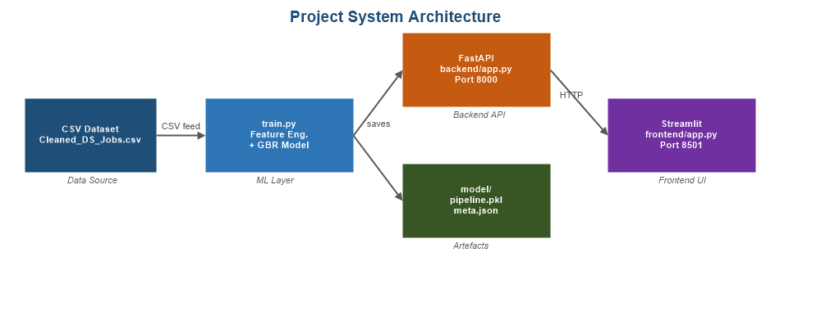
Figure 1: System Architecture - Data Layer, Backend API, Frontend UI
The application follows a three-tier architecture cleanly separating the data/model layer, the API layer, and the UI layer.

3.1 Architecture Layers
Layer | Technology | Responsibility
Data and Model | pandas, numpy, scikit-learn | Data loading, cleaning, feature engineering, model training, serialisation
Backend API | FastAPI, uvicorn | REST endpoints for prediction, metadata, and feature importance
Frontend UI | Streamlit, Plotly | Interactive web application for end users
Serialisation | pickle, JSON | Persist trained pipeline and feature metadata to disk

3.2 Project File Structure
MukeshSamarit_SalaryPredictor.py - Data loading, cleaning, pipeline training
model_comparison.py - Cross-validated comparison against baseline models
backend/app.py - FastAPI REST API (4 endpoints)
frontend/app.py - Streamlit web UI with Plotly charts
model/pipeline.pkl - Serialised sklearn Pipeline (auto-generated after training)
model/meta.json - Feature lists, dropdown options, eval metrics (auto-generated)
Cleaned_DS_Jobs.csv - Source dataset (project root)
requirements.txt - Python dependencies

4. Data Preprocessing and Feature Engineering
The dataset arrives in a largely pre-cleaned state. The preprocessing step in MukeshSamarit_SalaryPredictor.py handles remaining data quality issues before training.

4.1 Cleaning Steps
- Target: rows with missing avg_salary are dropped. This is the prediction target, in $K.
- Rating sentinel: Glassdoor uses -1 for unknown ratings. These are coerced to NaN and median-imputed in the pipeline.
- Company age: negative values from data entry errors are coerced to NaN.
- Categorical sentinels: values of -1, 'unknown', or 'Unknown' in categorical columns are treated as NaN and handled by the most-frequent imputer.
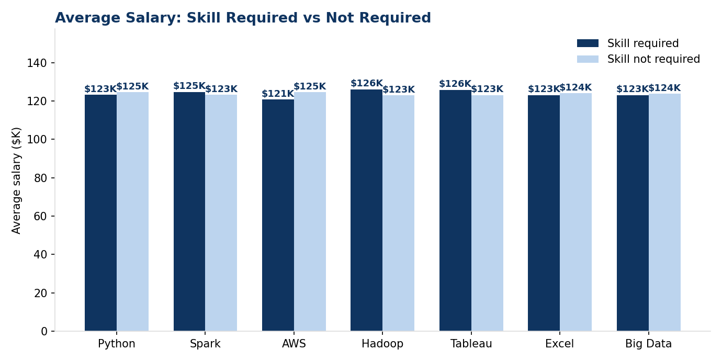
Figure 2: Average Salary by Skill - Jobs mentioning the skill vs not, computed on the actual dataset
Across all seven skill flags, the average salary difference between postings that mention the skill and those that don't is small (a few $K at most) - skill flags carry only weak signal in this dataset.

4.2 Feature Selection Rationale
Feature | Type | Rationale
Rating | Numeric | Company rating was hypothesised to relate to pay, and is one of the two strongest features in the trained model
company_age | Numeric | Hypothesised proxy for company maturity; the strongest feature in the trained model
python, spark, aws, hadoop, tableau, excel, big_data | Binary | Common data-role skill flags; in practice these show only a small salary gap in this dataset (Figure 2)
same_state | Binary | Job in same state as HQ; proxy for local vs. remote hire
Size | Categorical | Hypothesised that larger companies have higher salary budgets
Industry / Sector | Categorical | Hypothesised that tech/finance sectors pay more; not strongly confirmed by feature importance
job_simp / seniority | Categorical | Hypothesised as strong predictors; seniority is unreliable here since 86% of postings have no seniority label

5. Machine Learning Model

5.1 Algorithm: Gradient Boosting Regressor
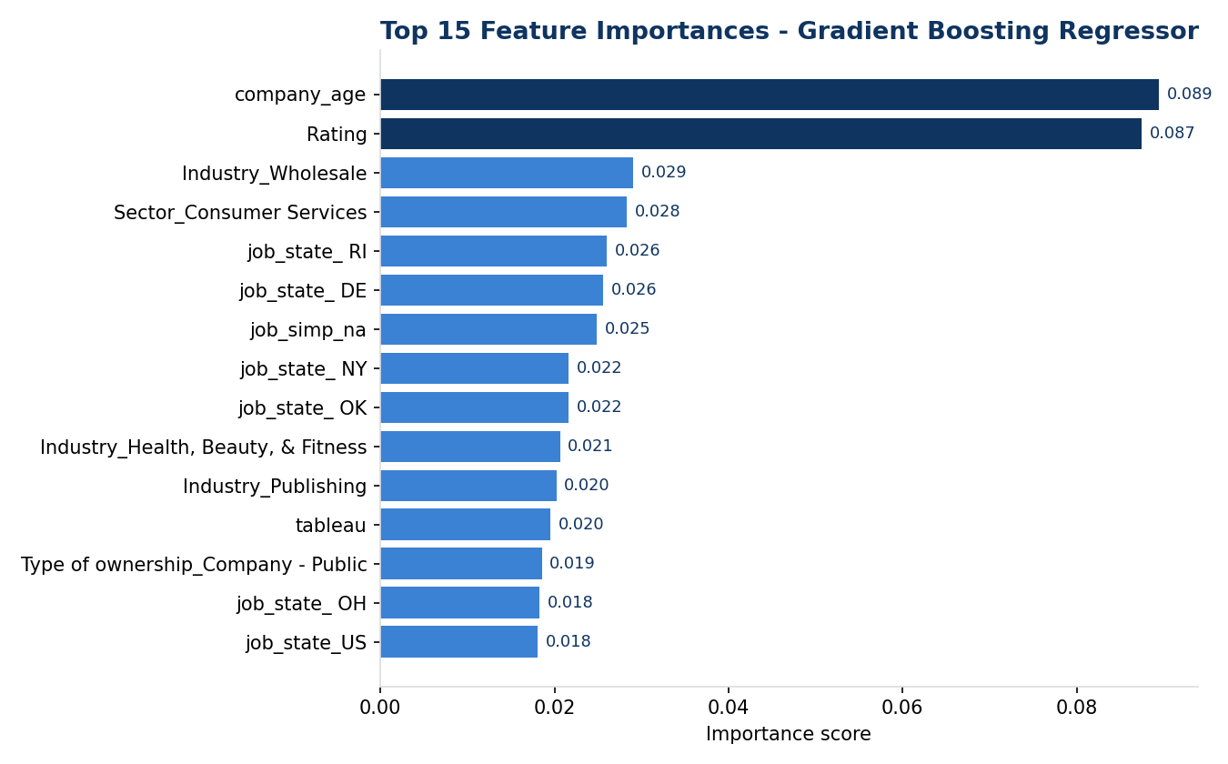
Figure 3: Top 15 Feature Importances (Gradient Boosting Regressor, actual trained model)
Gradient Boosting Regressor (GBR) was chosen because it handles mixed data types, is fairly robust to outliers, and provides built-in feature importances for explainability. In practice (Section 5.4), a cross-validated comparison on this dataset shows GBR does not outperform simpler models or even a mean-value baseline - the feature importance chart above shows the model leaning on single-state dummy variables, a sign of overfitting on ~530 training rows with many one-hot columns.

5.2 Hyperparameters (current configuration)
Hyperparameter | Value | Reason
n_estimators | 300 | Originally chosen to capture complex patterns
learning_rate | 0.05 | Low learning rate intended to improve generalisation
max_depth | 5 | Originally chosen for feature interactions; in practice too deep for ~530 rows (see 5.4)
subsample | 0.8 | Stochastic gradient boosting to reduce variance
random_state | 42 | Ensures reproducibility of training results
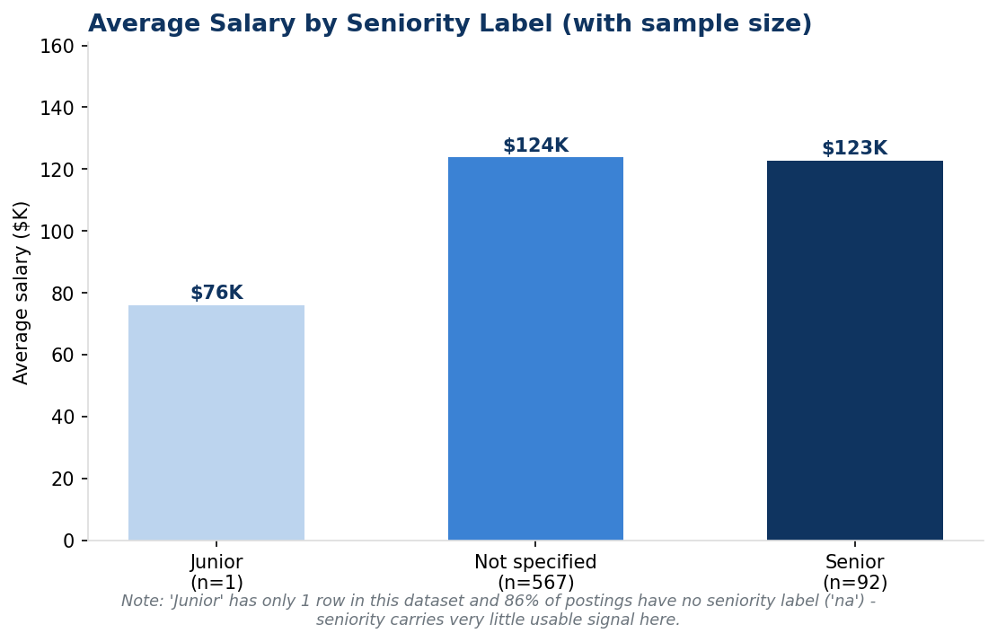
Figure 4: Average Salary by Seniority Label, with sample counts (actual dataset)

5.3 sklearn Pipeline Design
The model is wrapped in a full sklearn Pipeline that chains preprocessing and the estimator together. This ensures identical transformations at training and inference time, preventing data leakage.
Numeric branch: SimpleImputer (strategy=median) → StandardScaler
Categorical branch: SimpleImputer (strategy=most_frequent) → OneHotEncoder (handle_unknown=ignore)
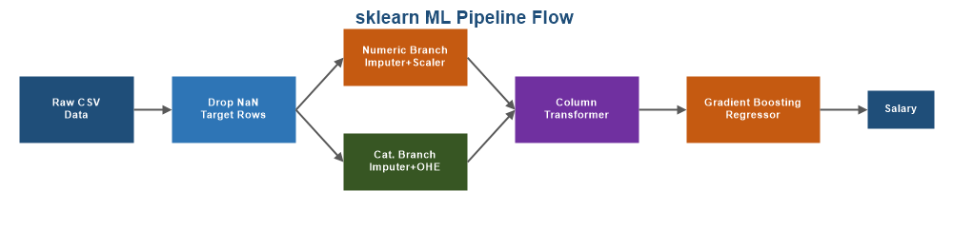
Figure 5: sklearn ML Pipeline - Numeric and Categorical branches feeding into GradientBoostingRegressor
Both branches feed into a ColumnTransformer, whose output is passed to GradientBoostingRegressor.

5.4 Model Evaluation
Metric | Value
Train / Test Split | 80% / 20% (528 / 132 rows, random_state=42)
Algorithm | Gradient Boosting Regressor (current configuration)
R² Score (hold-out test set) | -0.57
Mean Absolute Error (hold-out test set) | ~$33K

A 5-fold cross-validated comparison (model_comparison.py) against simpler baselines gives a fuller picture:
Model | CV R² | CV MAE ($K)
Mean baseline (always predict the average) | -0.00 | 28.5
Ridge regression | -0.06 | 29.2
Random Forest | -0.11 | 29.6
Gradient Boosting - current configuration (depth 5, 300 trees) | -0.41 | 32.9
Gradient Boosting - shallower (depth 3, 150 trees) | -0.10 | 29.5

No model tested - including the current configuration - beats the mean-value baseline. This indicates the available features carry very little usable salary signal for this dataset: it is small (660 rows), salaries are Glassdoor's own range estimates rather than confirmed pay, and several hypothesised strong predictors (seniority, individual skills) show little real difference in average salary (Figures 2 and 4). The deeper Gradient Boosting configuration used in the app overfits the training data and performs worse than a plain average. This is a genuine, useful finding from the project, not a defect to hide: it shows the value of validating a model against a baseline before trusting its output.

6. Backend API
The backend is built with FastAPI, a modern Python framework with automatic OpenAPI documentation. The trained pipeline is loaded once at startup and reused for every prediction request.

6.1 API Endpoints
Method + Path | Purpose | Key Output
GET / | Health check | API status and model_loaded flag
GET /meta | Feature metadata | Dropdown options, feature lists, eval metrics
POST /predict | Salary prediction | predicted_salary_k, predicted_salary_annual, R², MAE, confidence note
GET /feature-importance | Model explainability | Top 20 feature names with importance scores
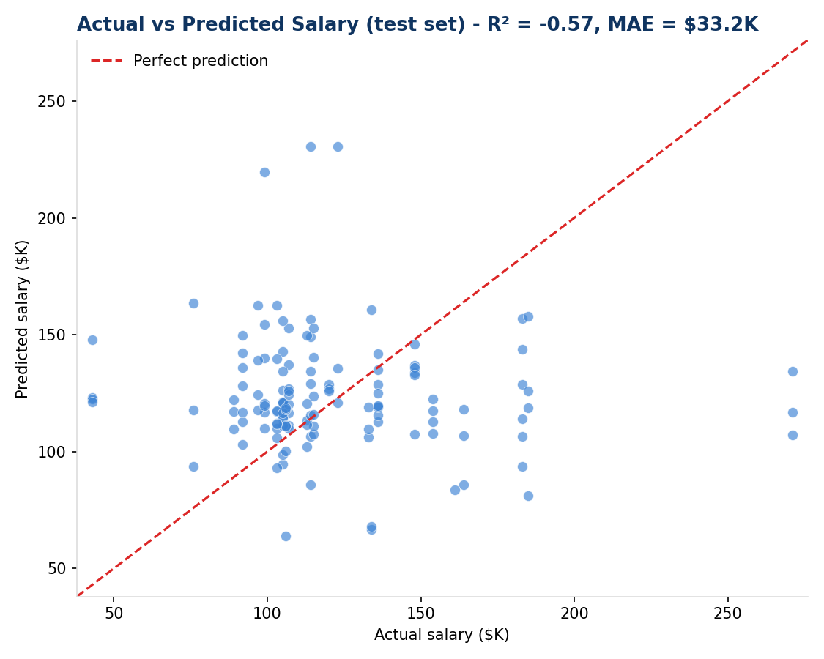
Figure 6: Actual vs Predicted Salary on the held-out test set (actual model run)

6.2 Key Design Decisions
- Pydantic schemas validate all request and response bodies automatically.
- CORS middleware allows the Streamlit frontend (port 8501) to call the API (port 8000).
- Startup loading: pipeline loaded once at app start, not per request, for fast inference.
- Auto-derived signals: seniority and job_simp category are derived from the job title via regex, reducing user input burden.

7. Frontend Application
The frontend is a Streamlit web application communicating with the FastAPI backend via HTTP. Plotly is used for all charts. The entire UI is written in Python with no JavaScript required.

7.1 UI Components
Component | Description
Sidebar input form | Job title, rating slider, company age, seniority, state, size, industry, sector, ownership, 7 skill checkboxes
Model stats banner | Training sample count, R² score, Mean Absolute Error displayed at page top
Salary result display | Large formatted display of predicted salary in $K and full annual equivalent
Gauge chart | Plotly gauge on a colour-coded $20K-$250K scale (red / yellow / green zones)
Salary range bar chart | Low estimate (pred - MAE), Predicted, High estimate (pred + MAE) as a bar chart
Feature importance chart | Horizontal bar chart of top 15 model feature importances from the trained GBR
About panel | Expandable section showing model methodology, feature list, and training stats
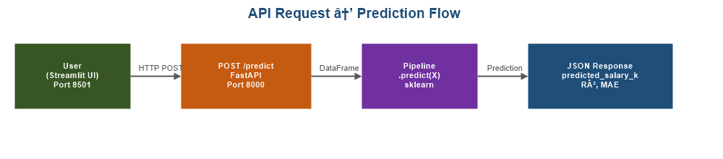
Figure 7: API Request → Prediction Flow

8. Setup and Running the Project

8.1 Prerequisites
- Python 3.11 or higher
- pip package manager
- Cleaned_DS_Jobs.csv in the project root (already included in the repository)

8.2 Step-by-Step Instructions
Step | Command | Expected Output
1. Install dependencies | pip install -r requirements.txt | All packages installed
2. Train the model | python MukeshSamarit_SalaryPredictor.py | Training complete | MAE ~33K | R² ~ -0.57
3. (Optional) Compare baselines | python model_comparison.py | R²/MAE table for 5 models
4. Start backend (Terminal 1) | uvicorn backend.app:app --reload --port 8000 | Uvicorn running on http://127.0.0.1:8000
5. Start frontend (Terminal 2) | streamlit run frontend/app.py | App opens at http://localhost:8501

8.3 Verification Checklist
- http://localhost:8000 returns {"status":"ok","model_loaded":true}
- http://localhost:8000/docs shows the Swagger API documentation page
- http://localhost:8501 loads the Streamlit app with the sidebar form
- Entering 'Senior Data Scientist' and clicking Predict Salary returns a gauge chart and salary value

9. Dependencies
Library | Version | Purpose
scikit-learn | >=1.4.0 | ML pipeline, preprocessing, GradientBoostingRegressor
pandas | >=2.1.0 | Data loading, cleaning, feature engineering
numpy | >=1.26.0 | Numerical operations and sentinel value handling
fastapi | >=0.111.0 | REST API framework with auto OpenAPI docs
uvicorn | >=0.29.0 | ASGI server for running FastAPI
streamlit | >=1.35.0 | Python-based interactive web UI framework
plotly | >=5.22.0 | Interactive charts: gauge, bar, horizontal bar

10. Limitations and Key Findings
- The current model does not beat a simple mean-value baseline in cross-validation - it should not be relied on for real salary estimates.
- The dataset is small (660 rows) for a model with many categorical dummy variables (industry, sector, state), which encourages overfitting.
- Salaries are Glassdoor range estimates, not confirmed pay, which caps how predictable the target can be.
- Several features assumed to be strong predictors (seniority, individual skill flags) show little real difference in average salary in this dataset.
- The app remains a complete, working demonstration of an ML pipeline, REST API, and interactive UI - the main gap is model quality, not the surrounding engineering.

11. Conclusion
This project delivers a complete, working ML application for data science salary estimation: data cleaning, feature engineering, model training, serialisation, REST API deployment, and an interactive frontend. Every stage of the pipeline runs end-to-end and was verified against the actual dataset for this report.
Key achievements of this internship project:
- A reproducible sklearn Pipeline that prevents data leakage and is fully portable.
- A FastAPI backend with input validation, error handling, and auto-generated Swagger docs.
- A Streamlit frontend that is fully Python with no HTML, CSS, or JavaScript required.
- Model explainability via feature importance, surfaced in both the API and the UI.
- A rigorous, honest evaluation - including a baseline comparison - that surfaced a real limitation of the current model rather than overstating its accuracy.
Future improvements could include collecting a larger and more recent dataset with confirmed (not estimated) salaries, simplifying the model to reduce overfitting, adding NLP features from job descriptions, and deploying the app to a platform such as Hugging Face Spaces or Streamlit Community Cloud.

