# SQL Customer & Order Analysis

## Project Overview

This project was completed as part of an Skill Nexis internship assignment of Week 2 to practice SQL querying and business data analysis.

The objective was to query a sample sales database and identify:

- Top customers based on total spending
- Average order value
- Total orders placed by customers
- Customer-wise sales performance
- Key insights that can support sales and customer-retention decisions

The analysis demonstrates the use of SQL aggregation, joins, grouping, sorting, and calculated metrics to transform raw order data into useful business insights.

## Objective

The main goal of this assignment was to analyze customer order data and answer important business questions:

1. Who are the top customers based on total purchase amount?
2. What is the average value of an order?
3. How many orders has each customer placed?
4. Which customers contribute the highest revenue?
5. What insights can be generated from customer purchasing behavior?

## Tools Used

- **SQL**
- MySQL
- GitHub for project documentation and version control

## Database Structure

The sample database contains “sales “ table

### Sales Table

| Column Name | Description |
|---------------|----------------------------------|
| `order_id` | Unique ID for each order placed |
| `customer_name` | Name of the customer |
| `order_date` | Date of order placed |
| `category’ | Category of the product |
| `sub_category` | Subcategory of the product |
|`product_name` | Name of the product |
|`quantity` | Quantity of ordered product |
|`unit_price` | Unit price for each product |
| `total_price` | Total Price of Order ( unit_price * quantity) |
| `region` | Region of the Customer |

## SQL Queries

### 1. Top Customers by Total Spending

This query identifies the customers who generated the highest total revenue.

```sql
SELECT
customer_name,
COUNT(order_id) AS total_orders,
SUM(total_price) AS total_spent
FROM sales
GROUP BY
customer_name
ORDER BY
total_spent DESC
LIMIT 10;
```
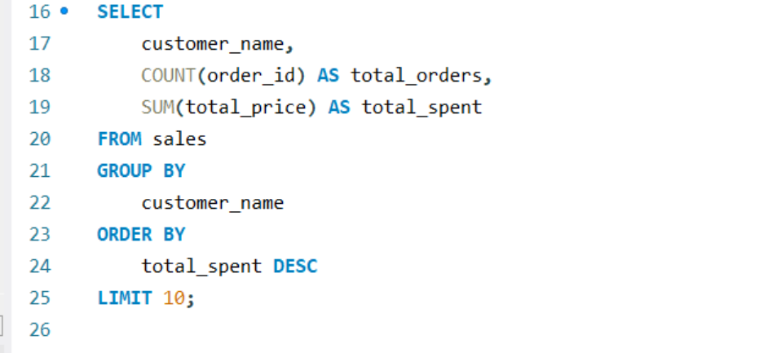

Output-

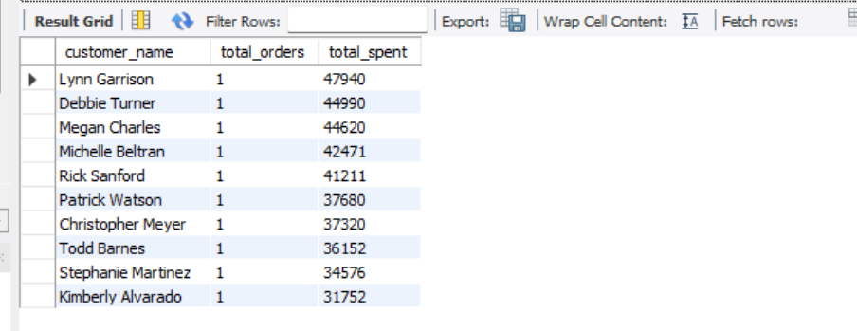

### 2. Average Order Value

This query calculates the average value of all orders in the database.

```sql
SELECT
ROUND(AVG(total_price), 2) AS average_order_value
FROM sales;
```
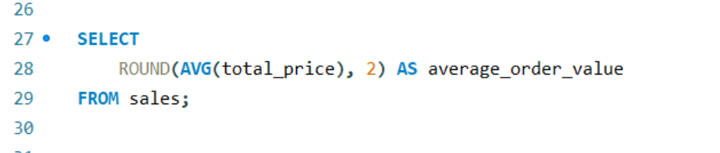

Output-
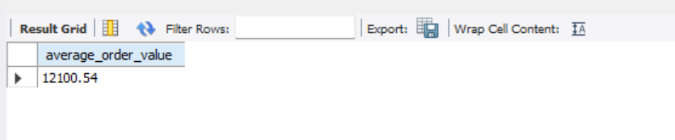

### 3. Customer-wise Order Summary

This query provides a summary of order count, total sales, and average order value for every customer.

```sql
SELECT
customer_name,
COUNT(order_id) AS total_orders,
ROUND(SUM(total_price), 2) AS total_sales,
ROUND(AVG(total_price), 2) AS average_order_value
FROM sales
GROUP BY
customer_name
ORDER BY
total_sales DESC;
```
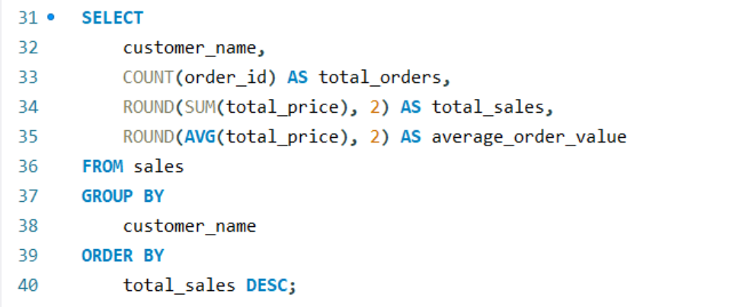

Sample Output-
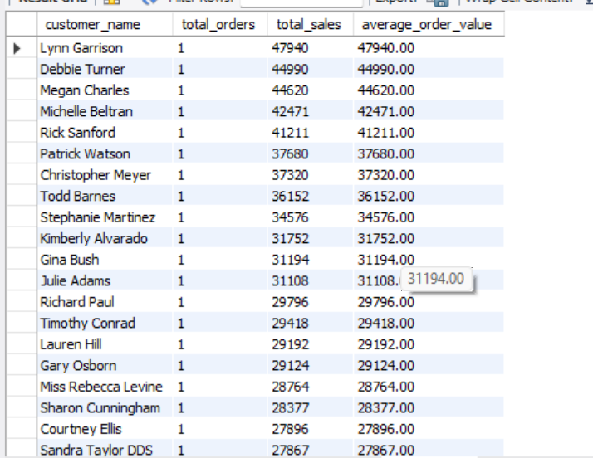
### 4. Customers With Above-Average Spending

This query finds customers whose total spending is higher than the average customer spending.

```sql
SELECT
customer_name,
SUM(total_price) AS total_spent
FROM sales
GROUP BY
customer_name
HAVING
SUM(total_price) > (
SELECT AVG(total_price)
FROM (
SELECT
SUM(total_price) AS customer_total
FROM sales
GROUP BY customer_name
) AS customer_spending
)
ORDER BY
total_spent DESC;
```
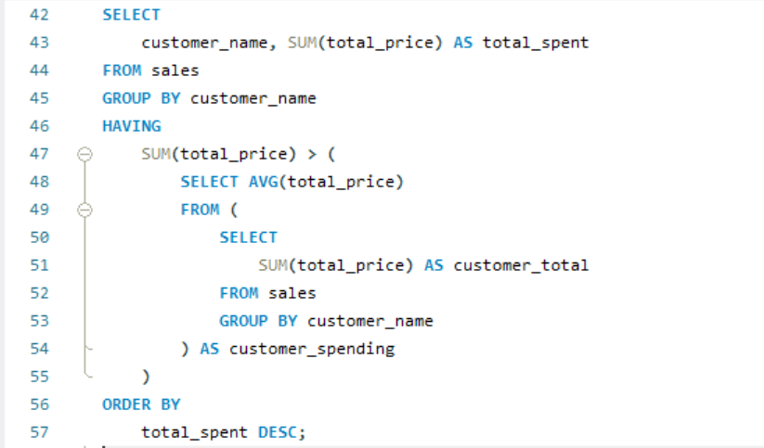

Sample Output-
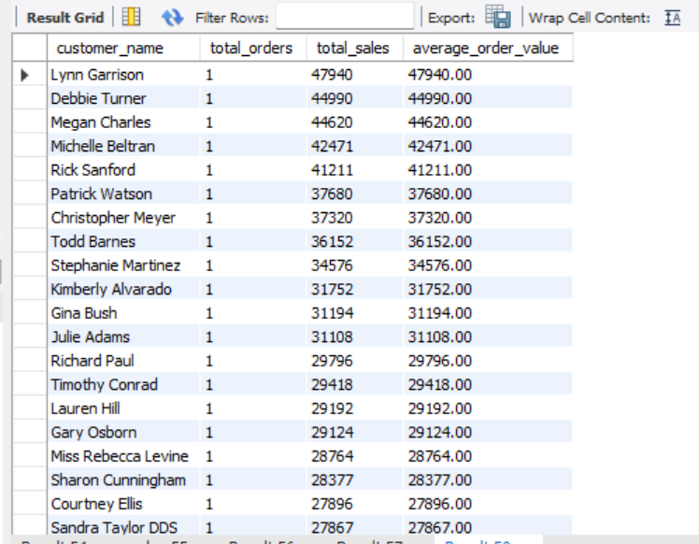
## Key SQL Concepts Used

- `SELECT` statement for retrieving data
- `COUNT()` to calculate total orders
- `SUM()` to calculate total customer spending
- `AVG()` to calculate average order value
- `GROUP BY` to create customer-level summaries
- `ORDER BY` to rank customers by spending
- `HAVING` to filter grouped results
- Subqueries for comparison with average customer spending
- `ROUND()` for cleaner numeric output

## Project Structure

```text
SQL-Customer-Order-Analysis/
│
├── README.md
├── sql_queries.sql
├── database_schema.sql
├── sample_data.sql
└── screenshots/
├── top_customers_result.png
└── average_order_value_result.png
```

## How to Run the Project

1. Download or clone this repository.

```bash
git clone https://github.com/MSDIAN124/Skillnexis-Internship-Projects
```

2. Open your SQL database tool, such as MySQL Workbench, pgAdmin, SQL Server Management Studio, or DB Browser for SQLite.

3. Create the sample database and tables using the ` SQL_Sales_Dataset_200_Rows.xlsx - Google Sheets ` file.

## Author

**Mukesh Samarit**
Aspiring Data Analyst | SQL | Excel | Power BI | Data Visualization

- GitHub: https://github.com/MSDIAN124
- LinkedIn: www.linkedin.com/in/mukesh-samrit-36b4a3283

## Note

This project was created for learning and internship-assignment purposes. The database and customer data used in this project are sample data only.

