Predictive Modeling and Optimization in Logistics Systems
Scenario Focus: Fresh-Food Warehouse & Distribution — Sprouts Farmers Market
Week 4 Task — Prepared by Mukesh Samarit

1. Introduction
This report is the final stage of the four-week logistics analytics project for Sprouts Farmers Market's fresh-food warehouse and distribution operations. Building on the strategic plan (Week 1), data preprocessing pipeline (Week 2), and exploratory visualization (Week 3), this report applies predictive modeling and optimization techniques to the same simulated logistics dataset. The goal is to forecast delivery time — a variable shown in Week 3 to be strongly linked to transportation cost and shrinkage — and to translate model insights into concrete optimization recommendations for warehouse and distribution management.

2. Problem Definition and Data Simulation

2.1 Prediction Problem
The core forecasting problem is defined as: given the characteristics of an order (shipment size, picking time, timing, product category, and warehouse location), predict the delivery time in hours. Accurate delivery-time forecasts allow Sprouts to proactively flag shipments at risk of late delivery — which, per the Week 3 correlation analysis, are also the shipments most likely to suffer higher spoilage (shrinkage).

2.2 Dataset
This task reuses the same simulated 1,200-record logistics dataset introduced in Week 3, ensuring consistency across the project. Two date-derived features (order day-of-week and order month) were added to capture potential timing effects. The features used and the target variable are summarized below:
Feature | Type | Description
shipment_volume_units | Numeric | Number of units in the shipment
picking_minutes | Numeric | Time taken to pick the order in-warehouse
order_dow | Numeric | Day of week the order was placed (0-6)
order_month | Numeric | Month the order was placed
category | Categorical | Product category (Produce, Dairy, Bakery, Packaged Goods, Frozen)
warehouse_location | Categorical | Distribution center handling the shipment
delivery_time_hours (TARGET) | Numeric | Hours from dispatch to delivery — the value being predicted

3. Model Selection and Implementation

3.1 Rationale for Model Choice
Two models were selected to represent different modeling philosophies, allowing their performance to be compared directly:
- Linear Regression — chosen as an interpretable baseline. Since Week 3's correlation analysis showed a strong linear relationship between shipment volume and delivery time (r = 0.64), a linear model is a reasonable and easily explainable starting point.
- Random Forest Regressor — chosen as an ensemble method capable of capturing non-linear relationships and interactions between features (e.g., category-specific effects) that a linear model cannot represent. It also provides feature-importance scores, which are valuable for the optimization stage of this analysis.

3.2 Data Preparation
Categorical features (category, warehouse_location) were one-hot encoded, and numeric features were standardized, using a scikit-learn ColumnTransformer wrapped in a Pipeline so that preprocessing is applied consistently to both training and test data without leakage. The data was split 80/20 into training and test sets.

3.3 Code: Data Preparation and Model Training
from sklearn.model_selection import train_test_split
from sklearn.linear_model import LinearRegression
from sklearn.ensemble import RandomForestRegressor
from sklearn.preprocessing import OneHotEncoder, StandardScaler
from sklearn.compose import ColumnTransformer
from sklearn.pipeline import Pipeline

features_num = ['shipment_volume_units', 'picking_minutes', 'order_dow', 'order_month']
features_cat = ['category', 'warehouse_location']
X = df[features_num + features_cat]
y = df['delivery_time_hours']

X_train, X_test, y_train, y_test = train_test_split(X, y, test_size=0.2, random_state=42)

preprocessor = ColumnTransformer([
('num', StandardScaler(), features_num),
('cat', OneHotEncoder(handle_unknown='ignore'), features_cat),
])

lr_pipeline = Pipeline([('preprocess', preprocessor), ('model', LinearRegression())])
lr_pipeline.fit(X_train, y_train)

rf_pipeline = Pipeline([('preprocess', preprocessor),
('model', RandomForestRegressor(n_estimators=200, max_depth=8, random_state=42))])
rf_pipeline.fit(X_train, y_train)

4. Evaluation and Validation

4.1 Evaluation Metrics
Three standard regression metrics were used to evaluate both models: RMSE (Root Mean Squared Error, in hours — penalizes larger errors more heavily), MAE (Mean Absolute Error, in hours — the average absolute deviation, easier to interpret directly), and R² (proportion of variance in delivery time explained by the model).
from sklearn.metrics import mean_squared_error, mean_absolute_error, r2_score
import numpy as np

pred = rf_pipeline.predict(X_test)
rmse = np.sqrt(mean_squared_error(y_test, pred))
mae = mean_absolute_error(y_test, pred)
r2 = r2_score(y_test, pred)

4.2 Results
Model | RMSE (hrs) | MAE (hrs) | R²
Linear Regression | 2.528 | 2.029 | 0.476
Random Forest Regressor | 2.554 | 2.056 | 0.465
Linear Regression performed marginally better than the Random Forest on this dataset (lower RMSE/MAE, slightly higher R²), suggesting the relationship between the features and delivery time is close to linear — consistent with the strong linear correlations observed in Week 3. Both models explain roughly 46-48% of the variance in delivery time (R² ≈ 0.47), meaning shipment characteristics are a meaningful but not complete predictor — external factors such as traffic, weather, or day-specific disruptions (not present in this dataset) likely account for the remaining variance.
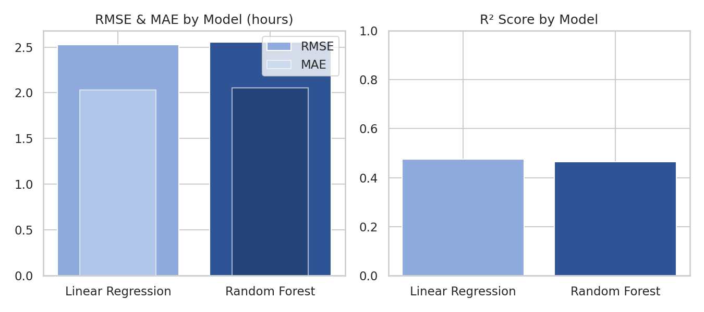
Figure 1: Model comparison — RMSE/MAE (left) and R² (right)

4.3 Cross-Validation
To confirm the Random Forest result was not dependent on one particular train/test split, 5-fold cross-validation was performed on the full dataset.
from sklearn.model_selection import cross_val_score

cv_scores = cross_val_score(rf_pipeline, X, y, cv=5, scoring='r2')
print(cv_scores.mean(), cv_scores.std())
# Output: Mean R2 = 0.427, Std = 0.056
The mean cross-validated R² (0.427) is close to the single-split test R² (0.465), and the standard deviation (0.056) is modest — indicating the model's performance is reasonably stable across different subsets of the data, rather than being an artifact of one lucky split.

4.4 Actual vs. Predicted and Residual Analysis
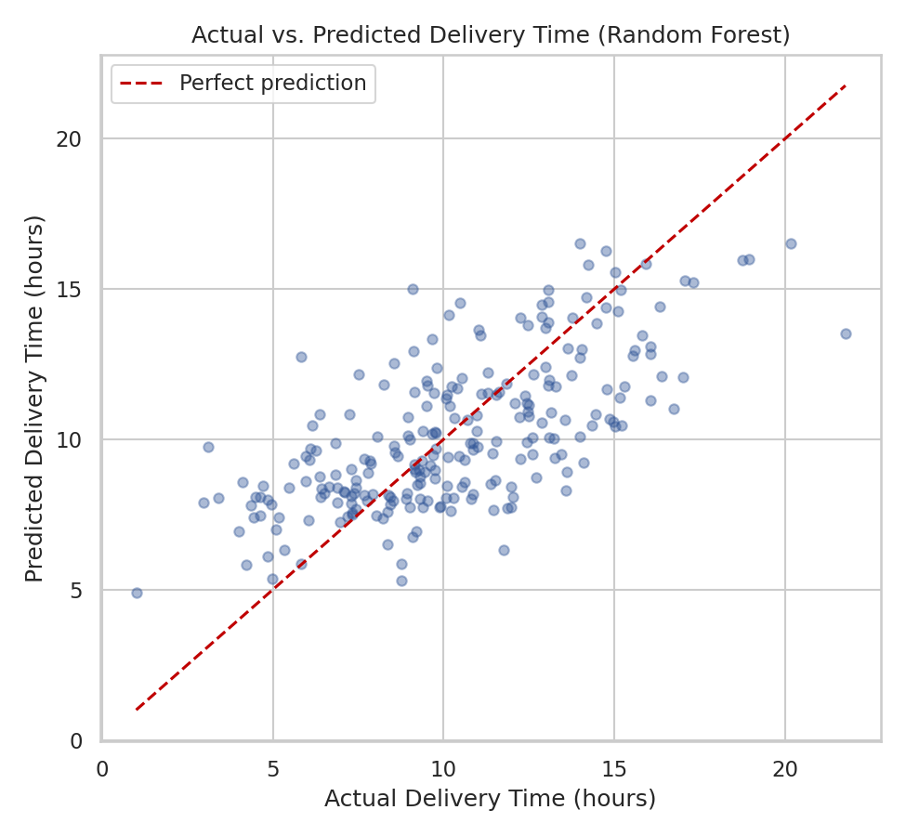
Figure 2: Actual vs. predicted delivery time (Random Forest, test set)
Points cluster reasonably close to the diagonal “perfect prediction” line, with wider scatter at higher delivery times — indicating the model is more accurate for typical (shorter) deliveries and less precise for the slower, longer-tail shipments identified as high-risk in Week 3.
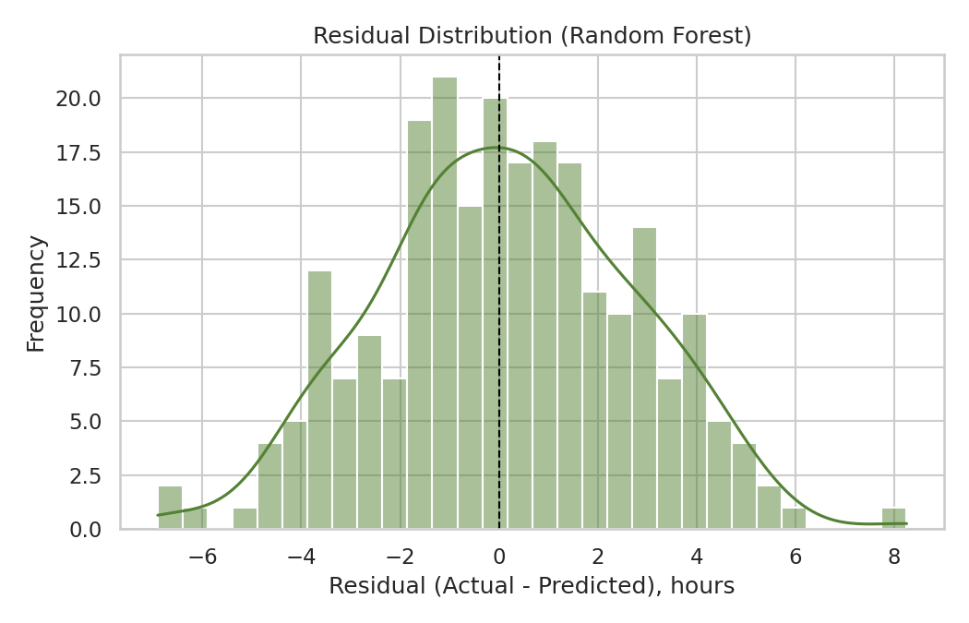
Figure 3: Residual distribution (Random Forest)
Residuals are roughly centered around zero and approximately symmetric, which suggests the model is not systematically over- or under-predicting delivery time — a reasonable, unbiased fit given the R² achieved.

5. Feature Importance and Optimization Strategies

5.1 What Drives Delivery Time
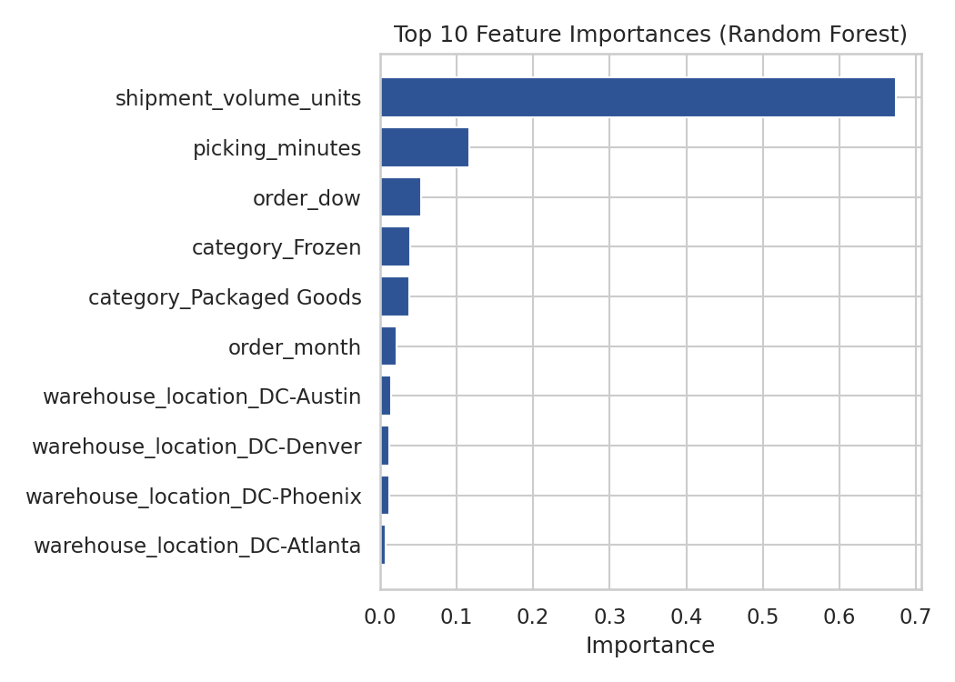
Figure 4: Top feature importances (Random Forest)
Shipment volume is by far the dominant driver of delivery time (importance ≈ 0.67), followed distantly by picking minutes (≈ 0.12) and order day-of-week (≈ 0.05). Category and warehouse-location effects are comparatively minor. This directly echoes the Week 3 correlation finding that volume, not category or location, is the primary driver of both cost and delivery time.

5.2 Optimization Recommendations
Based on these predictive insights, three optimization strategies are proposed:
- Shipment Consolidation & Batching — Since shipment volume is the dominant driver of delivery time, consolidating smaller, frequent orders into fewer, well-planned larger shipments (where feasible) can reduce the total number of delivery cycles and improve per-unit efficiency, rather than simply accepting delivery time as fixed per order.
- Resource Allocation by Predicted Risk — Use the trained model to score incoming orders in advance and flag those predicted to have high delivery time (and therefore higher shrinkage risk). These orders can be prioritized for earlier dispatch or expedited routing, directly supporting the Shrinkage Rate and Order Fulfillment Rate KPIs defined in Week 1.
- Picking-Time Reduction as a Secondary Lever — Since picking minutes is the second-most important feature, the pick-path optimization proposed in Week 1 (prioritizing near-expiry, high-risk SKUs) has a measurable, model-supported effect on reducing downstream delivery time, not just warehouse-internal efficiency.
- Formal Route/Load Optimization — Beyond prediction, an optimization layer (e.g., linear programming via PuLP or OR-Tools, as outlined in Week 1) can be applied on top of the demand forecasts to assign shipments to vehicles/routes in a way that minimizes total distance or delivery time subject to vehicle-capacity constraints.

5.3 Optimization Pseudocode
# Pseudocode: prioritize and batch shipments using model predictions
FUNCTION plan_daily_dispatch(pending_orders, trained_model, vehicle_capacity):
predicted_times = trained_model.predict(pending_orders)
pending_orders['predicted_delivery_time'] = predicted_times

# Flag high-risk (slow-predicted) perishable orders for priority dispatch
high_risk = pending_orders[
(pending_orders['predicted_delivery_time'] > threshold) &
(pending_orders['category'].isin(['Produce', 'Dairy', 'Bakery']))
]

# Consolidate remaining orders into capacity-constrained batches
batches = greedy_bin_pack(pending_orders, vehicle_capacity)

RETURN prioritize(high_risk) + batches

6. Final Recommendations and Conclusion
This four-week project has moved from strategic planning (Week 1) through data preprocessing (Week 2) and exploratory visualization (Week 3) to predictive modeling and optimization (Week 4), forming a coherent, end-to-end analytics workflow for Sprouts Farmers Market's fresh-food warehouse operations. The final predictive model — while not perfect (R² ≈ 0.47) — confirms and quantifies the relationships first observed visually in Week 3, and identifies shipment volume and picking time as the two most actionable levers available to warehouse management.
The recommended next step for Sprouts would be to deploy the trained model as a daily dispatch-planning tool: scoring each day's pending orders for predicted delivery time and shrinkage risk, prioritizing perishable and high-risk shipments, and using the consolidation and picking-time strategies above to close the gap between current performance and the KPI targets defined in Week 1 (Order Fulfillment Rate ≥ 95%, Shrinkage Rate ≤ 3-5%, and a 15-20% reduction in Average Picking Time).

