Advanced Data Analysis and Visualization in Logistics
Scenario Focus: Fresh-Food Warehouse & Distribution — Sprouts Farmers Market
Week 3 Task — Prepared by Mukesh Samarit

1. Introduction
This report extends the Week 1-2 work on Sprouts Farmers Market's fresh-food warehouse operations into advanced exploratory data analysis (EDA) and visualization. Using a simulated logistics dataset built on the cleaned data structure from Week 2, this analysis examines delivery times, shipment volumes, transportation costs, and spoilage patterns to uncover relationships and operational bottlenecks that are not visible from raw numbers alone. Python (pandas, matplotlib, seaborn) is used throughout to compute statistics and generate the visualizations presented below.

2. Data Simulation
A hypothetical logistics dataset of 1,200 shipment records was simulated, reflecting realistic patterns for a multi-warehouse fresh-grocery distribution network (four distribution centers: Phoenix, Denver, Austin, and Atlanta) over a 90-day period. The dataset structure builds directly on the fields defined in Week 2, with three additional logistics-specific variables — delivery time, shipment volume, and transportation cost — added to support this analysis.
Variable | Description
shipment_volume_units | Number of units in a given shipment/order
delivery_time_hours | Time taken (hours) from dispatch to delivery at destination
transportation_cost_usd | Cost (USD) of transporting the shipment
picking_minutes | Time taken (minutes) to pick the order within the warehouse
spoiled_units / shrinkage_rate | Units spoiled before sale, and spoiled units as a fraction of shipment volume
category | Product category (Produce, Dairy, Bakery, Packaged Goods, Frozen)
warehouse_location | Distribution center handling the shipment (Phoenix, Denver, Austin, Atlanta)
order_date | Date the order was placed (90-day window simulated)
Relationships were deliberately built into the simulation to mirror real warehouse dynamics: larger shipments take longer to deliver and cost more to transport; perishable categories (Produce, Dairy, Bakery) carry higher spoilage risk; and longer delivery times are associated with higher shrinkage — consistent with the operational challenges identified in Week 1.

3. Exploratory Data Analysis (EDA)

3.1 Central Tendency and Spread
Summary statistics were calculated for the key numeric variables using pandas' describe() function:
Variable | Mean | Median | Std Dev
Delivery Time (hrs) | 10.22 | 10.07 | 3.49
Transportation Cost (USD) | $736.40 | $672.15 | $398.60
Picking Time (min) | 15.42 | 15.10 | 5.38
Shrinkage Rate | 6.20% | 6.48% | 2.51%
The standard deviation for transportation cost ($398.60, against a mean of $736.40) indicates high variability — shipment size and distance differences drive a wide cost range across orders. Delivery time shows a more moderate spread, suggesting the delivery process is relatively consistent but still has a meaningful long tail (max observed delivery time exceeded 23 hours).

3.2 Distribution Analysis
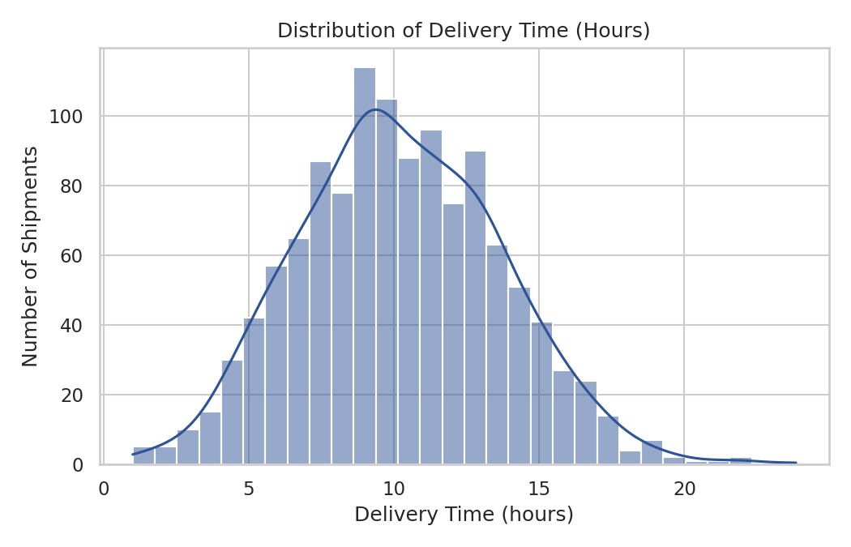
Figure 1: Distribution of delivery time across all shipments
A histogram with a kernel density overlay was chosen here because it shows both the overall shape of the distribution (is it normal, skewed, bimodal?) and the underlying smooth trend in one view. The distribution is right-skewed — most shipments deliver within 7-13 hours, but a tail of slower deliveries extends toward 20+ hours. This tail is operationally important: these are the shipments most likely to breach service-level expectations and, for perishable goods, most likely to spoil.

3.3 Cost Analysis by Category
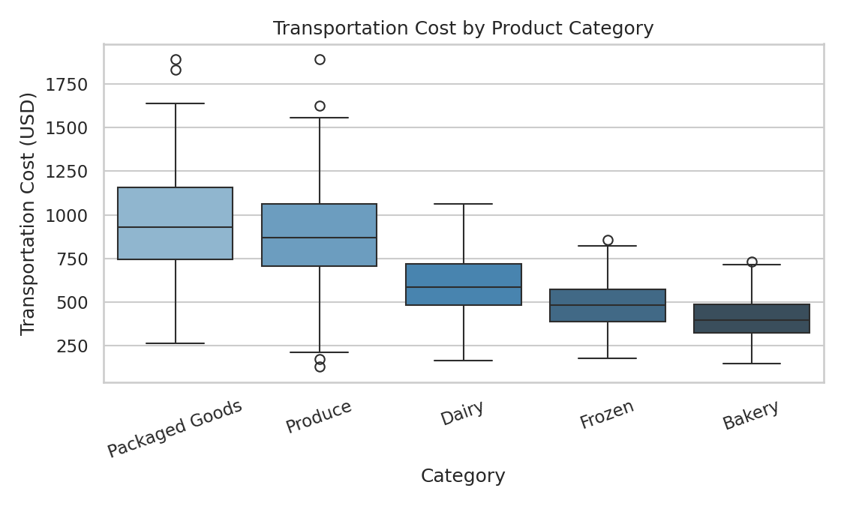
Figure 2: Transportation cost distribution by product category
A boxplot was used here (rather than a simple bar chart of averages) because it shows the full spread and outliers within each category, not just a single summary number. Packaged Goods and Produce show the highest median transportation costs, which is expected given their higher typical shipment volumes; Bakery and Frozen categories are both cheaper to ship and show tighter cost distributions, indicating more predictable, standardized shipments.

3.4 Correlation Analysis
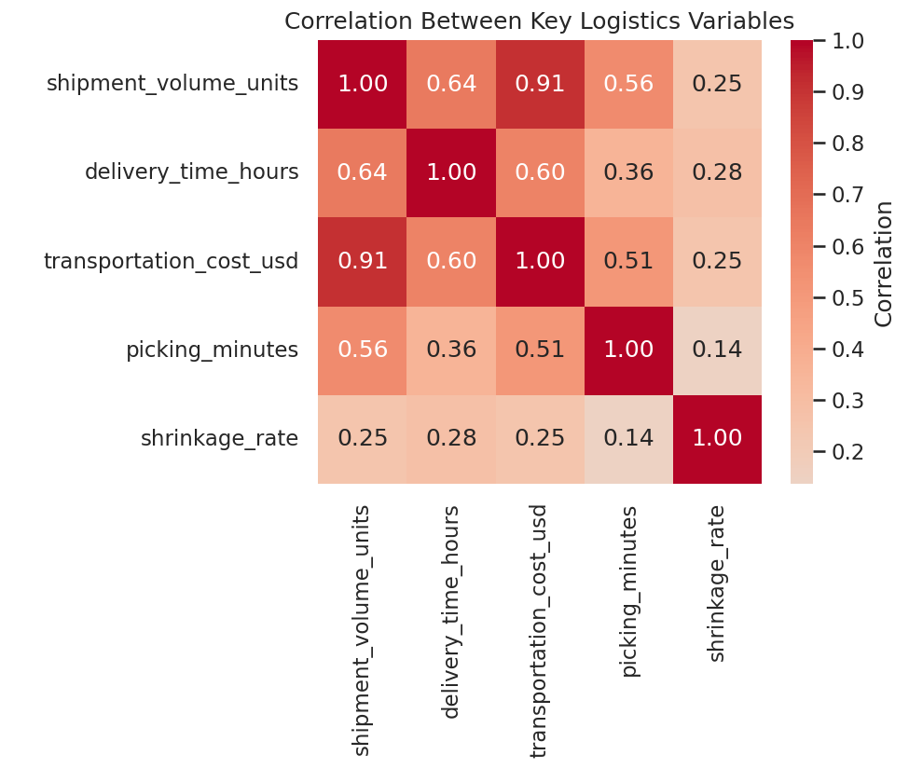
Figure 3: Correlation matrix of key logistics variables
A correlation heatmap was chosen because it condenses many pairwise relationships into a single, quickly scannable view — far more efficient than reading a table of numbers for five variables. The strongest relationship is between shipment volume and transportation cost (r = 0.91), confirming that cost is primarily volume-driven. Delivery time also correlates moderately with volume (r = 0.64), suggesting larger shipments take measurably longer to move through the network. Shrinkage rate shows a weaker but still notable positive correlation with delivery time (r = 0.28), supporting the hypothesis that longer transit times increase spoilage risk for perishable goods.

3.5 Relationship Between Shipment Volume and Delivery Time
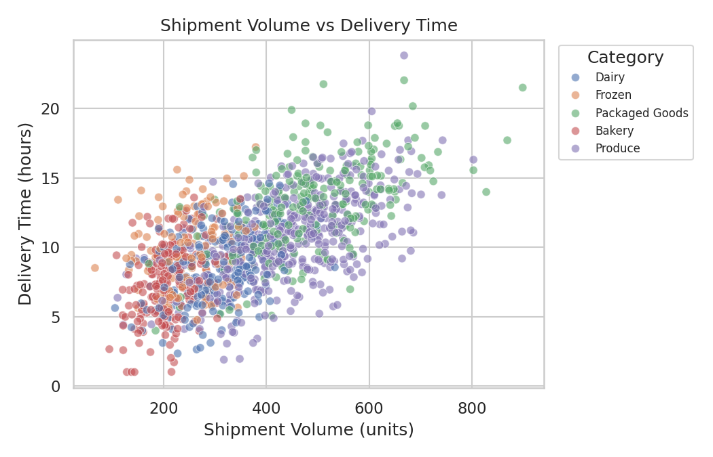
Figure 4: Shipment volume vs. delivery time, by category
A scatter plot, color-coded by category, was used to examine the volume-delivery relationship in more granular detail than the correlation coefficient alone can show. The upward trend confirms that larger shipments generally take longer to deliver, but the category coloring also reveals that perishable categories (Produce, Dairy) cluster toward shorter delivery times even at similar volumes — consistent with Sprouts prioritizing faster transit for time-sensitive goods, as intended by the picking-priority logic proposed in Week 1.

3.6 Shrinkage Rate Trend Over Time
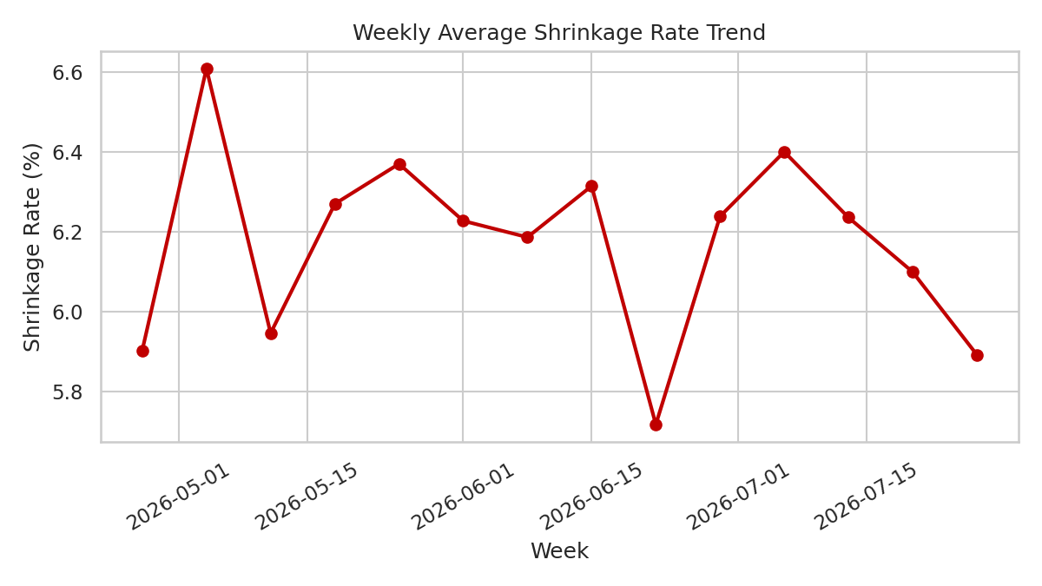
Figure 5: Weekly average shrinkage rate trend
A line chart was used to track the Shrinkage Rate KPI (defined in Week 1) over time, since trend visibility is exactly what line charts are best suited for. The weekly average fluctuates around 5-7%, without a strong sustained upward or downward trend in this simulated window — indicating that shrinkage is currently a stable but persistently elevated baseline problem, rather than a one-off event, and therefore requires a systemic fix (e.g., the clustering-based risk segmentation and pick-path prioritization proposed in Week 1) rather than a reactive one-time correction.

3.7 Picking Time by Warehouse Location
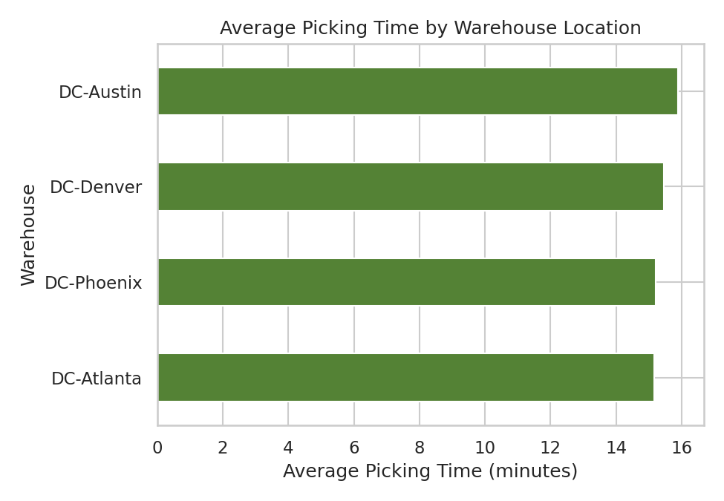
Figure 6: Average picking time by distribution center
A horizontal bar chart was used to compare the Average Picking Time KPI across the four warehouse locations, since bar charts are the clearest way to compare a single metric across a small number of discrete categories. DC-Austin shows the highest average picking time (15.89 minutes) while DC-Atlanta is fastest (15.17 minutes). While the gap is modest in this simulation, in a real operational setting this kind of comparison is exactly how a manager would identify which specific location needs process review, additional staffing, or a layout redesign.

4. Analytical Insights and Recommendations
- Cost is volume-driven, not distance-driven: Since transportation cost correlates far more strongly with shipment volume (r = 0.91) than any distance-related factor, cost-reduction efforts should focus on shipment consolidation and load optimization rather than route renegotiation alone.
- Delivery delays are a leading indicator of spoilage: The positive correlation between delivery time and shrinkage rate suggests that even modest improvements in transit time for perishable categories could measurably reduce waste — directly supporting the Shrinkage Rate KPI target set in Week 1.
- The delivery-time tail is the real risk, not the average: Because the distribution of delivery times is right-skewed, focusing only on the average would understate the problem. The slowest 10-15% of shipments deserve dedicated root-cause investigation.
- Warehouse-level differences in picking time are measurable and actionable: DC-Austin's comparatively slower picking time is a concrete, location-specific target for the pick-path optimization strategy proposed in Week 1.
- Shrinkage is chronic, not episodic: The stable weekly trend indicates an ongoing structural issue best addressed through the SKU risk-segmentation and near-expiry prioritization approach already planned, rather than a short-term fix.

5. Python Code Used
The following code excerpts show how the summary statistics, correlations, and visualizations above were generated using pandas, matplotlib, and seaborn.

5.1 Summary Statistics and Correlation
import pandas as pd

df = pd.read_csv('sprouts_logistics_data.csv', parse_dates=['order_date'])
df['shrinkage_rate'] = df['spoiled_units'] / df['shipment_volume_units']

summary = df[['delivery_time_hours', 'transportation_cost_usd',
'picking_minutes', 'shrinkage_rate']].describe()

corr = df[['shipment_volume_units', 'delivery_time_hours',
'transportation_cost_usd', 'picking_minutes',
'shrinkage_rate']].corr()

5.2 Distribution Plot (Figure 1)
import seaborn as sns
import matplotlib.pyplot as plt

sns.histplot(df['delivery_time_hours'], bins=30, kde=True, color='#2F5496')
plt.title('Distribution of Delivery Time (Hours)')
plt.xlabel('Delivery Time (hours)')
plt.ylabel('Number of Shipments')
plt.tight_layout()
plt.savefig('chart1_delivery_time_dist.png')

5.3 Boxplot by Category (Figure 2)
order = df.groupby('category')['transportation_cost_usd'].median()
order = order.sort_values(ascending=False).index

sns.boxplot(data=df, x='category', y='transportation_cost_usd', order=order)
plt.title('Transportation Cost by Product Category')
plt.xticks(rotation=20)
plt.tight_layout()
plt.savefig('chart2_cost_by_category.png')

5.4 Correlation Heatmap (Figure 3)
sns.heatmap(corr, annot=True, fmt='.2f', cmap='coolwarm',
center=0, square=True, cbar_kws={'label': 'Correlation'})
plt.title('Correlation Between Key Logistics Variables')
plt.tight_layout()
plt.savefig('chart3_correlation_heatmap.png')

5.5 Scatter Plot (Figure 4)
sns.scatterplot(data=df, x='shipment_volume_units', y='delivery_time_hours',
hue='category', alpha=0.6, s=35)
plt.title('Shipment Volume vs Delivery Time')
plt.legend(title='Category', bbox_to_anchor=(1.02, 1), loc='upper left')
plt.tight_layout()
plt.savefig('chart4_volume_vs_delivery.png')

5.6 Weekly Trend Line (Figure 5)
df['order_week'] = df['order_date'].dt.to_period('W').apply(lambda p: p.start_time)
weekly = df.groupby('order_week')['shrinkage_rate'].mean().reset_index()

plt.plot(weekly['order_week'], weekly['shrinkage_rate'] * 100,
marker='o', color='#C00000')
plt.title('Weekly Average Shrinkage Rate Trend')
plt.xlabel('Week'); plt.ylabel('Shrinkage Rate (%)')
plt.savefig('chart5_shrinkage_trend.png')

5.7 Bar Chart by Warehouse (Figure 6)
avg_pick = df.groupby('warehouse_location')['picking_minutes'].mean()
avg_pick.sort_values().plot(kind='barh', color='#548235')
plt.title('Average Picking Time by Warehouse Location')
plt.xlabel('Average Picking Time (minutes)')
plt.tight_layout()
plt.savefig('chart6_picking_by_warehouse.png')

6. Conclusion
This advanced analysis moves beyond the planning-stage KPIs defined in Week 1 and the cleaning pipeline built in Week 2 into concrete, visual evidence of how Sprouts Farmers Market's warehouse and distribution variables interact. The six visualizations collectively show that cost, delivery time, and spoilage are not independent problems but a connected system driven largely by shipment volume and transit time. This reinforces the Week 1 strategic roadmap's emphasis on demand forecasting, risk-based SKU segmentation, and pick-path optimization as the right levers — and gives Sprouts' warehouse managers a data-backed starting point for prioritizing which locations, categories, and shipment patterns to address first.

