Estimated Survival Probability for Overall Survival from Independent Standard Parametric and Flexible Parametric Spline Models
Against Empirical Survival Probability from Kaplan-Meier Analysis
During the Study Period in B: Placebo
Subtitle 1
(Population)
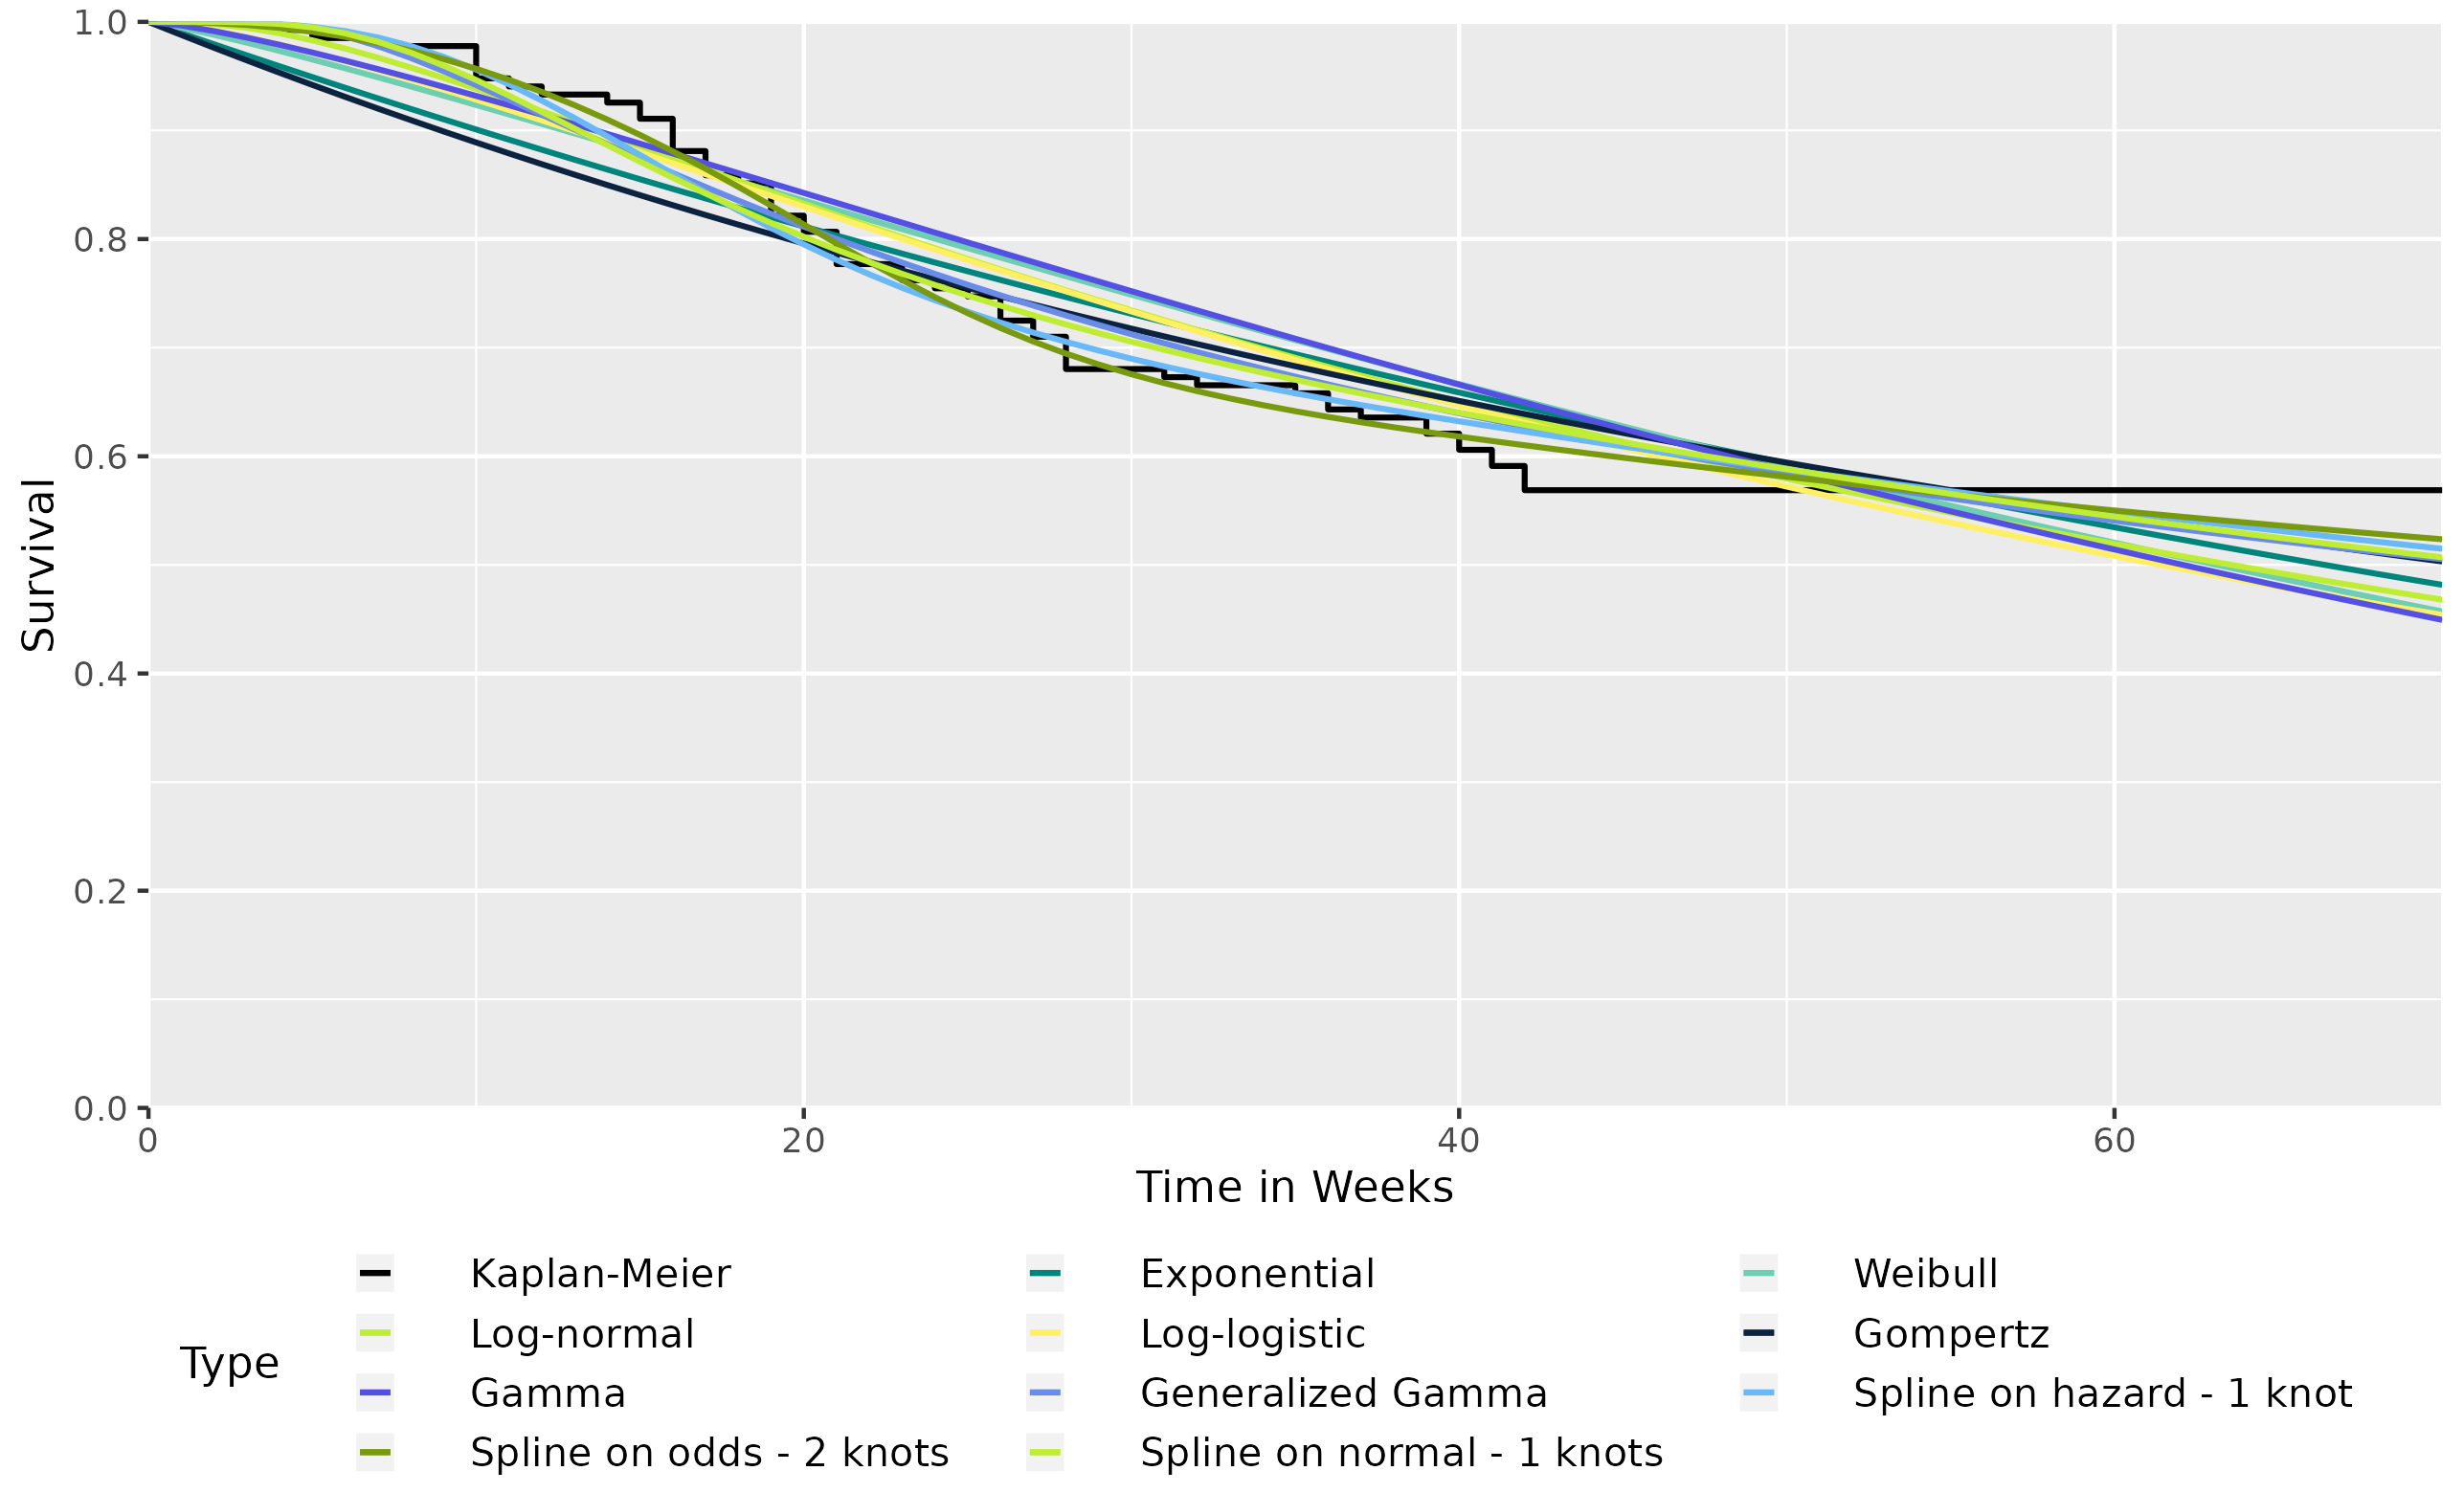

For more details on the survival models please refer to distributions reference vignette: https://cran.r-project.org/web/packages/flexsurv/vignettes/distributions.pdf.
Spline models are fitted on three scales: proportional hazards, proportional odds, and normal/probit.
Database Cutoff Date: XXX

