This is a test
(ITT Population)
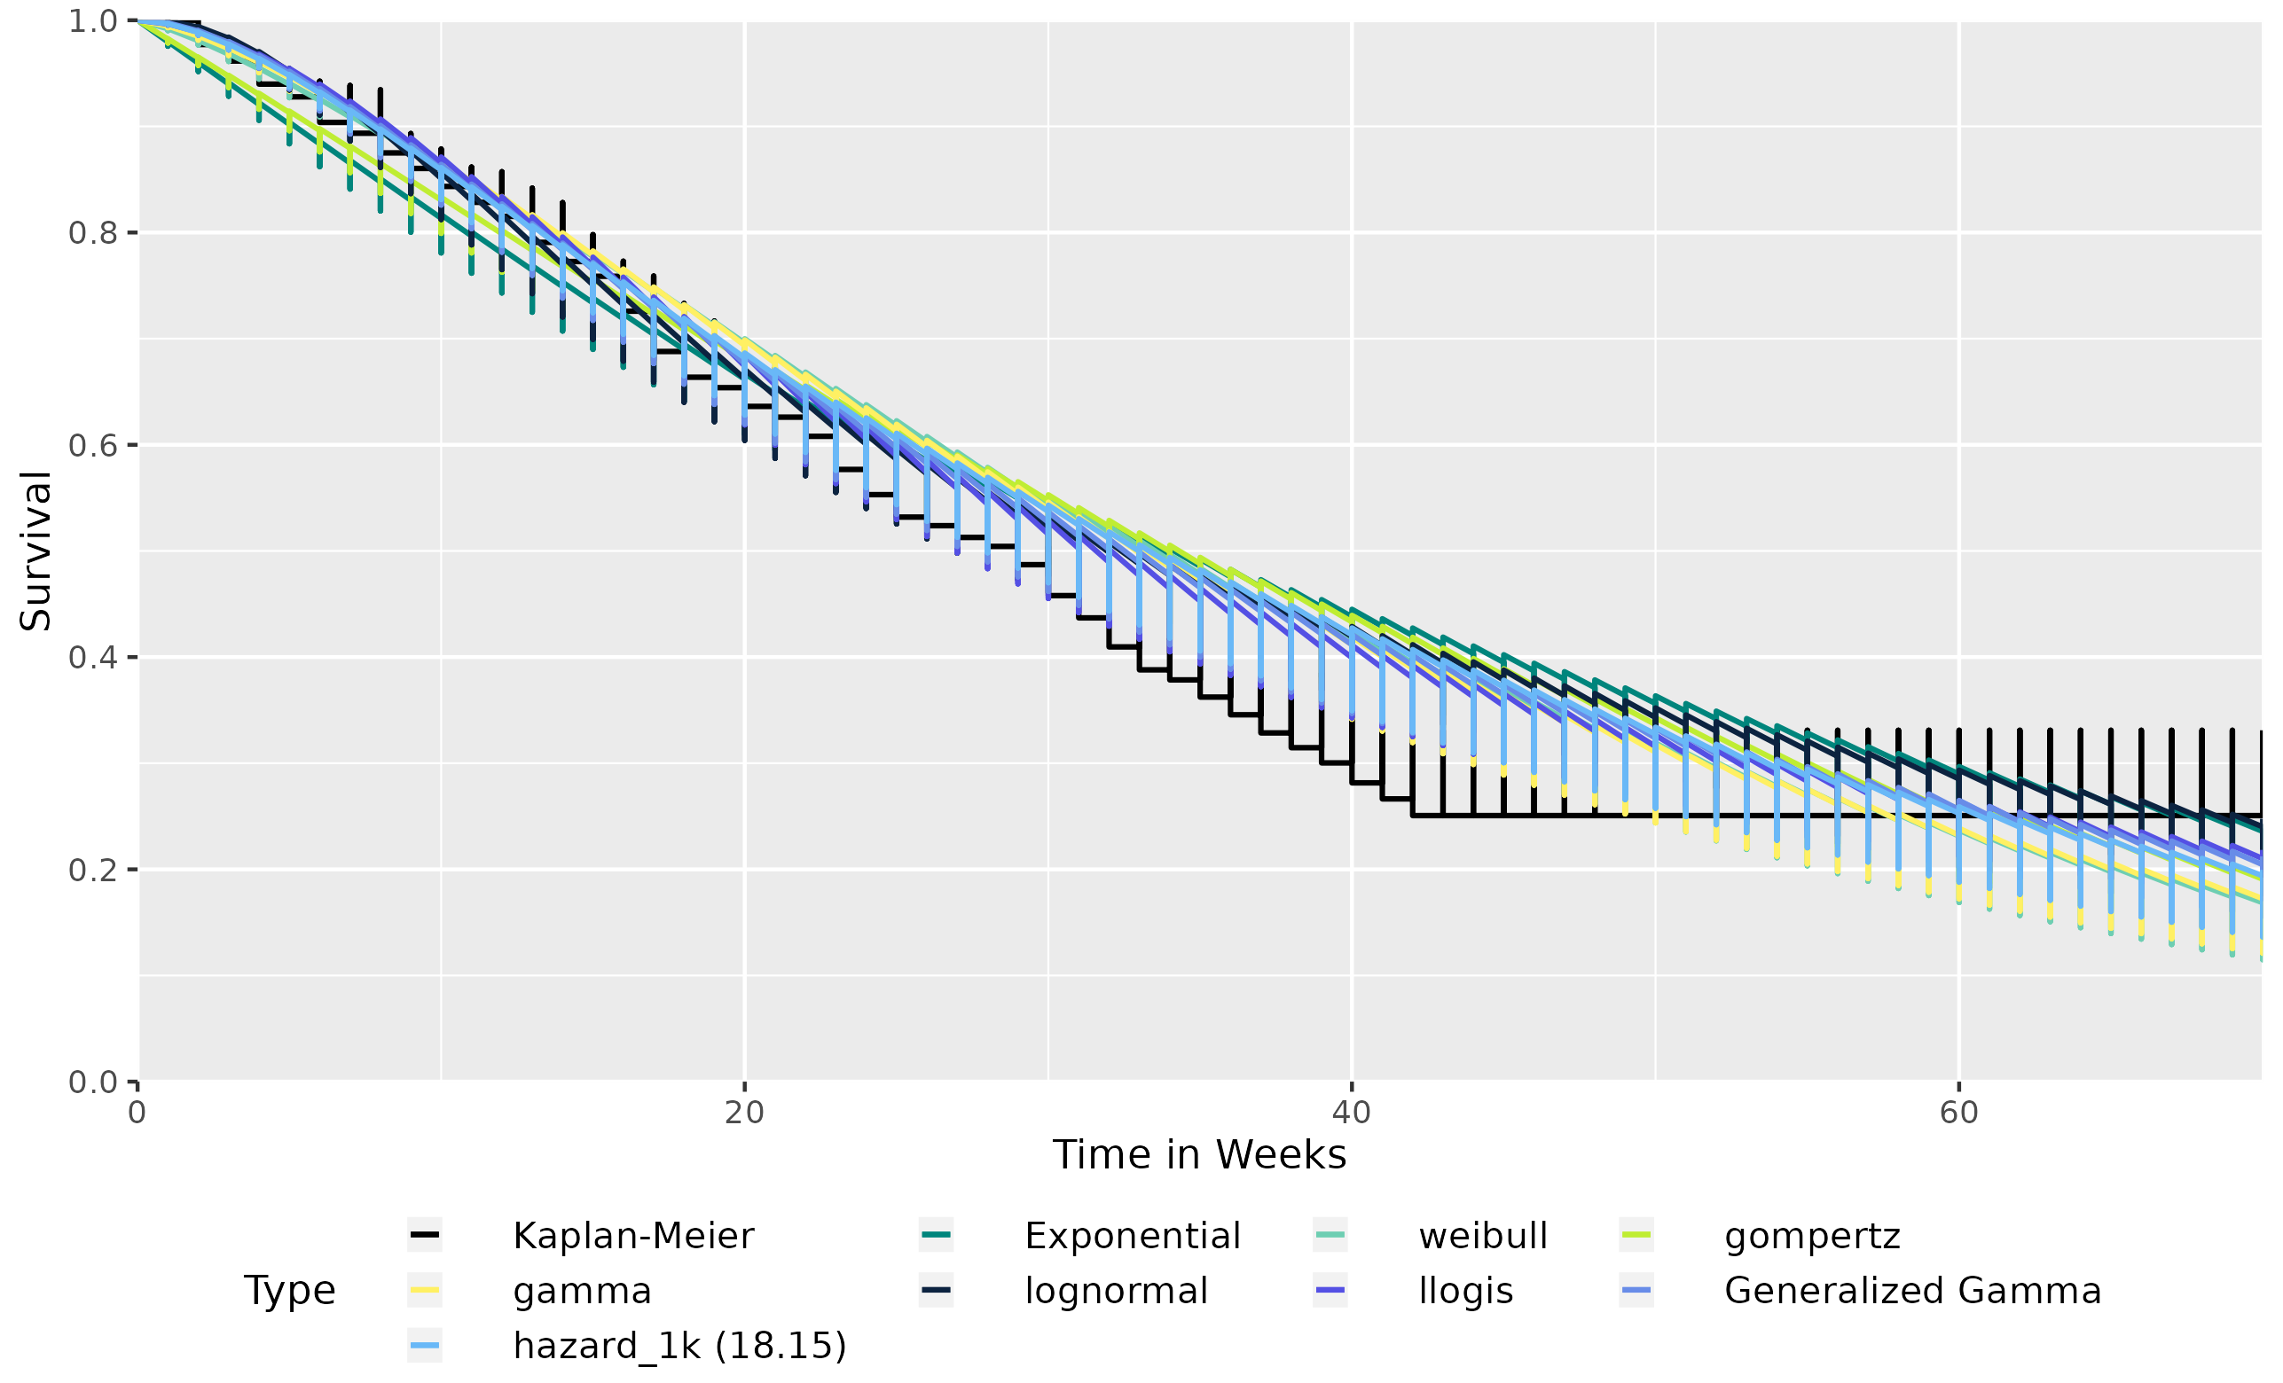

Database Lock Date: test

