EDA-498-Basic

Kavita

October 12, 2019

## R Markdown

This is an R Markdown document. Markdown is a simple formatting syntax for authoring HTML, PDF, and MS Word documents. For more details on using R Markdown see <http://rmarkdown.rstudio.com>.

When you click the **Knit** button a document will be generated that includes both content as well as the output of any embedded R code chunks within the document. You can embed an R code chunk like this:

library(ggplot2)

## Warning: package 'ggplot2' was built under R version 3.4.4

library(dplyr)

## Warning: package 'dplyr' was built under R version 3.4.4

##   
## Attaching package: 'dplyr'

## The following objects are masked from 'package:stats':  
##   
## filter, lag

## The following objects are masked from 'package:base':  
##   
## intersect, setdiff, setequal, union

library(sqldf)

## Warning: package 'sqldf' was built under R version 3.4.4

## Loading required package: gsubfn

## Warning: package 'gsubfn' was built under R version 3.4.4

## Loading required package: proto

## Warning: package 'proto' was built under R version 3.4.4

## Loading required package: RSQLite

## Warning: package 'RSQLite' was built under R version 3.4.4

base_data=read.csv("C:/Users/kmalhotra/Desktop/Course/MSDS-498/brazilian-ecommerce/Complete_dataset_new.csv", stringsAsFactors = FALSE)  
base_data$customer_id = trimws(base_data$customer_id)  
  
base_data$customer_city=as.factor(base_data$customer_city)  
base_data$customer_state=as.factor(base_data$customer_state)  
base_data$payment_type=as.factor(base_data$payment_type)  
base_data$product_category=as.factor(base_data$product_category)  
base_data$review_score=as.factor(base_data$review_score)

## Including Plots

You can also embed plots, for example:

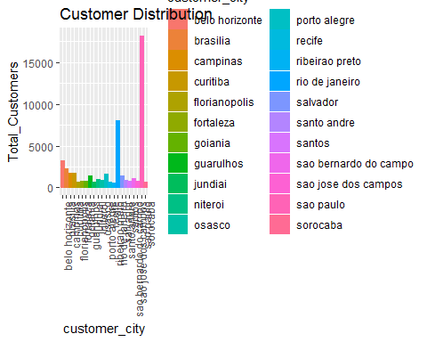

Note that the echo = FALSE parameter was added to the code chunk to prevent printing of the R code that generated the plot. 