Phase 2 Report

1. Baseline Evaluation Results
The baseline model developed in Phase 1 was trained and evaluated on the selected Aspect-Based Sentiment Analysis (ABSA) dataset. The dataset was divided into 80% training data (2,881 samples) and 20% testing data (721 samples) using stratified sampling to preserve the original class distribution.
After converting the input text into TF-IDF feature vectors, a Logistic Regression classifier was trained and evaluated on the test set.
(A fixed random seed (random_state = 42) was used to ensure that the experimental results are reproducible.)

Dataset Statistics
Item | Value
Total samples | 3,602
Training samples | 2,881
Testing samples | 721
Number of classes | 3
TF-IDF vocabulary size | 9,229 features

Class Distribution
Sentiment | Number of Samples
Negative | 805
Neutral | 633
Positive | 2,164
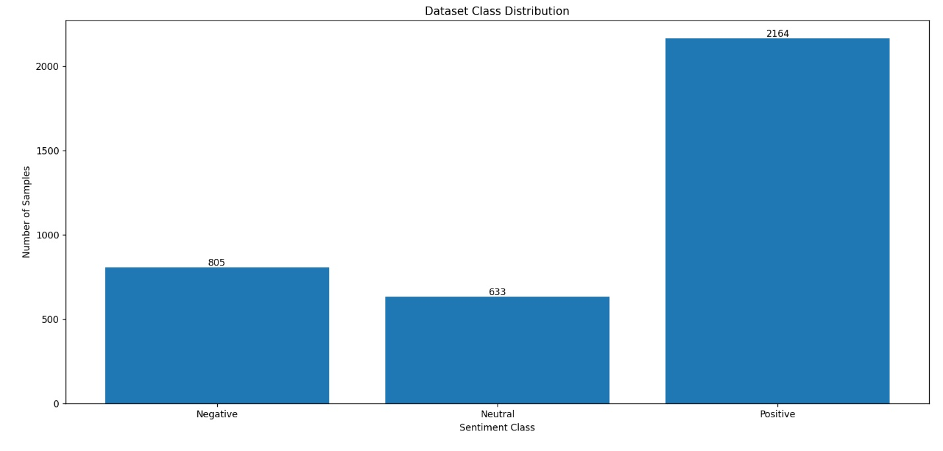
The dataset is noticeably imbalanced, with the Positive class containing substantially more samples than the Negative and Neutral classes. To reduce bias toward the majority class, the Logistic Regression model was trained using class_weight="balanced".

2. Evaluation Results
The baseline achieved the following performance on the testing dataset.

Metric | Score
Accuracy | 0.7143
Precision (Macro) | 0.6432
Recall (Macro) | 0.5964
Macro F1-score | 0.6131

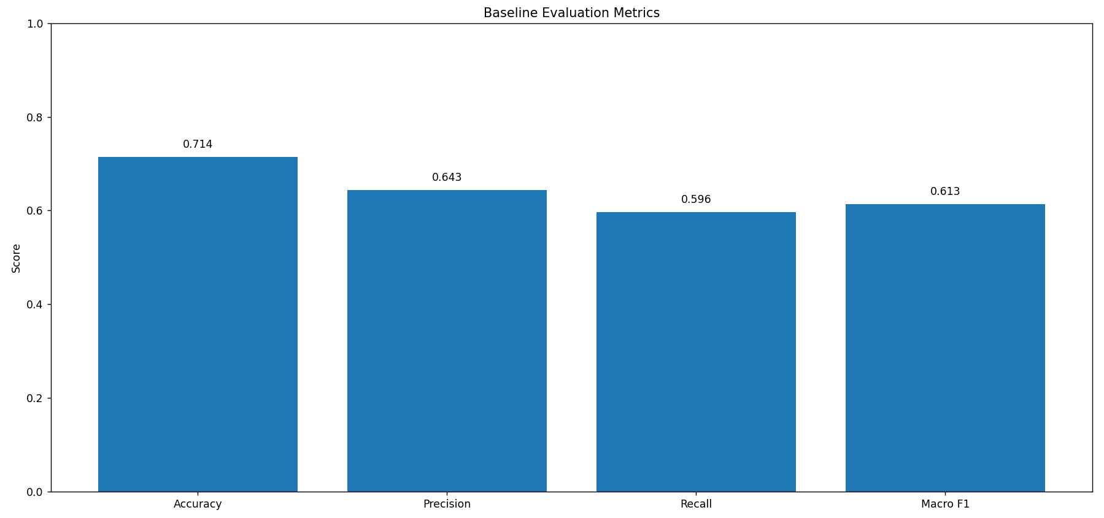

Classification Report
Class | Precision | Recall | F1-score
Negative | 0.60 | 0.50 | 0.55
Neutral | 0.55 | 0.40 | 0.47
Positive | 0.78 | 0.88 | 0.83
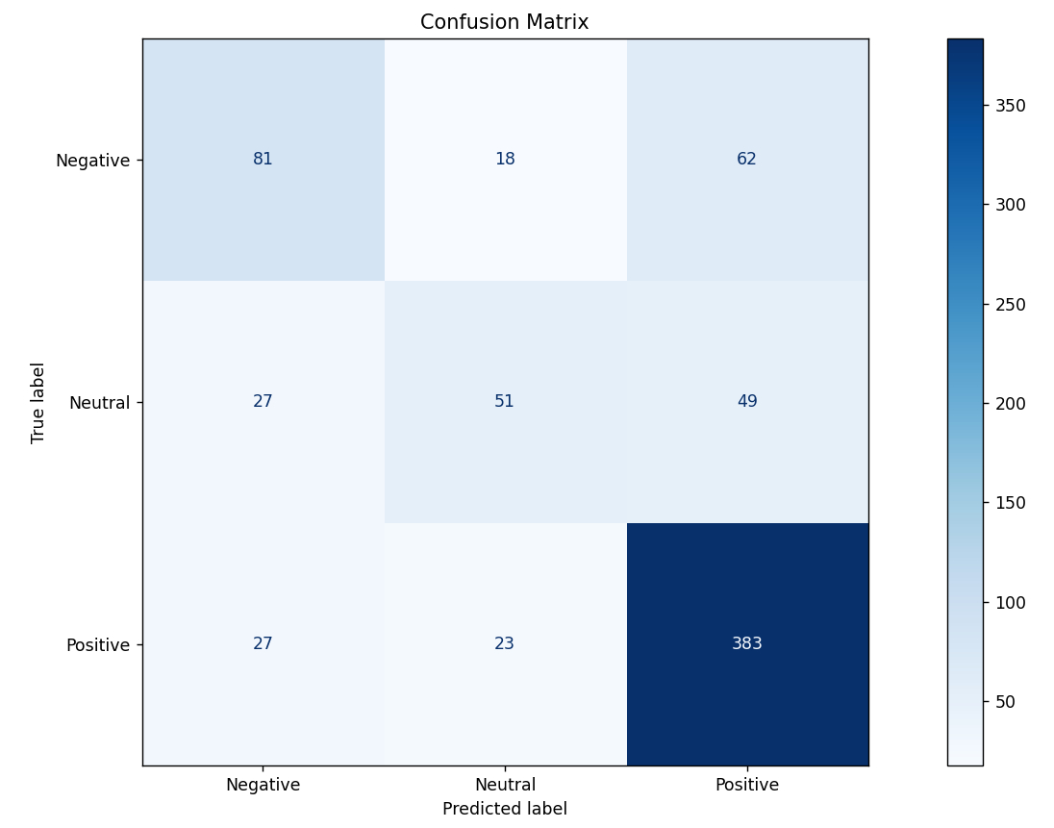
The confusion matrix shows that Positive samples are classified correctly more frequently than Neutral and Negative samples. Most errors occur between Neutral and the other two classes, indicating that the model struggles with weak or ambiguous sentiment expressions.

3. Interpretation of the Evaluation Metrics
Several evaluation metrics were used to assess the performance of the baseline model.
Accuracy measures the percentage of correctly classified samples among all testing samples. An accuracy of 71.43% indicates that the model correctly predicts the sentiment of approximately seven out of every ten aspect-sentence pairs.
Precision measures how often the predicted sentiment is correct. The macro precision of 64.32% indicates that, on average, predictions across all sentiment classes are reasonably reliable.
Recall measures how many actual samples of each class are correctly identified. The macro recall of 59.64% shows that the model misses a noticeable number of true examples, particularly for minority classes.
Macro F1-score combines precision and recall while giving equal importance to every class regardless of class size. The obtained Macro F1-score of 61.31% suggests that the classifier performs reasonably well overall but still struggles to classify all sentiment categories equally. Macro F1 was selected because the dataset is imbalanced. Unlike accuracy, it gives equal importance to all sentiment classes, making it a more reliable measure of overall performance.

4. Analysis of the Results
The classification report provides additional insight into the strengths and weaknesses of the baseline model.
The Positive class achieved the highest performance, with an F1-score of 0.83. This is expected because positive examples represent the majority of the dataset, allowing the classifier to learn their characteristics more effectively.
The Negative class obtained a moderate F1-score of 0.55, indicating that although many negative examples are correctly recognized, a considerable number are still misclassified.
The Neutral class achieved the lowest F1-score (0.47), making it the most difficult sentiment category for the baseline model. Neutral statements often contain weaker or less explicit sentiment expressions, making them harder to distinguish from both positive and negative opinions.
Overall, the model performs substantially better on Positive feedback than on Neutral or Negative feedback, suggesting that class imbalance and the subtle nature of neutral opinions affect classification performance.

5. Simple Result Breakdown
The baseline model was further evaluated by grouping the testing samples according to sentence length.
Sentence Length | Number of Samples | Accuracy
Short (<10 words) | 120 | 70.8%
Medium (10–20 words) | 349 | 76.2%
Long (>20 words) | 252 | 65.1%

The results indicate that the baseline performs best on medium-length sentences, achieving an accuracy of 76.2%. Performance decreases for both short and long inputs. Short sentences often contain very little contextual information, making it difficult for the classifier to determine sentiment. Long sentences frequently contain multiple opinions, several aspects, or more complex language, increasing the likelihood of incorrect predictions. This simple breakdown shows that input length has a noticeable effect on the performance of the baseline model.

6. Error Analysis
Several common types of errors were observed during evaluation.

6.1 Confusion Between Neutral and Polar Sentiments
Neutral comments frequently contain language that is only mildly positive or mildly negative. Because TF-IDF mainly relies on word frequency rather than deeper semantic understanding, such comments can easily be classified as Positive or Negative.
For example, a sentence such as:
"The menu was average."
was predicted as Negative, although the intended sentiment is closer to Neutral. This demonstrates that the model has difficulty interpreting mild or ambiguous opinions.

6.2 Multiple Aspects in the Same Sentence
Aspect-Based Sentiment Analysis requires the classifier to focus on the specified aspect rather than the overall sentence.
For example:
Sentence:
"The food was amazing but the service was terrible."
Expected predictions:
- food → Positive
- service → Negative
The baseline correctly predicted Positive for the food aspect, but it also predicted Positive for the service aspect.
This indicates that the model was influenced by the strong positive words in the sentence instead of correctly focusing on the selected aspect. Such sentences remain one of the main challenges for simple TF-IDF based models.

6.3 Examples of Misclassified Test Samples
Sentence:
Aspect: air conditioning Sentence: The service was mediocre[comma] and the lack of air conditioning made for a less than comfortable meal.
Aspect: air conditioning
True: Negative
Predicted: Neutral
--------------------------------------------------
Sentence:
Aspect: foods Sentence: We ate at this Thai place following the reviews but very unhappy with the foods.
Aspect: foods
True: Negative
Predicted: Positive
--------------------------------------------------
Sentence:
Aspect: fat Sentence: Food was very good as well[comma] considering that we tried the budget selection (though I wish the pork belly that I ordered was roasted a bit longer[comma] so that fat was more of a melt-in-your-mouth experience).
Aspect: fat
True: Negative
Predicted: Positive
--------------------------------------------------
Sentence:
Aspect: waiter Sentence: When my dessert came[comma] there was a candle in it - not because anyone asked for one - but because the waiter must have seen me opening my birthday card and gift[comma] and said he knew it was a special occassion of some sort.
Aspect: waiter
True: Positive
Predicted: Neutral
--------------------------------------------------
Sentence:
Aspect: dish Sentence: When asked about how a certain dish was prepared in comparison to a similar at other thai restaurants[comma] he replied this is not Mcdonald's[comma] every place makes things differently While it is understandable that every place is indeed different[comma] there was not a need to be uncourteous to customers and downright rude.
Aspect: dish
True: Neutral
Predicted: Negative
--------------------------------------------------
Sentence:
Aspect: manager Sentence: I asked for an open faced cheese sandwich and the manager basically told me to take my business elsewhere!
Aspect: manager
True: Negative
Predicted: Neutral
--------------------------------------------------
Sentence:
Aspect: dining Sentence: I would definitely go back for a very special occasion[comma] but not for regular fine dining.
Aspect: dining
True: Neutral
Predicted: Positive
--------------------------------------------------
Sentence:
Aspect: knishes Sentence: I didn't expect to like Nosh as much as I did[comma] but the pastrami on challah sandwich I had was otherworldly[comma] the soups are like Mom's[comma] and the knishes give Yonah Schimmel's a run for its money.
Aspect: knishes
True: Positive
Predicted: Negative
--------------------------------------------------
Sentence:
Aspect: take-out pizza Sentence: This is one great place to eat pizza more out but not a good place for take-out pizza.
Aspect: take-out pizza
True: Negative
Predicted: Positive
--------------------------------------------------
Sentence:
Aspect: delivered Sentence: So I've never actually been to M proper[comma] but I've had it delivered a few times.
Aspect: delivered
True: Neutral
Predicted: Negative

6.4 Difficulty with Short Feedback
Very short comments contain little contextual information.
Examples such as: "Average.", "Fine." and "Okay." provide very few informative words, making sentiment classification considerably more difficult.
Because TF-IDF represents text using word frequencies, limited context often leads to incorrect predictions.

7. Limitations
Although the TF-IDF + Logistic Regression baseline provides a simple and efficient solution, it has several limitations.
- TF-IDF ignores the meaning and context of words and relies only on word frequencies.
- The model cannot fully understand word order or long-range dependencies within a sentence.
- Logistic Regression is a linear classifier and cannot model highly complex relationships.
- The baseline struggles with sentences containing multiple aspects and different sentiments.
- Sarcasm, irony, and implicit opinions cannot be captured effectively.
- Performance is influenced by the imbalance of the dataset, where Positive examples greatly outnumber Neutral and Negative examples.

8. Future Work
Several improvements could be explored in future work.
- Replace TF-IDF features with contextual embeddings generated by transformer-based models such as BERT or RoBERTa.
- Increase the size and diversity of the training dataset.
- Apply hyperparameter optimization to improve classifier performance.
- Investigate data augmentation techniques for minority sentiment classes.
- Evaluate the model using cross-validation in addition to a single train-test split.
- Develop an end-to-end Aspect-Based Sentiment Analysis pipeline capable of automatically extracting aspects before sentiment classification.

9. Demo
A lightweight demonstration was implemented as part of the project.
The user provides:
- a sentence
- a specific aspect
The trained model predicts one of the following sentiment classes:
- Negative
- Neutral
- Positive
Example:
Sentence:
The food was amazing but the service was terrible.
Aspect:
food
Prediction:
Positive
Sentence:
The food was amazing but the service was terrible.
Aspect:
service
Prediction:
Positive
Sentence:
The staff were polite and friendly.
Aspect:
staff
Prediction:
Positive
Sentence:
The menu was average.
Aspect:
menu
Prediction:
Negative
The demo illustrates both the strengths and limitations of the baseline. While the model correctly predicts many aspect-sentiment pairs, it may fail when a sentence contains multiple aspects with different sentiments.

10. Integration with a Learning Assistant
The developed sentiment classifier can be integrated as a component of an educational learning assistant.
Students first submit textual feedback about a course. Each sentence and its corresponding aspect are then passed to the sentiment classifier, which predicts whether the sentiment toward that aspect is Positive, Neutral, or Negative.
The predicted sentiments can be aggregated across many students to produce summaries such as strengths of the course, common student complaints, frequently praised aspects, areas requiring improvement. Such summaries can assist instructors in identifying recurring issues and improving future course offerings.

11. Conclusion
This project implemented a simple and reproducible baseline for Aspect-Based Sentiment Analysis using TF-IDF feature extraction and Logistic Regression. The model achieved an overall accuracy of 71.43% and a Macro F1-score of 61.31%, demonstrating that a lightweight machine learning approach can perform reasonably well on course feedback sentiment classification.
The results also reveal several limitations. The classifier performs significantly better on Positive feedback than on Neutral or Negative feedback and struggles with ambiguous opinions and sentences containing multiple aspects. Despite these limitations, the baseline provides a strong reference point for evaluating more advanced Aspect-Based Sentiment Analysis methods in future work.

