**Android SIP Client - implementation**

**Technical documentation of the project**

**Version 1.0**

**Piotr Winiarski  
Paweł Durka  
Paweł Załuska  
Mateusz Goniprowski  
Janusz Cichocki**

# Description of the project

The following project resulted in developed Android application able to send, receive and read text messages between two mobile devices, remaining in connection within the same Wi-Fi network.

The interface of the application allows the user to manage sent and received messages in an easy way.

# Architecture

## Programming environment

Created application was build and tested with the usage of Android Studio in version 1.5.1.

## Main functionalities

Main functionalities included in final application:

* sending and receiving text messages between two devices with Android system,
* presenting message history on application screen,
* saving message history in device’s memory (stored in *SharedPreferences* object),
* deleting chosen messages,
* changing user’s name,
* reporting about new messages with sound notification,
* reading new messages and information about messages with usage of TextToSpeech mechanism.

## Data exchange in session

Data flow during the session establishing:

1: Invite

2: 200 OK

3: ACK

4: Sending messages

5: Byee

User A

User B

6: 200 OK

## Used external libraries

The following project makes use of Jain SIP library in Android –adapted Jain SIP RI version, release 1.2.258. The following version resolves some package name conflicts, and other issues occurred in the previous versions, what makes it the best choose to use in android application.

Additionally, standard Android API 23 components and libraries were used to provide proper application and its interface work, also library ButterKnife in version 7.0.1 for simpler binding Android views.

## Class diagram

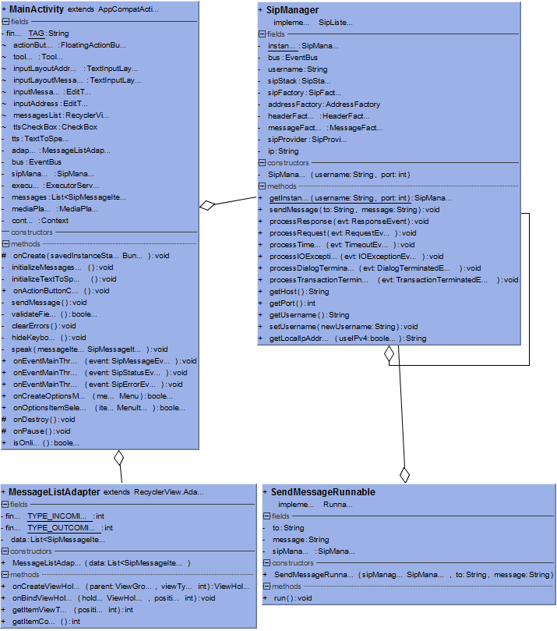

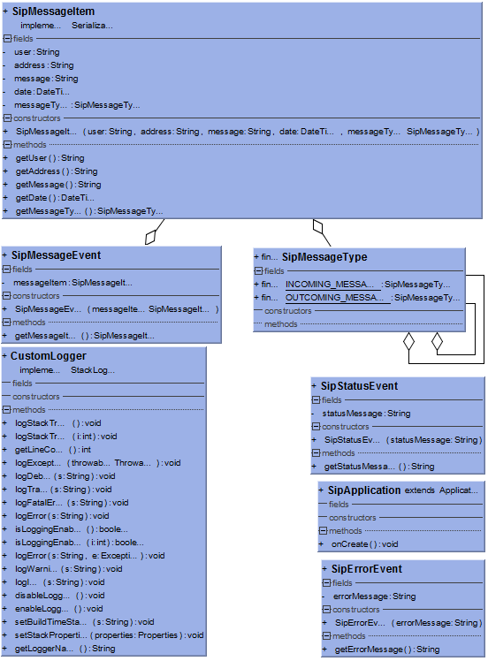

# Tests

Message was sent from phone to tablet:

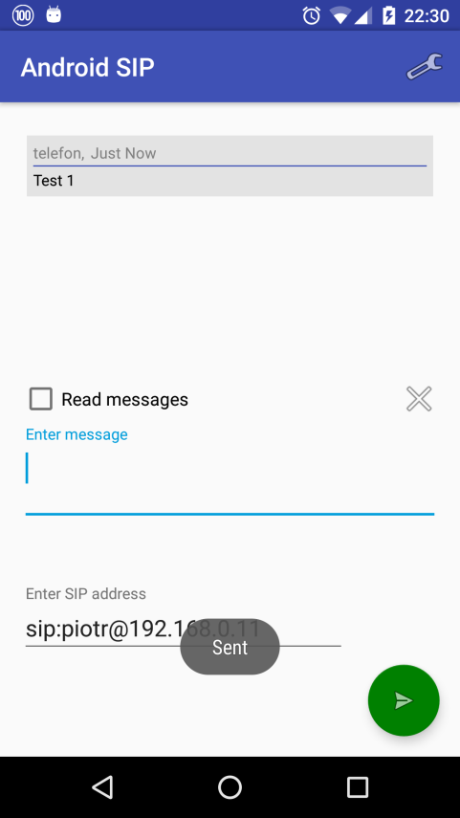

Message was sent from tablet to phone:

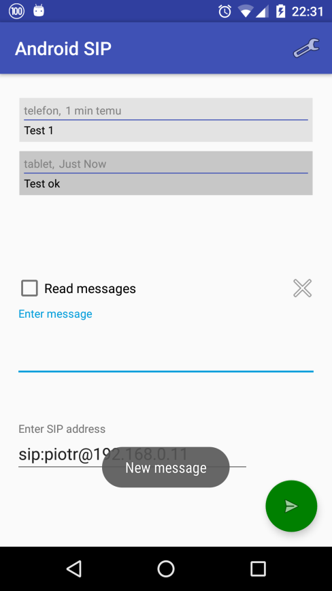

# Team member’s contribution

Piotr Winiarski:

- Group leader,

- Reading RFC ,

- Reading APIs and specification,

- Defining data types & classes,

- Making a project skeleton,

- Working on source code,

- Testing,

Paweł Durka:

- Reading RFC,

- Reading APIs and specification,

- Defining data types & classes,

- Making a project skeleton,

- Working on source code,

- Testing,

Paweł Załuska:

- Reading RFC,

- Reading APIs and specification,

- Defining data types & classes,

- Making a project skeleton,

- Working on source code,

- Testing,

Mateusz Goniprowski:

- Reading RFC,

- Reading APIs and specification,

- Presenting on intermediate review,

- Testing,

- Documentation

Janusz Cichocki:

- Reading RFC,

- Reading APIs and specification,

- Presenting on intermediate review,

- Defining data types & classes,

- Making a project skeleton,

- Working on source code,

- Testing,

# Compatibility & requirements

Requirements:

-WIFI network,

-Installed application,

-Android Device,

-Minimal android version on device is 15 (4.0.3) ,

-Maximum android version on device is 23 (6.0).

Compatibility:

Compatible version of android system:

- 4.03 Ice Cream Sandwich (15)

- 4.1 Jelly Bean (16)

- 4.2 Jelly Bean Mr1 (17)

- 4.3 Jelly Bean Mr2 (18)

- 4.4 KitKat (19)

- 5.0 Lollipop (21)

- 5.1 Lollipop (22)

- 6.0 Marshmallow (23)

# User’s guide

Installation .apk:

1. Copy the .apk file to the SD card
2. Find your file on SD card
3. Choose your .apk file and install

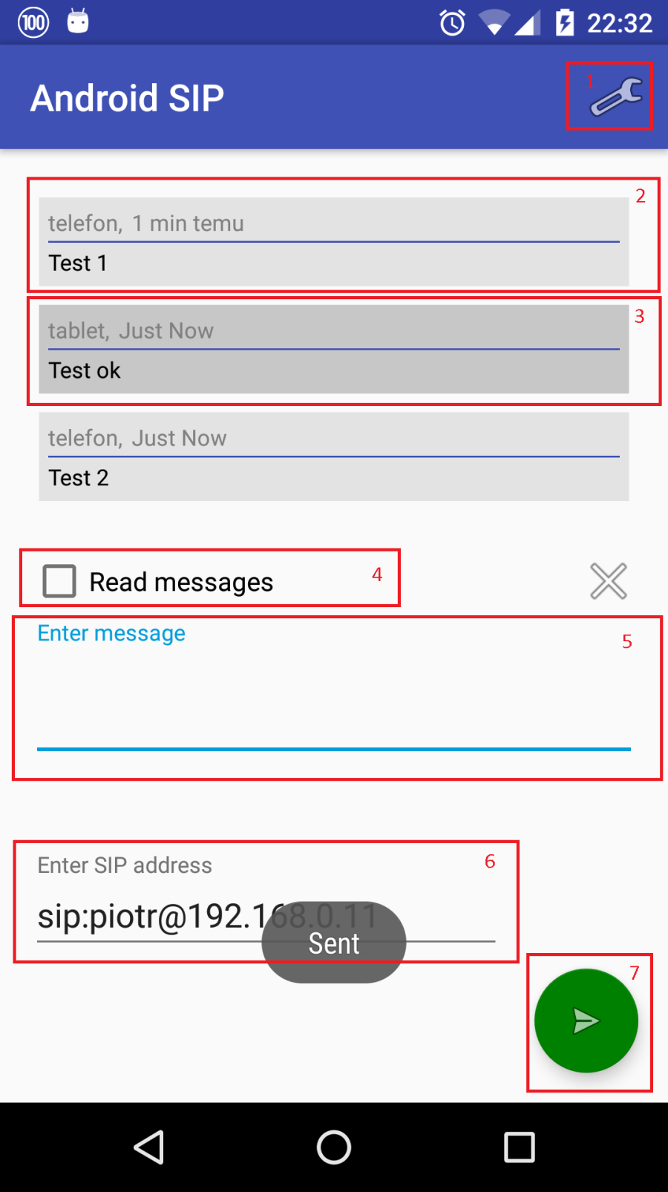

User guide:

1.Set your nickname

2.Your message to someone

3.Message to you from someone

4.Read message option- if you click on this checkbox application will read message for you (“new message from <username that send><message body>”)

5.here you enter your message

6.here you enter SIP address whose device you want to send a message

7. sending message button